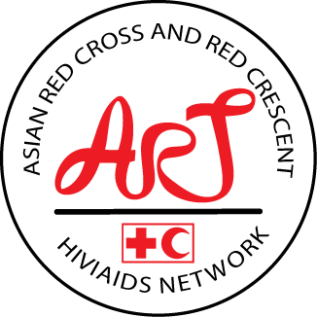Re

**Review of the Asian Red Cross and Red Crescent HIV/AIDS Network (ART)**

**2023**

# Executive Summary

The Asian Red Cross and Red Crescent HIV (ART) taskforce was formed in 1994. Forming a dedicated task force in response to the Beijing declaration, signed by National Societies present at the fourth Asia-Pacific Conference in May 1993, is an admirable accomplishment. Notably, this task force was renamed the ART Network in 2003 and comprised members nominated by their respective National Societies (NS) to serve as representatives and actively participate in HIV programming. It built momentum and capacity for HIV programming among NS across the region, resulting in better planning, stronger linkages between NS programs and national HIV strategic plans, and diversification of funding and activities for almost two decades. This review was conducted to assess the extent to which the network objectives have been achieved, identify lessons learned from 2019 to 2023, and provide a recommendation on the future of the network to the 20th SEA RCRC Leaders meeting in September 2023.

The ART network has made a general impact in some NS health education by integrating HIV projects and networking on HIV and substance abuse. It has continued to support positive progress in HIV/AIDS prevention and control, increased awareness of HIV/AIDS prevention and control of the quality of life of people affected by AIDS, and helped decrease the stigma and discrimination against the AIDS population.

It was apparent that the health pandemic has disrupted the core activities of the NSs and has further affected the objectives of the ART network. The network achieved fewer significant results from 2019 – early 2023, as the trend continuously declined in some areas of the objectives. The results demonstrate that for all commitment and engagement by the ART network between 1994-2023, the majority agreed, with one member strongly agreeing. This indicates that the network was functional at all levels of its commitment and engagement as per the terms of reference of the ART network. While 2019 to May 2023, it is noticed (figure 4) that there is a decrease in agree and strongly agree. However, there is still an indication that the network continued to provide mutual support, professional development, and exchange of information. During this period, there was an increase in neither agree, disagree, and disagree, as it was noted from the review of the minutes of the meeting and survey response that most NS areas of focus and resources changed to other programs, such as the COVID-19 response. It is presumed that the members of the ART secretariat were overwhelmed with their commitment while taking full-time roles in their NS in response to the pandemic.

The effectiveness and impact of the ART network and member NS HIV/AIDs program are challenging to measure due to a lack of data. The ART network did not have a clear set of indicators and annual targets on what the network wanted to achieve apart from the set objectives. However, the survey findings indicate that the member NS received the highest support in exchanging information material and resources, including funding, collaborative intervention on the NS's program (peer-to-peer support among NSs), and coordination and collaboration at the regional level. There is indicative of further support in coordination and collaboration at the regional level, monitoring and evaluation, and exchange of information. This further support does not need a network but can be scaled to cluster collaboration and integrate into other health networks.

## Summary of Recommendations

Based on the findings, the outcome of this review would like to make two streams of recommendation as per the following:

1. **Merge the ART Network**

* Collaborate and consolidate with other esteemed sub-regional health networks to establish a comprehensive regional strategy, to elevate the reach and guarantee longevity.

1. **Conclude the ART Network**

* The ART Network is facing significant challenges related to inadequate strategic planning, a lack of commitment from members, financial constraints, and limited resources, which may impede its ability to sustain itself in the future.

Either way, it is recommended that the IFRC country cluster and regional office facilitate the following during the transition:

* Support the NS to align their activities with other local government and non-government roadmaps, as well as regional and international networks.
* Assist in facilitating the sharing of resources and information among NSs, as required, through the provision of technical support.
* Assist in developing action plans for regions and encourage members to share data.
* Encourage NS to partner with local, regional, and international actors and community networks to build capacity and resources.
* It is advisable to promote the continuity of HIV/AIDS programs by encouraging NSs to maintain their stronger local partnerships and national-level support. Such measures can help ensure the long-term sustainability of these critical programs.

In order to achieve cost-effectiveness and promote sustainability, it is imperative to seamlessly integrate HIV/AIDS programs with other health programs and offer targeted support to the affected communities. Furthermore, it is critical to prioritize contextualization in the planning and execution of these programs to ensure their efficacy and success.

Table of Contents

1. Executive Summary 1

1.1 Summary of Recommendations 2

2. Introduction 4

2.1 Methodology 5

3. Findings and Discussion 5

4. Conclusion 14

5. Commendations 16

6. Recommendations 16

7. Appendix 17

# Introduction

The Asian Red Cross and Red Crescent HIV (ART) taskforce was formed in 1994. Forming a dedicated task force in response to the Beijing declaration, signed by National Societies present at the fourth Asia-Pacific Conference in May 1993, is an admirable accomplishment. Notably, this task force was renamed the ART Network in 2003 and comprised members nominated by their respective National Societies (NS) to serve as representatives and actively participate in HIV programming. The ART Network comprises a group of esteemed professionals specializing in HIV and AIDS from Southeast and East Asia affiliated with various Red Cross and Red Crescent Societies. These organizations collaborate to address HIV-related issues, and the ART Network plays an instrumental role in advancing effective HIV programming, sharing best practices, exchanging knowledge, and ultimately contributing to reducing the impact of HIV/AIDS within their respective regions.

The ART assists in strengthening NS's capacities to deliver and sustain scaled-up HIV programs which seek to promote the respect of human rights in all aspects through the following:

* Prevention of further HIV infections
* Expanding HIV care, treatment, and support
* Reducing HIV stigma and discrimination

The ART network has undergone evaluation for the period of 2004 – 2008 based on the objective of the ART Strategic Plan, which outlined as a vision[1]: 'The Asian Red Cross and Red Crescent Regional HIV/AIDS Network (ART) is a strong network and a key player in addressing HIV/AIDS-related issues in the Southeast and East Asia region.[2] The effectiveness of the ART network has been the subject of discussion, with some concerns raised regarding the ability of ART members to report and respond to information requests. The evaluation found that the ART network is generally strong and fosters a culture of information sharing among its members, but there are currently no incentives to ensure that ART members meet their membership requirements. The evaluation recommended implementing measures to improve compliance and accountability of ART member NS and network, to ensure that the funding invested in their participation in ART is being utilized effectively (evaluation report, 2008).

By 2008 the ART had 14 NS members: Cambodia, China, Hong Kong, Indonesia, Japan, Republic of Korea, Lao PDR, Malaysia, Mongolia, Myanmar, Philippines, Thailand, Timor Leste, and Vietnam, with Australian Red Cross (ARC) as a collaborative member. The ART network is expected to have a shared understanding among its members, to be effective and active. However, four-member NS exited the ART network. In 2015, it was noted that the ART network was already growing weaker due to inadequate commitment from some members and the leadership of the NS (Terms of Reference ART Review, 2015). Due to the lack of financial support, the network increased its membership fees for their sustainability, but at the same time, it was a burden to some NS. Since 2020, during the outbreak of COVID-19, it was noticed that only the management team members of the Network (Cambodian RC. Lao RC and Thai RC) plus the IFRC Bangkok have been actively in contact with each other.

As a result, a recommendation was put forward by Cambodian Red Cross, the secretariat for the network, to the 19th SEA Leaders meeting to officially review the network with the view to closing or revising the network. The evaluation will review the outcomes of the ART network from 2019 to 2023 to assess the extent to which the network's objectives have been achieved, identify lessons learned, and provide a recommendation on the future of the network to the 20th SEA RCRC Leaders meeting in September 2023.

## Methodology

A desktop review that included the ART network documents was reviewed. The documents under review covered various topics, including the terms of reference for the ART, minutes from meetings, data presented at leaders' and Asia Pacific Health meetings, case studies, member self-evaluations, progress reports, and evaluation reports. The comprehensive nature of the review likely yielded invaluable insights into the operations and effectiveness of the ART network. This information can prove helpful in assessing progress towards established objectives and identifying areas that require improvement.

The questionnaires were created and distributed online from June through early July 2023. In addition, members were allowed to participate in an in-depth survey interview. The online questionnaires were explicitly designed to gain insight into the independent views of the NSs. They were disseminated using Google Forms (online) and Word documents to the ten (10) active members of the ART Network. An email request was sent to these members, accompanied by several reminders, including personal messages from the ART chair and the IFRC Bangkok office. These efforts were undertaken to encourage all ART members to complete at least one method of the questionnaire. The overall evaluation process was conducted virtually. Respondents to the survey were from the member NS.

# Findings and Discussion

During the 2012 ART consultative meeting in Cambodia, a SWOT analysis was conducted and more to focus on the challenges with possible solutions for the future. However, the weakness prior to 2012 and after seemed to remain, especially the lack of communication, NS not being actively involved due to their workload, and frequent change of focal points. The SWOT 2012 also noted the increase in funding competition and mixed signals of the future direction of the network as threats.

For the ART network to effectively achieve its objectives, its members must share a common understanding and maintain effective communication. Unfortunately, four members have withdrawn from the network for various reasons. Their decision was likely impacted by a lack of involvement in ongoing HIV/AIDS projects or activities, which may be a prerequisite or expectation within the network. Another contributing factor was NS's decision to re-prioritize its strategic plans and allocate resources toward different goals. Additionally, changes in scope due to health emergencies have played a role in their decision to withdraw, as they have had to shift their focus towards immediate health concerns rather than longer-term HIV/AIDS projects. Lastly, one reason for their departure was to "collaborate" with the network or partnerships more closely aligned with their current objectives. The ART network comprises ten (10) active members.

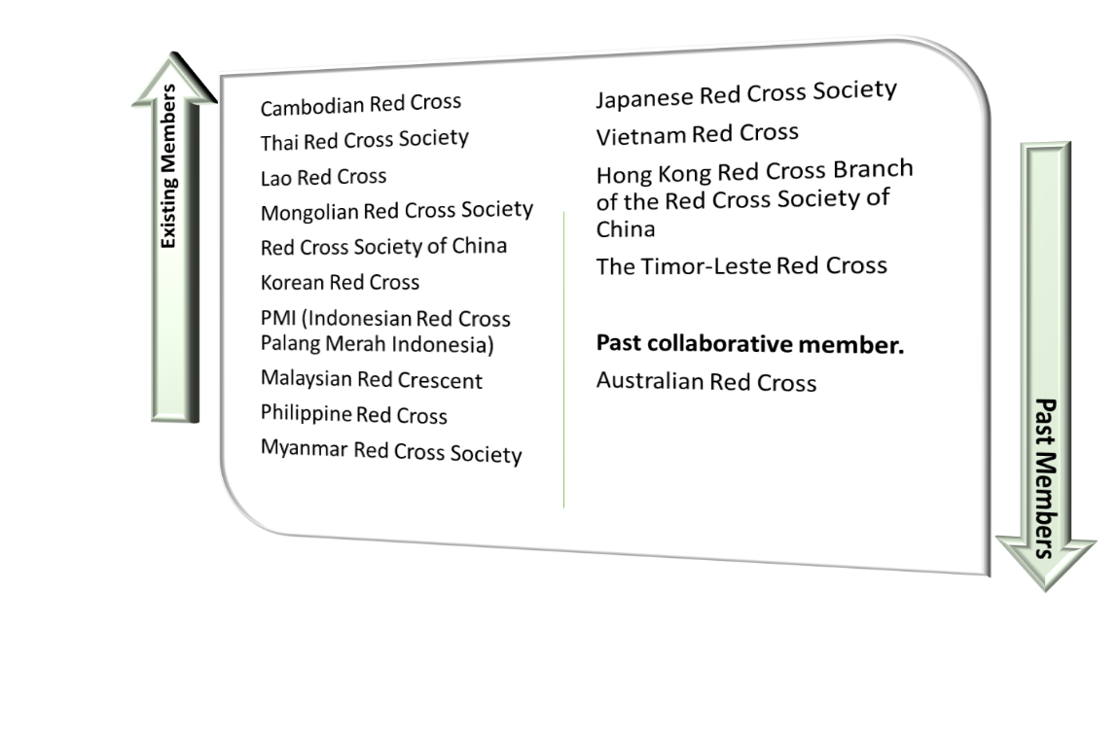

Figure ART Network Existing and Past Members

There was still no clear strategic direction for the network since the evaluation recommendations in 2008, SWOT in 2012, and terms of reference review in 2015. Those members that are very active have other in-country issues that seem to affect their external participation. From the ART online meeting in 2022, it is notable that NS is better equipped with in-country support and partnership with local communities as they can access funding actively. Therefore, many members of NS are no longer interested in the network and have a problem with membership fees, whereas that chunk of financial support can support the NS. Further, the network does not have the AMT and is survived by the Chair, who has continued in this role over the required term.

However, the ART network has made a general impact in some NS health education by integrating HIV projects, attending network meetings, and HIV and substance abuse has been beneficial. One of the NS mentioned that the work of the AIDS Research Center still needs supporting information and planning to provide services to service recipients from different countries. Another NS said, "Since the establishment of the network, it has continued to support positive progress has been made in HIV/AIDS prevention and control, the awareness of HIV/AIDS prevention and control has been significantly improved; the HIV/AIDS epidemic has been kept at a low level overall; the quality of life of people affected by AIDS has been further improved; the discrimination against AIDS population has been further reduced."

The future recommendations to the ART Network from the six-member NS are as follows:

* ART Network may remain a network with specific deliverables per region, as different regions have different contexts. NS sharing and technical support may be its central role.
* Since no activities are going on, there is not much to share.
* If it remains a network, it should scale to cluster collaboration/technical assistance and secretarial support from IFRC Bangkok. The second option is to resolve (close) the network, as each NS has integrated HIV into the overall health program.
* Still sees the importance of developing work with participation in the differences of the "Art Network" group members.
* The ART Network should integrate with the health network if possible.
* We suggest the network to adjusts and optimize the establishment of a structure to better adapt to the status of AIDS prevention and control and the needs of various countries. We also hope that the network can strengthen international cooperation and support exchanges.

Six of the ten members of the ART network participated actively in the survey, while one generally responded over email about their status. Therefore, the following analysis is based on the 70% response provided by the members.

What were some examples of valuable lessons acquired from the ART Network from 2016 to 2023?

The ART network facilitated information exchange. In 2017 and 2018, the network organized online information-sharing meetings which supported HIV works and positively influenced the HIV prevention work of one of the NSs. As such, one member of NS implemented HIV and substance abuse prevention project through the support of IFRC and Italian RC for 2016-2018. One respondent said they did not know much about the network but thought it could be helpful to exchange knowledge, while another respondent said minimal outcomes for their NS as the network was not as active as before 2016, and the NS has not seen any updated plan and report. One NS indicated that they do not have any activities regarding the network.

Based on the response, it indicates that the majority of the members received information on HIV and AIDs programs and related activities; however, the network did not seem as active as it used to be before 2016. The members also used `other platforms` besides the ART network for the HIV/AIDs program.

What does the ART Network provide/ has provided to the NS by facilitating?

A majority (66.7%) responded that the network facilitated information sharing, while one national society indicated skill development, technical support, and knowledge retention, including information sharing. 16.7% responded to knowledge retention and skills development, respectively. Technical support was rated at 0%, while 16.7% indicated the question as not applicable to the national society.

What best represents the added value of the ART network generated for the national society?

This section determines what best represented the network regarding the added value, which members were asked to rate. Figure 2 below shows that most members agreed that the network effectively and efficiently exchanged information and provided skills. Regarding providing technical support and preserving the knowledge gained through experience and retained lessons learned, two members agreed, two neither agreed nor disagreed, and one disagreed. None of them strongly agreed with any of the added values of the network, while one member strongly disagreed with all four.

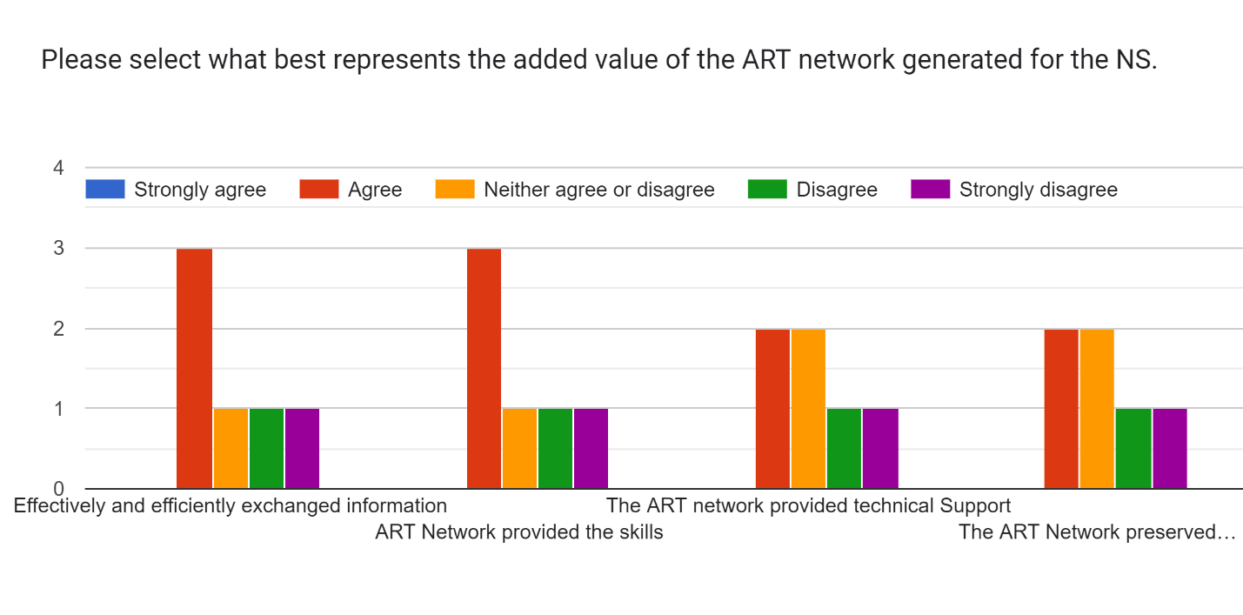

Figure Response to Different Streams of Added Value of the ART Network.

The results indicate that the network provided effective and efficient information exchange and skills, which may have benefited some members only.

Does the ART Network continue to provide NS with valuable resources like exchanging information, developing skills, technical support, and retaining acquired knowledge?

50% responded yes, while 50% responded no. The question was further expanded based on the yes and no. If participants said "yes," they were asked how often the network shares information before the COVID-19 pandemic. 66.7% indicated that the information pre-pandemic was shared annually, while 33.3% responded that it was shared quarterly with them. While those who answered `no` had the following reasons; poor communication among the ART members, no clear strategy, and HIV not being made a priority; one member mentioned that the year 2020-2023 was focused on the COVID-19 pandemic, and one NS mentioned that they did not implement any of the relevant activities from the ART network.

Rate the level of agreement.

The members of the ART network rated the level of agreement with each of the following statements:

* The ART network always reached out to the national societies (overall support)
* As a national society, we reached out to the ART network (overall support)
* Spiritual support and advocacy were provided to the national society members.

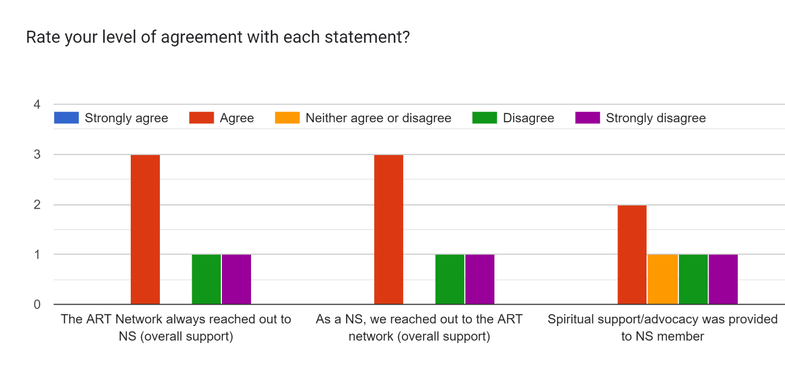

Figure Response to the Level of Agreement of the Statements

At least 50% of the members agreed that the network always reached out to the members, and as members, they also reached out. While two members disagreed, and one strongly disagreed, while one could not answer due to staff rotation. Regarding spiritual support/advocacy, only two of the seven respondents agreed.

Rate the commitment and engagement of the ART Network from 1993 – 2018 and 2019 – May 2023.

To rate the commitment and engagement level between 1993-2018 and 2019 to May 2023 to improve the roles of the national societies, the members responded as per the following:

* Mutual support and professional development support are directly provided.
* The exchange of information, best practices, and resources have effectively generated.
* The effectiveness of the HIV/AIDS program in the NS increased
* The coverage of the HIV/AIDS program in the NS has improved
* The quality of the HIV/AIDS program in the NS has improved
* The visibility of national society's work on HIV/AIDS has improved

Table 1 below describes the members' responses, including six NS for 1993-2018 and seven NS for 2019-2023. The seventh member NS was excluded from 1993-2018 because the NS is assumed to have commitment and engagement with the network from reviewing the documents as per part 1 of this section. However, the email response indicates that the member NS is in the position to neither agree nor disagree.



Table Shows the Commitment and Engagement Rate between 1993-2018 and 2019 to May 2023.

The results demonstrate that for all commitment and engagement by the ART network between 1993-2018, the majority agreed, with one member strongly agreeing. This indicates that the network was functional at all levels of its commitment and engagement as per the terms of reference of the ART network.

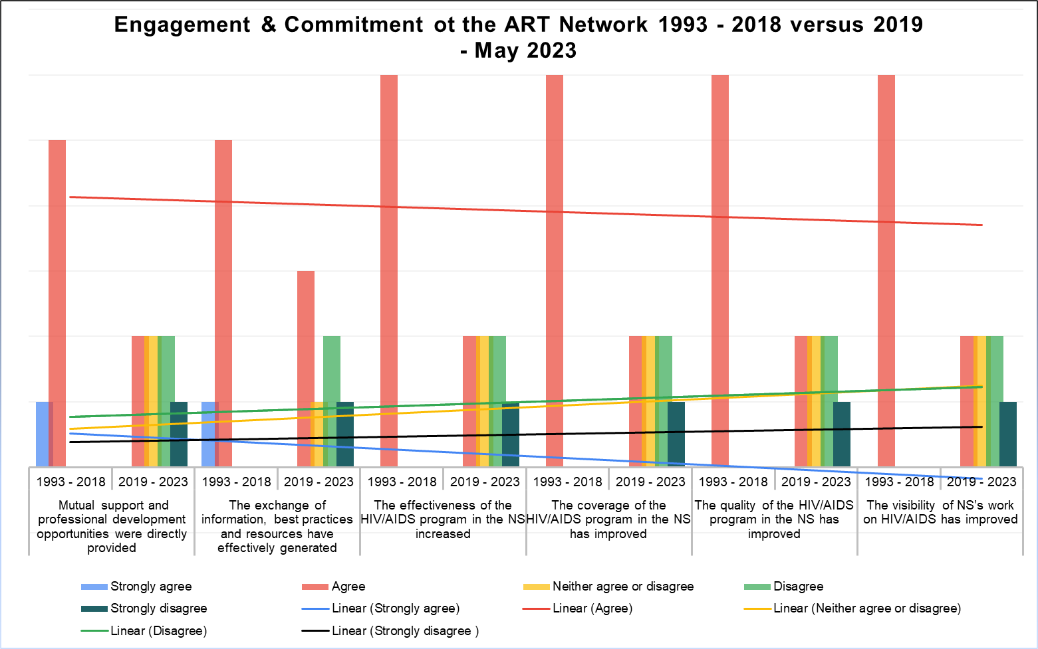

Figure shows the Linear Engagement & Commitment of the ART Network 1993-2013 versus 2019-May 2023

While 2019 to May 2023, it is noticed (figure 4) that there is a decrease in agree and strongly agree. However, there is still an indication that the network continued to provide mutual support, professional development, and exchange of information. During this period, there was an increase in neither agree, disagree, and disagree, as it was noted from the review of the minutes of the meeting and survey response that most NS areas of focus and resources changed to other programs, such as the COVID-19 response. It is presumed that the members of the ART secretariat were overwhelmed with their commitment while taking full-time roles in their NS in response to the pandemic.

Support Received from the ART Network, and does the member NS still needs this support in the future?

The ART network, in their plans and terms of reference, was mandated to provide the following support to the member NS:

* Assessment needs
* Skills training needs
* HIV/AIDs workshop
* Study Visits
* Exchange of information material and resources (including funding)
* Inter-country interventions and programs on issues
* Monitoring and evaluation
* Collaborative intervention on the NS's program (peer-to-peer support among NSs)
* Coordination and collaboration at the regional level

The members were asked what kind of support the NS received as part of the review and were allowed to select multiple options. Figure 5 below shows that the exchange of information material and resources, including funding, collaborative intervention on the NS's program (peer-to-peer support among NSs), and coordination and collaboration at the regional level stood out the highest at 66.7% from the 60% respondent. HIV/AIDs workshops and monitoring and evaluation stood at 50%, while skills training was at 33.3%. Study visits, inter-country interventions, and programs on issues stood at 16.7%, respectively. One of the members stated that after 2015, all activities with the ART were suspended. Assessment needs support stood at 0%.

Forms response chart. Question title: Select the support your NS received from the ART Network (multiple selections).
. Number of responses: 6 responses.

Figure shows the kinds of support ART network members received.

The results indicate that most support received from the ART network was on exchanging information material and resources, including funding, collaborative intervention on the NS's program (peer-to-peer support among NSs), and coordination and collaboration at the regional level.

To further investigate, the members were asked if there is a need for such support in the future by the network.

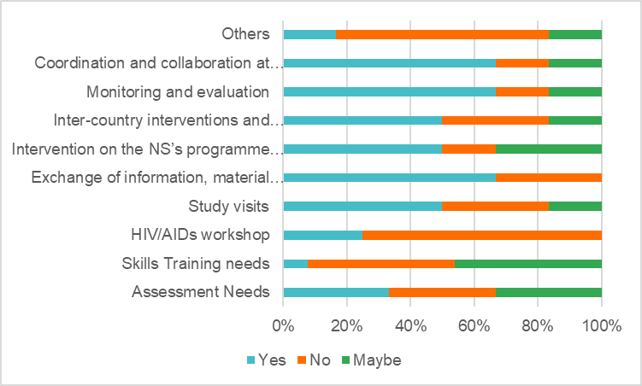

Figure shows the future needs of support streams required by the ART Network.

According to the results in Figure 6, the members still need further support in coordination and collaboration at the regional level, monitoring and evaluation, and exchange of information. These three support rank high-level. Inter-country interventions and programs on issues, collaborative intervention on the NS's program (peer-to-peer support among NSs), and study visits support must stand medium level while assessment needs, HIV/AIDs workshops, and skills training must be lower.

Did the ART Network successfully fulfill the goals?

As per the purpose of this review and to evaluate the network, existing members were also asked to evaluate, from their perspective, if the network has successfully fulfilled the goals specified in the terms of reference, strategy, and yearly work plan regarding HIV/AIDs programming.

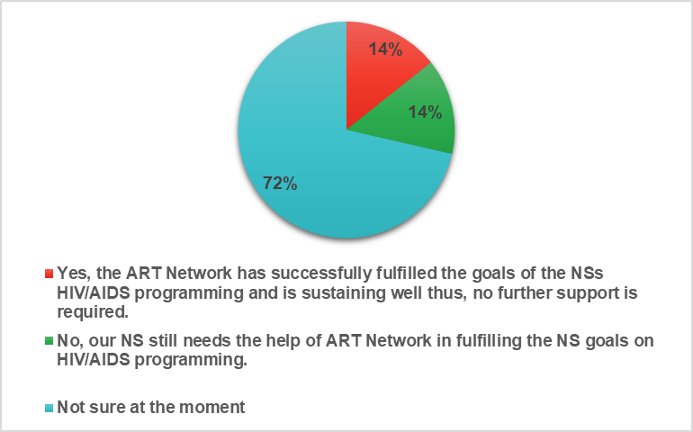

Figure shows the percentage of the ART Network fulfilling its goals.

Most respondents (72%) mentioned: "Not sure at the moment." One member answered yes, while one member answered no, and the NS still needs the network's support in fulfilling its goals in HIV/AIDs programming.

To further understand the NS response to "not sure at the moment," the members were asked to rank their level of involvement, engagement, and commitment toward the ART network.

Frequency of the NS's involvement, engagement, and commitment towards the ART Network.

These included the following responsibilities:

* The NS was actively engaged in all the meetings

None of the members actively engaged in the meetings—two members each, respectively, either often or sometimes engaged in the meeting. The rest of the three members were rarely, never, or unsure about the meeting engagement.

* The NS provided peer support (study visits) to other NS through the ART Network.

Most members never or rarely provided peer-to-peer support or study visits to other NS members through this network. Two members of NS provided this service sometimes.

* The NS was highly involved with discussion, issues, and impacts of the HIV/AIDS programming.

The member NS sometimes or rarely were involved in discussing issues and impacts of the HIV/AIDs programming. Only one member NS was often involved in such discussions, while one member was never involved, and one NS was unsure of their role.

* The NS shared the commitment through their short and long-term goals/objectives on HIV/AIDS programming.

One member was always involved in sharing their commitment through the short and long-term goals of HIV/AIDs programming, while the majority sometimes shared their commitments.

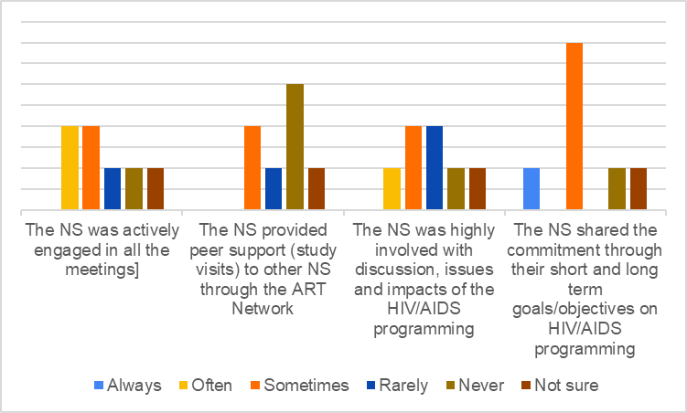

Figure shows the frequency of the member's commitment, involvement & engagement toward the ART Network.

The overall results show that most members often to sometimes were involved in the network activities or rarely to never. Thus, this would indicate the "not sure at the moment" response to if the ART has fulfilled the goals. For any network to fully function, commitment and responsibilities are expected from the members. However, the lack of commitment, engagement, and involvement could be related to many internal NS factors, their strategic directions, and the network's limitations with existing resources.

# Conclusion

It was evident that the health pandemic has disrupted the core activities of the NSs and has further affected the objectives of the ART network. Since the health pandemic, the scope and strategic plans of the NS have been reviewed and modified, and the role of activities in other vital areas has increased, leading to financial burdens and a lack of resources. Nevertheless, it is not just the pandemic, as it was noted earlier in the 2014 annual meeting that for some NSs, it is a challenge to allocate USD1000 per year with their ongoing local challenges and the issue of foreign currency payment. These affected regular coordination and the financial contribution to the network to function and support its activities. The local partners' funding has been stretched out or prioritized elsewhere during the pandemic, making it challenging for NSs. In the new normal, we do not need face-to-face meetings as online and remote learning has been part of many networks and organizations.

It is disheartening to learn that the ART network is experiencing a loss of members. All members must have a shared understanding to ensure the network's effectiveness. However, four members have departed from the network for various reasons, and more are likely to depart due to the lack of commitment observed from this review and some NSs' inability to pay the annual membership fees and allocate internal resources.

The network achieved fewer significant results from 2019 – early 2023, as the trend continuously declined in some areas of the objectives. A couple of evaluations were done on the ART network regarding its credibility, quality of service, and sustainability. The network cannot survive independently, and since the ART noted no significant achievements, external donors would be hesitant to collaborate. The network needs financial support, and members are challenged with their resources.

The effectiveness and impact of the ART network and member NS HIV/AIDs program are challenging to measure due to a lack of data. The ART network did not have a clear set of indicators and annual targets on what the network wanted to achieve apart from the set objectives. The fact sheet reported in the annual meetings by UNAIDS does not indicate whether the activities were related to the member NS supported by the ART network that showed a decrease in cases. Some member NS mentioned that they had not seen any recent strategic plan, and it is understood there is miscommunication between the network and the members regarding the ongoing role and responsibilities with future strategic directions. The restriction of data can also be a range of factors, such as the NS data sharing policy as HIV/AIDs is a sensitive topic and other national requirements. Nevertheless, the ART network should have periodically assessed its effectiveness or impact at some stage to ensure its reliability and sustainability. This way, the network would have known if the intended targets and goals were being accomplished; however, this needed an active strategic plan for the ART network.

The question of having or continuing the ART network can still be questionable. However, in the interest of its members, this review has been timely. The results indicate that the member NS received the highest support in exchanging information material and resources, including funding, collaborative intervention on the NS's program (peer-to-peer support among NSs), and coordination and collaboration at the regional level. There is indicative of further support in coordination and collaboration at the regional level, monitoring and evaluation, and exchange of information. This further support does not need a network but can be scaled to cluster collaboration and integrate into other health networks. There is a solid recommendation to adjust and optimize the establishment of the network structure with precise strategic planning to better adapt to the current needs of various countries, similar to what has been recommended in previous evaluations of the ART network. However, the question is, does the ART has the capacity to develop and implement clear strategic plans and the ability to provide technical support with insufficient funding? If the program lies with the NS as an integrated program or part of the overall health program, there would be more ownership.

A more detailed baseline survey is recommended to measure the need for the ART network throughout Asia. This would involve measuring the external support needed from such networks in terms of successful projects implemented with the help of the ART network against their strategic plans. Measuring the impact based on sharing of information, annual activities, and engagement is challenging.

There are multiple limitations noted in the review. Many of these limitations were also reported in earlier evaluations of the ART network.

* Out of the ten active ART members, there was six questionnaire survey response where one NS indicated that they do not implement any activities from the ART network. The seventh member NS was not in the position to respond due to staff turnover and was not in the position to provide current and future directions. The inactive participation in such a review limits the reviewers' understanding of the member NS viewpoint to make an effective decision. However, this also indicates the member NS's lack of commitment and effort towards the ART network for reasons unknown.
* The effectiveness of the ART network is challenging to measure as there is no indication of what activities were implemented versus what was achieved. There is also no data from the reviewer's point of view where due to the ART network activities and initiatives, the rate of HIV/AIDs number decreased or service improved overall in any respective member NSs. Therefore, it is not easy to measure the impact and effectiveness of the ART network without any indicators or targets.

# Commendations

* It is impressive to have built and sustained a network for 20 years.
* Most members were satisfied with the network's communication practices, citing regular and proactive outreach.
* The results show that the network facilitated the successful and efficient exchange of information and skills.
* The importance of developing work with participation from the "Art Network" group members is recognized.
* Despite the challenges, the network continued to exchange information material and resources, collaborated on intervention in the NS's program, and coordinated and collaboration at the regional level.

# Recommendations

Based on the findings, the outcome of this review would like to make two streams of recommendation as per the following:

1. **Merge the ART Network**

* Merge and integrate with other sub-technical working groups of the regional health networks - integrate and increase the scope by forming a regional action plan; otherwise, the network will barely survive.
* The NSs are encouraged to strengthen their partnership with local, regional, and international actors and community networks to build their capacity and resources.
* Since most NSs have built their programs and seem to have more robust local partnerships and support at the national level, they should be encouraged to sustain the HIV/AIDs program.
* The NSs are encouraged to integrate the HIV/AIDs program with other health programs and localize the support as part of the community-based health programs to be more cost-effective and time-efficient.
* The regional IFRC office should take the technical role to facilitate peer-to-peer support between NSs, sharing resources and information for those NSs in need.
* IFRC to facilitate regional action plans and promote data sharing among members.

1. **Conclude the ART Network**

* Based on the ongoing financial challenges, lack of commitment from NS, and limited resources, the ART Network will continue to struggle to maintain and sustain the network's objectives.
* As the network concludes, the IFRC should facilitate the NS to join the other local government and non-government roadmaps, regional and international networks, and help them align their activities.
* The NSs are encouraged to integrate the HIV/AIDs program with other health programs and localize the support as part of the community-based health programs to be more cost-effective and time-efficient. This approach will also ensure contextualization and program sustainability.
* The regional IFRC office should take the technical role to facilitate peer-to-peer support between NSs, sharing resources and information for those NSs in need.
* IFRC to facilitate regional action plans and promote data sharing among members.

# Appendix

* 1. **Survey Questionnaires**

**Questionnaire about the ART network**

Google form: <https://forms.gle/E2GYVNsZx9U5BZGf7>

1. Date of the survey
2. Name of National Society
3. Name of Respondent or Representative
4. Please provide specific examples of NS outcomes and valuable lessons acquired from the ART Network from 2016 to 2023.
5. What does the ART Network provide/ has provided to the NS by facilitating:

* Information exchange,
* Skill development,
* Technical support,
* and Knowledge retention
* All of the above
* Others ( )

1. Please select what best represents the added value of the ART network generated for the NS.

|  |  |  |  |  |  |
| --- | --- | --- | --- | --- | --- |
|  | Strongly Agree | Agree | Neither agree or disagree | Disagree | Strongly Disagree |
| Effectively and efficiently exchanged information. |  |  |  |  |  |
| ART Network provided the skills |  |  |  |  |  |
| The ART network provided technical support. |  |  |  |  |  |
| The ART Network preserved knowledge gained through experience-Retained lessons learned. |  |  |  |  |  |

1. Does the ART Network continue to provide NS with valuable resources like exchanging information, developing skills, technical support, and retaining acquired knowledge?

* Yes,
* No

If yes, how often does the ART network share the information before the COVID-19 pandemic?

* Weekly
* Monthly
* Quarterly
* Bi-annually
* Annually

If No, explain the reason.

1. Rate your level of agreement with each statement.

|  |  |  |  |  |  |
| --- | --- | --- | --- | --- | --- |
|  | Strongly agree | Agree | Neither agree or disagree | Disagree | Strongly disagree |
| The ART Network always reached out to NS (overall support) |  |  |  |  |  |
| As an NS, we reached out to the ART network (overall support) |  |  |  |  |  |
| Spiritual support/advocacy was provided to NS members. |  |  |  |  |  |

1. Rate the commitment and engagement of the ART Network from **1993 to 2018** in improving the following?

|  |  |  |  |  |  |
| --- | --- | --- | --- | --- | --- |
|  | Strongly agree | Agree | Neither agree or disagree | Disagree | Strongly disagree |
| Mutual support and professional development opportunities were directly provided |  |  |  |  |  |
| The exchange of information, best practices, and resources have effectively generated. |  |  |  |  |  |
| The effectiveness of the HIV/AIDS program in the NS increased. |  |  |  |  |  |
| The coverage of the HIV/AIDS program in the NS has improved. |  |  |  |  |  |
| The quality of the HIV/AIDS program in the NS has improved. |  |  |  |  |  |
| The visibility of NS's work on HIV/AIDS has improved. |  |  |  |  |  |

1. Rate the commitment and engagement of the ART Network from **2019 till May 2023** in improving the following?

|  |  |  |  |  |  |
| --- | --- | --- | --- | --- | --- |
|  | Strongly agree | Agree | Neither agree or disagree | Disagree | Strongly disagree |
| Mutual support and professional development opportunities were directly provided |  |  |  |  |  |
| The exchange of information, best practices, and resources have effectively generated. |  |  |  |  |  |
| The effectiveness of the HIV/AIDS program in the NS increased. |  |  |  |  |  |
| The coverage of the HIV/AIDS program in the NS has improved. |  |  |  |  |  |
| The quality of the HIV/AIDS program in the NS has improved. |  |  |  |  |  |
| The visibility of NS's work on HIV/AIDS has improved. |  |  |  |  |  |

1. Select the support your NS received from the ART Network (multiple selections).

* Assessment Needs
* Skill Training Needs
* HIV/AIDS workshop
* Study Visits
* Exchange of information, material, and resources (including funding),
* Collaborative intervention on the NS's program (peer-to-peer support among NSs)
* Inter-country interventions and programs on issues
* Monitoring and evaluation
* Coordination and collaboration at the regional level
* Others (please specify)

1. Does your NS still need the following support in the future?

|  |  |  |  |
| --- | --- | --- | --- |
|  | Yes | No | Maybe |
| Assessment Needs |  |  |  |
| Skill Training Needs |  |  |  |
| HIV/AIDS workshop |  |  |  |
| Study Visits |  |  |  |
| Exchange of information, material, and resources (including funding), |  |  |  |
| intervention on the NS's program (peer-to-peer support among NSs) |  |  |  |
| Inter-country interventions and programs on issues. |  |  |  |
| Monitoring and evaluation |  |  |  |
| Coordination and collaboration at the regional level |  |  |  |
| Others (please specify) |  |  |  |

1. The purpose is to evaluate if the ART Network has successfully fulfilled the goals specified in its ToRs, strategies, and yearly work plan. Indicate whether the ART Network has fulfilled the goals of the NS HIV/AIDS programming.

* Yes, the ART Network has successfully fulfilled the goals of the NSs HIV/AIDS programming and is sustaining well; thus, no further support is required.
* No, our NS still needs the help of ART Network in fulfilling the NS goals on HIV/AIDS programming.
* Not sure at the moment.
* Other opinions.

1. Rate the frequency of the NS's involvement, engagement, and commitment toward the ART Network.

|  |  |  |  |  |  |
| --- | --- | --- | --- | --- | --- |
|  | Always | Often | Sometimes | Rarely | Never |
| The NS was actively engaged in all the meetings. |  |  |  |  |  |
| The NS provided peer support (study visits) to other NS through the ART Network. |  |  |  |  |  |
| The NS was highly involved with discussion, issues, and impacts of the HIV/AIDS programming. |  |  |  |  |  |
| The NS shared the commitment through their short and long-term goals/objectives on HIV/AIDS programming. |  |  |  |  |  |

1. Summarize ART Network's impact on NSs' HIV/AIDS programming performance with data-driven evidence. Provide the data on the HIV/AIDS activities or programming from at least 2016-2023.
2. What are the recommendations of the ART network for the future in terms of institutional set-up, overall direction, and specific actions?

or

Please guide the recommended course of action for the institutional set-up, general direction, and specific steps for the future of ART Network.

* 1. **Terms of Reference for the Review**

**Review for the Asian Red Cross and Red Crescent HIV/AIDS Network (ART)**

**Background**

The Asian Red Cross and Red Crescent HIV Network (ART) was established as part of the overall response to the recommendations enshrined in the Beijing declaration, signed by all National Societies attending the fourth Asia-Pacific Conference in May 1993. ART is a regional network of Red Cross and Red Crescent Societies' HIV and AIDS professionals from Southeast and East Asia. The ART members are nominated by their National Societies to represent them in the network.

ART assists in strengthening National Red Cross/Red Crescent Societies' capacities to deliver and sustain scaled-up HIV programs which seek to promote the respect of human rights in all aspects through the following:

* Prevention of further HIV infections
* Expanding HIV care, treatment, and support
* Reducing HIV stigma and discrimination

The membership of the ART network has varied over time, and now only 4 societies remain as members. As a result, Cambodian Red Cross, the secretariat for the network, put forward the recommendations to the 19th SEA Leaders meeting to officially review the network with the view to closing or revising the network.

Since the network was established, there has not been a formal evaluation. However, other RC/RC HIV networks have been evaluated, and lessons have been learned. Therefore, it was considered that after 30 years, a review of the ART network is timely.

**Scope of the evaluation**

The evaluation will review the outcomes of the ART network from 2019 to 2023 to provide a recommendation on the future of the network to the 20th SEA RCRC Leaders meeting in September 2023.

**Objectives**

1. To assess the extent to which the network's objectives have been met.
2. To identify lessons learned and make recommendations to the network's membership for future direction.

**Specific questions**

|  |  |  |
| --- | --- | --- |
| 1 | **To summarize what empirical impact** the ART Network has had on the HIV programming performance of its member NSs. | 1. What are some examples of outcomes and key lessons learned for NS from the ART Network? 2. To what extent does the ART Network generate added value for NS regarding information exchange, skills and technical support, and lesson learning retention? |
| 2 | **To assess the extent to which the ART Network has achieved the objectives** outlined in the ART Network's ToRs, strategies, and annual work plan. | 1. Has the involvement of the ART Network improved the effectiveness, coverage, quality, and visibility of NS programming, and if so, how? |
| 3 | **To Summarize the future recommendations** and suggestions regarding HIV/AIDS by NSs | 1. What are the future recommendations regarding institutional set-up, overall direction, and specific actions? |

**Methodology**

1. **Online review meeting** **among the review team:** by desk review of relevant literature.

(For example, ART network ToR, work plans, budgets, meeting minutes and annual reports, and correspondence from 2016 to 2023)

1. **Key informant Questionnaire Responses and Online interviews:** by the review team, using a semi-structured questionnaire.

(For example, ART network Secretariat, ART member NSs (who are the member NSs), NSs (List the NSs) who fund the ART network budget, IFRC)

**Review management, team composition and responsibilities**

The review will be facilitated by the ART secretariat hosted by Cambodian Red Cross with support from IFRC Bangkok CCD. The review will be conducted remotely.

The review team will consist of up to 6 people: -

|  |  |  |
| --- | --- | --- |
|  | Members | Roles and responsibilities |
| 1. | **Team leader** (Consultant) | **Team leader** and reviewer.  Main interviewer for the key informant interviews.  Take minutes of meetings and interviews and prepare the review report and presentation. |
| 2. | **ART network chairman** | **Main Facilitator** for the review process.  Coordinate with the Review team and member National Societies. |
| 3. | **IFRC Health delegate, CCD Bangkok** | **Reviewer.**  Coordinate with Review team members and stakeholders in SEA region and others except the EA region.  Support the Team leader and ART network chairman. |
| 4. | **IFRC Health officer, CCD Beijing** | **Reviewer.**  Coordinate with Review team members and stakeholders in EA region. |
| 5. | **IFRC PMER officer** | **Reviewer.**  Support the Team leader for the report and presentation. |
| 6. | **The Japanese Red Cross Society staff** | **Reviewer.** |

**Outputs**

1. Report (10 pages max., including annexes) to include an executive summary, table of contents and annexes, methodology, conclusions, and recommendations.
2. PowerPoint presentation of main findings and recommendations – for presentation to the SEA Leaders meeting in September 2023.

**Schedule**

|  |  |
| --- | --- |
| **Activity** | **Day** |
| * Meeting (online) with the Review team to agree on schedule, roles, and responsibilities | 0.5 |
| * Briefing of the reviewing process by the Main facilitator * Explanation of how to obtain literature and self-review key points by Team leader and Main Facilitator * Explanation of Report format by IFRC PMER | 0.5 |
| * Meeting on a Desk review of literature | 1 |
| * Meeting for the online key informant interview process, including design of questionnaire | 1 |
| * Distribute the Questionnaire and/or Conduct Online Key informant interviews | 5 |
| * Compile draft final report and circulate to the review team for comments, then conduct a half-day meeting to finalize the review report | 5 |
| * Final report writing and presentation | 2 |
| **TOTAL number of days** | **15** |

**Utilization of the evaluation**

1. The report will be shared with all the ART network members and IFRC representatives.
2. The report findings and recommendations will be presented and discussed at the ART network and 20th SEA Leaders meetings.

1. Asian Red Cross and Red Crescent HIV/AIDS Network (ART), Evaluation report 2008, ART Secretariat (e-copy).
2. ART, 2003b. ART Strategic Plan 2004-2008 – Strength through partnership, IFRC, Bangkok (2nd edition, 2005), p.18.