Community Safety and Resilience Network Webinar

Wednesday 6 September 2023 – 10:00 to 12:00 (Bangkok time)

Summary Report

CSR Webinar 6 September 2023 Report

Introduction

The CSR Network webinar kicked off with the opening remarks by Mr. Dato'Danial Iskanda, Deputy Secretary General of Malaysia Red Crescent and Chair of tzhe CSR Network, and Ms. Kathryn Clarkson, IFRC Head of Country Cluster Delegation (CCD) in Bangkok. Both have mentioned the importance of the CSR Network in facilitating collective actions for a better and more stable future for the region. After a review of the revised ToR, all members adopted the draft unanimously. The revised ToR included, among other things, the protocol, rotation, responsibilities of the chair, and funding.
Mr. Pascal Bourcher, IFRC Programme Coordinator, gave a presentation on the Climate and Environment Charter for Humanitarian Organizations (the Charter) and suggested practical actions for the Network members to deliver on the Charter’s objectives. His presentation focused primarily on the Charter’s seven commitments and highlighted examples of how National Societies around the globe have commited to concrete actions and targets to address the climate and environment crisis. He stressed the importance for National Societies to turn their commitments into scheduled-driven action plans and emphasized the need for National Societies to base their actions on their priorities, their mandates, their capacities, and a thorough analysis of their respective contexts. Finally, the Southeast Asia National Societies who have not signed the Charter yet have been encouraged to do so.

The seven commitments of the Climate and Environment Charter for Humanitarian Organizations

- Commitment 1 Step up our response to growing humanitarian needs and help people adapt to the impacts of the climate and environmental crises
- Commitment 2 Maximize the environmental sustainability of our work and rapidly reduce our greenhouse gas emissions
- Commitment 3 Embrace the leadership of local actors and communities
- Commitment 4 Increase our capacity to understand climate and environmental risks and develop evidence-based solutions
- Commitment 5 Work collaboratively across the humanitarian sector and beyond to strengthen climate and environmental action
- Commitment 6 Use our influence to mobilize urgent and more ambitious climate action and environmental protection
- Commitment 7 Develop targets and measure our progress as we implement our commitments

Discussion and current efforts by the National Societies

The presentation session was followed by a fruitful discussion and exchanges of how CSR members are driving forward their commitments.

The Cambodian Red Cross took the primary steps in realizing its commitments to the Charter by stopping providing single-use plastic water bottles in meetings and, recently, organizing tree planting activities.

The Philippines Red Cross (PRC) initiated a partnership with the government and has an MOU on Climate Change issues while also developing climate policies and strategies. PRC is connecting with suppliers to produce relief kits with less carbon footprints.

The Myanmar Red Cross Society (MRCS) has been working as a steering committee member of the Myanmar Climate Actions Network (M-Can) since 2021. MRCS has also developed the Urban Heatwave Early Action Protocol (EAP) and sets out to develop environmental and climate policies.

The Lao Red Cross (LRC) has been working closely with the Swiss Red Cross and the Ministry of Environment on green response and green facilities. LRC has recently replaced plastic bags with cloth bags to decrease single-use plastic waste.

The Timor Leste Red Cross (CVTL) has been conducting community engagement activities, such as public awareness raising on public cleanliness. CVTL also has a National Action Plan on Climate Change policy in place. Timor Leste collaborated with UNEP and the Secretary of Environment to apply the Green Climate Fund to its community-based Early Warning system.

The Indonesian Red Cross (PMI) has made efforts to change the relief kits' packaging from single-use plastic to reusable. PMI has also initiated home-based care for elderlies as a countermeasure against heatwave and air pollution. PMI works closely with the Ministry of Environment and Forestry on climate change issues. Youth and school engagement are also at the core of their work.

CSR Network members have discussed the following proposed actions and considered them realistic and relevant for all Southeast Asia National Societies in their efforts to respond to the Climate and Environment crisis:
- 11 SEA National Societies have developed Environment and climate policies by 2024
11 SEA National Societies assess their Carbon footprints for their offices and projects and adopt plans of action to reduce their Carbon footprints.
- 11 SEA National Societies commit to stop using single-use plastic for their relief kits and instead use reusable, recyclable or biodegradable material.
- 11 SEA National Societies implement practical measures to address the compounding effect of heatwave and air pollution in their respective countries.

Conclusion

The webinar saw insightful contributions and discussions among the CSR Network members. The webinar confirmed its importance to serve as a platform for the CSR Network members to enhance collaboration and share information on Disaster Management, Health, and Organisational Development.

Annex
- Photos from the webinar
- The revised ToR
- CSR Webinar’s agenda

- Pictures from the Webinar
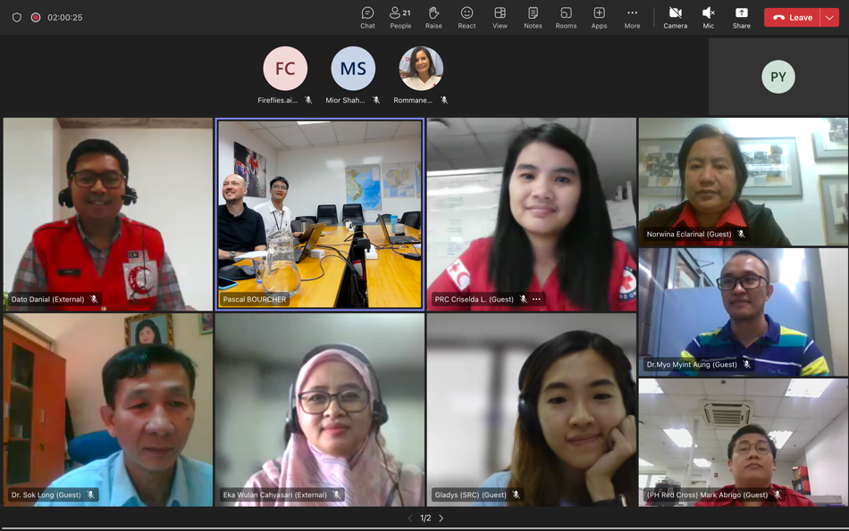
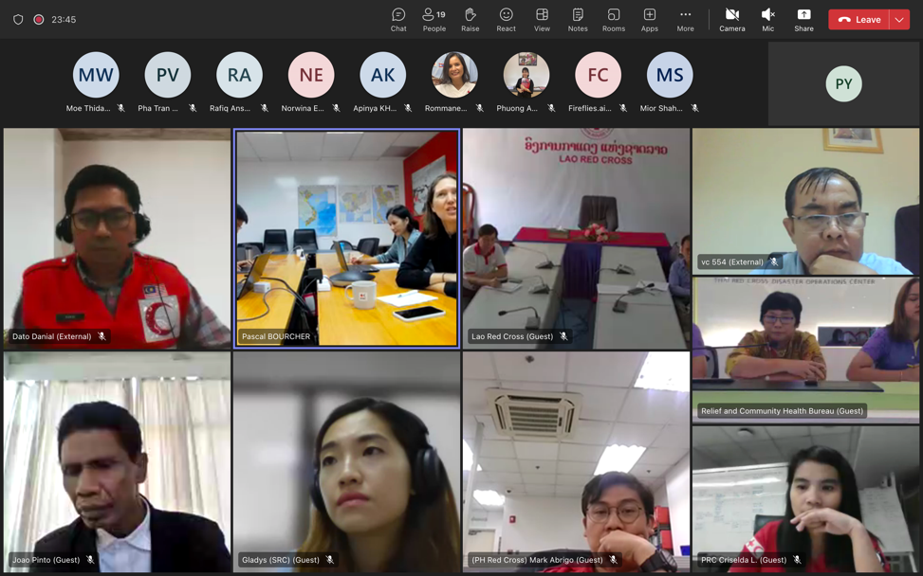

- The revised ToR

Southeast Asia Red Cross Red Crescent
Community Safety and Resilience (CSR) Network
Terms of Reference

Background
The Southeast Asia Red Cross Red Crescent Community Safety and Resilience (CSR) Network was initially established as a Community Safety and Resilience Forum in 2014 at the request of the Southeast Asia National Society Leaders to deepen integration between Disaster Management, Health, and Organisational Development as well as to oversee the implementation of the Regional Road Map for CSR in line with the strategic directions from SEA Leaders.

The last Forum was hosted by the Malaysian Red Crescent Society in 2017, however the funding that was used to hold the annual Southeast Asia CSR Forum ended and since that time, the Forum was not held. Following the COVID19 pandemic in early 2020 and new ways of working online, it was formally decided by the Southeast Asia leaders in 2021 to migrate the Forum to an online network and revitalize it. Malaysia RC was reconfirmed at the SEA leaders meeting in 2022 to lead the revitalization of the network. The Southeast Asia CSR Network is accountable to the Southeast Asia Red Cross Red Crescent Leaders and reports annually to their Leaders meeting.

Purpose
The main purpose of the Southeast Asia Community Safety and Resilience (CSR) Network is to enhance community safety and resilience in Southeast Asia, through a virtual platform for disaster management and health practitioners from 11 Southeast Asian Red Cross and Red Crescent societies to regularly exchange. Specifically the virtual platform will enable:
- Sharing of best practices, tools, information, lessons and discussing issues related to community, safety and resilience, climate change, anticipatory action, use of cash-based initiatives, public health, epidemic preparedness and disaster response.
- Options for increasing peer support and exchange between the members
- Increased learning on community, safety and resilience through requesting technical webinars
- Increased pathways for representation of Southeast Asian societies, particularly women, on the IFRC surge and technical rosters
- Collective support to progress on national society commitments and targets under the Climate and Environmental Charter for humanitarian organisations
- Guidance to the IFRC secretariat and Movement partners on collective priorities for support to Southeast Asian societies.
- Increased implementation and regular review of the ASEAN and IFRC MoU, particularly related to cooperation on elements of community, safety and resilience
Membership
All head of disaster management and health departments from 11 NSs (Brunei Darussalam Red Crescent, Cambodian Red Cross, Indonesian Red Cross, Lao Red Cross, Malaysia Red Crescent, Myanmar Red Cross, Philippines Red Cross, Singapore Red Cross, Thai Red Cross, Timor-Leste Red Cross and Viet Nam Red Cross). Other disaster management and health practitioners from Southeast Asian societies may also join, up to 5 per society, at the discretion of each society.
Network Meetings frequency and protocol
- Meetings will be held quarterly through online platforms
- The steering committee will meet and agree on a draft agenda. The agenda will be sent out to all members one week prior to all meetings
- Agenda items can be proposed by any member of the CSR Network and should be sent to the chair prior to the virtual meeting, and where possible prior to the distribution of the draft agenda
Network Chair
The chair will be selected among the 11 NSs for a period of one year, to enable rotation amongst the members. The chair will be elected prior to the Southeast Asia Leaders meeting and their term commence following endorsement at the meeting. The role of chair is voluntary.
Responsibilities of the Chair
- Chair virtual meetings of the Southeast Asia CSR Network
- Chair virtual meetings of the Southeast Asia CSR Network steering committee
- Actively facilitate open communication and engagement amongst all members
- Liaise regularly with IFRC for secretariat support
- Report annually on the achievements of the CSR Network for each Southeast Asia Leaders meeting
Network Steering Committee
The steering committee is comprised of the Chair of the Southeast Asia CSR Network and representatives from 2 other National Society Heads of Disaster Management or Health. The purpose of the committee is to support the chair with developing the draft agenda of the network meetings and the annual Forum. The steering committee will meet virtually as requested by the Chair, approximately once every quarter. The steering committee will be gender balanced.
Secretariat
The IFRC Country Cluster Delegation for Thailand, Cambodia, Laos and Viet Nam will provide secretariat support to the network, the steering committee and the Forum, with support from other IFRC delegations in Southeast Asia as required.
Community Safety and Resilience Forum
The CSR Network steering committee is responsible for organising an annual Community, Safety and Resilience Forum. The Forum may be online or in person. The host society of the Forum will rotate amongst the Network members, in alphabetical order. Each member has the option to opt out.
The Forum will be 2-3 days.
Each NS can be represented by up to 5 people from Disaster Management and Health, at the discretion of the society. Representatives must be nominated with respect to diversity and inclusion principles.
IFRC Secretariat, IFRC members outside Southeast Asia, ICRC and other external organisations may be invited to attend the Forum.
Working language
The working language will be English.
Funding
Attendance at virtual network meetings and Forums is at the cost of each national society.
Funding for in person Community Safety and Resilience (CSR) Forums will be the responsibility of the host society. Each society will be responsible to cover their own travel costs to attend the Forum. Additional support may be requested from the IFRC secretariat and Movement partners.

- CSR Webinar’s agenda

Agenda (draft)
Southeast Asia CSR Network Webinar
Wednesday 6 September 2023
Participants: Disaster Management and Health Managers and representatives from the 11 Southeast Asia National Societies
Duration: 2 hours
Time | Activity | Speakers
10:00 am | Presenting and adopting the revised CSR Network Term of Reference (15 minutes) | Chair of the CSR Network
10:15 am | Presenting the Environment and Climate Charter for humanitarian organizations: objectives, commitments and proposed targets for SEA National Societies (40 minutes) | IFRC CCD  / APRO
10:55 am | Q&A (10 minutes) | IFRC CCD / APRO
11:05 am | Discuss and agree on common key actions and targets for all 11 National Societies on the following areas (60 minutes)  a) Reducing carbon footprint;  b) Addressing the impact of Climate Change on Health;  c) Promoting Environmental sustainability. | National Societies’ representatives
12:00 pm | Wrap-up and conclusion

