LOGISTIC NOTE
19th Southeast Asia Red Cross Leaders Meeting
Bandar Seri Begawan, Brunei Darussalam

Greetings from the International Federation of Red Cross and Red Crescent Societies!
Welcome to this event and we would like to share you some information which you may find useful when preparing for your trip and arrival to Brunei Darussalam.
Before arrival
Based on Government Regulation updated as of 15th September 2022
Travellers are required to :
- Purchase a minimum coverage of BND 20,000.- Travel Health Insurance with COVID-19 coverage from their preferred Insurance agent or company, except returning Brunei citizens and permanent residents.
- Pay Chaj Perkhidmatan (CAP) BND$3 via Exit and Entry System (EES) https://login.bdnsw.gov.bn/ees for Individuals travelling via land, the control post will operate from 0600 to 20.00.
- Check visa requirements by clicking below link to find out whether you require a visa or not and how long you could stay in Brunei (90,30 or 14 days), then click the initial letter of your country name:
https://www.mfa.gov.bn/Pages/Visa-Information.aspx#close
- Have valid return flight tickets.
- Ensure that your passport is still valid for at least six months before the expiry date.
- Information on immigration assistance can be found in this link immigration.gov.bn
Travellers are no longer required to :
- Undergo COVID-19 tests
- Complete COVID-19 vaccination
- Complete Arrival Declaration form
Venue and Accommodation
The meeting has two-day event and hosted by the Brunei Darussalam Red Crescent Society in Bandar Seri Begawan. For confirmation on your attendance and accommodation, please contact:
sheikhkadir@bruneiredcrescent.com or suhaimi.ibrahim@bruneiredcrescent.com
For this Southeast Asia RC Leaders Meeting, the venue and accommodation are in the same place at:
WAFA Hotel and Apartment
Annajat Complex, Lot 71077, Kampong Mata-Mata, Mukim Gadong,
Bandar Seri Begawan, Brunei
Reservation: +673 2426889 / +673 2425889
Email : reservations@wafahotelbn.com
http://wafahotelbn.com/

The hotel location is about 10.3 km away from Brunei International Airport, Bandar Seri Begawan, Brunei Darussalam BB 2513. Please click this link Brunei International Airport to Wafa Hotel for GMap Location.

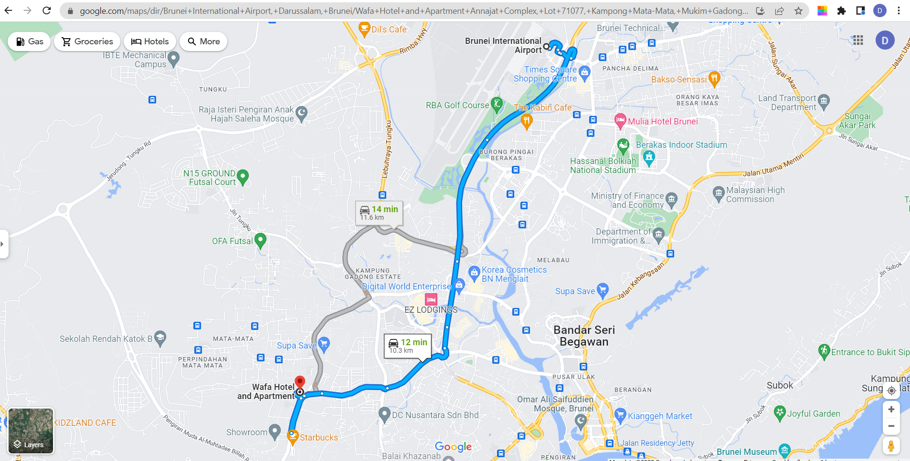

Upon arrival

Brunei Airport has a single passenger terminal hosting all international flights. The terminal is able to handle two million passengers. Brunei Airport Terminal is split into a couple of levels as follows:

Ground level, this is the Arrivals Hall with the following services: Immigration, Customs, Baggage claim area, lost baggage, Baggage handling, Lost & Found, Meeting services.

First level, this is the Departures level.
Once you arrive at Brunei International Airport and after complete the immigration clearance, baggage clearance and customs, you now head toward the arrival hall.

Transportation

Beside Airport pick up services from the Hotel, below are the alternative transportation:
TAXI
Taxi ranks are located outside the Arrivals Hall at the pick-up points.
To book a taxi, please call: +673 2222214 / +673 2226853
Estimated fare to Bandar Seri Begawan city centre is around BND $25.
Taxis in Brunei are metered, with a base price of BND 3.50 for the first minute or kilometer, and an additional BND 0.20 for every 250m or 15 seconds (whichever comes first). There’s also a surcharge of BND 3 for trips going to and from the airport, as well as an additional BND8 for travelling from one district to another. Travellers should also note that there are additional charges for more than two pieces of baggage, as well as carrying more than four passengers per taxi. Taxis are also available at most hotels and shopping centers.
BRC Secretariat (Liaison Officers) will be at the airport to meet delegates upon arrival and transportation will be provided. Please look around at our BRC Volunteers with their name tag and BRC LOGO.

PUBLIC TRANSPORT
Brunei has one form of public transport, the Franchise Bus, formerly known as the Purple Bus, and it’s the cheapest way to get around town, with an average fare of BND1 per ride!
It serves six lines, which are distinctive thanks to the bright colours of the buses. The Eastern Line, which is the royal blue bus, and the Northern Line, marked as the green bus, pass through the international airport.
Download TransportBN on iOS or Android for more information on bus routes and time.
Bus Station approximately every 30 minutes with total trip time is 30 minutes.

Schedule Buses run from 06:00am to 00:00am. Location Buses depart from the end of the car park.

Fares Single ticket is BND$ 2. Tickets are sold on board to the driver.

DART
Dart is a local transport app; think of it as Brunei’s Uber or Grab (both of which are currently unavailable in Brunei). It can be competitively priced against Brunei’s taxis, with the additional convenience of booking a ride through the app. Click here to download it on the Apple App Store, and here on the Google Play Store.

Other Services at the Airport

- Information Desk and Customer Service Counters in Departures.
- Telecommunication companies : Datastream Digital Sdn Bhd, Imagine Sdn Bhd, Progresif Cellular Sdn Bhd. Travellers can buy a data package at the airport arrival hall.
- Free Wi-Fi is available at the lounge, restaurants and café. Outside these locations, Wi-Fi is available upon payment.
- Currency exchange booth at Departure Hall open 24 hours.
- ATMs are available at Departure Hall, accept cards with worldwide ATM functionality (Visa, Mastercard Cirrus).
- Airport hotel located on the ground level of the Departure Hall.
- Day rooms are also available on Departures level, Rates: $28 (3 hours), $36 (6 hours), $42 (9 hours).
- Banks
- Food and drink concessions
- Tourist information
- Retail shops
- Duty free shops
- Royal Brunei Airlines Sky Lounge: Mezzanine level, between Gates 1-5. Open from 06:00 am to 09:30 pm.
Services: Premium food, Snacks, Wi-Fi, Showers, Flight monitors, Newspapers, Magazines, TV, Children’s area, Internet terminals, Telephones. Please note it is a non-smoking facility.

General Information on Brunei

https://www.bruneitourism.com/
Overview
The Nation of Brunei, the Abode of Peace, is a country located on the north coast of the island of Borneo in Southeast Asia. Apart from its South China Sea coast, it is completely surrounded by the Malaysian state of Sarawak. Brunei is the only sovereign state entirely on Borneo; the remainder of the island is divided between Malaysia and Indonesia.

The government is an absolute monarchy ruled by its Sultan, entitled the Yang di-Pertuan, and implements a combination of English common law and sharia law, as well as general Islamic practices.
On 7 January 1979, another treaty was signed between Brunei and the United Kingdom represented by Lord Goronwy-Roberts. This agreement granted Brunei to take over international responsibilities as an independent nation. Britain agreed to assist Brunei in diplomatic matters. In May 1983, it was announced by the UK that the date of independence of Brunei would be 1 January 1984.

Operating hours
Shops and Restaurant generally open around 09.30. The city winds down around 22.00. However, everything is close every Friday noon from 12.00 to 14.00 in consideration of Sholat Jumaat (Friday prayers). In addition, during the Islamic fasting month of Ramadhan, restaurant only allow food takeaway or delivery at all times, which typically starts at about 04.00-05.00 and ends at around 18.00-19.00 daily until Ramadhan ends.

Custom and Culture
DO’s
WEAR PROPER ATTIRE
If you decide to visit mosques. Women are required to cover their head, shoulders, and knees. Some mosques will provide simple robes and shawls to meet this standard. Observe silence.
OBSERVE PRAYER TIMINGS
Note that all banks, businesses, offices, places of interest retail, food and beverage outlets are closed between 12 noon and 2pm on Fridays.
BRUNEIANS SPEAK ENGLISH
Do approach them as they are open to providing assistance if required.
MINDFUL CONSUMPTION OF ALCOHOLIC BEVERAGES
Alcohol consumption is only allowed in private areas, such as in hotel rooms, or place of residence of the importer.
ALCOHOL IMPORTATION LIMITS
Non-muslim passengers over 18 years of age are not allowed to bring in more than 2 bottles of liquor and 12 cans of beer @ 330ml per can. The Liquor Declaration Form must be kept with the unfinished alcohol at all times.

DON’ts
DON’T MAKE LOUD NOISES
when you hear the azan or the Muslim call to prayer.
DON’T WEAR FOOTWEAR
in a mosque.
DON’T SHAKE HANDS
with members of the opposite sex, unless offered first by the other person.

Currency
The unit of currency is the Brunei Dollar (BND). BND1 is also equivalent to below nominal as per 26 Sep 2022 (depending on current rates):
MYR | SGD | THB | CHF | USD | IDR
3.20 | 1 | 26.23 | 0.69 | 0.70 | 10,559

Safety
Frequently of crime in Brunei is low and safety isn’t a particularly huge issue. Even so, as safety precautions, please:
- Keep your travel documents safe
- Be mindful of your personal belongings and avoid bringing large amounts of cash with you
- Do take care and be cautious if walking at night, walk opposite the traffic direction. Please avoid quiet and unlit roads/alleys.
- Find out the nearest your country’s embassy/High Commission and save the details in case of emergencies.
- Travelling on public transports is safe, but have an eye on the luggage that is taken out on interstate stops.

Emergency Contact
Ambulance 991
Police 993
Fire Brigade 995
Search and Rescue 998
Hospital Raja Isteri Pengiran Anak Saleha +673 2222366 (major government hospital)
Hospital Gleneagles +673 2611883 (private hospital)
Hospital Jerudong Park Medical Centre +673 2611433 (private hospital)
The Brunei Red Crescent Society address is:
1st floor Bunut Post office
Jl. Haji Halus BF1320 Brunei Darussalam
BRC Hotline +673 7121989 / +673 8260380

Time
The time zone is Greenwich Mean Time (GMT) +8

Language
The official language is Standard Malay, but the principal spoken language is Melayu Brunei, English is widely used as business language. The people of Brunei also converse in a range of Arabic, Chinese and Kedayan Malay dialects.

Culture
The culture of Brunei is predominantly Malay (reflecting its ethnicity), with heavy influences from Islam, but is seen as much more conservative than Indonesia and Malaysia. Four periods of cultural influence have occurred: animist, Hindu, Islamic, and Western. Islam had a very strong influence and was adopted as Brunei's ideology and philosophy. As a Sharia country, the sale and public consumption of alcohol is banned. Non-Muslims are allowed to bring in a limited amount of alcohol from their point of embarkation overseas for their own private consumption.

Population
The population of Brunei in 2021 was 445,373, of which 76% live in urban areas. In 2014, 65.7% of the population were Malay, 10.3% are Chinese, 3.4% are indigenous, with 20.6% smaller groups making up the rest.

Economy
Economic growth during the 1990s and 2000s, with the GDP increasing 56% from 1999 to 2008, transformed Brunei into an industrialised country. It has developed wealth from extensive petroleum and natural gas fields. Brunei has the second-highest Human Development Index among the Southeast Asian nations, after Singapore, and is classified as a developed country.

Religion
Islam is the official religion of Brunei with more than 80% of the population. Other faiths practised are Buddhism (7%, mainly by the Chinese) and Christianity (7.1%).

Weather
Clear, blue skies are pretty much a daily phenomenon, but please take noted that the wettest months are from October to January and from May to July. An up-to-date daily forecast of the weather can be found here.

Clothing
Modern-day Bruneians still wear a style of traditional Malayan dress: — the baju kurung — that has been in existence since the 15th century. Although the design of such garments once denoted social status, contemporary Bruneians tend to be less aware of these signifiers.
The average relative humidity remains above 85% and creates an uncomfortably high heat index. Thus it favours lightweight and sweat-absorbent material like cotton for daily dressing.

Cuisine
Bruneian cuisine concerns the cuisine of Brunei. It is similar to, and heavily influenced by the cuisine of neighbouring Malaysia, Singapore, and Indonesia, with additional influences from India, China, Thailand, and Japan. As is common in the region, fish and rice are staple foods, though beef is expensive and thus less common. Due to the predominance of the Islamic religion, the food is halal and pork is avoided. Alcohol is banned in Brunei.
Dishes from Brunei are often spicy, and are commonly eaten with either rice or noodles. Beef rendang, nasi lemak and pajeri nanas, are popular foods in Brunei. Common drinks include coconut milk, fruit juice, tea and coffee.
Sight of Brunei Darussalam

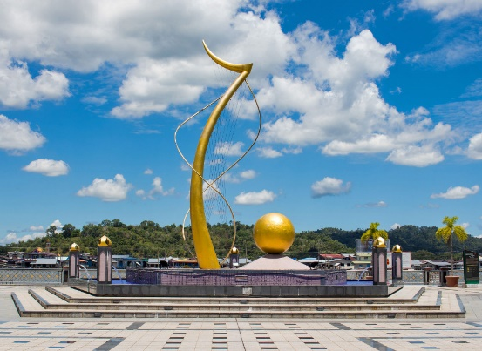
Dermaga Diraja (The Royal Wharf)
More popularly known as the ‘Waterfront’, the Royal Wharf is situated by one of the Brunei River banks and was recently redeveloped into a scenic promenade that now also leads to the Mahkota Jubli Emas Park. This is a perfect place to enjoy those long strolls at night without ever being too far from some of Brunei’s finest eats. One of the best viewing spots of Brunei’s heritage site – Kampong Ayer, a historic water village

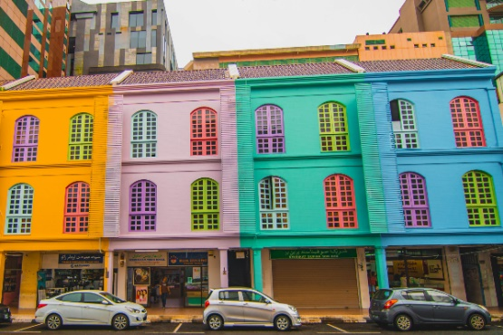
Jalan Roberts
The most photogenic street in downtown Bandar Seri Begawan is Jalan Roberts, next to Jalan Pretty and Jalan McArthur. This street is named after E. Roberts, the first Head of Public Works Department in 1906. A walk through this technicolour lane comprising vintage shophouses with classic louvered wooden shutters will reward you with a pop of colour for your Instagram feed. Car-free Sunday is the perfect time to stroll around here when pedestrians are kings of the street for the day.

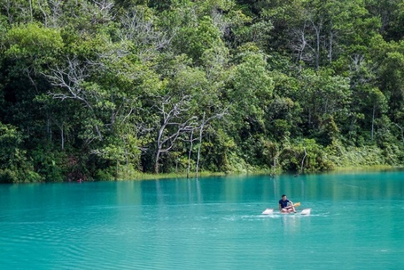
Lugu Lake (along the Jerudong-Tutong highway)
A former man-made pit turned freshwater lagoon, Lugu Lake will definitely dazzle the eyes with its uniquely turquoise lustre. On any given weekend, you can find local resident kids waddling and splashing around in the blue lake. For those who are more experienced on the water, you can try your hand at paddleboarding! Soak in the warm rays as you float atop the dreamy blue lagoon.

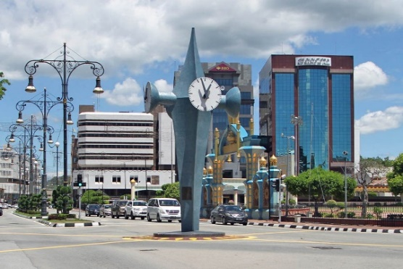
Time Piece Monument
The Time Piece Monument stands in the middle of Bandar Seri Begawan as an important historic landmark. The clock was made as a commemoration for Tuanku Abdul Rahman's visit to Brunei in 1959. He also laid the foundation stone of the clock during that visit. Many refer to the Clock Tower as "Ground Zero", as many use it as reference to measure the distance between the capital and other important places in Brunei.
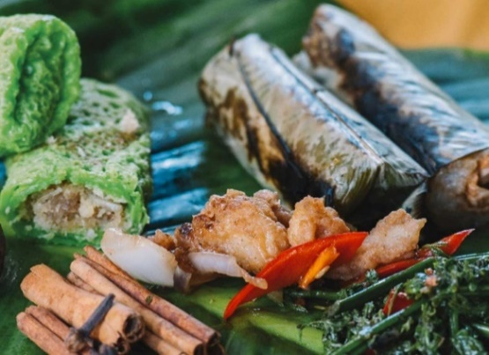

Local Delicacies

Carried down from generation to generation, if there’s one thing that has survived the test of time in Brunei, it’s definitely our food and our love for it. Live our culture in the best way possible, through your sense of taste.

Till then, we wish you :
Selamat datang di Brunei
(Welcome to Brunei)

