***TITLE OF SUCCESS STORY:* Building Bridges, Reducing Risks and Mobilising Government Support in Myanmar – A Story of Success from Myanmar Red Cross**

***Agencies names, address and focal contact person:* Mr Maung Maung Khin, Head of Disaster Management, Myanmar Red Cross HQ, Yangon,mmk.mrcs@gmail.com**

*"The culvert, that also functions as a bridge, is very good for us because we have to cross this area to reach our work. We could not pass through in the rainy season before this bridge was built. It was previously a small bamboo bridge made from waste material of bamboo and plastics and was not appropriate to be used when submerged in water. Now we can use the bridge at all times" U Kyaw Win*

*IMAGES OF THE STORY: Please share as attachment separately high resolution  
(above 1 MB) images to support the success story.*

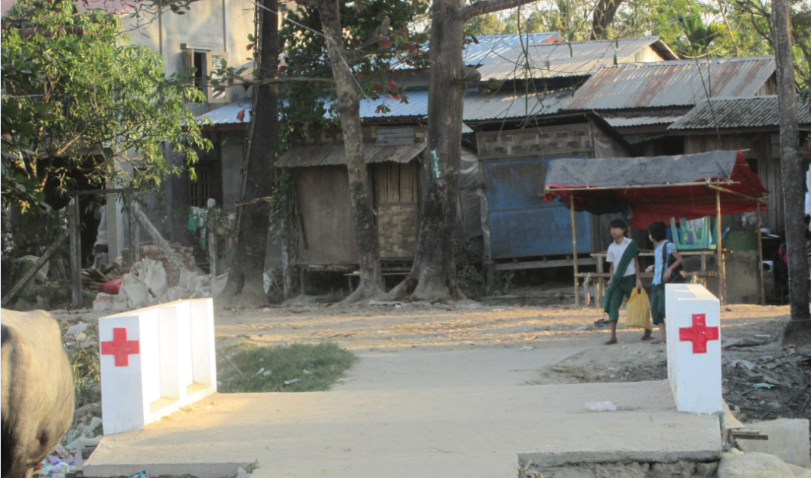

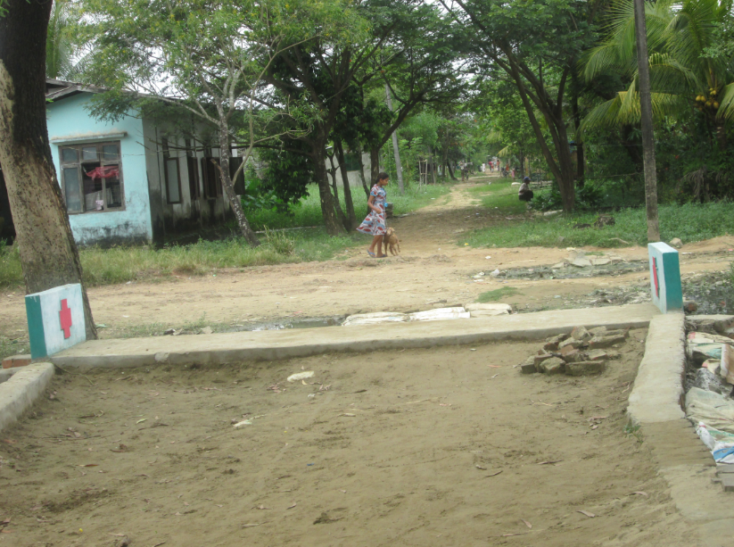

All photos © Myanmar Red Cross

**THE PROBLEM:**

During the rainy season, Kyun village becomes an island within Myanmar - community members, including around 2,000 persons, students, peddlers, workers and others, are unable to pass through.

This presented a problem for the community in many respects – including access to work and health services. Insufficient rainwater drainage was also identified as a flooding risk.

*IMAGES OF THE STORY: Please share as attachment separately high resolution (above 1 MB) images to support the success story.*

*IMAGES OF THE STORY: Please share as attachment separately high resolution (above 1 MB) images to support the success story.*

|  |
| --- |
| **THE OUTCOMES**  Safe access to and from the community during the wet season and the proper drainage of rainwater to canal or creek, resulting in better health and sanitation of the community. |

**WAY FORWARD**

Recognising the benefit of the intervention, the ward disaster risk reduction committee shared their risk reduction plan with the local government to obtain further support.

Responding to the request, the Union Government allocated 42 million Kyats for the construction of 85 small culverts that will cover the entire ward: "Based on our plan, and the success of the initial culvert constructed with Red Cross support, the local government submitted a request to the regional government. The Regional Government advanced the request to the Union Government . After that, the Union Government allocated a budget for 85 small culverts to be constructed in our ward. Now we are starting the construction" - U KyanMyint, 71 Ward Administrator.

**THE ACTIVITIES**

Needs assessments were conducted by Myanmar Red Cross, together with the Kyun ward's disaster risk reduction committee.

Following the needs assessment, a plan of action was developed to address the risks identified, including inadequate rainwater drainage.

In response to the problem, a culvert was constructed by the Kyun community, with the support of MRCS.

IMPLEMENTING AND PARTNER AGENCIES LOGOS:

