***TITLE OF SUCCESS STORY:* Preparing for Climate Change in Viet Nam – A Success Story from Viet Nam Red Cross**

***Agencies names, address and focal contact person:* Mr. Dang Minh Chau, Deputy Secretary-General, Viet Nam Red Cross HQ, 82 Nguyen Du Street Hanoi, chauvrc@gmail.com**

*IMAGES OF THE STORY: Please share as attachment separately high resolution  
(above 1 MB) images to support the success story.*

© Viet Nam Red Cross is the credit for first photo – others areJason Smith – the last unmarked one with RC flag is © IFRC

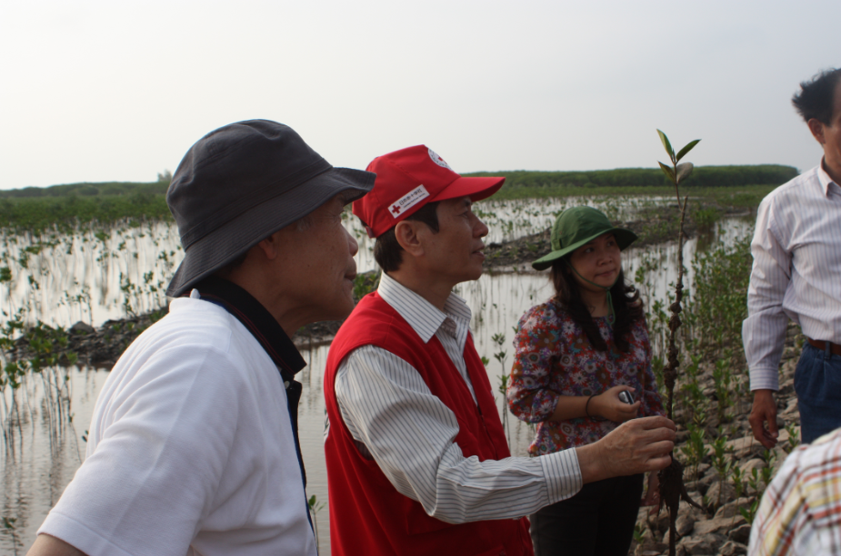  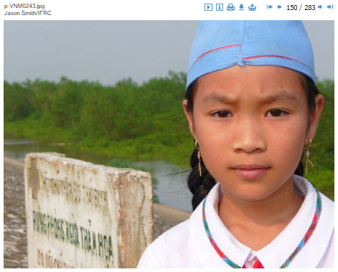 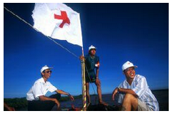

*QUOTE FROM LOCAL COMMUNITY MEMBER INVOLVED IN THE PROJECT*

**THE PROBLEM:**

The science is clear: it is very likely that global warming is leading to an increase in weather extremes like heat waves and heavy rainfall. It is likely that droughts will occur more often, and that tropical cyclones (typhoons and hurricanes) will become more intense (Intergovernmental Panel on Climate Change, Fourth Assessment Report, 2007).

Vietnam has always suffered from extreme weather events and is struck by typhoons annually. Strong winds and sea surges cause death and destruction along the long and low-lying coastal area, while heavy rains hit the mountainous hinterland and river deltas with floods and landslides. In other times of the year, parts of these very same areas suffer from prolonged periods of drought.

Understanding how to anticipate and reduce the rising climate risks is of utmost importance for the Vietnam Red Cross (together with the Vietnamese government and other aid organisations) to succeed in its efforts to improve the lives of the most vulnerable people.

**THE OUTCOMES**

The project helped over 30 communes in Viet Nam to become less vulnerable to climate-related disasters.

Over 268,000 people in 30 disaster-prone communes learnt how to prepare for disasters, and profited from small scale mitigation works.

Approximately 1,200 VNRC staff and volunteers gained considerable knowledge, skills and experience in the areas of climate change and disaster preparedness, helping them to further develop and strengthen disaster management programmes.

Both VNRC staff as well as local authorities and social-political organisations at provinical, district and local level, boosted their knowledge and skills in the participatory assessments of hazards, vulnerbailities, and capacity, planning for disaster preparedness, first aid and search and rescue.

The experiences have been disseminated both nationally and internationally to be used by Red CRoss and Red Crescent Socities and other organisations worldwide.

The results and lessons learnt helping make VNRC's other disaster preparedness programmes 'climate change proof'

The results and lessons learnt have also helped the RCRC develop similar programmes worldwide, and have served many other organisations working in the same field by sharing experience.

**THE ACTIVITIES**

In 2003 the Vietnam Red Cross was one of the first national societies of the Red Cross/Red Crescent to start a pilot project to integrate climate change into its existing disaster preparedness programs. At that time the global debate about climate change mainly focused on how to limit the greenhouse gas emissions that cause global warming (climate change mitigation). There was very limited experience with reducing people’s vulnerability to climate change and extreme weather events (climate change adaptation). The Vietnam Red Cross joined forces with the Netherlands Red Cross and the Red Cross/Red Crescent Climate Centre to start learning by doing in order to find the right approach.

Step 1. Raising the awareness of Vietnam Red Cross staff. In meetings and workshops the Vietnam Red Cross learned more about climate change, its link to the occurrence of extreme weather events, and the relation to the organisation’s core mission: to support vulnerable people. These activities provided the necessary background and were needed to build the confidence and capacities of the staff on this issue.

Step 2. Raising a voice among disaster preparedness stakeholders. Through consultations with Vietnam’s meteorological institute, several other climate experts, and existing partners like the government agency for disaster preparedness, the Vietnam Red Cross learned a lot about the projected impacts of climate change. The main findings were summarised in a publication, which together with a national seminar on climate change and disaster preparedness was used to advocate the issue and the need for action among relevant NGOs and governmental institutions. The Vietnam Red Cross and the Netherlands Red Cross delegation in Vietnam started to raise their voice to underline the importance of integrating climate change projections into existing policies and programs. To explain the value of climate risk reduction to a wider audience, two documentaries were produced. Both were broadcasted nationally.

Step 3. Making people aware of their capacity to reduce their vulnerability. The Vietnam Red Cross has access to an extensive network of trainers throughout the country. They are specialised in raising awareness among vulnerable communities, on hazards, disasters and the importance of disaster risk reduction. During the climate change pilot program, the Vietnam Red Cross integrated climate change into its disaster preparedness training modules Information about climate change and extreme weather events has been included in education and training materials ever since.

Step 4. Getting into action. Reducing vulnerability starts with self-awareness on vulnerabilities and opportunities to reduce risks. The Vietnam Red Cross has extensive experience with participatory assessments in vulnerable communities, how to consider people’s vulnerability to disasters, and how to increase people’s resilience. The notion of climate change has been integrated into the assessment to increase the awareness of the people living in the pilot communities. Based on the outcomes of the assessments, the Red Cross supported the implementation of small scale disaster risk reduction measures, prioritised by the communities themselves. This resulted in a wide variety of measures, such as the construction of search and rescue centres, the training of search and rescue teams to coordinate rescue operations, the strengthening of existing loudspeaker systems for early warning, the planting of trees and the construction of dams to protect the (agricultural) land against strong winds and sand-drift or salt-water intrusion.

|  |
| --- |
|  |

IMPLEMENTING AND PARTNER AGENCIES LOGOS:

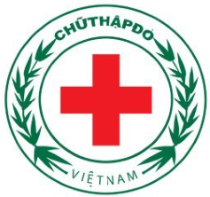

**WAY FORWARD**

Where to from here? The pilot project ended in 2006. Since then the Vietnam Red Cross has been integrating the lessons learned into ongoing and new disaster preparedness projects. In cooperation with a different variety of sister Red Cross/Red Crescent societies, the Vietnam Red Cross is continuing its mangrove-planting project for coastal and riverbank protection, and is currently starting up two new community-based disaster preparedness projects in 6 provinces throughout the country, funded by the EU.

The Vietnam Red Cross also explored the possibility of linking tree planting (afforestation) for the purpose of disaster preparedness to generate funds from reducing greenhouse gas emission (Clean Development Mechanism).

The pilot project on disaster preparedness and climate change has created a valuable pool of knowledge and experience. The challenge is now to transform and upscale these into effective practices to better address the risks that are rising due to climate change.