***TITLE OF SUCCESS STORY:* Building A Fortress of Mutual Assistance against Flood Disaster – A Story of Success from Indonesia Red Cross (Palang Merah Indonesia)**

***Agencies names, address and focal contact person:* ARIFIN M. HADI Head of Disaster Management Division, Indonesian Red Cross National Headquarter Ph: +62 21 7992325 E-mail: Arifin_mhadi@pmi.or.id**

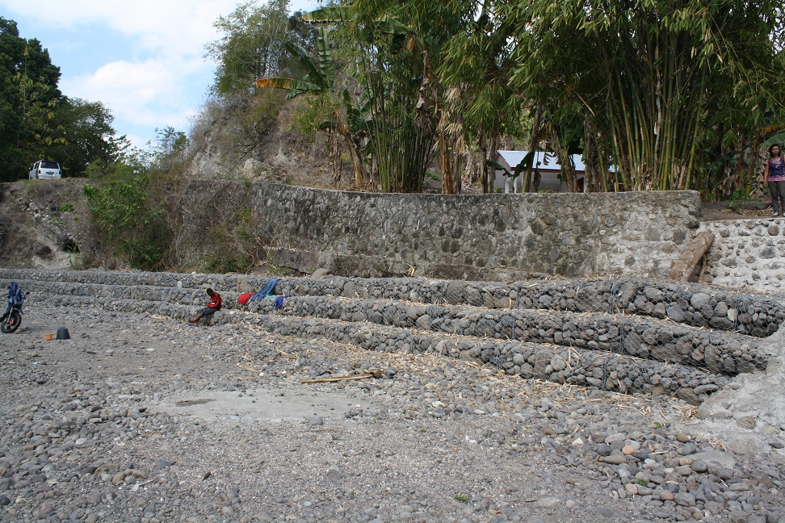

Dyke is under heavy test when flood comes – photo by Indra Yogasara

**“***It takes 5 or 6 years for bamboo to grow strong – but the flood comes every year. The flood can sweep away the bamboos easily." Levinus T. Han, a member of Adang Village PMI Community based Action Team (CBAT), explaining how the flood has overwhelmed them, despite the effort of planting bamboo along the river banks to prevent flood.*

**THE PROBLEM:**

The villages of Alila, Adang and Morba, Alor Barat Daya sub-district, East Nusa Tenggara, are flooded every rainy season. Yet, conversely, every dry season the Abuar river, which cleaves the village of 1303 households, goes arid. These contrasting conditions cause problems for the residents.

The rain was causing the river, which is normally ankle-deep, into a deluge, eroding riverbanks and overflows into houses. The community attempted to prevent flooding, by actions such as planting bamboo along the riverbanks - however the bamboo was easily swept away by floods.

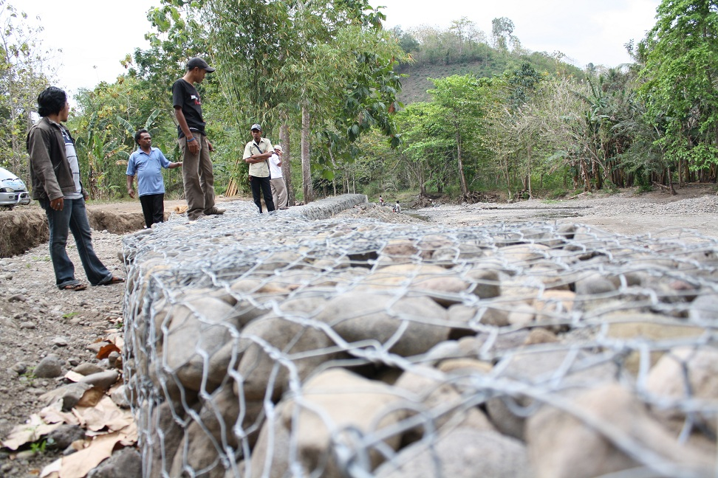

Mutual assistanceto build the a protecting fortress – photo by Indra Yogasara

**THE ACTIVITIES**

In response to the problem, the community, together with community-based action team (CBAT) members, local village government and volunteer corps (Korps Sukarela/KSR), carried out mapping of hazard vulnerability, risks and capacity, based on the condition of each village.

After mapping and discussion, they ageed to construct gabions and a river dike at flood-prone spots to prevent flooding. This mitigation measure was the main step of a series of integrated community-based risk reduction (ICBRR) program activities - a joint program of PMI and Netherlands Red Cross, implemented since March 2008.

During the course of the project, it was not difficult to mobilize the communities of the three villages. They were highly motivated and undersood that the actions being taken were aimed at fortifying them against floods.

The construction was done one-by-one at the flood-prone spots, involving not only the local people from where the gabions and dike were to be built, but all community members.

|  |
| --- |
| **THE OUTCOMES**  Construction was completed within a month.  In Adang village, the community's self-reliance efforts did not end with the construction of gabions and dike.  The mutual assistance - *gotong royong* in Indonesian - among the community continued, with residents building a one-kilometre-long drainage of Anuving River.  This was done to channel the flow directly to the sea, through small creeks (through people's lands and gardens) during the rainy season, so the overflowing river wouldn't inundate people’s houses. |

IMPLEMENTING AND PARTNER AGENCIES LOGOS:

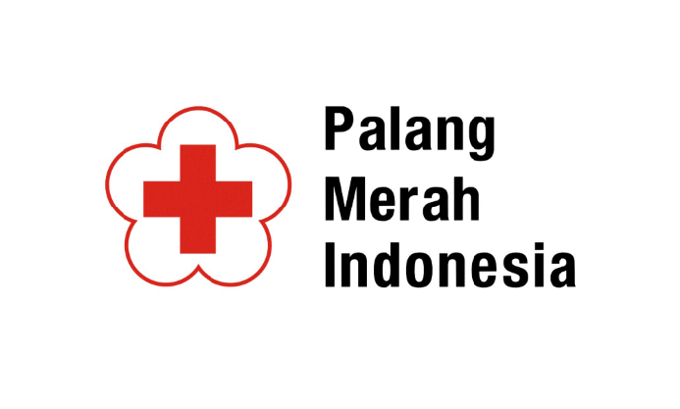

**WAY FORWARD**

The mitigation efforts at the village of Morba, Alila and Adang did not stop at completing the mitigation measure itself.

The Indonesian red Cross’ ICBRR (Integrated Community Based Risk Reduction) program may have initiated such efforts, but it is the community's self-reliance and strong mutual assistance which has become the community's solid fortress against disaster.

Source: Hand in Hand - A Collection of Disaster Risk Reduction Success Stories, PMI, 2012, pg.78-79