***TITLE OF SUCCESS STORY:* Planting Mitigation, Harvesting Coffee – A story of success in building resilience to disaster from Indonesian Red Cross (Palang Merah Indonesia)**

***Agencies names, address and focal contact person:* ARIFIN M. HADI Head of Disaster Management Division, Indonesian Red Cross National Headquarter Ph: +62 21 7992325 E-mail: Arifin_mhadi@pmi.or.id**

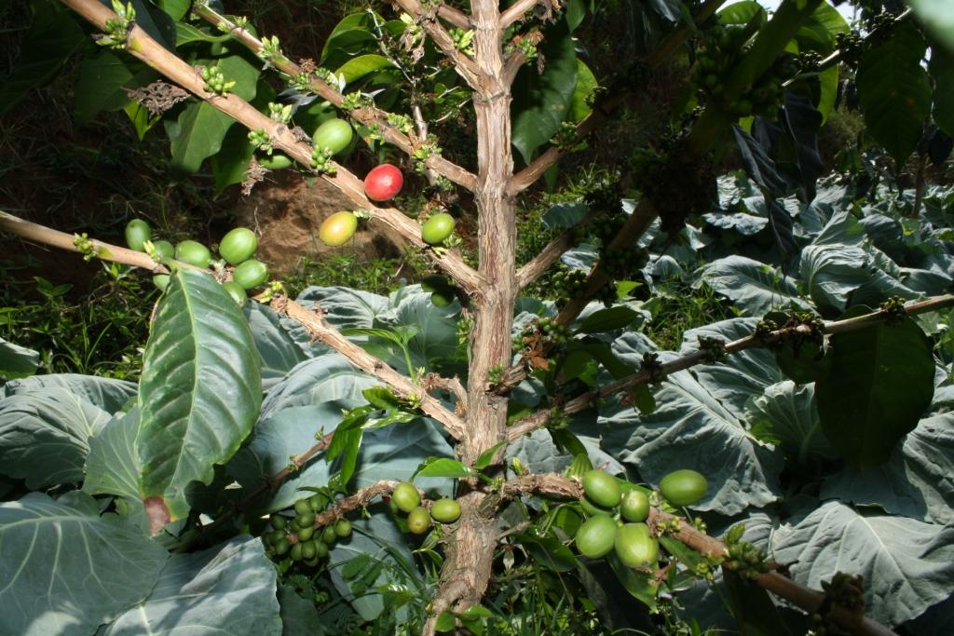

Coffee plants, one of mitigation means in West Java to build community resilience –© Indonesian Red Cross

*"Isn't it great and such a relief after knowing that planting coffee is fruitful even though you and the community are still learning to carry it out?"*

**THE PROBLEM:**

Sitting on a sharp angled slope of a hill, Pangauban village (Garut Regency, West Java Province) is vulnerable to landslide. In fact, the hill is landslide prone and landslide disasters have often caused life and material losses, as illustrated by the last landslide in 2007, which claimed two casualties.

Prior to the project, 160 village farmers cultivated the 7-hectare land on the landslide-prone spot, planting cash-crops such as carrots, peppers, onion, corns, tomatoes, eggplants and vegetables (fast-growing and easily-harvested cash crops).

**THE ACTIVITIES**

Encouraged by PMI's CBAT (Community Based Action Team), village officials and the community body of forest villagers (Lembaga Masyarakat Desa Hutan/LMDH), with the farmers of Pangauban village, intensively discussed striking the balance between the need to mitigate landslides and the need to plant cash crops to support the villagers’ livelihoods.

Following discussion, consensus was reached to begin planting coffee as well. Why? Coffee has roots that are strong enough to mitigate/restrain landslides and yet it still promises substantial harvest. Moreover, it is possible to plant other fast growing, quick harvested cash crops between coffee trees.

In November 2009, 6000 coffee trees - interspersed with 5000 umbrella trees - were planted on the landslide-prone land.

In implementing this mitigation effort, the community faced potential loss of income, but they developed a full awareness to of the need to mitigate landslides. This awareness was enouh to act as strong encouragement to dispel doubts about shifting crops.

The community was willing to contribute more. The farmers decided to give 10% of their revenue in support of a village disaster contingency plan.

After 4 years, the coffee started to grow fruit. The farmers would be busy picking the coffee beans every week for the next four months.

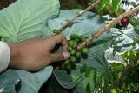

Coffee Plants – Indonesian Red Cross

|  |
| --- |
| **THE OUTCOMES**  The community's decision to prioritize mitigation of landslides has gradually but progressively shown a positive result.  One community action has proved to reap double success: resilience against disaster and resilience in economy. |

IMPLEMENTING AND PARTNER AGENCIES LOGOS:



**WAY FORWARD**

From the project, two key learnings emerged, which may inform future similar initiatives:

1. Raising awareness is an important step to starting community disaster resilience efforts. Community awareness is the basis of community decision-making processes.

2. Community ownership may be derived from collective funding and collective decision-making mechanisms. These bring communities together, solidifying the value of social capital in disaster resilience.

Source: Hand in Hand - A Collection of Disaster Risk Reduction Success Stories, PMI, 2012, pg. 76-77