12th Annual South-East Asia Red Cross Red Crescent Leadership Meeting 2015
Youth Development
Youth/ Cambodia / 25-27 February 2015

Introduction
Year 2014 was a year of Youth in Southeast Asia. The 6th Asian Ministerial Conference on Disaster Risk Reduction (AMCDRR) Bangkok held from June 21-26 has recognised meaningful engagement of youths and its specific role in building community safety and resilience. The conference endorsed the Youth and Children statements which also include the SEA Red Cross and Red Crescent Youth statements. All governments, International Non-governmental organizations in Asia and Pacific and other relevant stakeholders have indicated/pledged their support to further strengthen meaningful participation of youths in DRR to ensure to reduce future disaster and climate change risk.

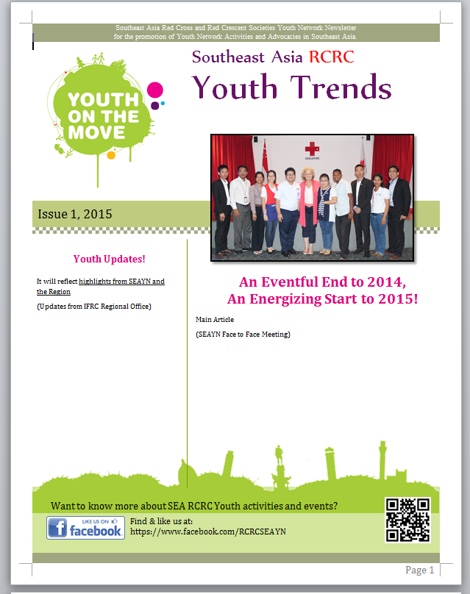
The Southeast Asia Youth Network (SEAYN) has firmly strengthened its capacity through its active participation/representation in various events and conferences. Implementation of action plan 2014 and reinforcement of its structure and system with active participation of youth volunteer leaders led by Cambodia Chair with its coordination team, with the support of 11 NS leadership and youth sections, especially from 8 national societies: Cambodia, Indonesia, Laos, Myanmar, Philippines, Singapore, Thailand, Timor Leste have further contributed in strengthening youth activities in the region. 5 webinars and 6 coordination team meetings were held during the year providing an interactive platform for discussion, exchange, planning, briefing and preparatory works and gained more trust and credibility from each NSs and other regions. SEAYN became more active contributor to the APYN (3 representatives sitting in APYN) by representing and advocating the SEA youths as a whole as well as reflecting the opinions of youth supporters in a considerable way.

In addition, the 2nd Asia Pacific Youth Summit held in Beijing in October last year has also re-affirmed the importance of regional RCRC Youth Network, and endorsed to include the SEAYN commitment in the final Beijing Youth Summit Commitment as a key component for the 9th Asia Pacific RCRC conference agenda.
Layout of SEAYN Newsletter

By adopting the IFRC Youth Engagement Strategy (2013), SEA national societies have started to invest and pay attention to youth empowerment through creation of enabling environments for young people to become agents of change for building safe and resilient communities.

Key developments and achievements

- Following the recommendation of SEA leaders in 2014 (youth as being champions on IT social media), the SEAYN has connected/included this recommendation into their own action plan, “advocacy and innovation” and pioneered to open its own webpage for a better space for the youth discussion, linked to 11 national RC youth page and Zonal Youth page (Asia Pacific Youth Network). It has established its system to develop newsletter on a regular basis and will run/include all articles of youth best practises and issues from 11 NSs in the region. (pls see attached Newsletter issue 1). By the end of 2015, the SEAYN will encourage 1.5 million youth volunteers out of 3.9 million to use their national youth network page or SEAYN page for their RCRC advocacy. New coordination Team was nominated according to ToR endorsed by the SEA leadership.

The action plan for 2015-2016 was developed on basis of SEA Leadership recommendations;

- SEA Youths champion on social media including IT initiative through interactive webinars, Tweeter & social media platforms, webpage, newsletter for the purpose of advocacy and innovation on the basis of National youth network establishment (SEAYN)
- Healthy Safe School programme initiated and strengthened (Indonesia, Timor Leste, Philippines) in a good link with the Asian Coalition for school safety (ACSS) and within the comprehensive School Safety framework (CSS)
- Youth Empowerment Project (with YABC) initiatives and implementation (Cambodia, Singapore, Myanmar) linked to NS programming (Health, Principles and Values, DRR, Migration)
- Peer to peer support and youth exchange facilitation thru events, conferences, skill training, youth camps & symposium (Lao, Singapore, Thailand, Malaysia, Brunei)

In 2014, Cambodia and Myanmar have revised youth policy and strategy according to the youth engagement strategy (YES) and IFRC Youth policy and Brunei, Singapore and Timor Leste are in planning for 2015. (pls see attached annex 1)

- Youth Empowerment Project has been initiated from Cambodia Siem Reap with the objective of mainstreaming youths into Health programme in a meaningful way, as one SEAYN action plan 2014 and finally completed into full success that all targeted youths became agents of change through YABC training and rose up and mobilized 150 peer students to join in the HIV/AIDS Prevention campaign and 100 community people in Stueng Thmey Village to sign up to join in non-discrimination campaign for PLHIV.
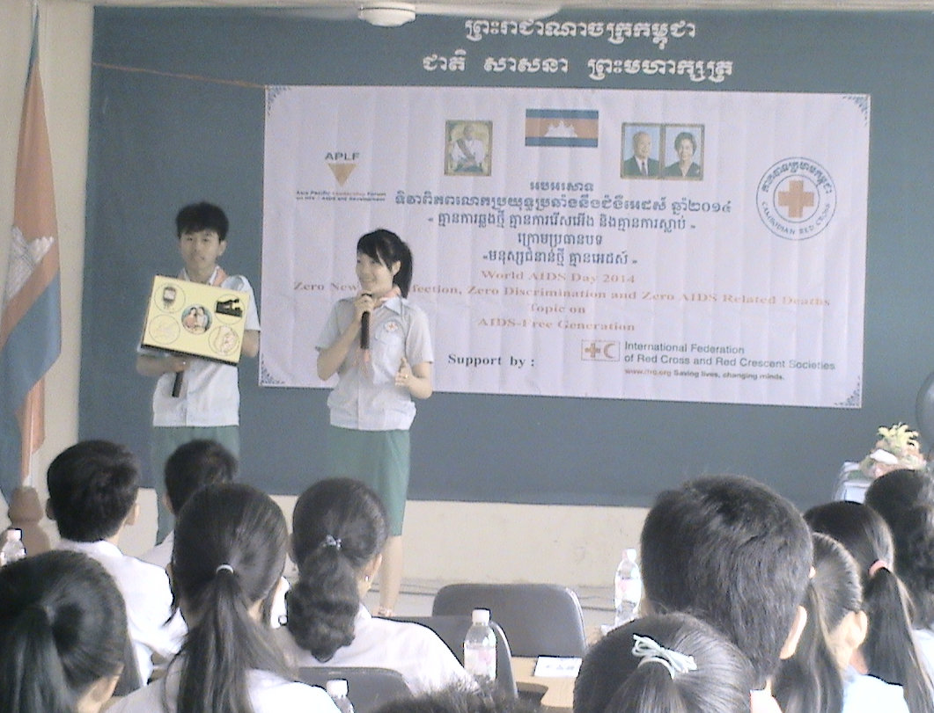
This flame has kindled to Singapore and Singapore RC also initiated YABC training and those trained youths organized Peer to Peer Symposium by mobilizing 300 Singapore youths and other SEA Youths. They have been successful in engaging Singapore youths into Community Led Action for Resilience for Elderly (CLARE) project starting from 2015. Singapore NS Leadership encouraged and supported to host the 2nd SEAYN meeting in Singapore after Beijing Youth Summit by consolidating all 11 youth leaders into one, for promoting youth on move, doing better, doing more and reaching further.
Siem Reap Youth in dissemination on HIV/AID on World AIDS Day

- Cross Regional Cooperation with strong Youth representation.
- Excellent Youth peer cooperation (regional and cross-regional such as Japan RC/Korean RC) has been facilitated in a bilateral way as well as with the support of IFRC office among SEA NSs such as Cambodia, Thailand, Lao and Vietnam .
- The 2nd Asia Pacific Youth Summit and 6th AMCDRR have been great platforms for all SEA youths to strengthen the cross regional cooperation and to build capacity and share youth voices.
- Two face to face SEAYN meetings in Cambodia and Singapore have also given opportunities for members (staff and volunteer leaders) to share their issues, challenges, best practices openly and carry out further plan in an honest and realistic manner.
- Finally those commitments and action plans have contributed to key outcomes of AP RCRC conference, Youth Engagement Strategy implementation and will be a key preparatory route for global youth conference to be held in Geneva 2015.

Directions/ Decisions
The overall goal of the Youth Development in the region is to mainstream youths into community safety and resilience actions with their improved positioning and increased representation.
Specific directions for 2015 and beyond include:
- Better positioning and increased Youth representation through upgrading NS Youth policy/ strategic planning in line with Youth Engagement Strategy (Y.E.S).
- Develop youths as champions for RC advocacy including Humanitarian Diplomacy and Humanitarian Education (School-based programming) with stronger peer cooperation.
- Promoting a culture of non-violence and peace, inspired by RCRC Fundamental Principles and Humanitarian Values
- “Youth-led pioneered” programmes initiated and strengthened (in the social inclusion: Inter Cultural & inter Religious dialogue, Inter-generational programming, violence prevention through YABC approach) & strengthening of NS youth database, systems (RMS).

Leaders’ support is required in the following areas:
- Endorsement to upgrade NS Youth Policy, Strategy and database and increased youth representation at governance level
- Strong support in integrating/mainstreaming youth-led activities into NS programming (DM, Resilience, Health) and advocacy
- More Investment to youth empowerment and events as well as higher representation of SEAYN members in national, regional, zonal and global events; 2015 key events; World Humanitarian Summit, Sendai conference, 2015 Youth Conference cum International conference and SEAYN annual meeting
- Approval and Support to SEAYN to circulate Youth Newsletter among NSs, Region and Zone
- Strong Support to peer cooperation within the region building on common identified priorities.

Contact information
For further information, please contact:
Dr Lilis Wijaya, SEAYN Chair
Email: lilis_wijaya@pmi.or.id; tel: +62-878-8181-8465,
Mohammad Zaidi Ariffin, SEAYN Co chair
Email: Zaidi.rcy@gmail.com; tel: + 65-9069-7207

Anne E. Leclerc, Head of South-East Asia Regional Delegation
Email: anne.leclerc@ifrc.org; tel: +66-02-661-8201

Most of Stueng Thmey villagers are those people living with HIV.

