11th Annual South-East Asia Red Cross Red Crescent Leadership Meeting 2014
Youth Development
Youth Network/ Singapore / 24-26 March 2014

Introduction
Strategy 2020 calls for a special focus on young people not only for today but also for the future as well as recognizing their particular role in building and sustaining communities that are based on respect and solidarity. In line with Strategy 2020, through the IFRC Youth Policy (2011) and Youth Engagement Strategy (2013), national societies (NS) increasingly recognize the benefits of investing in education, empowerment, and creation of enabling environments for young people to change themselves and their societies.
In South-East Asia (SEA), youth empowerment is a cornerstone of building safe and resilient communities. SEA NSs are actively developing their youth structures to ensure youth engagement in decision-making processes at all levels of management, governance and service-delivery. This process not only enables meaningful participation of youth but also facilitates their broker role between communities, national societies and regions. To date, eight out of eleven NS developed a youth policy or strategy and have a staff member or department to support youth action; ten national societies have school, university, college, or community-based youth networks or clubs. And finally youth is represented in the governance of four SEA NS. However, despite these significant developments, youth action and engagement in service delivery has not reached its maximum potential in the region.
The establishment of South-East Asia Youth Network (SEAYN) was in part a result of SEA Leaders calling for more streamlined networks and enhanced youth representation in NS decision making and service development. This regional platform aims “to enhance National Society service delivery by mobilizing resources of youth in the region and by developing the regional youth action in aspiration for positive change”.

Key developments and achievements

- The first South-East Asia Youth Network was established in May 2013 during the joined OD and Youth Forum held in Kuala Lumpur.

Headed by the Coordination Team of six, SEAYN is composed of 22 members. The Chair of SEAYN is a representative of the NS hosting Annual SEA Leaders meeting.

The Network Terms of Reference and Action Plans 2013-2014 are developed and subject to Leaders’ endorsement.

The key action plans for 2013-2014 include:

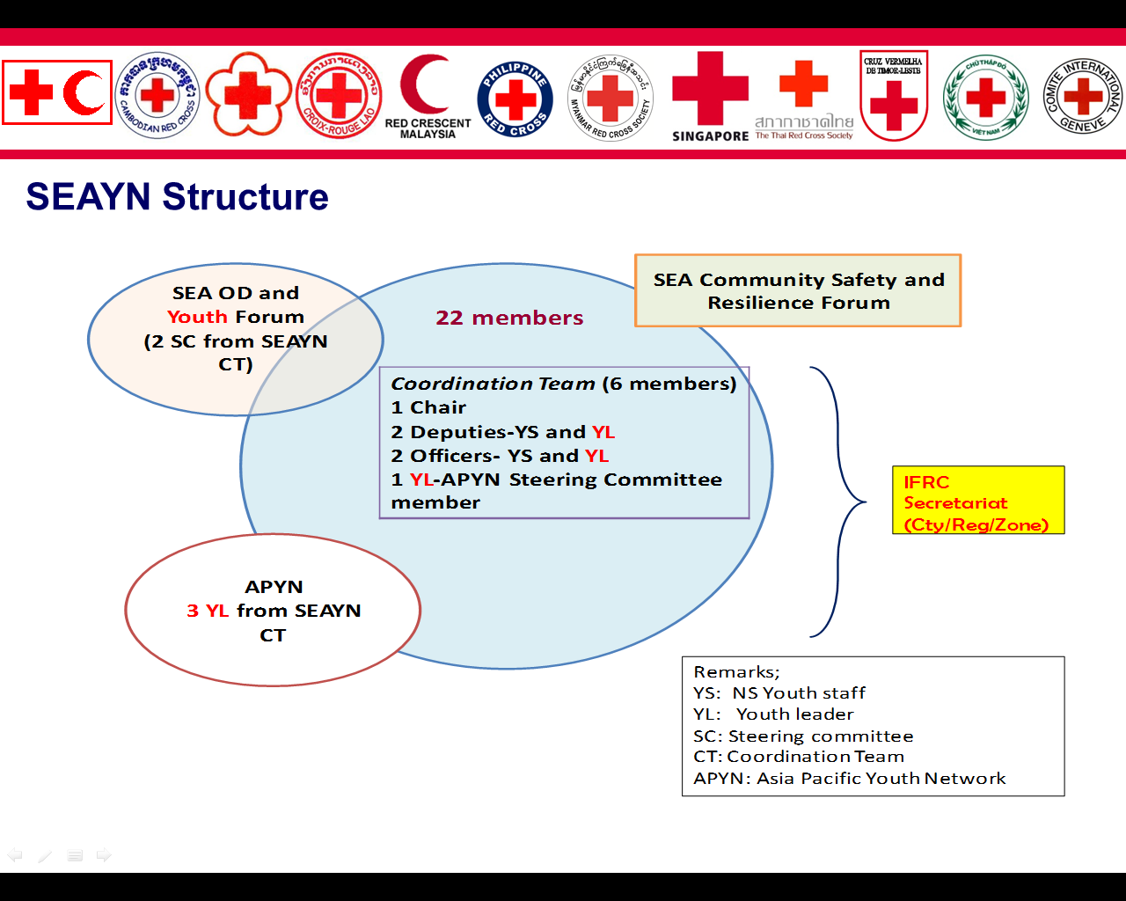
- Strengthening the Youth Policy/Strategy and Structure in Malaysia and Cambodia RC.
- Support to the improvement of school RC youth in CVTL (started).
- Support to the establishment of national youth network in Lao RC.
- Development of the Regional Youth Project.
- Regular update and exchange of Youth related information between NSs and youth exchange programme (started).

- Development of new initiatives. The regional Youth Empowerment project proposal has been developed with the aim to build safe and resilient communities through increased engagement of Youth in the NS programmes and services. The proposed activities are focused on youth in National Societies of Cambodia, Myanmar and Timor Leste. The target NS were selected through a survey conducted by SEAYN. The proposal has been submitted to potential donors and is subject to Leaders’ approval and endorsement. SEA Youth will be more empowered and integrated into programmes through Youth representation in the 6th Asia Ministerial Disaster Risk Reduction Forum with the support from CSR and by joining in the ASEAN Coalition for school safety.

- Cross regional cooperation. SEAYN is closely linked to the Asia Pacific Youth Network (APYN). Three members of the former are represented in the APYN and play a broker role between the two networks through regular reporting and information exchange on the current and planned activities.
Participation of SEA youth in the second Model IFRC General Assembly organized by South Korean Red Cross (SKRC) contributed to cementing cross regional relations. In addition, it resulted in the exchange visit of the Korean youth to Viet Nam Red Cross as part of the Youth exchange programme. To strengthen and ensure continuity of the partnership between SKRC youth and SEAYN the exchange mechanisms need to be further explored. This area requires Leaders’ support and approval.
At the global level, SEA youth has been represented in the Global Youth Conference in Sydney in 2013. The youth delegates, representing five SEA NS (CRC, CVTL, PMI, MRC and TRC) held a side meeting to discuss and exchange ideas how global issues raised at the Conference can and should be addressed in the context of their region and National Society.
To mark the 9th Asia Pacific Regional Conference with successful achievement of the Ajloun commitments 2010, the SEA Youth worked together to promote the Solferino Youth Declaration by strengthening youth network at regional level.

Directions/ Decisions
The overall goal of the regional Youth Network is to work towards improved positioning and representation of youth structures in NS management, governance and service delivery through their participation in decision-making.
Specific directions for 2014 and beyond include:
- Better positioning and increased representation of youth in existing RC programmes through YABC tool.
- Stronger peer cooperation through Youth exchange programme and joint events.
- More effective SEAYN including capacity building of members and promotion of youth success stories through online and face to face meetings.

Leaders’ support is required in the following areas:
- Stronger mainstreaming of youth into all RC programmes through YABC tool.
- Approval of Regional Youth Empowerment Project Proposal.
- Endorsement of SEAYN ToR and key action plans, including the nomination of members from Singapore, Viet Nam and Myanmar Red Cross Societies.
- Peer cooperation between regions or sister NSs and more investment in youth activities and events as well as higher representation of SEAYN members in regional, zonal and global events.

Contact information
For further information, please contact:
Sam Kosal, Cambodia Red Cross Youth Representative, SEAYN Chair
Email: Kosal.sam@redcross.org.kh; tel: +85-5-1293-1430

Anne E. Leclerc, Head of South-East Asia Regional Delegation
Email: anne.leclerc@ifrc.org; tel: +66-02-661-8201

Annex 1. ToR of SEAYN
Annex 2. Youth Empowerment project proposal
Annex 3. NS survey summary report
Annex 4. Presentation on the 6th AMDRR
Ajloun commitment called upon Presidents, Secretaries General and senior management teams of the AP and MENA National Societies to: - Endorse and further support the AP and MENA youth networks including regional network. - Integrate and support the implementation of effective youth programmes which use peer-to-peer and non- cognitive methodologies as reflected in YABC initiative. - Recognize the importance of the Ajloun Commitments, which are linked to Solferino Youth Declaration and provide the human and financial resources for their implementation. - Provide greater support and appropriate resources to enable quality use of and access to technology.

