International Federation of Red Cross and Red Crescent Societies
Southeast Asia Climate Change Master Training
Session Plan of Session 7: Public Awareness Public Education for Disaster Risk Reduction and Climate Change / SEARD Bangkok / 2014

Session Plan of Session 7: Public Awareness Public Education for Disaster Risk Reduction and Climate Change

Objective: At the end of this activity, the participants are able to:
- Enhance their knowledge on strategies, methodologies and tools to inspire communities, general public and youth on climate change.
- Describe PAPE Guide and key messages
- Share experiences about RCRC or other organizations contributing in public awareness
Key terminologies to cover in the session:
- The PAPE Guide and key messages
Proposed Methodology:
Group work, presentation, discussion and lecture
Tips to Facilitator:
After step 5 in the process below (Slide 20), and subject to availability of time, facilitator can deliver a presentation of a success story of raising public awareness (see Earth Hour presentation link in the references above) as an example.
Reference Materials:
- IFRC_Public Awareness Public Education for DRR 2011
- IFRC_Key Messages Short Version_Public Awareness Public Education for DRR 2013
- IFRC_Key Messages_Public Awareness Public Education for DRR 2013
- Earth Hour presentation http://www.youtube.com/watch?v=FovYv8vf5_E
Duration: 1,5 Hours

Timing Session | Purpose/ Objective | Methodology | Material/Facilitator
*From when to when  (min) | What the activity aims at | How the activity is conducted, including the methods to be used (e.g. brain storming, group discussion, role play, etc.), questions, time duration, expected information, what the participants should do, etc.  If case study or role-play will be used, explanation or information should be provided as well. | What materials, facilities, equipment are required to conduct this activity (e.g. flip charts, marker pens, color cards, etc.)
5 minutes | Participants are aware of the objectives | - Facilitator presents session and session objectives (slides 1-3)
25 minutes | To train participants to tailor key messages according to different stakeholders | Group Work 1  - Facilitator conducts Group Work 1 by: (slide 4)  - Divide participants into the following group of stakeholders: Family, RC Branch, Academic, Local Government and Disaster Management Agency  - Ask each participant to visit each post (there are five posts as described above, and each post has different questions based on the role of each stakeholder)  - Ask each participant to answer the 5 questions by writing their answers in metacard in each post. Each question should be answered within 2 minutes - No talking with each other.  - The questions are available in:  - Session 7A-Exercise on Public Awareness Public Education Community and  - Session 7B-Exercise on Public Awareness Public Education Stakeholders  - Facilitator conducts plenary discussion by using fishbone method. In this activity, the participants should discuss: (slides 5-7)  - What is the difference between the answer from family with other stakeholders (RC Branch, Local Government, Academic Institution, Disaster Management agency? (Refer to the fishbone diagram below)  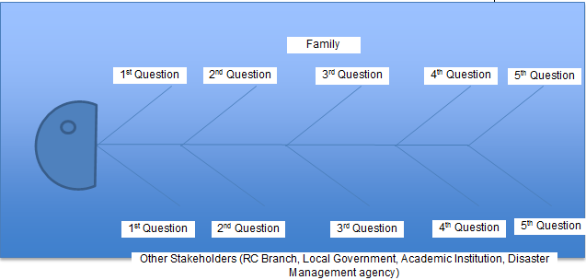  (b) What will happen with the community if they receive different key messages from different key stakeholders?  (c) How can the RC have better role to build consensus on key messages from local level to Global Level? | Flip chart  Metacards  Markers
25 minutes | To familiarize participants to PAPE guide and tools | Presentation: (slides 8-32)  - Facilitator continues delivering power point presentation about PAPE Guide: (a) Planning; (b) Four Key approaches; (c) Four Principles; (d) Tools; (e) Ensuring Qualities; (slides 12-18)  Facilitator shares experiences about translating Global Campaign to Local Level and emphasize the importance of having key messages from global level to be translated into local languages in coordination with local government. (Slide 19-20)  video presentation: The earth hour global campaign  - Facilitator introduces PAPE-Key Messages: (slide 21-32)  - The global workshop and consultation process to develop the messages;  - The importance of the key messages;  - Key messages structure: family and hazard specific. | Flip chart  Markers
20 minutes | To familiarize participants to the different context specific key messages | Group Work 2:  - Facilitator lead group work 2 (slides 33-34)  - Step 1: Facilitator divides the participants into 3 groups and assigns one set of hazard key messages to each group (drought, flood, and tropical cyclones).  [Please note that these 3 sets of key messages are available in IFRC Key Messages Public Awareness Public Education for DRR 2013 in the Resource folder].  [Facilitator and participants can use the table indicated in the presentation slide 34].  - Step 2: Participants identify 2-3 key messages you will use to deliver to the target group (target group refers to the community)  - Step 3: Participants add “Climate Change perspective” on the context-specific details  - Step 4: Participants decide which medium of dissemination they can use (example: radio, brochures, etc.)  - Step 5: Participants decide with whom they need to coordinate about the content of the Key Messages.  - Presentation of group work and discussions | Flip chart  Markers  Pdf document: ‘IFRC_Key Messages_Public Awareness Public Education for DRR 2013’, for key messages for drought see page 29, floods see page 38, tropical cyclones page 46.
5 minutes | To familiarize participants to resources available on PAPE | - Facilitator continues with the Presentation. (Slides 35-39)  - Facilitator seek questions and further clarifies if needed | Flip chart  Markers
10 minutes |  | - Facilitator asks questions to the plenary: How can we use the existing tools in a better way? (Slides 40-41)  - Summary | Flip chart  Markers
End of Session 7

