International Federation of Red Cross and Red Crescent Societies
Southeast Asia Climate Change Master Training
Session Plan of Session 5: Assessing climate risks at community level and mainstreaming adaptation in community-based project activities / Bangkok Country Cluster Support Team / 2016

Session Plan of Session 5: Assessing climate risks at community level and mainstreaming adaptation in community-based project activities

Outcome: At the end of this activity, the participants are able to:
- Understand how to integrate into the existing community level risk assessment process and tools, information on the additional risks and vulnerabilities linked to climate change when carrying out a community assessment/VCA and facilitating planning steps toward a climate smart community action plan.
Key terminologies to cover in the session:
VCA process and tools,
Proposed Methodology:
Group work, discussion, presentation, and lecture
Tips to Facilitator:
- If possible, ask participants to read the IFRC publication: Integrating climate change and urban risks into the VCA (2014), before the session
- Key discussion points in this session include:
- Why integrate climate change into community risk assessments?
- Introducing relevant VCA/community assessment tools to consider changes in climate at community and local level and introduce tools that need some modifications to capture climate risks and vulnerabilities - see the list in the attached document.
- Communicating climate change for risk reduction and review of analysis templates that support development of a climate smart plan of action.
- Prepare a flipchart table (step 5 below) with the list of VCA tools on a flip chart paper. (This table should be prepared before the session starts)

Reference Materials:
- IFRC VCA guides (IFRC_How to Do A VCA 2007, IFRC_Integrating climate change and urban risks into the VCA 2014, IFRC_VCA Toolbox 2007, IFRC_What is VCA 2006
- IFRC CBHFA guides (IFRC_Volunteer Manual for CBHFA in Action 2009, IFRC_Facilitator Guide for CBHFA in Action Vol.1 2009, IFRC_Facilitator Guide for CBHFA in Action Vol.2 2009, IFRC_Implementation Guide for CBFHA in Action 2009)
- IFRC publication: Integrating climate change and urban risks into the VCA (2014)
- Climate Centre guidance note: How can climate change be considered in VCA (2012)
- Climate Centre Climate Guide (2007)
- Communicating Climate Change for Risk Reduction in Pacific Communities (2014)
- Examples of VCA reports.
- World café exercise available at: http://www.theworldcafe.com/key-concepts-resources/world-cafe-method/ )
Duration: 2 hours 45 minutes

Timing | Purpose/ Objective | Methodology | Material/  facilitator
*From when to when  (min) | What the activity aims at | How the activity is conducted, including the methods to be used (e.g. brain storming, group discussion, role play, etc.), questions, time duration, expected information, what the participants should do, etc.  If case study or role-play will be used, explanation or information should be provided as well. | What materials, facilities, equipment are required to conduct this activity (e.g. flip charts, marker pens, colour cards, etc.)
40 mins | Introduction to the session | - Facilitator introduces session and session objectives: (slides 1- 2)  - Ask participants why is it important to consider and integrate climate change in community risk assessments. (Slide 3)  - Ask if everyone has facilitated or is familiar with VCA process and tools.  - Discuss some VCA tools that can be used for assessing climate risks in community risk assessments. (Slides 4-5)  Secondary Information sources exercise (slide 6)  - Ask participants: “If you are planning a Community Assessment/VCA, what secondary information would you use to make sure that you guide the Community Assessment/VCA to become a ‘climate smart’ one?”  - Note their replies on the whiteboard.  - Coach for and add any answers that the participants don’t mention (you may want to prepare your own background list – adding to the list mentioned above – for the specific setting e.g. country or region  - Further ask participants “how they might use the secondary information? (E.g. in planning where and who to do the Community Assessment/VCA, knowing what trends to expect and ask communities about). “  - Present and explain slides 7- 8  - Consider investigations with: Meteorological office (but don’t ask for raw data!). The national climate change focal point – usually at the environment ministry 'Preparedness for Climate Change' (PfCC) background document (prepared if the NS was part of the PfCC process – see http://www.climatecentre.org/downloads/File/programs/PFCC/CC_PfCC_version web.pdf), Research institutes, NGOs and UN agencies (e.g. UNDP) and Climate helpdesk: mailto:ifrc@iri.columbia.edu.  - Present examples of tools and highlight guide questions on how to ensure climate risk is included in the tool (Slides 9-14)  - Facilitate a discussion to further consolidate the understanding on the usefulness of the tools. | Flip charts  Markers  Presentation and discussion  Flip chart with a list of VCA tools  Green, yellow and red post it spots
40 minutes | To understand which tools need changes | Group Work  - Divide participant into four groups and assign each group 3 VCA tools each. Ask them to consider the following questions:  - What is the information relevant to climate change to be collected per tool?  - What are the uses of this information?  - Display another table (see sample below) on the wall and ask each group to fill in the information required in the empty cells.  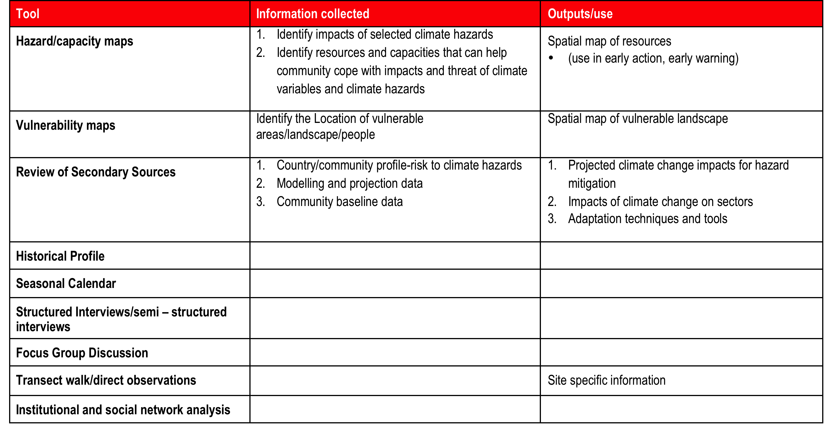  - Once done, consider which tools need changes to better support collection of climate information and analysis. Refer to existing guides.  - Review the components and templates for risk analysis with the participants that support development of a climate smart action plans. (Slides 15-17) | Flip charts  Markers  Presentation and discussion  Flip chart table with a list of VCA tools
85 minutes | Simulate the use of selected tools in the context of climate change. | Group Work  - Divide the participants in to four groups and distribute four VCA reports to each group.  - Ask each group to discuss what changes are needed in the two VCA tools assigned to the group (template/analysis) so that the tools will be able to collect climate change information and assess climate risks.  - Facilitator guides groups to use IFRC and other guides for climate-smart VCA if needed.  - In addition, ask participants to identify top three VCA tools that can be potential entry points to initiate the discussion on climate change. Please give two reasons on how and why.  - Once completed, ask the participants on their reflection of the tools and the utility of it through a world café exercise (10 minutes in each, 30 minutes in total, plus 5 minutes plenary and feedback for each group. (World café exercise available at: http://www.theworldcafe.com/key-concepts-resources/world-cafe-method/)  - Facilitator summarizes discussions and makes further clarifications if needed | Flip charts  Markers  Four VCA reports from the participating countries  The number of tools to be provided to the participants would depend on time allocated for the exercise. In case of time constraints, tools should be prioritized and provided to participants
End of Session 5

