ANNEX 2(a)
CSR Resilience House – revised during the 2014 CSR Forum
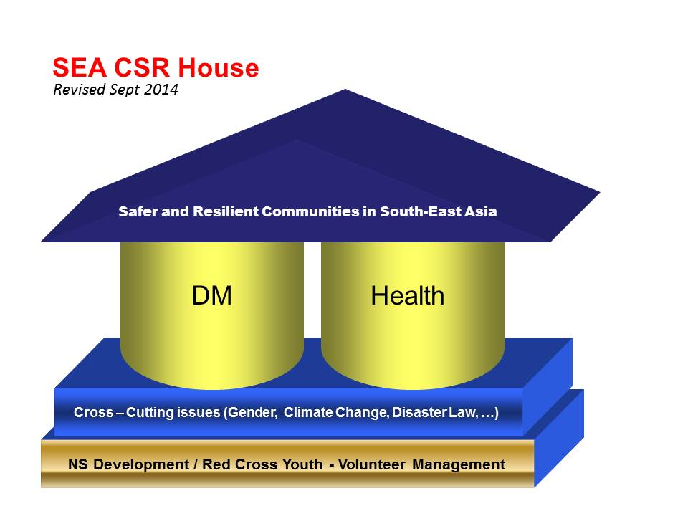

Technical areas of three thematic working group:
DM | Health | OD
DP/Response and Recovery | CBHFA and WATSAN | Advocacy, Partnerships, Networking
CCA/EWEA | Emergency Health and PSP | Volunteer and Youth
DMIS/ Knowledge Sharing | Blood Services and HIV/AIDS | Resource Mobilization
RFL/Migration | Health Care Services | Integrated Assessment and Planning
Cross- cutting issues: Gender; Climate change; People with disability; Children , Disaster Law, etc.

Annex 2b:
Integrated Roadmap – revised during the 2014 CSR Forum (Bangkok)
 | Why | What | 2012 | 2013 | 2014 | 2015 | Who is responsible
1 | Lack of capacity and organization to support risk reduction operations | Building Capacity of Red Cross and Red Crescent volunteers + Trainers/facilitators + database + financial + Youth (OD) |  | - Standardization of OD, health and DM training curriculums  - Workshop integration (OD/DM/Health) | - Cross country training  - Internships and exchange  - Peer to peer learning | - Case studies and impact on integrated approaches  - Look back study and for sustainability  - Planning for next road map | - CSRU  - RCSRF
2 | Health + DM + OD are not yet integrated in planning and implementation | Integration (planning + services) Health/DM/OD |  | - Standardization Planning/training tool  e.g. Multisectoral assessment tool | - Integrated country level plan | - Implementation and monitoring  - NS promote FA in all departments – becomes a cross-cutting activity  - NS have an integration policy and monitoring mechanism  - Pilot school based DRR initiatives | - CSRU  - RCSRF
3 | Still few NSs have no CP + SOPs | Contingency planning + SOP for NSs  Health in emergency | - Mapping of NSs for CP and SOP | - Mapping of NSs for CP and SOP  - Developing CP and SOP | - Tsunami CPs and SOP development for Indian ocean  - Mekong river CPs + SOPS and EWS  - Epidemic CP (H7N9, corona, other)  - ACTUAL SIMULATION plus TTX | - Implementation/review + amendments and evaluation  - ACTUAL SIMULATION plus TTX (involving health)  - Joint SOPs  - Pandemic preparedness | - CSRU  - RCSRF  - Invite ministries (health)
4 | No cooperation framework, mechanism between IFRC and ASEAN plus relevant INGOs | Regional networking and ASEAN + relevant INGOs  Mapping different technical networks  WHO and ASEAN working with health |  | - Continuation meeting NDMO + ASEAN - RDMC  - Participation of RDMC to ADDMER – Part Group APG  - Chair RDMC participation at open session ASEAN and APG  - WHO etc health networks | - Participation coordination + communications | - Participation coordination + communications and follow up  - Address disaster law with support from SEARD, based on country-level developments and NS needs (including capacity building for the NS).  - ASEAN Pandemic Preparedness TWG  - WHO | - CSRU  - RCSRF  - AP zone
5 | Communication gap between leadership forum and RCSRF | Advocacy support to the leaders -  2012 in Myanmar  Integrated roadmap to be presented to leadership |  | - Participation of relevant professionals in leadership meeting (AHA, NCD…etc)  - CSRU visit to respective NSs | - information bulletin about RDMC for NS leaders.  - Participation of relevant professionals in leadership meeting (AHA, NCD…)  - CSRU visit to respective NSs  - humanitarian diplomacy in country / NSs  - humanitarian diplomacy in country / NSs | - information bulletin about RDMC for NS leader.  - Participation of relevant professionals in leadership meeting (AHA, NCD…)  - CSRU visit to respective NSs  - humanitarian diplomacy in country / NSs | - CSRU  - RCSRF  - AP region and zone
6 | Lack of information on overall situation of NS response capacity .  Group did not have info on the yearly plans! | - Standardize NDRT curriculum manuals with RDRT  - Work group for development of SOPs for NDRT to maintain standard across region.  - SOPS for cross border disaster response  - Upgrade RDRT capability e.g. by specialised RDRT training |  | - Formation of task force for NDRT standardization and relevant SoP.  - Secretariat to consolidate the resources for disaster response, recovery and disaster risk reduction.  - Adaptation of RDRT to NDRT training curriculum (responsibility lies with: sub group 2 member)*  - NDRT training (responsibility lies with: CSRU and sub group member)*  - Identify trainer(s) for NDRT (responsibility lies with: CSRU and RDMC)*  - Draft of SOP for cross border for 18th (responsibility lies with: RDMC – Sub Group 4)*  - Submit draft SOP to leadership meeting (responsibility lies with: chair person of RDMC)*  - Finalize SOP on 19 RDMC (responsibility lies with: RDMC members)* | - Dissemination and application of SOP by RDMC*  - Simulation of SOP by RDMC/CSRU  - Review of RDRT roaster  - Revisit RDRT SOP and curriculum | - Review of SOP  - Review of emergency health training curriculum for RDRT  - Inclusion of health component in NDRT training  - TTX RDRT | - RCSRF  - CSRU  - AP Zone
6 | Lack of information on overall situation of NS long term programming | - Priority areas in long term programming to be highlighted for cross-NS sharing and integration  - Balance between country needs and leadership wishes |  | - Updating SEA online library with health and DM information  - More real time information sharing (early warning) | - Databases of active resources e.g. RDRT NRDT trained volunteers, CBHFA facilitators  Maximize the use of social media, for example Facebook, Twitter | - Inform each other of important meetings with external stakeholders (AHA, Governments, etc.) and peer-to-peer visits  - Use RMS as database for RDRT | - RCSRF  SEARD to support as administrator
7 | The current RDMC ToR needs to be revised to include other technical departments. | - Sub group meeting to review current framework | e-consultation and discussion | - Sub-group to review and finalize.  - RDMC meeting to give final touch.  - Leadership meeting to endorse the revise RDMC-ToR. | - Joint meetings with cost sharing | - Endorsement of RCSRF regional forum in Cambodia in 2015  - Review and revise TOR | - RCSRF  - CSRU  - Sub-groups
8 | Regional Integrated Cooperation Network | - Meeting, Trainings,  - Common name? | - Sharing within RDMC members from all members including CSRU | - Sharing within RDMC members from all members including CSRU | - Sharing within RDMC members from all members including CSRU  - Cooperation with AHA Centre enhanced (include participation to planning meetings for simulation exercises, TTX and other simulation exercises such as ARDEX) | - Sharing within RCSRF members from all members including CSRU  - Contribution to SASOP revision | - RCSRF  - CSRU
9 | Inadequate beneficiary communication document | - Collection of success story on technical fields and on integration | - Determine theme for case study  - Collection of information | - Drafting of case study  - Finalization of case study for sharing | - Determine theme for case study  - Collection of information | - Drafting of case study  - Finalization of case study for sharing | - RCSRF
10  To be doiscussed | Lack of funds and resource mobilisation | Joint technical proposals  - Use appropriate technical area as an entry point |  | - Educate donors on integrated approaches, demand not donor driven |  |  | - RCSRF

Comments from the OD/Youth steering committee:
- Inclusion of branch development, volunteer development, youth development and engagement, capacity building (gender & diversity, finance development, resource mobilisation), should be reflected in the road map.
  - Gender & Diversity to be included in an integrated planning
  - Promote youth integration at all levels / Greater investment in youth / Promote OD & Youth engagement in all programs/projects
  - Develop strong online communications / Sharing of information, learning experience, success stories.
  - Ensure allocation of funding in all programs for OD and Youth (existing model from Cambodia and Myanmar RC can be replicated).
- CSR forum should have representatives of DM, Health, OD and Youth, from 11 NSs
  - Recommend youth representative in the chair group.
  - 3 days forum :
    - 1st day, plenary session (joint presentations from all NSs)
    - 2nd day, TWG meeting, 4 TWGs
    - 3rd day, plenary session

