The Philippine National Red Cross
Red Cross Youth Department

YOUTH COUNCIL POLICY GUIDELINES

INTRODUCTION

Over the years, recruitment policies of Red Cross Youth Councils have varied depending on each and every Youth Council’s initiatives, drives, culture and goals. Several area conferences and consultation meetings were held over the years, and the same problems, questions and issues were encountered and raised over and over again. Some of the biggest issues were: (i) the lack of standard guidelines and procedures on Council recruitment, (ii) the ability or inability of Youth Councils to sustain the enthusiasm of its members and the keep them active; and (iii) the proper way to effectively manage the operations and funds of the Youth Councils.

Due to these perennial problems, the Red Cross Youth Department deemed it imperative to develop and pass policy guidelines for Youth Councils all over the country so that all Youth Councils, be they in the schools, communities and/or chapters, act and function uniformly, especially with respect to the main concerns of management, operation and recruitment (which includes membership activities and retention).

These policies are a collection of the best practices followed and observed by successfully functioning Youth Councils all over the country.

Article 1. These guidelines shall be known as THE RED CROSS YOUTH COUNCIL POLICY GUIDELINES ON MANAGEMENT, RECRUITMENT AND RETENTION.

Article 2. Declaration of Policy. It shall be the policy of all PNRC Chapters to promote the participation of, and actively recruit children and youth between the ages of 7-25 years, whether from the school levels and/or the community as a whole, within their respective areas of jurisdiction.

Article 3. Definition of Terms. For the purpose of these Guidelines, the following shall have the following meanings:
- PNRC – Philippine National Red Cross
- RCY – Red Cross Youth
- Youth Council –
- Recruitment Cycle – recruitment period of time occupied by a series of events that repeat themselves regularly and in the same order.
- DepEd – the Department of Education
- CHED – the Commission on Higher Education
- LGU – Local Government Units
- TESDA – Technical Education Skills Development Authority
- DILG – Department of Interior and Local Government

Article 4. The Recruitment Cycle.
(a) PHASE I (ASSESMENT) – During this period, the Chapter must assess the potential number of youth volunteers for their Youth Council and within their respective areas of jurisdiction, in respect of:
(i) The number of elementary schools, high schools and/or colleges/universities are operating;
- The number of barangays;
- The level of support of the Regional Offices of the DepEd, CHED and LGUs;
- The number of school councils, if any, over the past five (5) years, and whether or not they are still active or growing;
- The proportion of the number of schools versus the number of school councils;
- Previous problems encountered on management, operations, project implementation and recruitment (which includes membership retention); and
- Whether the Chapters themselves actually have a Youth Council formed that spearheads or merely assists the chapters themselves in their recruitment drives.

(b) PHASE II (ORGANIZATION) – If it is determined that the chapter does not have a Youth Council to begin with, it will immediately form a committee of three (3) from among the members of its Board of Directors and/or PNRC personnel. This committee shall undertake the rest of the phases hereunder provided.

(c) PHASE III (COORDINATION). After carefully assessing the major concerns and issues listed in Article 4(a) above, the chapter should proceed to the coordination phase. This is intended to facilitate a smooth and highly involved process of recruitment of youth volunteers for the Youth Councils. Thus, the Chapters shall:
  - Secure national, regional and/or division memorandum orders from the DepEd, CHED, TESDA and/or DILG to encourage the youth in the schools and communities to join the Youth Councils and become active members thereof.
  - Coordinate meetings with the heads/principals/deans/presidents of the schools within their areas of jurisdiction, as well as the Offices of Student Affairs/Services and the Student Councils therein. Meetings should also be coordinated with Barangay Officials as well.
  - Organize and coordinate organization and strategic trainings for chapters, school principals, school heads and barangay officials.
  - Provide and coordinate general orientation and organizational strategic trainings (OST) for all qualified and selected RCY Advisers. The general orientation shall include a discussion on the history of the Red Cross Movement (including the difference between the International Federation of the Red Cross and the International Committee of the Red Cross), the Philippine National Red Cross, the relationship between the PNRC and it’s chapters nationwide, and the Red Cross Youth.

- PHASE IV (RECRUITMENT and ORIENTATION). The Chapters shall conduct the following activities after all the proper coordination shall have been made:
  - General Orientation (GO)- The chapter and/or Youth Council, after getting the necessary permit from the school head/principal/president, must conduct a General Orientation for all pupils/students of the school concerned. This GO may be in the form of a school program, a room-to-room campaign, or merely setting up an information center for RCY in the school. In school programs or room-to-room campaigns, the presentation must not exceed forty-five (45) minutes. Another fifteen (15) minutes should be allotted for the students to be able to freely ask questions about RCY projects and programs. The GO must always be conscious of the time the students are taken away from their classes, and must, at all times be conducted with the least disruption to the same.
All GOs must discuss the following: (1) history of the Red Cross Movement; (2) the Seven Fundamental Principles; (3) PNRC’s Vision, Mission and Core Corporate Values; (4) the Six Major Services of the PNRC; and, (5) RCY, its activities, projects and programs. In this phase, 4.3.2 of this policy can be immediately done, however, bear in mind the disruption we are causing to the class/es.
  - Massive Membership Recruitment (MMR) – The chapter and/or Youth Council shall conduct conduct a two (2) day recruitment drive in the schools and/or barangays within their areas of jurisdiction by setting up tables in conspicuous places or designated areas within the school and/or barangay.
During this process, the youth volunteer shall accomplish RCY Official Form 1- Membership Form and submit two (2) passport sized photos for the Chapter’s/Youth Council’s records. Thereafter, the youth volunteer should accomplish the Membership Health Insurance Form and remit the corresponding payment therefor.
  - Basic Leadership Training must be conducted for all RCY members, especially Youth Council officers.
  - Chapters should conduct these activities at least once a month until the desired number of youth volunteers are met. For purposes of these Guidelines, the desired number of youth volunteers to constitute and Youth Council is fifty (50). However, Chapters are not precluded, and are in fact encouraged, to conduct recruitment activities all year round.

(e) PHASE V (POST RECRUITMENT ACTIVITIES)
  - All youth volunteers recruited into the RCY and Youth Councils in the various chapters all over the nation, must be indorsed by the School Principal (if they are enrolled in an elementary, high school or college/university) or Barangay Captain (if they are not enrolled but residents of the community) within the area of jurisdiction of the Chapter to which the RCY or Youth Council belongs.
  - After recruiting a minimum of fifty (50) duly registered RCY members, a council assembly must be held to elect Council Officers.
  - The Youth Council Officers shall be: (1) President; (2) Vice-President; (3) Secretary; (4) Treasurer; and (5) PRO-Liaison Officer

- PHASE VI (COUNCIL ACCREDITATION). All School or community councils must be duly accredited by the RCY. This is to authorize the school/community council to undertake different activities and represent the PNRC with limitations. Furthermore, all activities of the school and or community councils shall all be subject to the approval of the Chapter Administrator, with the recommendation of the council adviser/s and the recommending approval of the school head/principal/president of the school.
For the council to be duly accredited the school and or the community must submit the following forms:
(i) Council profile – The Youth Council shall submit in written/narrative form the (1) history of the Council; (2) profile of the school; and, (3) officers/heads of the school. This is a one time submission; provided, that, if the Chapter already has a record of the school or community profile, the Youth Council shall check every other year if such profile is current. If the same is current, then nothing further has to be done. However, if it is determined there are changes, then such changes shall be recorded in the profile and immediately submitted to RCY at the PNRC National Headquarters.
- Plan of Action – A Plan of Action detailing the Youth Council’s various activities, projects and budget shall be submitted immediately during the first (1st) quarter of the school year. This will ensure the harmonization of the school/community council’s activities and projects with that of the Chapter Youth Council’s plan of action. This Plan of Action must be submitted to the PNRC National Headquarters on RCY Official Form No. ____.
- Roster of Members – Within the first quarter of the school year, the Council’s must submit its roster of members which will indicate the following information: (1) Name of the youth volunteer; (2) Address; (3) Age; (4) Parents’ names; (5) Blood type; (6) School/Community Council connected with; and (7) Favorite area of service within the Red Cross. This Roster of Members must be submitted to the PNRC National Headquarters on RCY Official Form # ___.
  - Issuance of Certificate of Accreditation to School Council- After accomplishing all the pertinent documents, the adviser shall submit it to the chapter and the chapter shall make the necessary recommendations to the National Headquarters to release Certificate of Accreditation. Only the RCY Department can issue a Certificate of Accreditation. This is to ensure that all pertinent documents needed for the accreditation will be passed. Evaluation shall be done by the National Headquarters.
All forms must be submitted in triplicate copies, with one copy for the school/barangay, another copy for the PRNC Chapter concerned, and the last copy for RCY.
After completing all the above stated forms, RCY shall issue the RCY Official Identification Card. No Identification card/s will be released if the council is not accredited by the PNRC National Headquarters.
Upon submission to the Chapter of all pertinent documents, the latter shall put a registration code on the space provided for in the forms to ensure that the Council’s data is recorded in the database of PNRC National Headquarters. Due to the existence of schools with similar names all over the country, every chapter will maintain its own unique code to prevent duplication of the name of the Council All registration numbers shall start from 001-001000 (i.e LUSFC 001, that is La Union San Fernando City Chapter Registration Code 001). The said database shall indicate: (1) the Council’s profile; (2) it’s set of officers and adviser/s; (3) it’s roster of members; (4) it’s plan of action; and, (5) all other relevant information.

- PHASE VII (DELIVERY OF PNRC/RCY SERVICES). Councils shall be officially entitled to the various services of PNRC and RCY.
(i) HIV/AIDS Prevention Education Program (HAPE) – A basic dissemination course aimed to provide factual information on the prevention of HIV/AIDS. Other sexually transmitted diseases/infections and reproductive health shall also be discussed.
  - Pledge 25 – A project of the RCY in support of the drive on voluntary blood donation. It involves young people aged 18- 25 years old, who pledge to donate blood 3-4 times a year.
  - Project 143 (RCY KaBarangay) – A training for the youth aged 17- 25 years to become members of the Barangay Youth Disaster Response Team.
  - Drug Abuse Prevention Education Program (DAPE) – A basic dissemination course aimed to provide proper education on drug abuse.
  - Leadership Formation Course (LFC)- A course to prepare the youth for Basic Leadership Training (BLT) through assessing one’s strengths and weaknesses, clarifying and assessing their values, and integrating RCY corporate values to further increase leadership ideals and capabilities.
  - Junior First Aiders’ Program (JFAP) - The centerpiece of this program is lifesaving skills and development among the Junior RCY Members in the elementary school level.
  - Youth Advocacy on the Preservation and Protection of the Environment (Climate Change Advocacy) – While this is still being developed, it will cover raising consciousness and awareness among the youth of how to deal with climate change issues, and how to contribute to the protection and preservation of the environment given such issues.
  - National Youth Congress – The highest deliberative body of RCY, which is convened biennially with qualified RCY officers and members aged 15- 25 years as delegates. This Congress, which is highly participatory, is designed to draw the youth’s interest in bringing out the best in them, and to lay down policies and resolutions to guide RCY in achieving its goals which consistent with that of the PNRC and the Red Cross Movement.
  - SuperCamp Philippines – A 4-day training camp for junior and senior RCY Members with workshop modules and visioning sessions highlighting the event. It is also an opportunity to enjoy the wonders of nature, which is facilitated through team building activities, wholesome outdoor games and other environment-friendly competitions.
  - National Trainers’ Training – A crucial youth activity participated in by RCY members aged 17- 25 years, who wish to become National Volunteer Trainers for Leadership and are certified to capably conduct trainings for leadership, HAPE, DAPE and Pledge 25 orientations.
Collections of fees for the above activities are subject to the recommendations of the school/community adviser/s and the school head/principal/president of the school, as well to the approval of the Chapter Administrator. This policy shall be included in the General Orientation that will be conducted to the school/community heads and the advisers as provided in Article 4(d)(i) herein.

(h) PHASE VIII (RETENTION POLICIES). Chapters should continuously support the activities of the Youth Councils. Due recognition must be given to active Youth Councils and their members as well. Competitions for best school/community council should be done annually. This is to encourage the councils to be more proactive members of the organization. The following are awards are prescribed to be given to councils on an annual basis:
(i) Most Outstanding School/Community council – Recognizing the efforts of the councils is important chapters shall see to it that every end of the school year, councils must be given recognition
- Most Outstanding Council President – Given to the school/community council president who rendered exemplary leadership and unselfish service.
- Most Outstanding Council Adviser - Given to the school/community council adviser/s who rendered unselfish dedication and service to the organization.
- Certificate of Recognition – Given to all Councils, officers, schools and advisers.
- Ten Outstanding Red Cross Youth of the Philippines – This is an annual national search for outstanding RCY volunteers who have rendered unselfish service of excellence to the PNRC. It aims to recognize the volunteers for their invaluable support and contributions to the PNRC through the RCY.
- Most Outstanding Chapter Youth Council Awards – This is another national recognition for youth who have made a difference by providing service to and advocating for vulnerable people in the communities. All innovative programs conceptualized by the Council is given due recognition through this award.
- International Exchange Program – Given to qualified and active RCY volunteers and council advisers who are sent abroad through partner National Societies every year. Some of the partner National Societies include Japan, Singapore, Spain, and the like.
- Regular Council Meeting- Chapters should encourage RCY Council to have regular may it be in a monthly basis or quarterly, to discuss issues and problems of the council and to monitor the performance of the Council. A CYC officer must be present during the meeting of the council. This is to supervise the council.
All Chapters are required to organize a monthly, quarterly and annual Council of Presidents’ meeting. The Agenda must include updates and accomplishments of the Chapter Youth Council.
All Chapters shall also regularly visit the Councils on a quarterly basis. For this purpose, Chapter Youth Council officers are encouraged to be the ones to conduct the visits.
Chapter Youth Council (CYC) should hold regular monthly and quarterly meetings. Their by-laws must incorporate this requirement.

(i) PHASE IX ((MONITORING AND EVALUATION). The last part of the cycle shall be the monitoring and evaluation. Chapter should encourage every council to submit a regular accomplishment report monthly, quarterly and annually. Chapters should monitor the performance of their respective councils.

Article 5. ORGANIZATIONAL/CYCLE DIAGRAM. For easy reference and guidance, all Chapters shall be guided by the diagram below to effectively implement the Youth Council recruitment, management and retention program:

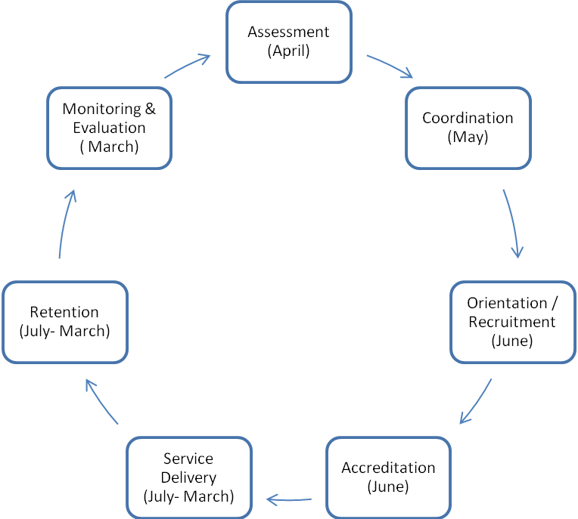

Article 6. BUDGET. The annual budgets of the Youth Councils shall be set according to these Guidelines and the activities and projects herein provided. The following activities are compulsory and must be provided budgets for:
- Phase I on Coordination
- Phase IV on Recruitment and Orientation
- Phase VI on Delivery of PNRC/RCY Services
- Phase VIII on Retention
- _______ can be a fund raising activity depending on the agreement of the school and the chapter administrator.
Article 7. RELATIONSHIP WITH RCY. These Guidelines shall form part of RCY’s policies and are subordinated thereto.

Article 8. REPEALING CLAUSE. All guidelines, policies, rules and memoranda which are inconsistent with these Guidelines are hereby repealed and declared ineffective.

Article 9. EFFECTIVITY CLAUSE. These Guidelines shall be effective immediately upon approval of the Board of Governors of the PNRC.

