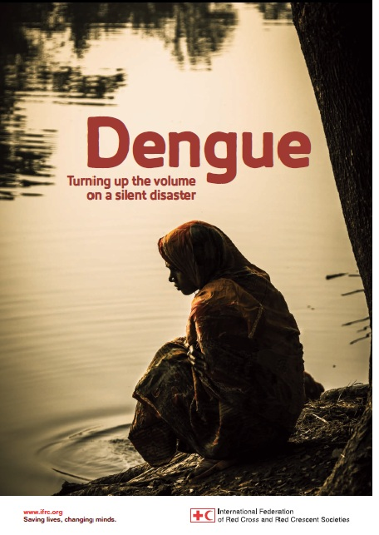
Regional Community Safety and Resilience Unit (CSRU)

Overview of activities for the month of March 2014

Dengue: “Turning up the volume on a silent disaster”

The IFRC’s global health team developed an advocacy report on dengue titled: ‘Dengue: Turning up the volume on a silent disaster’. The report has officially been launched in Geneva on Friday, 4 April, 2014, ahead of World Health Day (7 April 2014).

This year’s World Health Day is centered on the theme of vector-borne diseases. The SEARD Community Safety and Resilience unit (CSRU), along with the Communication team contributed to the report sharing experiences from the region. Philippines RC, Timor Leste RC and Viet Nam RC from SEA have been highlighted in the report.

SEARD is coordinating with the Asia Pacific zone health team to launch the report on ASEAN Dengue Day in June in Manila.

Early Warning Early Action

The IFRC SEARD organized a Regional Lessons Learned Workshop on Early Warning Early Action from 26-27 March, 2014. The main purpose of the workshop was to bring together participants with hands-on experience in implementation of community based risk reduction activities and community based early warning initiatives on the ground in Indonesia, Myanmar, the Philippines, Thailand and Viet Nam and review and identify the best practices and lessons learned and identify best way forward.

The workshop was attended by 14 participants from five national societies and Thai governmental agencies: Department for Disaster Prevention and Mitigation and Thai Metrological Department and National Warning Centre. In addition, one representative from the Academic Institute (AIT) also took part in the workshop.

Under the guidance of the Thai National Warning Centre a desk top simulation exercise was organized enabling participants to identify common challenges prepare their own response preparedness plan and eventually check its efficiency with implementation of the plan after a warning message had been received.

Following the exercise, psychological support and preparedness were highlighted to strengthen the importance of timely response and accurate information dissemination to community people. The final evaluation from the participants suggested that in the future EWEA should systematically involve other sectors such as Health, Livelihoods, and psychological service support. The participants also appreciated the importance of partnership with other organizations/stakeholders in EWEA field.

Peer-to-Peer - Exchange Visit

An exchange visit was organized from 9-14 March, 2014 for 16 people from Thailand to Viet Nam.

The purpose of the exchange visit was to expose TRC programme staff, both NHQ and Branch level, to new experiences, learn more about VNRC programmes, specifically the implementation process, relevant guidelines

applied in CBDRR, trainings and teaching materials. Participants were volunteers and staff members of Thai Red Cross and along with representative of community members from CBDRR project sites.

Participants visited VNRC headquarters to understand the overall programme of VNRC and travelled to two provinces (Nghe an and Quang Nam) of Viet Nam where VNRC has been implementing their CBDRR programme and mangrove plantation project. The following two points have been agreed among the participants to take as way forward after the exchange visit:

- Upon return to Thailand, TRC participants committed themselves to conduct debriefing sessions with other TRC colleagues at community and health station levels to share their experiences
- Staff members of TRC who were part of exchange visit were impressed with VNRC DRR school program and mangrove plantation project and will propose to their own senior management willingness to replicate the same.

Human Rights, Climate Change, Environmental Degradation and Migration
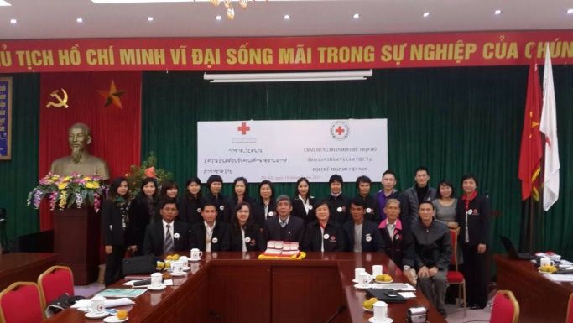
On 20th March 2014, International Organization for Migration (IOM) organized an event to facilitate discussion covering critical issues of Human Rights, Climate Change and Environmental Degradation. The launch of the Issue in Brief was also done at the same time. SEARD was represented by CSRU Heath Officer.
The event highlighted the findings of the paper written by IOM (available for download: Human Rights, Climate Change, Environmental Degradation and Migration: A New Paradigm) which focuses on the implications of climate change on forced migration.
Challenges caused due to lack of a clear framework creating problems for states seeking to address forced migration due to climate change. Countries do not have clear guidelines regarding their responsibilities towards vulnerable populations.
The brief itself offers succinct insights on migration issues affecting the Asia-Pacific region today, exploring options how to protect climate change-induced migrants.
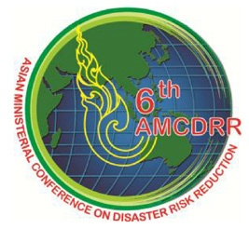
6th Asian Ministerial Conference on Disaster Risk Reduction (AMCDRR) – Preparation

The preparation for the conference has taken full swing considering there are less than 3 months left before the event takes place from 22-26 June 2014, in Bangkok.

After the peer review the Final Report on Key Area 1 “Building community resilience – turning vulnerability into resilience”, for which the IFRC is the coordinator, is expected to be submitted at latest by first week of April.

Instantaneously the preparation of the background document for the Technical Session 1 “Enhancing Resilience at Local Levels” reflecting progress in the Asia Pacific region on enhancing resilience at the local level has commenced. Deadline for submission is 15th April 2014. Key recommendations of the report will be presented during the IAP meeting planned for 22-24 April in Bangkok.

In addition to the background documents the IFRC and ADRRN also designed draft outline of the technical session itself. The technical session itself should come up with the list of outcomes and recommendations to be addressed by the Ministers at the High-Level Round during the plenary session at the conference.

Regular communication and information exchange meetings continue to be held between IFRC, UN ISDR, ADRRN and other key stakeholders involved in the planning of the conference addressing several aspects of the conference.

With regards to the Special Session on School Safety few teleconferences were held with the Asian Coalition on School Safety members regarding the preparation of both: School Safety (led by Save the Children) and Youth Forum (led by World Vision) special sessions for which RCRC would like to ensure participation and contribution. IFRC is coordinating involvement for both sessions focusing on Nepal RC youth (through AmCross) and Thai RC youth (through SEARD youth focal point).
In addition, opportunities are being explored for possible RCRC engagement in Side Events, in particular regarding the Disaster Law in Emergencies and possible Global Disaster Preparedness Centre – innovative technologies and DRR.

SEARD CSRU and other colleagues will continue to support Asia Pacific DMU in coordination of events among RCRC and external stakeholders leading towards conference.

It is important to note that participant have to make their own individual registration and the deadline for:

- Registration of participants is 30th April 2014 (ONLINE).

For further information please visit: http://203.124.98.37/6thamcdrr/

School Safety / School Based Disaster Risk Reduction Initiative in Southeast Asia

After the approval of funding from the Hong Kong Red Cross, the CSRU has been working on development of the Terms of References for engagement of an expert to lead the process of development of the RCRC comprehensive model for engagement in School Safety/SBDRR that would include necessary tools and guidelines contributing to training and building capacities of the RCRC to implement integrated and multi-sectoral approach to school safety.

The model would aim to address issues related to multi hazards and their impacts in School Based Risk Reduction initiatives raising resilience levels among school going children, teachers, parents and communities to face known threats, act preventively, respond effectively in times of need and bounce back to after the impact of disasters.

Expected outcomes of the initiative are:

- School Based Disaster Risk Reduction Model and framework developed for Red Cross National Societies

- Built capacities of Master Trainers on School Safety in two pilot countries - Thailand and Myanmar

- Tool kits providing assistance to the Master Trainers to conduct school safety program effectively

- IEC materials developed as a non-teaching aid for School Safety

- Guidelines for Education Ministry developed for larger advocacy

- Online systems established for continuous monitoring and review of the process

The consultancy is expected to start in April 2014.

THAILAND

Post Emergency Preparedness Operation

SEARD and Thai Red Cross met two times during this reporting period to review the overall process of implementation to improve the quality ensuring compatibility with processes applied. The following activities were completed during this reporting period:

Thai Red Cross Administrative Bureau is progressing to build warehouse in order to store 8 water purification equipment’s and 42 flat-bottomed boats that they received during 2011 flood operation. Warehouse will be constructed in Angthong Province. The initial work has been completed for tendering process. TRCS also procured window film protection to prevent possible infection that would come from using the medical equipment at the medical warehouse.

IFRC/SEARD is supporting the process of procurement of necessary equipment for the warehouse to increase the effectiveness in warehouse management.

Training on “Trend of Epidemic in Thailand” was conducted from 10-12 March, 2014. The main aim of the training was to organize the introduction program on trend of epidemic in Thailand. Total 45 participants attended the training (Medical Service Division, TRC Health Stations, Relief Division, Warehousing Division, TRC Optometrist and Eye Glass Center, First Aid Center and TRC Nursing Center).

In order to strengthen engagement of youth and build their skills further, from 9-11 March, 2014, a three day training was organized to establish youth Public Relations (PR) Network that can provide information to TRC and general public about disasters, inform them how to request for relief assistance by using different communication channels i.e. Telephone, social media etc. Total 41 students (from high school, university) and TRC youth members along with 13 teachers from 13 North Eastern provinces of Thailand took part in the training.

Following this training, PR volunteer project was initiated targeting volunteers living at the disaster prone areas, teaching them how to use communication tools. The volunteers are also seen as possible liaison between TRC, local authority and people who need help. Total 27 participants from Provincial Red Cross Chapters from North Eastern Thailand provinces: Nong Bua Lamphu, Roi Ed, Loei, Sakol Nakorn, Udorn Thani, Mahasarakam, Chaiyaphoom, Khon Khen, Umnatcharoen, Ubon Ratchathani, Srisaket, Surin, Buriram, Nakorn Phanom and Mukdaharn attended the workshop.

The Managerial Grid – Result Oriented Practical Workshop for Executives

Leaders of organizations must have both managerial and people skills to drive effective organizations and lead people to achieve their organization mission. The Managerial Grid – Result Oriented Practical workshop is designed to develop leaders with the effective leadership skills. TRCS organized four days’ workshop from the support of external consultants in two phases (6 March, 19-21 March). The overall objectives of the workshop are given below:
- To learn managerial grid model which is a behavioral leadership model developed by Robert R. Blake and Jane Mouton. The model is based on two behavioral dimensions: concern for people and concern for production. The model analyzes main and sub behaviors of Executives. Each individual will receive openness and feedback from peers and learn about different working styles from others. The team will be able to synergize better by knowing others’ working styles.
- Practice the effective teamwork skills from setting team objectives, direction, communication, decision making, critique culture; achieve synergy within the organization.
- To understand the important of participative work, the team can have common mission according to the principal of “commitment” (Participant + Involvement = Commitment or P+I = C).
- To learn and understand Change by Design principal systematically which was developed by Grid theory. It starts from the development of Executives to become leaders (self-development) to develop team (team development) and reach organizational level (organization development).
- Assess the actual organization culture in comparison with the right culture (sound) to find out the real causes that lead to organizational development.
- As a team, participants will work together to find problems and challenges that keep the organization from becoming effective and stimulate the synergy of the team to solve all those obstacles.

Total 30 senior managers (Deputy Directors, Assistant Deputy Directors, Directors, Chief of Nurses/Assistant Head Nurse and Division Head represented) attended the workshop from all Bureau of TRCS.

Tsunami Residual Funding Programme

Two days training on Website Emergency Operation Center (EOC) was conducted from 10-11 March, 2014 for Officers of Provincial Red Cross Chapters of the Thai Red cross and Provincial Disaster Prevention and Mitigation Office of 6 Tsunami Affected Provinces. Total 31 participants from Ranong, Phang Nga, Phuket, Krabi, Trang and Satun Province took part in the training.

EOC website was originally initiated by National Disaster Warning Center 3 years ago but hasn’t been officially launched or shared with its partner organizations. Its main objective is rather to help systemize communication and coordination among relevant agencies during emergency and disaster situations. TRCS, as one of the partners that would collaborate in making use of website EOC then, tries to implement and apply website EOC to its Integrated Mock Exercise activity to make its staffs and partners feel familiar with the website and to improve the website’s features.

National Disaster Response Team (NDRT)

Five days training on NDRT was organized from 17-21 March to strengthen Thai Red Cross response capacity. The training aimed to develop the skills and knowledge of TRC staff to make effective relief operation. Health and PSS components were incorporated into Training agenda. Total 28 participants attended the training coming from both, national headquarters and provincial branches. A follow up meeting on the training will be held in early April as the CSRU will also support the next NDRT training in June. The training was organized under the Post Emergency/Preparedness Operation.

LAOS

Voluntary and Non-Remunerated Blood Donation (VNRBD)

The Swiss Humanitarian Fund will provide financial support for another year for voluntary and non-remunerated blood donation (VNRBD) promotion, especially through youth clubs. Lao Red Cross has managed to secure funding under this call. The funding will be used to conduct a national YDC (Youth Donor Club) ToT (Training of Trainer) workshop aiming to train key provincial blood center staff on YDC so that they can implement the programme in their respective provinces.

MALAYSIA

Psychosocial support (PSS)

PSS delegate from CSRU travelled to Malaysia (March 6-13, 2014) to meet with Malaysia Red Crescent (MRC) in Kuala Lumpur and facilitate an introduction course to Psychosocial Support (PSS) for MRC Penang Branch. MRC is currently piloting a volunteer-based home care programme in collaboration with the Ministry of Women, Family and Community Development and implementing NGOs.

The aim of the Home Help Services programme is to enable older people who have lost the ability to fully care for them to continue living as long as possible in their own home and community, whether independently or with their families. The aim of the two day course was to give the 23 participants from Penang Branch a basic introduction to the field of psychosocial support with a particular focus on psychological first aid and supportive communication for the elderly.

The next step will be to support training on the module for core MRC staff that will be responsible for implementation of the programme.

INDONESIA

Pilot City Study on Urban Risk Reduction

Project agreement between PMI and SEARD is in its final stage and once approved the implementation of the Pilot City Study on Urban Disaster Risk Reduction, as a part of global initiative, will commence.

The objective of this initiative is to strengthen urban communities’ resilience to potential risks posed by disasters and climate change through capacity building in PMI as well as in the targeted communities. Following are the expected outcomes:
- The Capacity of PMI to build community resilience in urban context are strengthened
- The Capacity of community to prepare and reduce risks in urban areas is strengthened
- The Coordination and collaboration amongst PMI, Local Government and other related stakeholders are strengthened.

The operation plan has been approved for this project has been approved.

Mentawai Megathrust Disaster Relief Exercise (MM- DIREX) - Indonesia

Mentawai Megathrust Disaster Relief Exercise (MM- DIREX) was initiated by the President of the Republic of Indonesia during the East Asia Summit (EAS) held in Bali, 19 November 2011. It was stated Indonesian National Authority Disaster Management (BNPB) to take lead in coordinating and organizing a joint civil-military exercise involving EAS participating countries, namely 10 ASEAN countries, with China, Japan, Republic of Korea, India, New Zealand, Australia, United States, and Russia as a means of building and maintaining cooperation in disaster emergency response.

NDMA (BNPB) organized Mentawai DiREx with military civilian context with the aim of improving preparedness and raise gradually, especially in the priority areas from 17-23 March in Padang and Mentawai, West Sumatera, Indonesia. Tsunami was the scenario of the Drills. The main theme of Mentawai DiREx was to strengthening collaboration and partnership in disaster response to build a resilient region. The objective of the Direx was strengthening the capacity of preparedness through information and experience sharing, enhances international cooperation to overcome bottlenecking and to strengthen the interoperability among stakeholders to enhance regional disaster resilience.

PMI was directly involved as senior controller on CPX and After Action Review (AAR) team. In addition, Health, Wash, First Aid and Evacuation were the main responsibility of PMI for FTX to support BNPB efforts in the exercise. PMI involved in few side events like First Aid Service and stand by Blood donor bus. Total 110 volunteers and staff members – both from local branch as well as HQ - took part of in this exercise. IFRC country and SEARD were also part of the exercise.

Knowledge Information Management (KIM)

Online library (https://sites.google.com/site/drrtoolsinsoutheastasia/health-and-care/health-bulletins.) continues to be regularly updated to promote the knowledge sharing within and beyond the Movement. Number of uploaded documents related of DRR and Health is growing from day to day and it is only valuable if used by targeted audience.
The site has been integrated into IFRC standard web-link as well.

Upcoming Events for April 2014

Date | Events | Venue
1-3 April, 2014 | 11th Meeting of the Regional Consultative Committee on Disaster Management | Myanmar
13 -16 April, 2014 | Master Trainer workshop on “Healthy lifestyle | Kuala Lumpur
17-18 April, 2014 | AP Zone Health and WatSan meeting | Kuala Lumpur
23-25, April, 2014 | 1st Red Cross/ Red Crescent International Nursing Conference | Bangkok
22-24 April | Final IAP Meeting before the 6th AMCDRR | Bangkok
22-24 April- 2014 | Flood Resilience project | Indonesia
26 April – 2 May | ASEAN Humanitarian Exercise (AHEX) 11 | Chacheargsao Province, Thailand.
28-29 April | Thailand Flood Disaster Conference | Bangkok

For Further information please contact:

Indira Kulenovic, Head/Coordinator-
Email: indira.kulenovic@ifrc.org

Sanjeev Kafley, DRR Advisor-
Email: sanjeev.kafley@ifrc.org

Rommanee Klaeotanong, DRR Officer- Email: rommanee.klaeotanong@ifrc.org

Abhishek Rimal, Sn. Health Officer-
Email: abhishek.rimal@ifrc.org

Zara Sejberg, PSS Delegate-
Email: zara.sejberg@ifrc.org

Hung Ha Nguyen, DP Delegate-
Email: hungha.nguyen@ifrc.org

Juthamanee Khotchasarnmanee (Fiat), Sn.Program Assistant, Tsunami Program- Email:juthamanee.khotchasarnmanee@ifrc.org

Nutchapang Khowinij (Tum), CSRU Assistant- Email: nutchapang.khowinij@ifrc.org

ADRRN-Asian Disaster Reduction and Response Network

