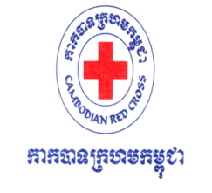

KRATIE RED CROSS BRANCH
Community Based Health and First Aid (CBHFA) Project

REPORT ON
VULNERABILITY AND CAPACITY ASSESSMENT (VCA)
FOR 24 NEW TARGET VILLAGES
KRATIE PROVINCE

- Background

In 2013, Kratie-Community Based Health and First Aid (CBHFA) project planned to extent new 24 target villages over 24 existing villages based on the two main objective of the project which 1. To improve the health status of vulnerable community especially women and children, 2. To increase the capacity of Kratie red cross branch to deliver high quality service to more vulnerable people. Because of these two objectives, the project had organized vulnerability and capacity assessment (VCA) in new target villages to figure out the real issues that always take place, the capacity of community to cope with and the need requirement from the outsider/stakeholder/NGOs.
VCA is a core task for developing the communities that can seek for and bring information from the community to project implementers to set out framework and apply in the community for coping with the vulnerability that likely occurring in the community. According to the VCA result, the project team has prepared any kind of methodologies to deal with the vulnerability and enable community to get well prepare and respond to become more resilience.

- Objective
- Seek for possible implication in all 24 target villages and classified at least 5 priorities to implement in Kratie-community based health project.
- To set up plan of action to respond to the right need of community through identify the real need, vulnerability and capacity of target community.
- Share finding with stakeholder/partner and local authority to be a basic information.

- Date
- May 28th 2013 to June 05th 2013

- Facilitators

There were 39 people attending in VCA process which included project team at NHQ (3), branch project staff and branch staff (6), project RCVs (8), CBDRR RCVs (5) and RCYs (17). Those people were divided into 4 big groups (9 people / group) and each big group also divided into 3 small groups 1. Female group (3 people in charge in the beginning village), 2.Mapping group (3 people in charge in the middle village) 3.Male group (3 people in charge in the end village) and the Observation group (3 people in charge in general observation of all groups). Each small group interviewed from 20 to 25 people.

A. Role of each small group
1. Interviewer (1)
2. Recorder (1)
3. Village observer (1)
Furthermore, orientation, preparation and practice were brought up and applied in one day advance for each group before the assessment start ( May 28th 2013).
B. VCA group member and schedule

Target village and Date | May 29,2013 | Pa ear village | 105 village | Svay Chrom village | Krosang village
Target village and Date | May 30,2013 | Mean Chey village | Knach village | Chronoal village | Thnot village
Target village and Date | May 31,2013 | Veal Sombo village | Thmey village | Prek Chik village | Beoung Chreng village
Target village and Date | June 1, 2013 | Sob Leu village | Sob Krom village | Chroy Bonteay village | La eat village
Target village and Date | June 2, 2013 | Ksach Tob village | Rokar Thom village | Keng village | Kompong Dor village
Target village and Date | June 3, 2013 | Por village | La vear Tong Village | Prek Kov village | Phrea Konlong village
Female Group  (Beginning village ) |  | 1.Mr. Veng Thearom  2.Mr. Lak Logn  3.Mr. Sang Bona | 1.Mr. Ya Sophat  2.Mr. Yik Chantha  3.Mr. Treang Hong | 1.Mr. Plan Molin  2.Ms. Norng Dany  3. Mr. Hou Phira | 1.Mr. Hang Chansana  2.Ms. En Somlika  3.Ms. Bo Daneth
Mapping Group  (Middle Village) |  | 1.Mr. Trou Hol  2.Mr. Em Tola  3.Mr. Leng Hoy | 1.Mr.Ngon Leang  2.Mr.Hean Sokheng  3.Mr. Ouch Savuth | 1.Mr. Moung Som onn  2.Mr.Kheang Sokchea  3.Mr.Kean Sokun | 1.Mr. You Yong  2.Mr. Ngoun Veasna  3.Mr. Chhea Sithea
Male Group  (End Village) |  | 1.Mr. So Sakan  2.Mr. Ken Chen  3.Mr. Chea Rong reoung | 1.Mr. Moun Virak  2.Mr. Ty Kimleang  3.Mr. Loun Chanthy | 1.Mr. Mil Manith  2.Ms. Phom Joudy  3.Ms. Bo Kanha | 1.Mr. Min Song  2.Mr.Veoun Vai  3.Ms. Kim Sothy
General Observation Group |  | - Mr. Thong Virada  - Mr. Mom Cheng Ngoun  - Ms. Ouk Srey Leak

- Process and Methodology
- Secondary data
- Orientation meeting organized by project team
- Group discussion in accordance with arranged question by using mind map (small group).
- Transact walk
- Village mapping and seasonal calendar
- Daily consolidation the findings of each small group
- Finalized finding of VCA draft with RCV leaders, local authority and health center staff.
- Prepared final VCA report
- Target Population in all 24 Villages

Commune/District | Village | Population data
Commune/District | Village | Family | Total Population | Female | Male | Children (Age 1-12 years old)
Sob commune, Prek Prasob district | 1.Prek Chik | 779 | 3,080 | 1,845 | 805 | 430
Sob commune, Prek Prasob district | 2.Beoung Chreng | 302 | 1,898 | 659 | 778 | 461
Sob commune, Prek Prasob district | 3.Sob Leu | 201 | 1,641 | 593 | 603 | 445
Sob commune, Prek Prasob district | 4.Sob Krom | 333 | 2,046 | 787 | 793 | 466
Chroy banteay commune, prek prasob district | 1.Chroy Bonteay | 465 | 2,935 | 1,208 | 1,050 | 677
Chroy banteay commune, prek prasob district | 2.La eat | 210 | 1,115 | 483 | 375 | 257
Chroy banteay commune, prek prasob district | 3.Ksach Tob | 411 | 2,652 | 1,020 | 1,020 | 612
Chroy banteay commune, prek prasob district | 4.Roka Thom | 350 | 2,142 | 791 | 857 | 494
Chroy banteay commune, prek prasob district | 5.Kaeng | 371 | 1,852 | 883 | 850 | 119
Chroy banteay commune, prek prasob district | 6.Kompong Dor | 343 | 2,121 | 852 | 796 | 473
Bos leav commune, chitra borey district | 1.Prek Kov | 157 | 1,097 | 407 | 405 | 285
Bos leav commune, chitra borey district | 2.Lavea Torng | 153 | 1,070 | 370 | 360 | 340
Bos leav commune, chitra borey district | 3.Phrea Konlong Village | 90 | 617 | 235 | 240 | 142
Bos leav commune, chitra borey district | 4.Por | 208 | 1,288 | 501 | 470 | 317
Thmey Commune,  Chitra Borey District | 1.Thnot | 144 | 1,222 | 402 | 452 | 368
Thmey Commune,  Chitra Borey District | 2.Veal Sombou | 183 | 1,374 | 467 | 438 | 469
Thmey Commune,  Chitra Borey District | 3.Krosang | 121 | 1,190 | 619 | 310 | 261
Thmey Commune,  Chitra Borey District | 4.Mean Chey | 122 | 936 | 333 | 314 | 289
Thmey Commune,  Chitra Borey District | 5.Treap (105) | 404 | 3,350 | 1,095 | 1,134 | 1,121
Thmey Commune,  Chitra Borey District | 6.Svay Chrom | 94 | 590 | 237 | 234 | 119
Thmey Commune,  Chitra Borey District | 7.Knach | 380 | 2,651 | 942 | 877 | 832
Thmey Commune,  Chitra Borey District | 8.Chronaol | 205 | 1,513 | 510 | 538 | 465
Thmey Commune,  Chitra Borey District | 9.Thmey | 246 | 1,859 | 619 | 643 | 597
Thmey Commune,  Chitra Borey District | 10.Pa Ear | 227 | 1,717 | 585 | 612 | 520
Total | 24 Villages | 6,499 | 41,956 | 16,443 | 14,954 | 10,559

- VCA Finding and Prioritized issues

Result from observation, discussion, mapping and seasonal calendar
- Group Observation Result
- Sanitation and Environment: Out of 24 villages, there are 10 villages adjacent to Mekong river, 4 villages adjacent to canal and the other 10 villages located at the mountain. These 24 villages are being faced with hygiene and sanitation problem (no latrine, muddy, animal farced, household surrounding by forest) that remain the critical challenges for these new villages.
- Water utilizing: river, lake and canal were the main water sources for community in both dry and rainy season. There are 2 or 3 public wells at each village. According to the discussion with villagers, those wells couldn’t provide enough water for daily use of community and at some household did not have jars/tools for keeping the rain (about 50% household have only 1 or 2 jars/tools in each household and another 50% did not have).
- Latrine use: According to the data from village, commune and real observation, each village have used household latrine only 4% to 5% except school and pagoda. Some villagers prefer open air defecation at the nearby forest (some cover after defecate and some did not) because of no latrine and insufficient water for using.
- Health resources: There are health centers at each villages but among those 24 villages only 15 have easy road to access and locate near health center whereas another 9 villages located far and hard to access (the farest village from health center is about 35-40 Km and in rainy season the villagers could use only cart, boat or walk in order to access the health center). The difficulties mostly arise in rainy season or during flood due to community people refer patient to health center through boat & motor. In case of nobody at health center, they will continue refer the patient to the hospital.
- Safe area: There were safe areas along mountain waist and pagoda. For the villages without safe areas, the family and livestock will be evacuated to another village.
- Group Discussion Result, Mapping and Seasonal calendar
All information got from small groups’ discussion in each village (female group, male group and coalition group or mapping group) was consolidated and identified common issues as below:

N | MAJOR IMPLICATION | CASES & SOLUTIONS
1 | Tuberculosis, Cough, running nose, slightly cold, severe cold, fever | - Almost all people challenge this disease in both dry and rainy season; in particular 75% were children.  - Responding to the disease, the people use traditional medicine or buy medicine at the village store.  - In case of severe, they will refer the patient to health center or district/provincial hospital.
2 | Malaria, dengue, joint, headache, fever (chikungunwa) | - Normally happen to young and elder, and only people who live nearby health center have tested blood to identify disease and who live far Health Center did not go at all. (Ex. Fever or chill…)  - Use traditional medication or buy medicine from store nearby in the village.  - Some sleep under the nets and some not and if they stay at farm/orchard, they use fire instead of net.  - In case of deterioration, they call the nurse home or send the patient to health center.  - These disease always happen on young children (70%) rather than elder (30%)
3 | Diarrhea , diarrhea with mucus, stomach ache, typhoid | - Happen on both young and old people, particularly in rainy season and during flood season or in hot weather.  - Buy medicine or use traditional khmer medicine and in case of severe, they will refer the patient to HC.  - Base upon the small group meeting, 25 % of cases came up from lack of hygiene and 75% arise from climate change and other factors.
4 | Lack of clean water and poor household sanitation | - Normally, the villagers use water from canal, river, or lake and brought it home through bicycle, cart and motorbike whereas some who live nearby school or pagoda prefer to use wells.  - Some people use water filter in case they can afford.  - When they stay at home, some boil water and some not. But when they go to the farm they did not boil at all.  - Drink raining water during rainy season. Not enough jar for keeping water.  - In rainy season, it is hard to keep the household clean because many livestock need to keep away from water and there is no place to keep it beside household compound.
5 | Lack of household latrine in new 24 target villages | - It was only 3 % among all the family/household use latrines at those 24 target villages.  - Defecate at nearby forest, rice field,and along canal or river bank.  - For the elder sometime cover stool after defecation.  - 100% of children open air defecation.  - About 10 villages out of 24 faced with water issue in dry season, so those villagers did not interest in using household latrines.
6 | Hand Foot Mouth Disease (HFMD) | - Mostly occur in people at the age from 1 to 18 year old.  - Some infected use antibiotic and some use traditional treatment.  - Young children handle muddy and do not wash their hand/shower their body after it.  - Older people work hard and sleep without taking shower and body hygiene.
7 | Red Eye Disease | - Mostly happen on young children during hot weather, early year raining, and flood.  - It was transmitted from one to another without knowing the reason.  - Using traditional treatment  - Using medicine and refer to health center to inject.
8 | Pregnant women, antenatal care, vaccination for mother and child health | - Some pregnant women delivery at health center and majority of the rest delivery at home by using traditional midwife specially during flood season due to the accessibility to the far-distant health center and insufficient money to stay long days in the health center.  - Most of pregnant women did not use antenatal care.  - Women and children can only vaccinate during village vaccination campaign.  - The new born baby did not weigh except the one who was delivery at health center.  - Baby diet is also the same as their mother diet and it is depend on their ability to afford for the nutrition food.
9 | Medical service, health center and health education | - Provincial health department and health center had distributed nets to all families in the villages but because of a lot member in the family, some members didn’t sleep under the net.  - Some villages located nearby health centers, but some not and hard to access due to road condition because severe patients always send there by cart or hammock.  - Health center disseminated vaccination issue, malaria and delivery case only in vaccination campaign.
10 | Disaster issue (flood) and livestock disease | - Flood often take place almost every year that make difficult to villagers in farming (damage crops) and destroy road.  - The villagers save money to buy food and seed and some migrant to live/do business in other village/district.  - Evacuate livestock to safe area or nearby mountain.  - Arrange boat for evacuate emergency case/ sick and unaffordable people but they will rent or borrow if they can afford.  - During flood, livestock (cow, buffalo, pig etc) always infect scarlet fever.  - They follow one another for apply preventive measure and they get news from the radio only. Occasionally, the people see authority promote flood preventions at those target communities.
11 | NCDs (diabetes, high blood pressure, chronically lung disease , heart attack) | - Majority of people in target communities didn’t know what the root causes of these diseases were.  - They raised that normally the 70% of village people smoke cigarette and use alcohol.  - Traditional treatment has been used so far. For whom who can afford will seek medical service at provincial hospital, hospital at Phnom Penh and some at Viet Nam (severe case).  - Based on VCA finding, there were 10-15 people in each village have these diseases mostly elder (age from 40-60 year old).
12 | Other issues | - Traffic accident, gangster, domestic violence, thieves also consider as the challenges in community and the villagers just report this case to local authority to take action.  - Poison, referral to health center in case of danger  - For gangster case normally happened in a village gathering (dancing, wedding..) only

- Secondary Data
8.1 Data received from target communes
- General situation of the commune
- Bos leav is one commune of Chitra borey district distant 45 km from Kratie town to the farest village. There are 8 villages in the commune, bordering Sangkat Roka kandal to the north, Kanchor commune to the south, Mekong River to the west and Da commune to the east. 4 villages among 8 were the new target villages situated along prek te and impact by flood almost every year. There are 7 safe areas in the villages, but only one safe area (Toul ta khin safe area in Prek kov village) were used for evacuation. In term of road accessibility, medium-size vehical, motorbike, and bycicle can accessible but in rainy season only boat or ship can reachable. All mobile networks are able to access.
- Thmey is one commune of Chitra borey district situated about 35 km from kratie town to Thmey commune office and to the farest village about 84 km. There are 10 villages in the commune, bothering Chongkrong commune to the north, Svay chreas commune/snoul district to the south, Kontout commune to the west and Mondolkiri province to the east. The people in the communities are ethnic minorities (Phnong, Kouy, Tieang…). There is one big road in the commune connected from village to village where accessible by small vehicle, motorbike, bicycle etc. Except 3 villages (Krosang, Treab and Paear) couldn’t access by vehicle due to there is not yet have a big road connection that enable to travel easily (in dry season, the road is abundant with sand and in rainy season, a lot of water flow across the road & fill up with muddy).
- Sob is one commune of prek prasob district located about 21 km from kratie town to the commune office by using ferry to cross Mekong river. There are 8 villages in the commune situated along the river. The commune bother the Mekong river to the east, Prek prosob commune to the west, Thmor Reap commune to the south and Chroy banteay commune to the north. About 90 % of villagers are famers. All mobile services are able to access.
- Chroy Banteay is one commune of Prek prasob district located about 28 km from Kratie town to commune office by using ferry cross Mekong river. There are 6 villages in the commune, bother Mekong river to the east , Sob commune to the south, Prek prasob to the west and sambo district to the north.
Number of People Receiving Health Services from Kontout Health Center
N | District | Commune | Village | Family | Total Population
 |  |  |  |  | Total | Male | Female
1 | Chitra Borey | Boslev | 09 | 1,835 | 9,263 | 4,442 | 4,821
2 | Chitra Borey | Thmey | 10 | 2,126 | 16,402 | 8,072 | 8,330
3 | Prek Prasob | Sob | 08 | 2,121 | 9,788 | 4,850 | 4,938
4 | Prek Prasob | Chroy Bantey | 06 | 2,150 | 12,817 | 6,264 | 6,553
Total |  | ០៤ | 32 | 8,232 | 48,270 | 23,628 | 24,642

- Main works of community people (4 communes)
- Civil servants 9%
- Vendor/business people 6%
- Farmer and worker 85%
- Commune Resources
- 4 Health centers (Bosleav, Thmey, Sob, Chroy banteay)
- 36 wells in 24 villages ( the authority did not dig wells at the villages adjacent to river/lake due to acenich )
- 25 schools in all 4 communes (22 elementary schools and 3 secondary schools)
- 5 Pagodas and 22 Rest places
- 4 commune offices (Bos leav, Thmey, Sob, Chroy banteay)
- 3 safe areas made by local authorities in Phrea Konlong , Por and Lavea Tong villages.

8.2 Data receive from health center

8.2.1 Health data in 2012 receiving from 4 health centers (Chroy banteay, Sob, Bos leav and Thmey health center) was combined together by each disease and shown in table below. The head of health center indicated that most of community people did not utilize health services. They came only when their disease became severe.

N. | HEALTH ISSUE | Year of 2012
N. | HEALTH ISSUE | TOTAL CASE | REFERAL
1 | Diarrhea | 457 | 00
2 | Diarrhea with mucus | 639 | 03
3 | Cholera | 18 | 00
4 | Upper Respiratory infection | 1,034 | 36
5 | Lower Respiratory infection | 2,321 | 30
6 | Cough more than 14 days | 52 | 0
7 | Minor malaria | 668 | 00
8 | Severe malaria | 182 | 17
9 | Dengue suspected | 282 | 10
10 | Hypertension/ high blood pressure | 248 | 0
11 | Skin disease | 455 | 00
12 | Vaginal discharge | 224 | 08
13 | Head injuries by traffic accident | 19 | 11
14 | Injuries/wound by traffic accident beside head | 24 | 18
15 | Eye disease | 425 | 97
16 | Malnutrition (weight/age) | 92 | 00
17 | Other health issues | 6,050 | 110

    - Antenatal care/checkup, delivery and post delivery
Antenatal care/check up and search for danger sign of pregnant women (Yearly)

Health Center | 1st Check up | 2nd Check up | 3rd Check up | 4th Check up | 5th Check up | Total Check up  1+2+3+4+5.. | Referral women | 1st Check up
Thmey | 168 | 99 | 69 | 35 | 25 | 396 | 14 | 8
Bos Leav | 244 | 218 | 182 | 158 | 137 | 939 | 23 | 2
Sob | 316 | 260 | 211 | 147 | 237 | 1,171 | 60 | 12
Chroy bonteay | 243 | 145 | 102 | 49 | 09 | 548 | 20 | 00
- Delivery (yearly)
Center | Place | Total Children | Normal delivery | Bleeding | Refer to different places
Total 4 health centers | At health center | 361 | 361 | 01 | 13
Total 4 health centers | ​​At home: Health center staff  : Traditional Birth Attendant | 05 | 05 | 00 | 00
Total 4 health centers |  | 466 | 466 | 00 | 06
Total |  | 832 | 832 | 01 | 19
- Post-Antenatal Care (Yearly)
Health Center | 1st Check up | 2nd Check up | 3rd Check up | 4th Check up | 5th Check up | Total Check up  1+2+3+4+5.. | Referral women
Thmey | 47 | 70 | 66 | 44 | 00 | 224 | 0
Bos Leav | 40 | 40 | 11 | 41 | 00 | 132 | 00
Sob | 168 | 176 | 71 | 13 | 00 | 428 | 00
Chhroy Bontey | 98 | 56 | 10 | 00 | 00 | 164 | 00

- Finding & Major Identified Priority
​
The project team had compiled mapping for each village by defining significant resources in the community and its hazards that always occur on the map together with seasonal calendar following the highlights/brought up from the attended villagers. (below the sample of village mapping and seasonal calendar).
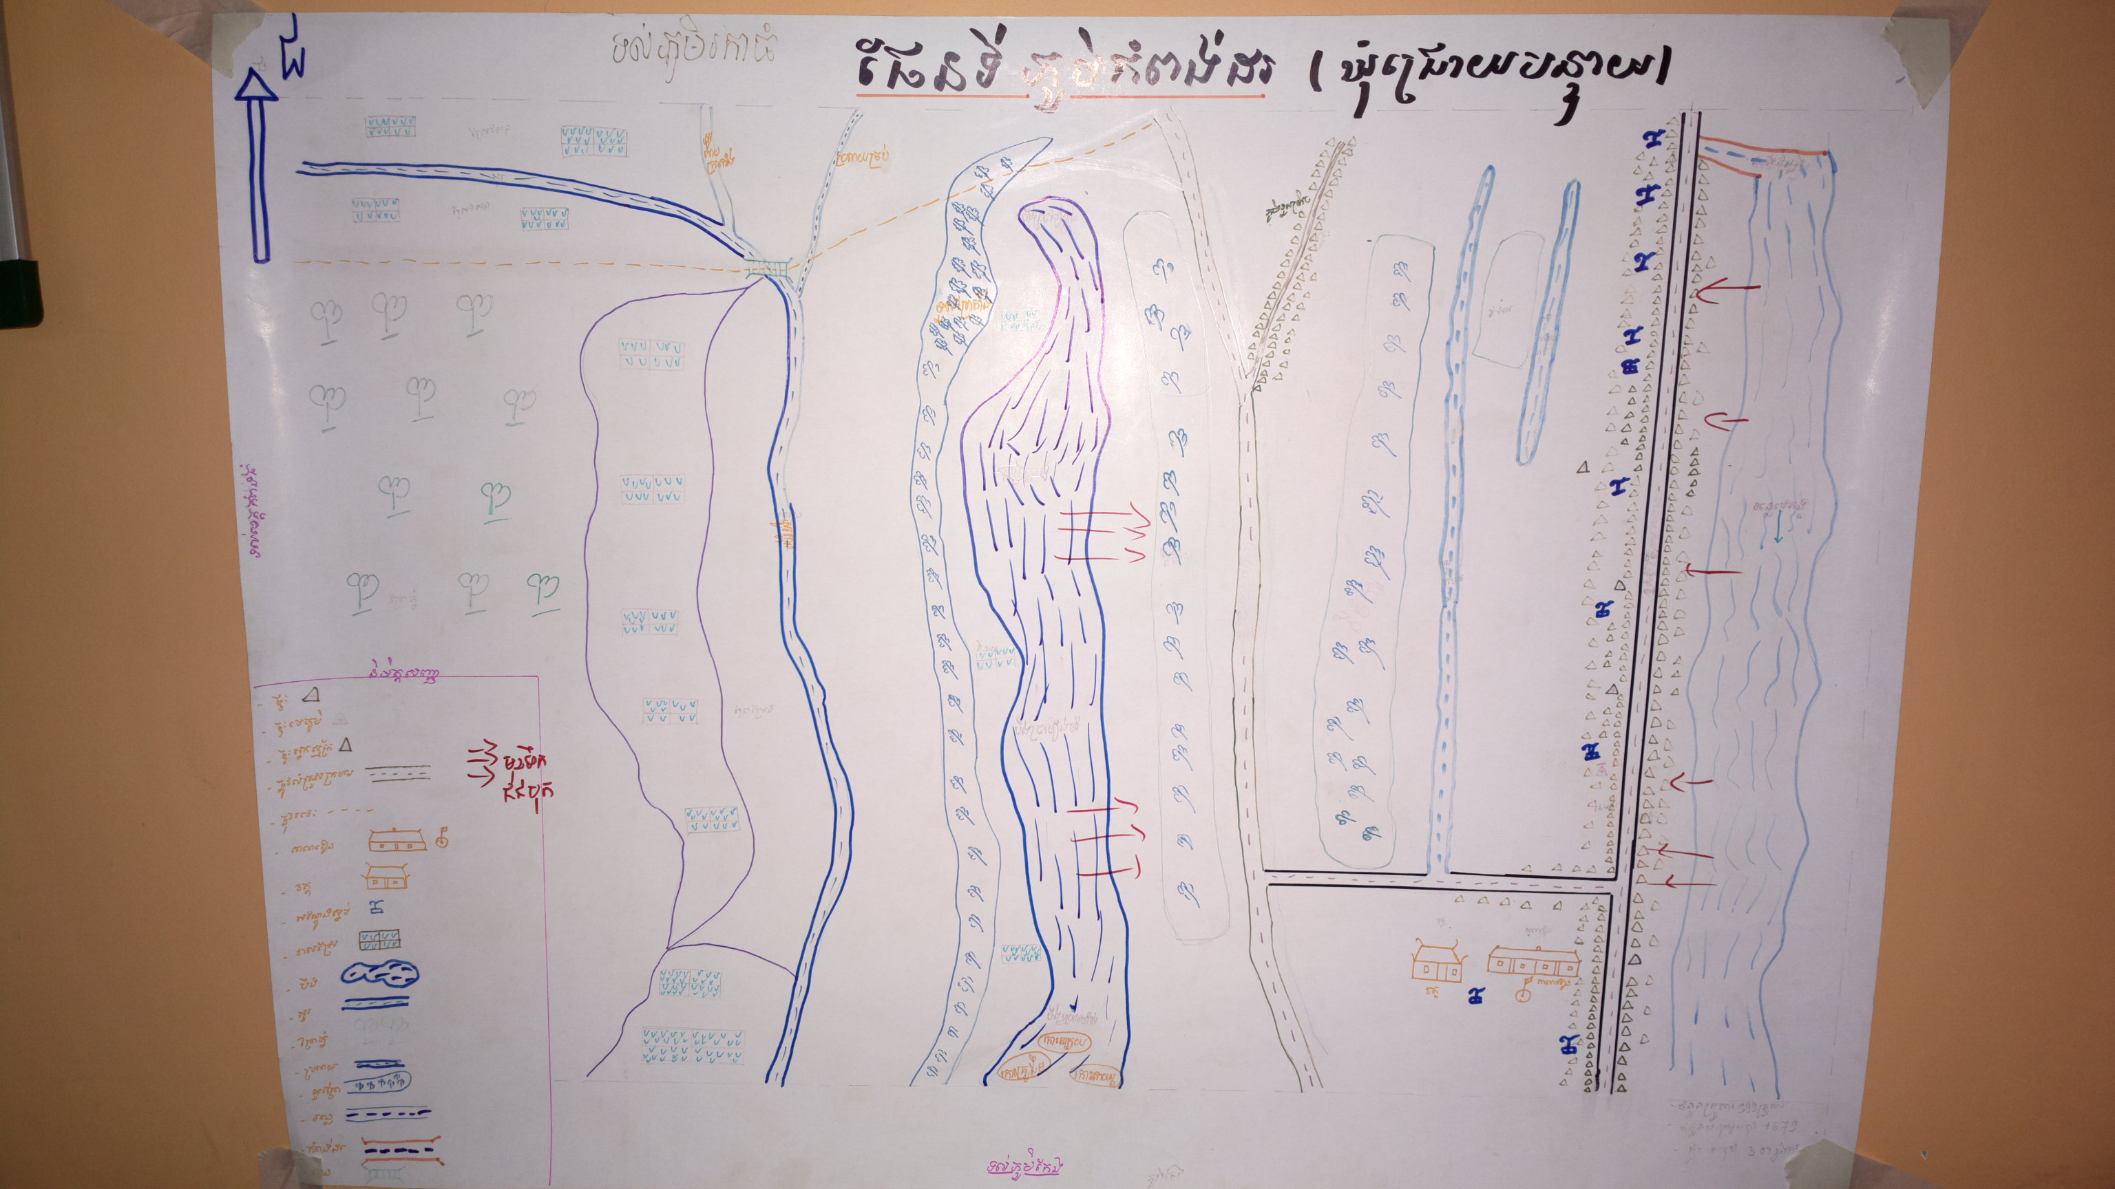
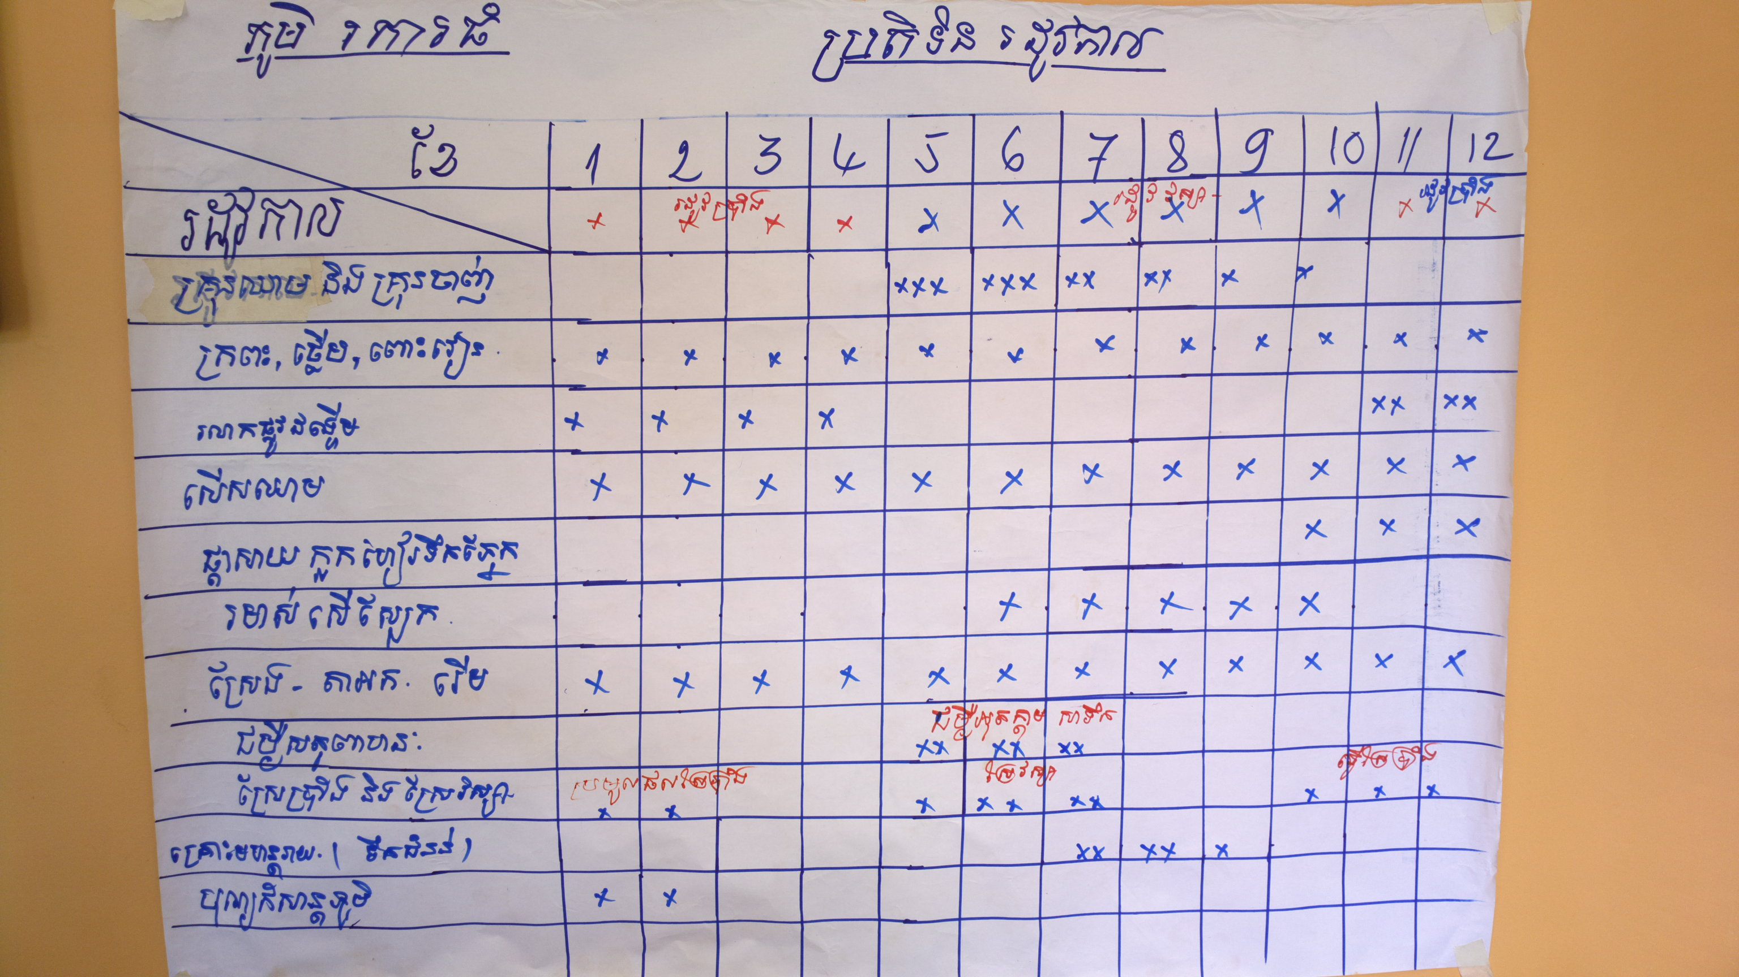

According to the receiving data from 4 health centers, data from target communes, and finding from VCA, the project team had brought up these priority issues to finalize with representatives from health center, local authorities, RCVs and villagers and they also agreed with those raised 5 health priority 1.Acute Respiratory Infection (ARI), 2.Water-Sanitation, 3.Malaria-Dengue, 4.Mother and child Health (MNCH), 5. Diarrhea including another two priorities 1.Disaster (flood) and 2.NCDs (hypertension, diabetes..) and to make the communities aware these kinds of disease while implementing the project.

Based on the attendant list and record from the 3 small groups (male group, mapping group, and female group) the representatives from 24 target villages attending in VCA activity were 1296 individuals and they were the people who identified the found five main priorities through the following graph:
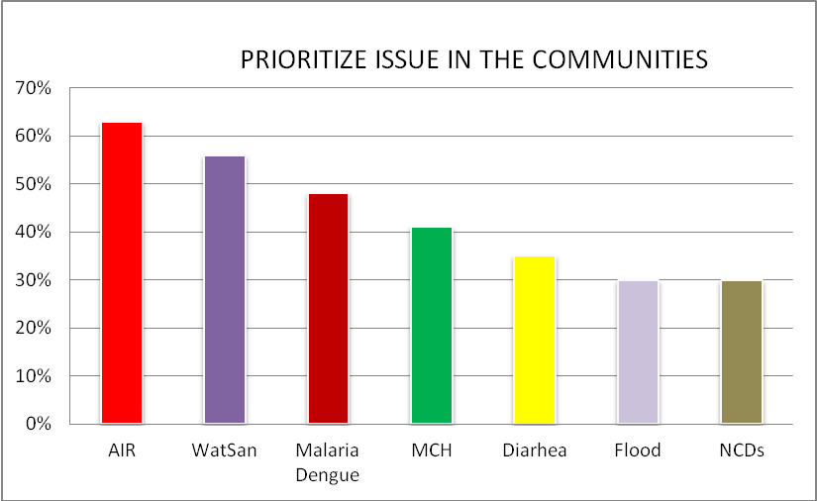

- Acute Respiratory Infection (ARI): Climate change, health carelessness and limited knowledge were the main challenges for community people to get ARI and transmit from one to another, mostly in young children. However the villagers thought that it was just only ordinary disease in case it become severe, they seek for medical service where available in their community.
- Water and Sanitation: Most people have used canal/lake, drink un-boiled water, open air defecation, no latrine, household full of muddy, animal feces, forest, chemical utilization and especially a lot of people living with unhygienic that cause to many skin diseases such as eye disease, typhoid, diarrhea etc. These because of unhealthy livelihood and limited knowledge of community people.
- Malaria & Dengue: Though there was an instruction and distribution of net to all family, the people did not pay much caution in preventing themselves from diseases and understanding the disease danger signs because many of them did not change their way in living, household surrounding by forest, grass, muddy and some seek for traditional medication rather than timely accessing to the health center.
- Mother and Child health: According to the health center data, limited amount of women delivered at health center, regularly using antenatal care service and vaccination. Many challenged factors such as habit of community people; far-distant road (difficult in traveling), livelihood, delivery at home and limited health knowledge were considered as the main priority to the health center.

- Diarrhea & Diarrhea with mucus: Based on community responding during VCA, this disease mostly happens in summer and during flood. Dirty food (unwell cook, no hand washing) drink unclean water and no hand washing are the factors leading to the spread of diseases.

- Conclusion

According to the result from observation group, interview group, mapping group, health center data (4) and another 4 commune data, the project team has identified 5 priority issues that often take place in the target community during normal and flood period. During ordinary period the people did not have broad knowledge in term of health, so they live in unhealthy ways. Refer to disaster preparedness and respond, the community knowledge is also limitable, however they can prepare themself to flood responding such as evacuate to safe area, prepare food, seed etc. The main issues that normally happened during and after flood were health issues (diarrhea, skin disease, eye disease, malaria, dengue, sanitation ,hygiene and so on) that occur when they live without focus on clean eating & drinking, body hygiene, particularly health related-knowledge in term of prevention. The priority findings were identified by the Kratie community based health and first aid project at target community and also brought the whole community to take it into account and pay more attention in their daily living so as to mitigate and get rid of the issues as well as to make a healthy community in the future.

Prepared by,

Ms.Dim Vantha,
Project Officer
CBHFA Project,
Health department,
Cambodian Red Cross



