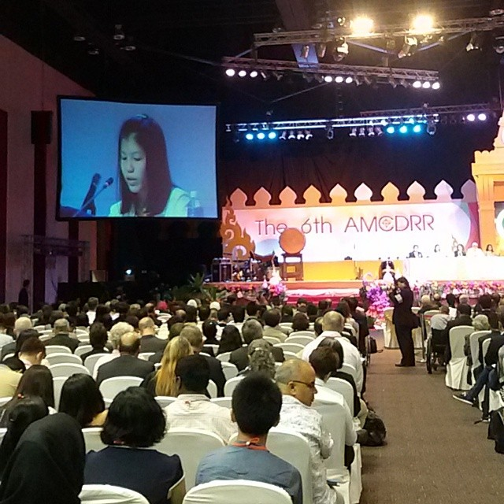
Engagement of RC Youth and Volunteers in the 6th Asian Ministerial Conference on Disaster Risk Reduction (6th AMCDRR)

The Thai Red Cross Youth Volunteer reading out Children and Youth Statement on behalf of Stakeholders’ Group in the Final Plenary session during the 6th AMCDRR

22 - 26 June
Bangkok Thailand
1. Background

The 6th Asian Ministerial Conference on Disaster Risk Reduction was held in Bangkok from 22 to 26 June 2014 with attendance of over 4,000 participants.
The Asian Ministerial Conference on Disaster Risk Reduction (AMCDRR) is a biennial conference in the Asia region to ensure political and stakeholder’s commitment towards Disaster Risk Reduction implementation. Five AMCDRR conferences have been organized by countries in Asia in collaboration with the United Nations Office for Disaster Risk Reduction (UNISDR) since 2005. Previous hosts were Beijing, People’s Republic of China (2005); New Delhi, Republic of India (2007); Kuala Lumpur, Malaysia (2008); Incheon, Republic of Korea (2010); and Yogyakarta, Republic of Indonesia (2012).
This was also the final regional inter-governmental forum in Asia before the completion of the Hyogo Framework for Action 2005-15 in March 2015 and the 3rd World Conference on Disaster Risk Reduction (WCDRR). This AMCDRR provided a unique opportunity for Asian DRR practitioners, government representatives and other key stakeholders including Children, Youth and child-centred organizations Stakeholder Group to shape the HFA2, the successor arrangement of the HFA1.
Child-centered agencies have worked together to raise the profile of children and youth as agents for change in risk reduction and resilience building since 2007 when the first engagement in Global Platform for Disaster Risk Reduction was made.
In Asia (SEA region), the IFRC has been actively involved in this group, as one of key stakeholders, and started in 2012. Since this, IFRC has been facilitating levels of discussions among group members to draw out joint statement for Youth and Children and to conclude voluntary statement for organizations to submit to the Conference for HFA2.As a result, this 6th AMCDRR Children and Youth sessions including a Children and Youth Forum, Special Session on School Safety and Side events for school safety as well as the final presentation in the plenary sessions were all carried by engaging RC Youth and by RCY volunteers.
Red Cross Red Crescent Movement was well represented in the Conference and successfully contributing to the RC Youth and Children Engagement in DRR during the different sessions. and events.
2. Children and Youth Participation

2.1 PREPARATION

The Children and Youth Session was a special and major event in the 6th AMCDRR. The Group (IFRC, UNICEF, UNESCO, Plan international, SAVE the Children, World Vision International) jointly facilitated the engagement of children and youth after several months of discussions and consultation among group members and individual with specific roles and responsibilities.

Engagement process

- As a result of an internal discussion the IFRC SEARD decided to approach the Thai Red Cross youth and encourage their active engagement in both special sessions. The American Red Cross offered to facilitate participation of Nepal RCY for the side event on school safety.

- Back in March 2014, Regional CSR Unit coordinator and Youth focal point held a meeting with TRC Youth Bureau briefing them about the 6TH Asia Ministerial Conference for Disaster Risk Reduction (AMCDRR). Recommendations were made to the TRC Youth Bureau to join in for better positioning of RC youth in Thailand. The TRC appreciated the information and expressed genuine interest in participating IFRC SEARD supported in following up their internal protocol to get an approval from their NS senior management. .

- TRC was actively engaged with SEARD support in the preparation of the Children and Youth Forum, promoting better the positioning of RC youth in Thailand and increase their visibility.

Preparation stage

- TRC selected two specific Youth delegates/speakers to participate in the conference. In the end, one of those two youth delegate was selected as the final speaker from the Thai RC to make a presentation in the special session as well as in the final conference plenary representing all the RC youths from the Asia and the Pacific.

- To ensure her effective participation and delivery, Youth focal point worked very closely with the Youth Bureau of Thai Red Cross and the team of the SEARD. A strong support from all the Units, in particular, two Coordinators (NSDU and CSRU) was made available.

- Two rehearsal meetings prior to attendance of the youth from the Thai Red Cross were held and these meetings were participated in by different Units of SEARD office and TRC Youth Bureau. Feedback was provided to the youth of the Thai Red Cross on her presentation and also a suggestion was provided by all to ensure her effective participation/representation.

- Due to a cancellation of children and youth attendance from other countries and organizations due to security concerns, TRC youth was more mobilized for this conference through the support of the IFRC SEARD.

- In addition, the SEARD Youth focal point also provided support to Nepal Red Cross Youths for their preparation and participation in the School Safety Side Event. SEARD Youth focal point suggested holding a joint event with TRC and NRC youth, developing a script for their preparation and coaching their speech step by step. Meanwhile, the IFRC managed to reserve one panelist slot for RC representation in the event through discussion with the leading agency, Plan international along with two resource panelists from different government level. Nepal RC DM coordinator finally became resource panelist.

- SEARD Youth focal point also coordinated with other stakeholders such as UNICEF, UNESCO, Plan International, World Vision and Save the Children for drafting a consolidated voluntary statement for the children and Youth stakeholders’ group - representing all children and youth, with meaningful participation of RC youth delegates.

- Youth and Children voluntary statement of commitments was developed with the significant inputs from RC youth/IFRC. These inputs have been incorporated in the final children and youth stakeholders’ group statement for HFA2 and as such annexed to the conference declaration as an official document. As such it has been endorsed by all the Governments and stakeholders in the plenary sessions of the conference.

2.2 ACHIEVEMENTS

- A total of 15 Thai RC youth volunteers and 2 Nepal RC provided significant participation of youth volunteers in the Conference, representing not only RC youth delegates but also with prominent role given to represent all the youth and children for the Asia Pacific region on behalf of the Children and Youth Stakeholders Group.

- RC Youth representatives did exceptionally well in various sessions. They participated effectively in plenary sessions, side events for school safety, special sessions for Youth and Children and School Safety.

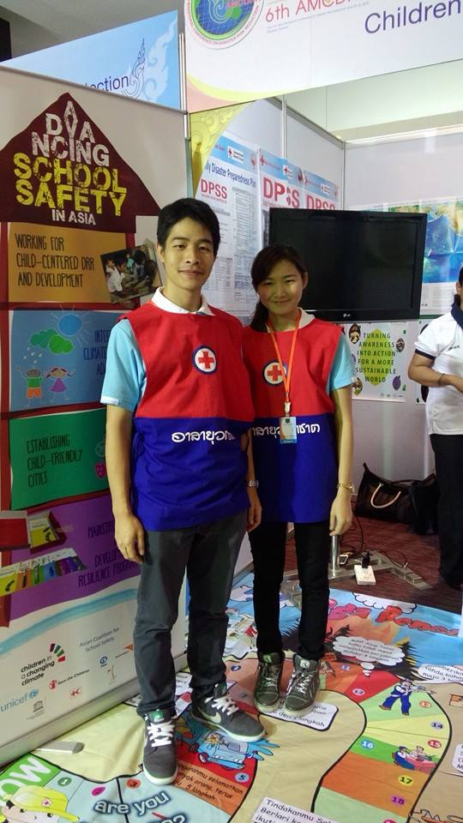
- The RC Youth Delegate from Thai Red Cross, representing all the children and youth centered organizations read out a statement prepared with the coaching of the youth focal point in the Final Plenary session. That statement was endorsed by all the governments and stakeholders in the Final summary session. For the first time ever, the IFRC SEARD had been very successful in promoting involvement of RCY with other stakeholders in this forum.

- Nepal RC Youth and Thai RC Youth delegates were invited to present in the Safe School Special Session as key speakers as requested by the lead agency (chair of the session), Save the Children - representing Red Cross Movement and AP youth and children.
Thai RCY volunteers manning the booth of the Asian Coalition for School Safety

- All Youth and Children Centered organizations and other stakeholders appreciated and acknowledged the tremendous capacity and engagement of RC Movement. Therefore, IFRC was requested to be a key leading partner for youth and children sessions to bring all statements and recommendations to Sendai, Japan for the 3rd World Conference on DRR in 2015 and even invitation was extended for participation of a Youth Delegate in the Pre-conference to be held in GVA in July.

- There was also a good display of resources in the booth in the market place for the youth and children centered organizations. TRC, Nepal RC and SEARD IEC materials were fully displayed. More importantly, there was a strong visibility of RCRC throughout the conference.

2.3 Key messages and voices of Youth and Children for the conference

- Since April, more than 1,000 children across the region have met in their towns and capitals to discuss the threat that disasters pose to their lives, communities and futures. Young representatives including RC Youths called on governments and stakeholders to recognize that they are not just victims of disasters, but also key to building a resilient and sustainable future.

- Children and youth from Asian counties have spoken powerfully to representatives of their governments asking that children and young people’s rights are included in international conferences and future intergovernmental agreements on disaster risk reduction, particularly the Post 2015 Framework for DRR, commonly referred to as the Hyogo Framework for Action 2, to be finalized next March in Japan.

“I was 13 years old when the horrible floods hit my country in 2011. Then I decided to become a Thai Red Cross volunteer to help victims from floods in my community and I realized youth power counts. I appeal to all youths to prepare themselves for any types of disasters and to all governments and DRR organizations to engage us in any relief, recovery operations and any DRR interventions“ said by Ms. Sasinat Chindapol, Leader of Thai Red Cross Youth. (Provided by Thai Red Cross)

In Japan, a 14 year old girl from Iwate Prefecture said, “If Prime Minister, I would create opportunities for children to express their opinions. Even in response to the earthquake, everyone’s hearts are wounded differently, so we need to share our experiences to ease our minds and to discuss better ideas for reducing disaster risk”. (Provided by the Save the Children)

“During flooding in Cambodia, people die. If children and youth participate regularly in local government’s planning, then we can make everyone understand better the risks that we face and how to protect ourselves ”, said Davith Mok and Srey Mom, youth leaders from Battambang and Prey Veng, Cambodia.(Provided by Plan international)

Tran Cong Danh, 11 years old from Vietnam, implored governments to reach the most vulnerable at times of disaster, "Please train children with disabilities on disaster risk reduction, especially with children with hearing impairment because they cannot receive information of flood and storm. So they can evacuate before non-disabled people. For deaf children, you can invite their family members for the training as well so they can help the children to understand the information. " (Provided by Disability Inclusive DRR network)

- Finally children and Youth statements included as follows;

- Their meaningful participation in disaster risk reduction
- Their right to access information and decision-making that will affect their lives
- Equity and access of children and risk-prone households to quality basic social services;
- Safe community infrastructures, Relief and reconstruction must help to reduce future risk;
- Safe schools and for schools to be safe spaces in times of disaster
- Environmental protection and management
- Good governance on DRR
3. Recommendations
- IFRC has certainly been acknowledged as important stakeholder among Youth and Children Network, Youth and Child-centered organizations through this AMCDRR. Furthermore, all organizations have fully entrusted the capacity and efficiency of the IFRC as potentially being a key agency representing youth and children in the Sendai World Conference on DRR to be held in 2015.

- However, IFRC SEARD will continue to ensure such privileged role is capitalized on. It is acknowledged that there are many efficient child centered agencies that can take the lead role. Agencies such as the Plan International, Save the Children, World Vision and UNICEF can possibly bring better agenda and mechanisms with their own Youths and Children.

- IFRC should build on this successful experience and capitalize on the good RCRC Youth representation to present the RCRC Movement in the global level and stakeholders’ level. Senior leadership support and further engagement is key to the success of this approach.

- To do this, a strong coordinator from IFRC for this engagement should be appointed / nominated and he/she should facilitate the next steps in the process with all capacity and through active engagement of NSs and other stakeholders.

- It is also worth noting that advocacy activities for the RC youth and Children engagement was weak in this conference and in the next process; it should be included/covered more during the planning stage.

Stakeholder Group Recommendation

During the debriefing session among stakeholder group, all members of the Children and Youth Stakeholders group discussed about the engagement and participation of spontaneous youth groups such as Youth beyond disasters, Youth for tomorrow and decided to validate their participation process with all agreement among group and agreed during the debriefing session to share written feedback on this AMCDRR through email.

Follow up Actions

It is just eight months for the Sendai conference. It requires a lot of preparation and coordinated action to ensure effective participation of the IFRC and National RCRC Societies and promote collective presence. Therefore, let me present following as the recommended actions ;

- Nominate a facilitating level by decision makers immediately for Sendai Conference (Zone/ GVA/ EA region)

- Hand over/ take over the process of youth and children engagement from the 6th AMCDRR for the Sendai Conference by SEARD to the Facilitating level (Zone/ GVA/ EA region)

- Continue building relationships / links among children and youth stakeholders group - facilitated by SEARD

- Selection of Youth/Child delegate for Pre-conference to be held in GVA on July 16 and preparation for presentations, funding support for this participation

- Brainstorming ideas/ thoughts how to present well RC youth and children in Sendai.

- Continuous coordination between stakeholder group and keep updates to all RC movement for advocacy.
4. Conclusions

AMCDRR was an excellent opportunity to present RC movement and demonstrate/showcase the RCY work to all partners. The office has been successful in that endeavor. All achievements were made through months of preparations, engagements and joint collaboration between teams and individuals.

All of the RC youth delegates and supporting members from TRC Youth bureau and IFRC SEARD played very pivotal role to represent and empower the youth and children in Asia Pacific and the Movement.

Youth Participants have expressed their appreciation to the IFRC SEARD and American Red Cross for this meaningful engagement of RC youths and NS Youth bureau and also about ‘warm atmosphere and good team building’ displayed in the conference. Youth bureau of TRC deserves a huge appreciation for their sincere cooperation in team work.

Five-day intensive sessions and months of preparation were challenging at times … but no member ever lost his/her energy, everybody continued to display strong commitment, passion and enthusiasm to the last minute.

Thank you very much for your all support and collaboration for this conference!

Annex 1; Statement of Child Centered Organizations, Children and Youth Statement

The Children, Youth, and Child-centered Organizations consist of two major coalitions: the Children in a Changing Climate Coalition (CCCC) and the Asian Coalition for School Safety (ACSS). The CCCC which was established in 2007 consists of leading child-centered development and humanitarian organizations that include Plan International, Save the Children, UNICEF and World Vision. On the other hand, ACSS which was set up in 2012 was founded by ADPC, IFRC, Plan International, Save the Children, UNESCO, and UNICEF.

