**International Federation**

**of Red Cross and Red Crescent Societies**

**SOUTH-EAST ASIA YOUTH NETWORK ANNUAL MEETING**

**(Summary Report)**

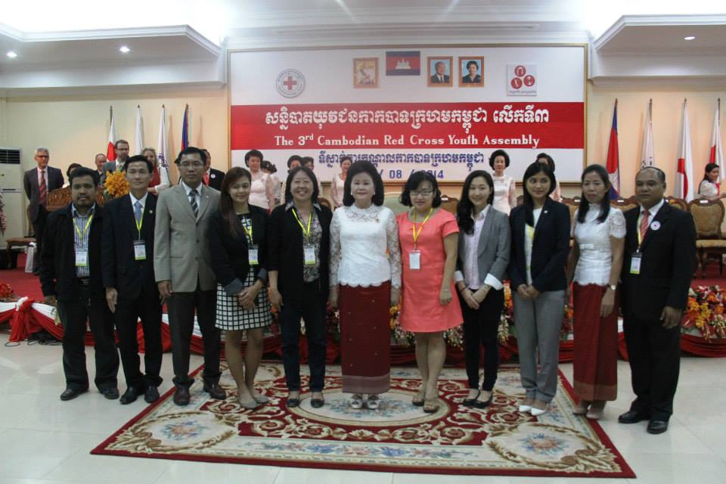

**August 4-5, 2014**

**Phnom-penh, Cambodia**

# **introduction**

Strategy 2020 stresses the importance of the Red Cross and Red Crescent Youth “acknowledging their skills as innovators, inter-cultural ambassadors and peer- to-peer facilitators”. Youth Policy (2011) and Youth Engagement Strategy (YES) 2013 also promotes national, regional, and international networks established by young people themselves as “an invaluable contribution to sharing knowledge and innovation across the Red Cross Red Crescent Movement”.

The South East Asia Youth Network(SEAYN) was developed as a sub-network linked to a zone-wide APYN in May 2013. It has a special characteristic as a youth network by ensuring equal participation of NS staff and Youth leaders in it. By nominating their NS youth staffs and youth leaders (volunteers) to be members of the SEAYN, each NSs in the SEA region follows the SEAYN terms of reference which was officially endorsed by the Southeast Asia Leadership Meeting held in Singapore in March 2014.

The SEAYN nominates its Coordination Team in the Network and develop its action plans to allow for SEA National Societies to strengthen youth and to encourage youth initiatives through the SEAYN, while also building capacity to extend peer to peer support among the SEAYN.

Following the Terms of Reference of Southeast Asia Youth Network, the SEAYN annual meeting has been held in Phnom-penh, Cambodia hosted by the SEAYN Chair and Cambodia Red Cross Society followed by the 3rd CRC youth assembly.

Altogether 15 NS youth staffs and volunteers from 5 NSs such as Cambodia, Indonesia, Philippines, Singapore, Lao and 4 IFRC representatives from Zone, Region and Countries (Indonesia and Cambodia) attended in this meeting and reviewed about 2013-2014 activities and held in-depth discussions and group work how to improve and strengthen the Network with good commitment of members.

Finally the meeting concluded with some concrete results e.g **drafting 2015-2016 action** **plan** by looking at issues of Youth in each NS programming and by considering each NSs’ expectations and commitment to SEAYN for their youth engagement and development. It also decided to finalise the plan through confirmation of absent members in near future.

The meeting was significant in that it nominated <**Coordination Team members** II> after a successful handover from its predecessors with the aim to represent the SEAYN as a whole and assume greater leadership and ownership of the Network.

# **2. NETWORK REVIEW**

# **2.1 review of 2013-2014 activities**

*Kumju Ho, Youth Development Focal, IFRC SEA office.*

**2.1.1 Main successes;**

1. Coordination and Cooperation
2. Timely nomination of network members by SEA NS leadership after the formation in May 2013
3. Good fulfilment of roles and responsibility by <coordination Team I> members from Cambodia, Indonesia and Brunei.
4. Active support from all members despite of heavy workloads in each NSs
5. Regular working system established through online meeting activation as scheduled, ownership of the annual meeting by Chair NS.
6. Singapore RC and VNRC now fully joined in the network as member Societies.
7. Project implementation (Four Key action plans)
8. 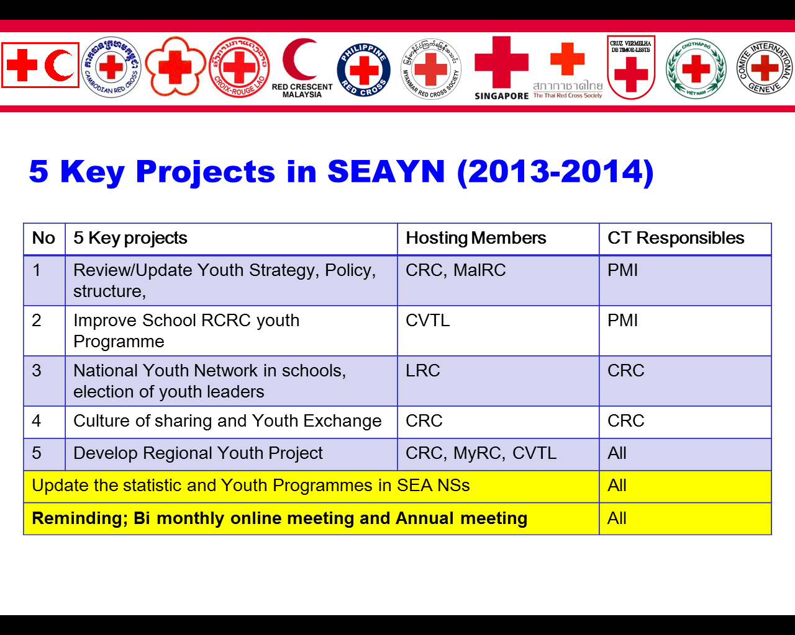Youth policy upgraded in Cambodia and adopted in Youth Assembly.
9. CVTL School RCY programme improved through network discussion and recommendation
10. Culture of sharing project improved in Cambodia and Youth exchange initiated in Thai RC
11. Regional youth empowerment project (YEP) developed

**2.1.2 Main challenges:**

1. Project implementation and resources were limited.
2. One project (Lao RC youth network establishment) was not started
3. Funding resources were limited to hinder the participation of network members in annual meeting
4. Members termination in RC and new members replacement.
5. Limited engagement and involvement

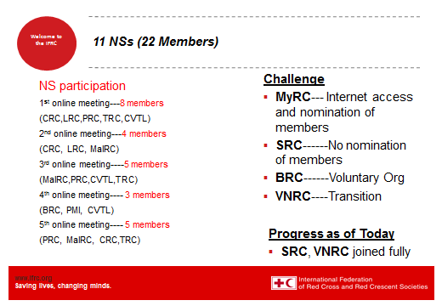

# **coordination team (CT) feedback and Revision of ToR**

**2.2.1 1st term CT members’ Challenges and recommendations for 2nd Term CT**

|  |  |  |
| --- | --- | --- |
| **No** | **Challenges/Issues** | **Recommendations** |
| 1 | Access to internet | * Use **IFRC offices** as much as possible |
| 2 | Awareness of Webex technology | * Brief in advance how to use it by IFRC SEA office |
| 3 | Time constraints, Urgencies | * Appoint **2nd member to be ready** for the meeting if urgencies * Reschedule the meeting in advance with the moderator, IFRC country offices |
| 4 | Finding interesting topics to attract members | * In CT online meeting, every CT members should bring **interesting topics** for a discussion as an agenda |
| 5 | Language barrier | * Try to use simple and clear English for all members to understand * Need more practices, exercises in advance of meetings |
| 6 | Culture of work including supporting members positioning | * Supporting members here, mean IFRC staffs. They should be fully involved until each NSs become higher in capacity to lead all meetings by their own. * IFRC Staffs are also engaged at national level and therefore, their opinions and suggestions are equally valuable with NS members * All meetings will include IFRC supporting members at any time and at any places |
| 7 | Understanding of Hosting NS situation | * When implementation of action plan, it is better to have a **briefing session between CT team and Hosting NS** for better understanding of situation |
| 8 | Selection of agenda | * Too many agenda makes people boring and out of focus. It is better to **have 2-3 agenda** in one meeting and the other information can be collected from CT members in advance and shared as **attachment matrix** |
| 9 | Appropriate time for meetings | * After lunch, it is most appropriate time to attend meetings |
| 10 | Participation and engagement | * Members participation and engagement should be encouraged **through web stories, advocacy** to leadership * Minutes of meetings should be circulated and collected feedback from members, leadership on regular basis |

* + 1. **Revision of Terms of Reference**

No need to revise in 2015, but if there is anything to revise, members can provide their comments at any time

# 

# **3. ACTION PLAN 2015-2016**

*All participants*

For brainstorming, IFRC SEA regional office made some presentations about the following topics in order for members to consider further for the possible plans;

1. Continuous YEP initiatives into NS programmes
2. Comprehensive School Safety Programme Initiatives
3. SEA Leaders requests; Youth to be champion on Media, IT, Digital Divide, and youth mainstreaming into programmes

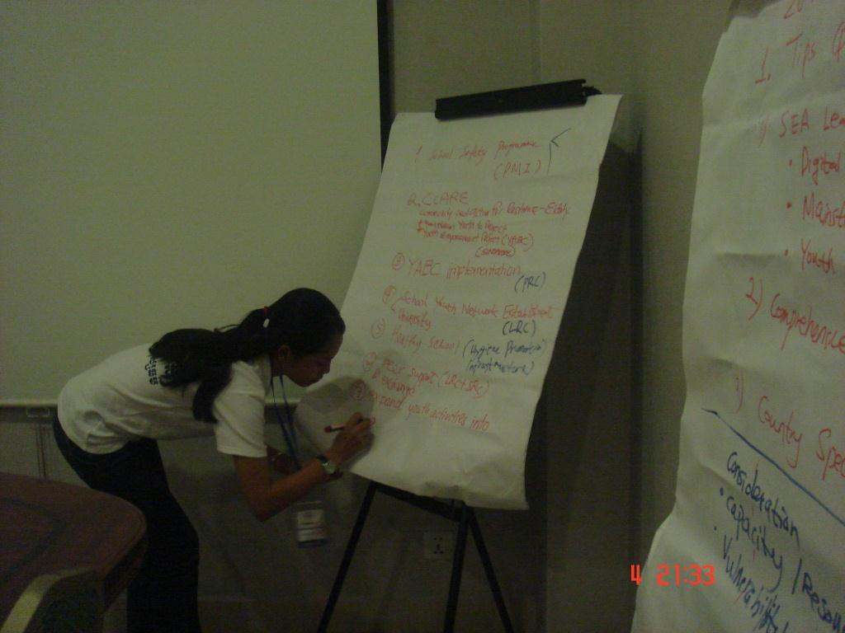All members were divided into groups, country teams and they discussed about tentative plans by considering current capacity/ resources and vulnerability. In addition, all members agreed that Network plans should be linked with the country plans and IFRC Y.E.S implementation.

After group discussion, each member presented their ideas and concluded with 8 tentative plans in Y.E.S category.

|  |
| --- |
| These below 8 plans will be prioritised into 3-5 key action plans by considering the function and character of the network through members’ consultation process in August and September 2014. |

|  |  |  |  |  |
| --- | --- | --- | --- | --- |
| **No** | **IFRC Y.E.S** | **Tentative Plans** | **Hosting NS** | **Methodology** |
| 1 | Youth as Leaders | Invite NS youth leaders when organising any **events/conference** to learn the leadership skills and play a leading role in representation of RC | SRC | Youth Symposium |
| 2 | Establish **Youth Network at national level** to create youth-led structures that allow elected youth leaders to represent their peers | LRC | School youth network |
| 3 | Youth as Volunteers | **Youth** **Empowerment initiatives** into NS programmes | SRC | CLARE Project  (Community Led Action of Resilience for Elderly) |
| 4 | YABC implementation | PRC | YABC continuation |
| 5 | Youth activities in community level | CRC | Youth programmes in community |
| 6 | Youth to be **champion on social media including IT** initiative and advocate SEAYN activities thru recognising it as contributors to innovation | All | Open SEAYN page led by PRC and update it with the support of all members every month |
| 7 | Youth as Beneficiaries | **Healthy School Safety** programme | PMI | SPLASH programme with the support of SRC |
| 8 | **Peer support and youth exchange** for peer to peer mentoring, skill sharing | LRC+SRC  CRC+JRC | Exchange visit |

\**All members remarked that it was a good decision and timing to combine Youth Network meeting with CRC youth assembly.*

# **4. UPDATED EVENTS / CALENDARS**

*Ms Naomi AKAMATSU, IFRC AP Zone, OD and Youth Delegate*

**Asia Pacific Youth Summit**.

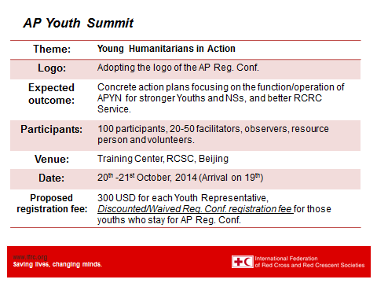

# 

# **5. NEW COORDINATION TEAM NOMINATION**

*Sam Kosal, Chair of SEAYN 2013, Cambodia Red Cross*

Finally on the 5th of August, there was an official handover. The members of the newly nominated Coordination Team members with one year term 2014-2015 are as follows:

1. Dr Lilis Wijaya Indonesia Youth Director Chairwoman
2. Dr Kaviphone Southy Lao Head (Youth&Comm)Deputy
3. Mr Khamla phonfnhakdee Lao youth leader Deputy
4. Ms Lyn Garcia Philippines youth officer Officer
5. Mr Allan P Claveria Philippines youth leader Officer
6. One more youth leader will be elected in the coming APYS and will be representing the region in the APYN steering committee

**Conclusion:**

All of the participants expressed their deepest thanks to the Cambodia Red Cross Society for their kind hospitality in hosting the 1st SEA Youth Network annual meeting followed by the 3rd CRC Youth assembly on August 5. Participants also thanked IFRC for facilitating the meeting.

Participants were impressed by the Road Safety activities by CRC youths on August 6. Half day intensive meeting until 10 PM was challenging but participants never lost their energy and displayed their strong commitment, passion and enthusiasm to the last minute.

Thank you very much for all participants in the meeting!

# Annex 1: Meeting Agenda and Abbreviations

**6th Southeast Asia Youth Network Meeting**

**(Annual Meeting)**

**August 4 2014. Phnom-Penh, Cambodia**

**Agenda**

|  |  |  |
| --- | --- | --- |
|  | | |
| **Time** | **Item** | **Presenter/facilitator** |
| 16.00-16.10 | Welcome  Agenda briefing | * Chair * IFRC regional office |
| 16:10- 16.30 | 1. Review of 2013-2014 Network activities   * Action plan review * Successes and Challenges * CT feedback   Q and A | * IFRC regional office * CT members |
| 16:30-17:00 | 1. Network ToR revision and Working system improvement  * ToR revision and handover process   (official handover on Aug 5)   * Online,F. meeting Challenges   Discussion and Recommendations (15 min) | * All |
| 17:00-18:00 | 3. Action plan 2015-2016   * Possibilities (SEA leaders requests, School Safety, YEP, Disability) * Group discussion   (Good ideas, Y.E.S, Priorities)   * Summary of discussion and priorities | * All |
| 18:00-18:30 | 4. Updated Events/calendars   * Country level Youth events or activities for 2015 (2mins each) * AP conference and Regional updates * Wrapping up | * All |
| 20:00-22:00 | Any pending issues, or Individual NSs discussions | * All |

|  |  |
| --- | --- |
| YEP | Youth Empowerment Project |
| CRC | Cambodia Red Cross |
| APYN | Asia Pacific Youth Network |
| APYS | Asia Pacific Youth Summit |
| CT | Coordination Team |
| SEAYN | South East Asia Youth Network |
| Y.E.S | Youth Engagement Strategy |
| ToR | Terms of Reference |

# **Annex 2; National Society Plans And Participants list**

Pls see below table. IFRC SEA office added some more plans from some members who cant join in the meeting through some communication channels

|  |  |  |
| --- | --- | --- |
| No | Country | Plans 2015 |
| 1 | Brunei | * Youth Policy Update * FA accreditation system for Youth volunteers * YEP initiatives (TBC) |
| 2 | Cambodia | * YEP extensions * Culture of sharing project expansion * Fundraising for youth project * My RC story and voice of youth campaign * Exchange between JRC and CRC |
| 3 | Indonesia | * National Youth Gathering (possible invitation of network members) * Healthy Safe school project * Social media for Youth |
| 4 | Lao | * High school/University Youth network establishment * Exchange between LRC and Korean RC * Road Safety Project with ambulance service |
| 5 | Singapore | * CLARE Project * SPLASH Project * RC Youth Camp Symposium |
| 6 | Philippines |  |
| 7 | Myanmar |  |
| 8 | Malaysia |  |
| 9 | Thailand |  |
| 10 | Timor leste |  |
| 11 | Vietnam |  |

**Participants list**

|  |  |  |
| --- | --- | --- |
| **No** | **Name** | **Position** |
| 1 | Lilis Wijaya | Indonesia Youth Director |
| 2 | Kaviphone Southy | Lao Comm, Youth Director |
| 3 | Sahari Ani | Singapore Youth Director |
| 4 | Edlynna | Singapore Youth officer |
| 5 | Lyn Garcia | Philippine Youth officer |
| 6 | Sam Kosal | CRC HR director |
| 7 | Sokna | CRC youth coordinator |
| 8 | Yam Pagnha | CRC youth volunteer leader |
| 9 | Hang Pisey | CRC youth volunteer |
| 10 | Naomi Akamatsu | IFRC Zone office |
| 11 | Kumju Ho | IFRC Regional office |
| 12 | Ahmad Husein | IFRC Indonesia |
| 13 | Lak Mony Rasmey | IFRC Cambodia |