- Information about food

Basic concept:
Foods
Energy
Organism
Nutrients

Food contains several nutrients that are needed to produce energy for body function.

Food composition:
- Macronutrients: intake several gramms/ per day
  - Carbohydrates
  - Proteins
  - Fat
  - Water

- Micronutrients: intake below 1-2 gramms/ per day
  - Vitamins
  - Minerals
  - Trace elements

Why is healthy nutrition important for human beings?

- Important for good health
- primary prevention of diet-related diseases
- maintenance of wellness in the whole population

Attention: It is strongly recommended that mothers breast feed their infants for at least the first 6 month of their life. There is not any other food to be given.
Reason:
- Breast milk give the infants all nutrients they need to grow up and develop properly
- prevent them from several diseases, such as diarrhea and dehydration and infections
- reinforce the immune system

- Food pyramid

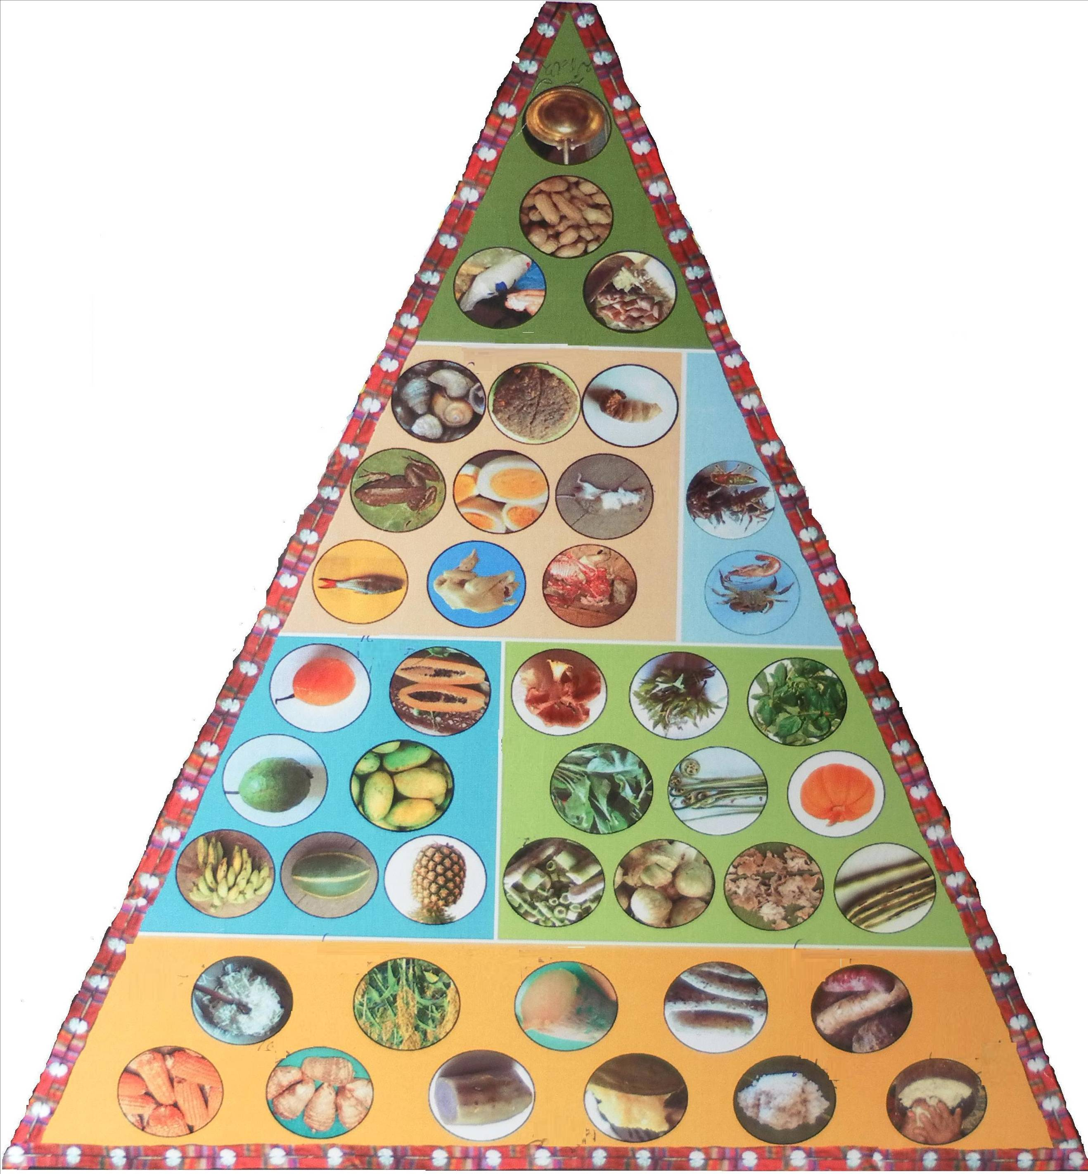
Fat and oil (fatty acids)
preferably eat lean or low fat
​food

Meat, fish, eggs, soya bean,
2-3 servings per day Insects

Fruits Vegetables 3-5 servings per day
2-4 servings per day

Grain
6-11 servings per day

Source: WFP IEC materials

- food and its function for body

There are 6 different groups of food.

Group 1: grain and other dietary staples: rice, corn, wheat, taro, potato, sweet potato …
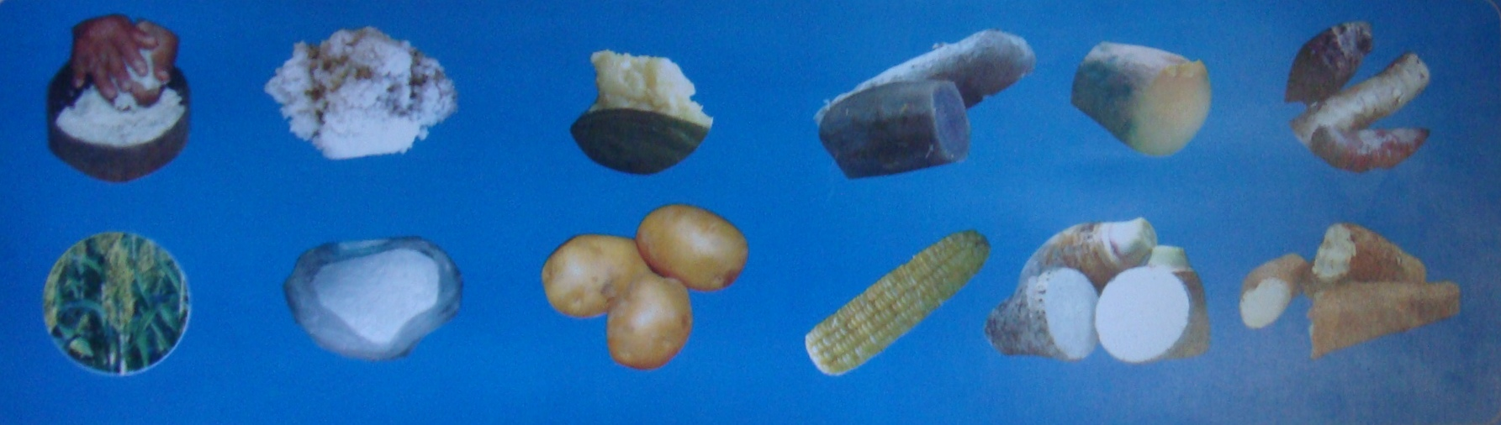

​

Source: WFP IEC materials

Function for body:
- this kind of food contains: -protein, low fat, vitamin B and dietary fiber
- The body need these nutrients to produce energy for body functioning e.g. all moving, thinking, walking, working, breathing, and balance the body temperature

Group 2: Fruits
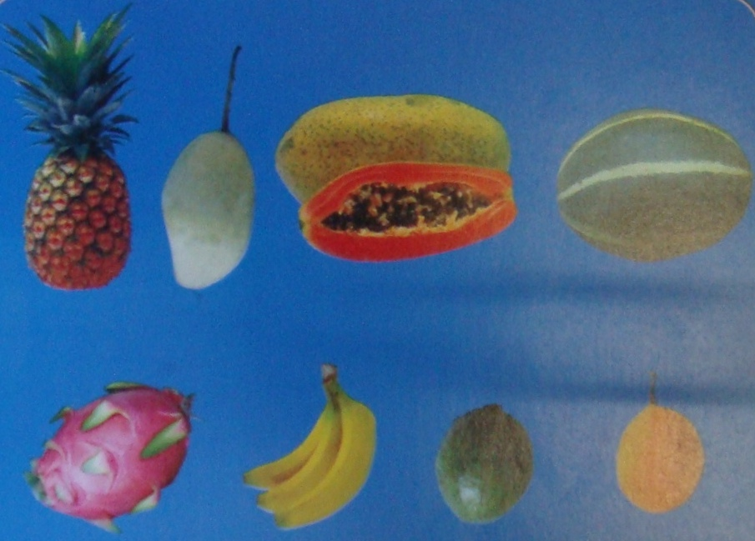

Source: WFP IEC materials

Function for body
- ​All kind fruits (from forests and garden) contain several vitamins and minerals, dietary fiber and fruit sugar
- fruits can be suit or sour
- sweet fruits spend energy because of the fruit sugar
- fruits contain flour
- serving 2-4 times different kind of fruits every day
- reinforce the body
- can prevent many kind of diseases

Group 3: Vegetables
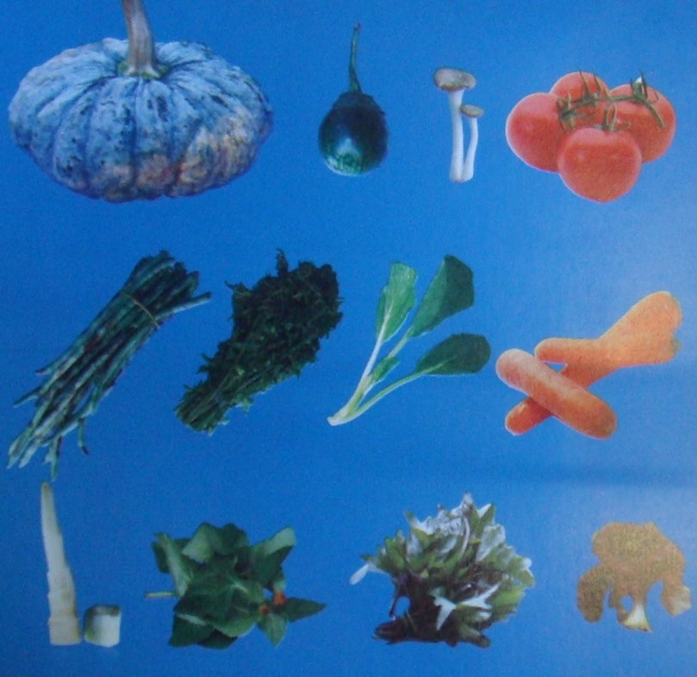

Source: WFP IEC materials

- ​coloured vegetables and other vegetables contain vitamins (A…), minerals and dietary fiber
- should be served 3-5 times daily
- green vegetables should be mixed with e.g. lemon, peach and chili in order to get the entire vitamins, minerals and dietary fiber

Group 4: meat, fish or others, e.g. egg and soybean

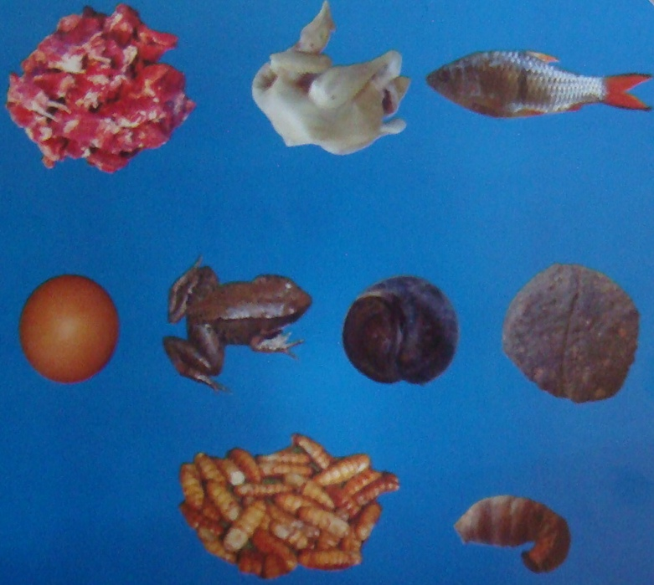

Source: WFP IEC materials

Function for the body:
- ​contain high proteins
- contain minerals and vitamins such as zinc, iron (meat) and calcium (fish)
- ​serving according to the demand (not too much)
- protect muscle, skin, hair, blood and bone
- children need this food to grow up
- pregnant women need this food for themselves and for the development of the fetus
- adult need this food to be able to recover quickly after sickness

Remark: Some vegetables, such as winged beans, mushrooms etc. contain the same nutrients than meat but in lower consistency and quality.

Attention: Never eat raw meat, fish etc.!!!!!!!!!!!!!!!!!
Group 5: insects, fish nuts, fish cartilage, shrimps, crabs etc.

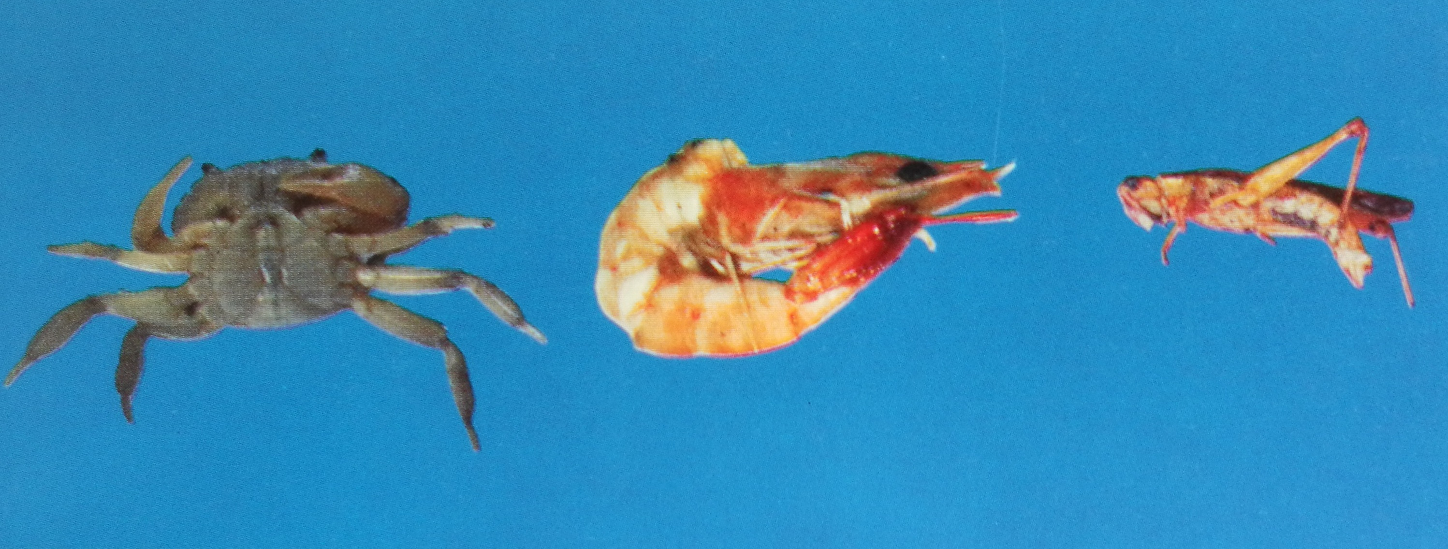

Source: WFP IEC materials

Description:
- contain proteins
- contains calcium – good for strong bones
- compensation for lack of milk products in Lao PDR
- important for children, teenagers, pregnant woman and woman who breast feed

Remarks: other insects, such as horseshoe crabs, crickets, shrimp, shell or small fish have also a lot of calcium

Attention: never eat raw insects, fish nuts, fish cartilage, shrimps, crabs etc. !!!!!!!!!!!!!!!!!!!!!!!!!!

Group 6: all kind of fat
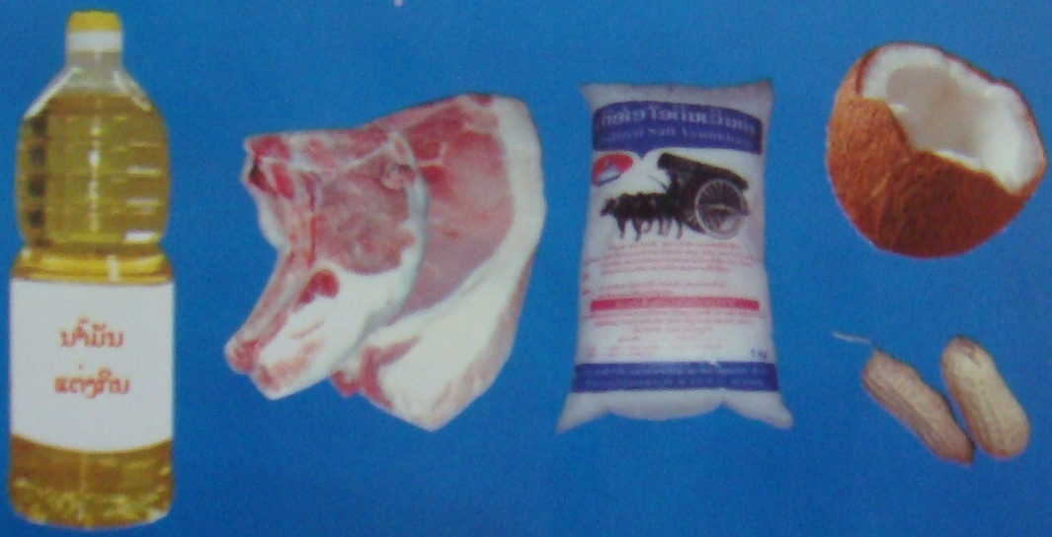

Source: WFP IEC materials

Discription:
- fatty acids can be taken in with different food: fatty/ adipose tissue from animals or from vegetables
- give a lot of energy
- ​make food tasty
- ​needed for good functioning of the brain, nerve system and other organs in the body
- should be served every day, especially for children in a appropriate amount
- green vegetable should be served with fatty acids ,because fatty acids allow the transportation of dietary fiber in the body

Attention: intake of too much fat is unhealthy and can caused obesity and several diseases !!!!!!!!!!!!!!!!!!!!!!!!!!!!!!!!!
- Malnutrition and Undernutrition?

- What is Malnutrition/ Undernutrition?

The body does not get the right amount of food (undernutrition) or get the right amount of food but in both cases not the right amount of vitamins, minerals, dietary fiber and other nutrients needed to maintain healthy tissues and organ function.

- Reason:
- insufficient food
- poorly balanced diet
- by medical condition such as problems with digestion or absorption, chronic diarrhoea (inadequate digestion and therefore utilization of food) or severe gastrointestinal diseases

- Signs of malnutrition or undernutrition

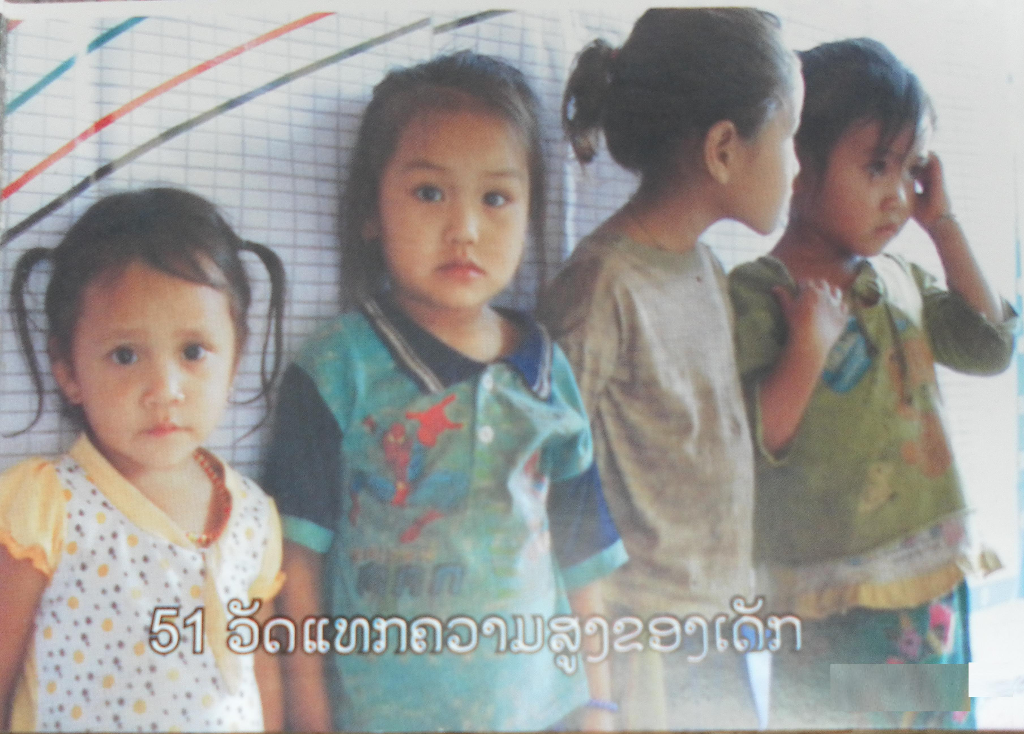
How can we identify malnourished or undernourished children under 5?

- shortness in children:
height is not matched
with the age
(starvation – undernutrition)

Source: WFP IEC materials
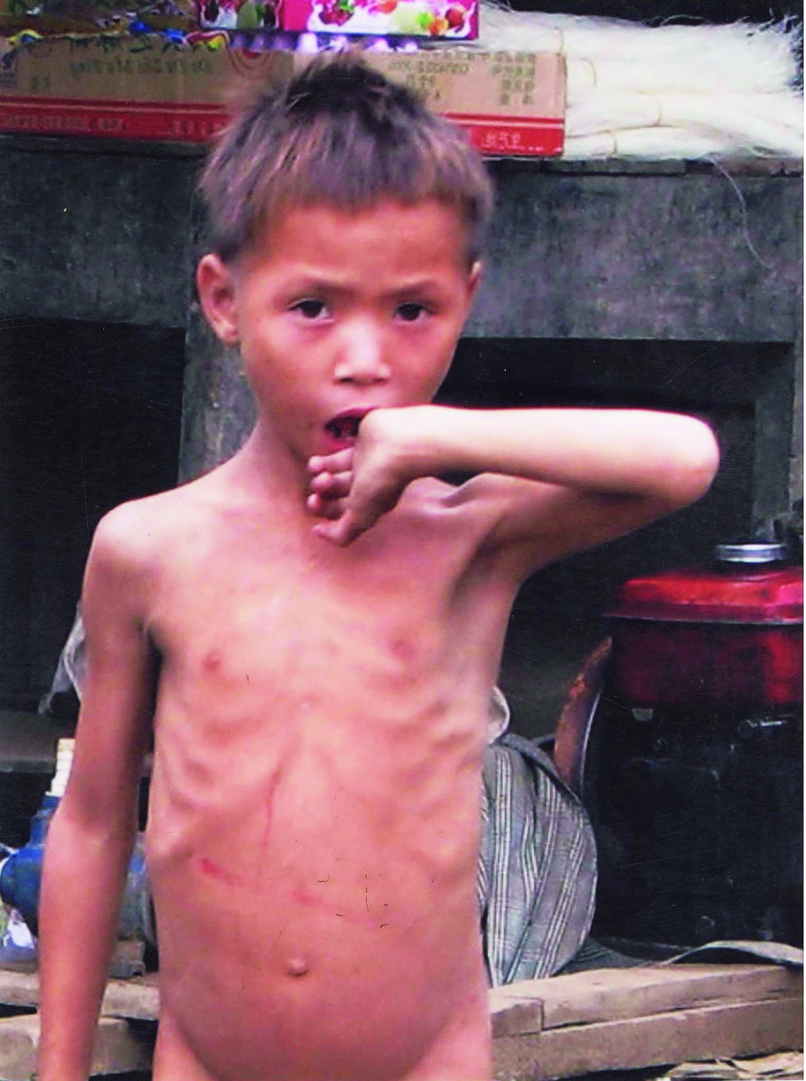
- thinness children: not matched
with the height
(undernutrition or malnutrition)

- low weight not matched
with the age
(undernutrition or malnutrition)

- hair can become dry, not shiny
or change the colour (bronze),
or can be lost
Source: WFP IEC materials
Further signs of malnutrition and undernutrition:
- bones feasible: rib, scapula, pelvis
- damaged skin (pale skin) with different skin colour, easily irritated
- not able to see clearly during the night
- children do not like to eat or they are disgusted to eat properly
- Consequences of malnutrition and undernutrition
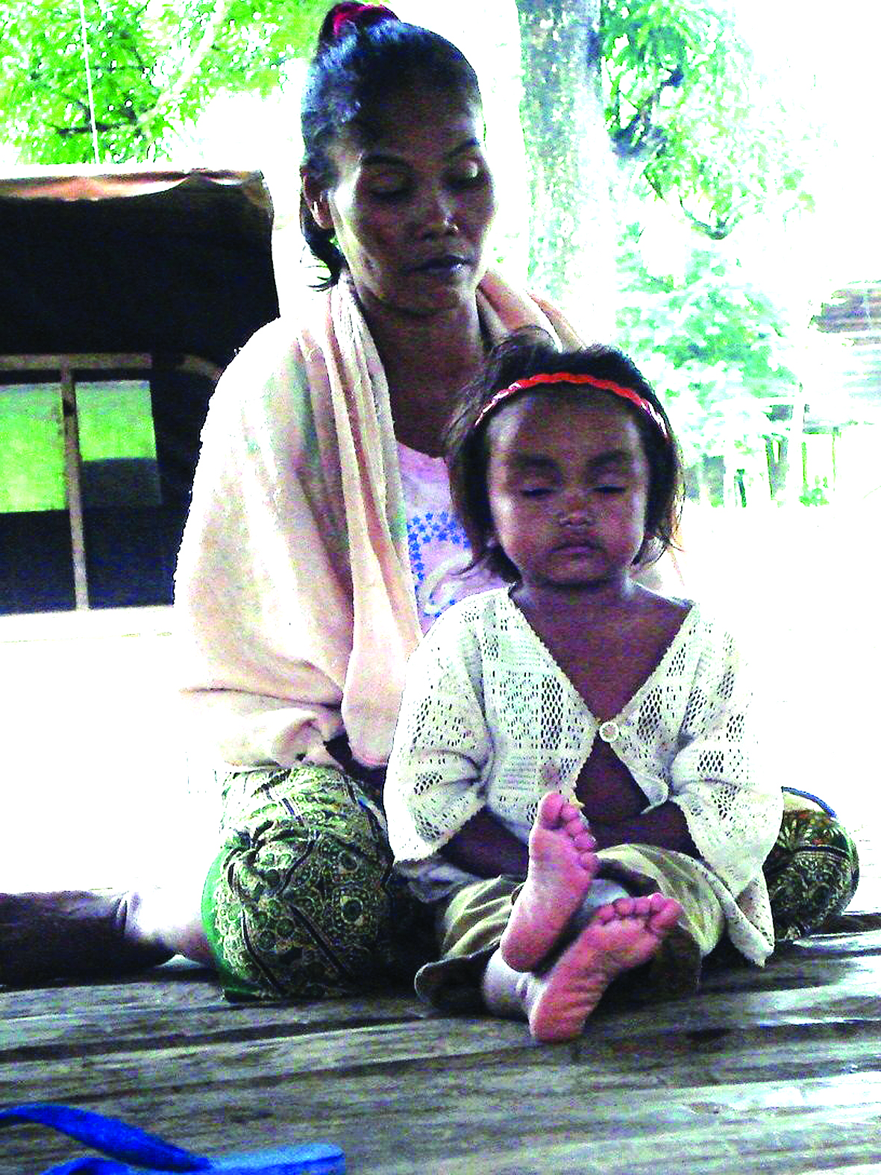

- always tired and sick
- not active

Source: WFP IEC materials
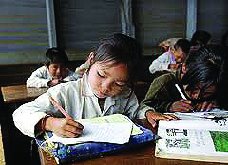

- not able to be
concentrated
during studying

Source: WFP IEC materials

Remark: The first stages of malnutrition or undernutrition in children it’s not easy to identify
​​
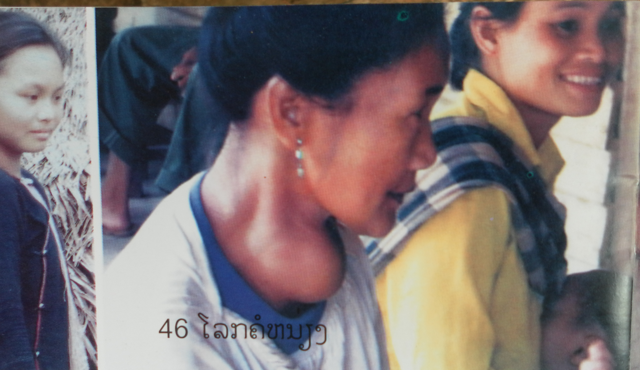
- Why is malnutrition/undernutrition dangerous?

Source: WFP IEC materials
- children are not able to grow up and develop properly and gain the height and weight appropriate for their ages
- children are not able to learn properly
- children are more likely to get sick and develop chronic diseases, they are less likely to survive
- lack of vitamin A can cause eye problems in children and can lead to blindness
- lack of iodine is dangerous especially for children and pregnant woman → can lead to severe swelling on both limbs or both arms
- can lead to anemia (not enough blood)
- functioning of organs can be reduced or be stopped at all

Attention: malnutrition/ undernutrition can lead into death in all human beings
- Food compensations

If there is not enough staple food available e.g. rice, meat, fatty acids, nutrients can be compensated with other food

- Lack of sufficient rice can be compensated with wheat, cassava, corn, potatoes, taro, bamboo and banana
Remark: replaced food might have more energy than rice

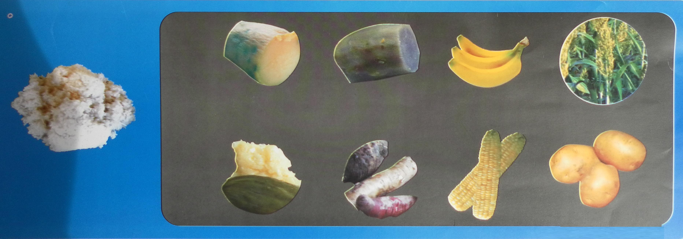

Source: WFP IEC materials

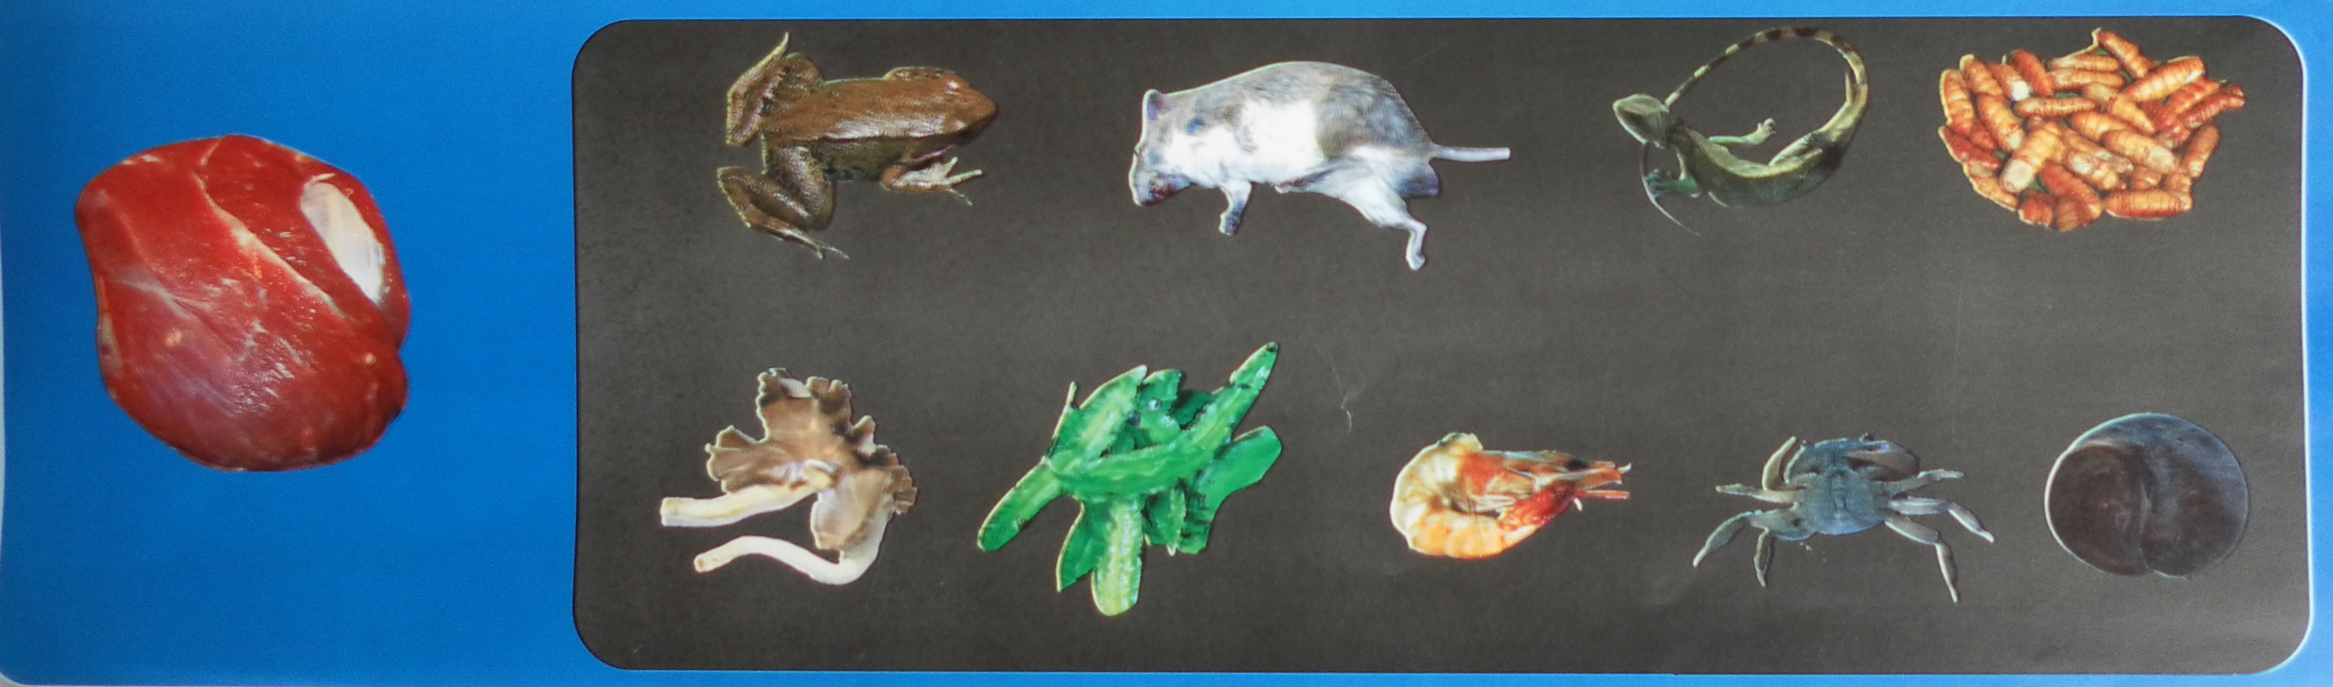
- Usual consumed meat and fish can be compensated with other kinds of animals and food such as wild animals, insects, eggs and some vegetables

Source: WFP IEC materials
- Palm oil or fat of pork can be compensated by beans, seeds or insects, such as pea nuts, seed of jackfruit, sesame, coconut or adipose insects
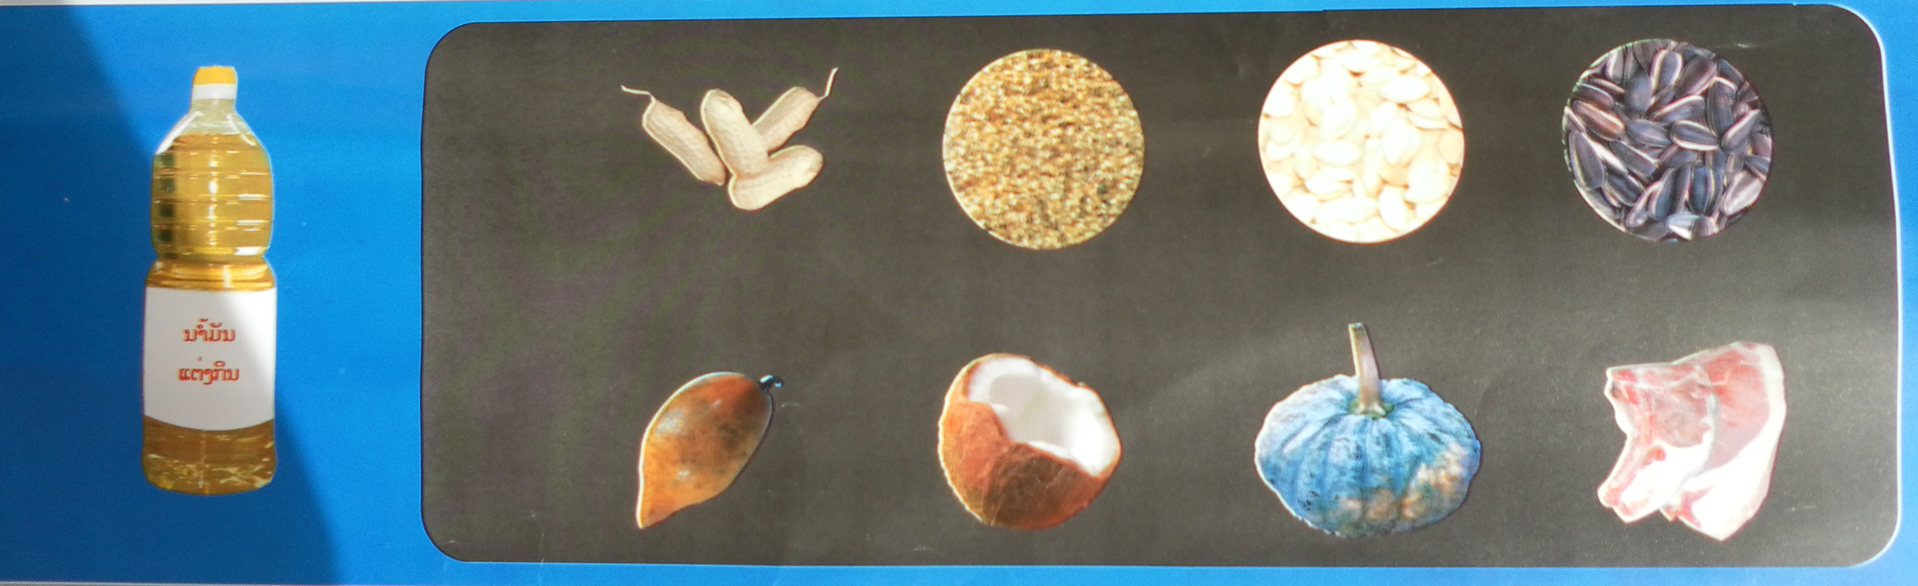

​

Source: WFP IEC materials

