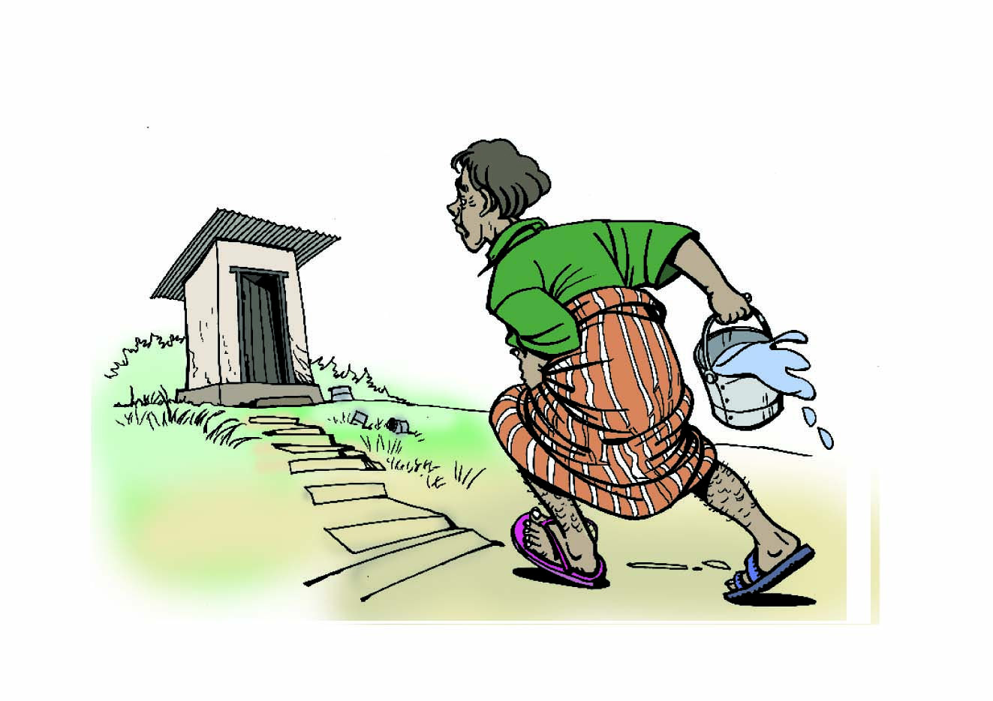
- Definition and sign of diarrhoea

- Passing of three or more loose or liquid stool or more frequently than normal for the individual per day (24 hours)
- Diarrhoea stool often smells strongly and pass noisily
- When stool contains more water than normal and might contain blood or mucous

Complaining and attention
Complaining:
- weakness and tiredness
- muscle cramp
- stomach pain


Attention:
- dysentery and cholera cause severe
sometimes life threatening forms of diarrhoea
- Diarrhoea can be serious for children
under 5 and can result in death
- Diarrhoea is dangerous because of loosing
nutritients, it can lead to malnutrition
- Diarrhoea can lead to dehydration
because of loosing water and salt,
- Dehydration can result in death

Sign of dehydration:
- sunken eyes
- loose conscious
- dry mouth and skin
- little urine
- muscle cramp
- fever
- ​vomiting
- very thirsty
- do not want drink and eat

→ go to the health centre immediately

