The first roll out of CBHFA Healthy Ageing and the pilot projects in Cambodia in preparing for an ageing society, by Cambodian Red Cross Society and IFRC, 13-15 June 2017 in Phnom Penh, Cambodia

This training summary report presents the results of the Training of Trainers on Healthy Ageing (TOT HA) conducted and hosted by Cambodian Red Cross Society during 13-15 June 2017 at Cambodian Red Cross National Head Quarters, Phnom Penh. The healthy ageing programme is considered as one of key priorities because the aged dependency ratio in Cambodia in 2016 is 5.9 % or 3.8 % of total population (600,845 out of 16.07 millions), estimated by United Nations Statistics Division.

In the current Cambodian context, young people are moving from rural communities seeking jobs in the cities, urban and or oversea and leaving behind old people in their villages taking care of children and even animals with very little support or without support. As the result, many Cambodian elderly are confronting hard work, health issues, isolation, human rights and poverty. This is an essential reason that driving the Cambodian Red Cross’s spirit establishing this project intervention, with the expectation of saving lives, restoring dignity and contributing to the improving quality of life of elderly people.

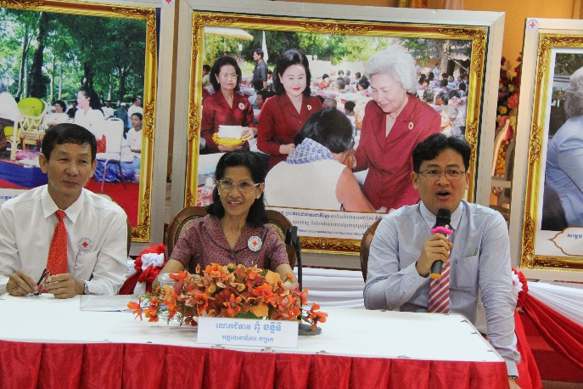

Mme. Pum Chantinie, Secretary General of Cambodian Red Cross presided over opening and closing of the TOT HA on the 13th and the 15th of June 2017 respectively. “This is a good timing to implement the Healthy Ageing Programme in Cambodia because we can apply and simplify the knowledge and skills to support our senior family members, prepare our Red Cross volunteers to care for vulnerable people in communities, and organize public awareness campaigns in Red Cross branches and communities” highlighted Mme. Chantinie.

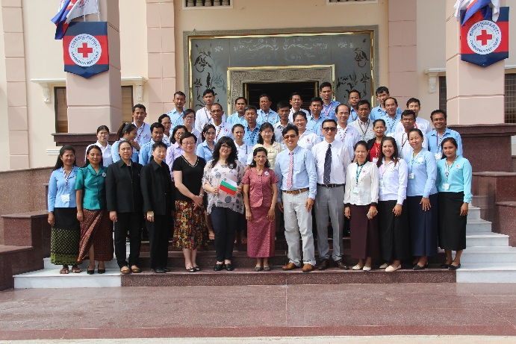

Cambodian Red Cross National Society is the third country in the world to show the leadership and the commitment in implementing “Community Based Healthy Ageing Programme” after Montenegro, and India. IFRC supports National Societies to play a key auxiliary role to the Cambodian Government and the Ministry of Health in promoting healthy ageing which contributes to the World Health Organization’s (WHO) Global strategy and action plan on ageing and health, that focuses on five strategic objectives: 1) Commitment to action on healthy ageing in every country; 2) Developing age-friendly environments; 3) Aligning health systems to the needs of older populations; 4) Developing sustainable and equitable systems for providing long-term care (home, communities, institutions); 5) Improving measurement, monitoring and research on healthy ageing.

The main objective of this project is to improve the quality of life of Cambodian elderly people in rural community by restoring hope and dignity via non-communicable diseases and health promotion education.
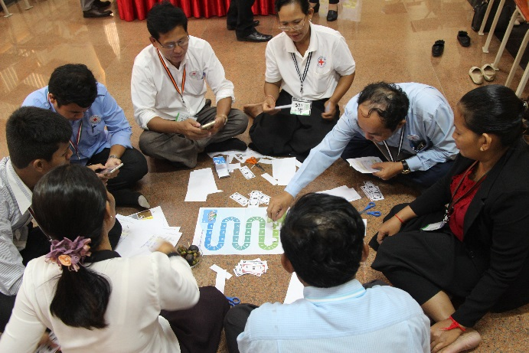
The 3-day training of trainers on Healthy Ageing (TOT HA) has been developed by IFRC in partnership with and support by Pfizer Inc. which explained about the functional life- course approach, healthy ageing determinants and evidence-based behaviour change theories. The training toolkit package includes content about noncommunicable diseases, risk factors such as falls and social isolation, healthy eating, physical activity, lifelong learning and plan of action as well as tools which provide guidance and activities to help people pursue healthier lives and enable active ageing with dignity and a better quality of life.
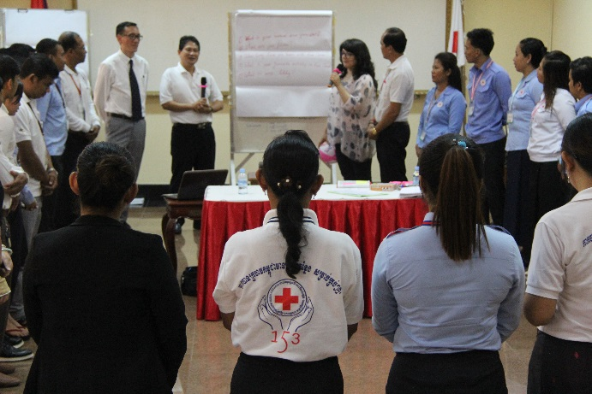
There were 36 participants (Male 16, Female 20) from 24 provincial Red Cross branches and two Thai Red Cross’s representatives participating in this training course focusing on Healthy Ageing. The Adult Learning Process and Group Discussion and Participatory Learning Approach were deployed for this training class. The peer-to-peer facilitation team consists of two specialists from Bulgarian & Mongolian Red Cross National Societies with the technical support from IFRC Bangkok and Geneva.
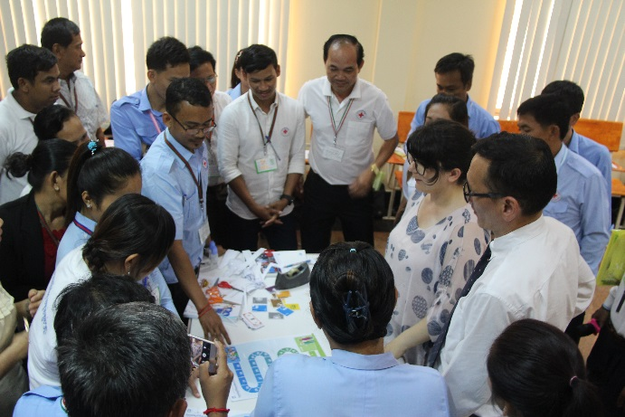
The results of pre & post-test were computed. Knowledge and skills about healthy ageing of participants were significantly improved from beginning at 68.48 % with compared at the end of training at 81.67%. The expectation of each participant has been elaborated and clarified by the facilitation team (> 90-95%). The feedback from all participants about this training workshop was carefully analyzed by using the training evaluation form.
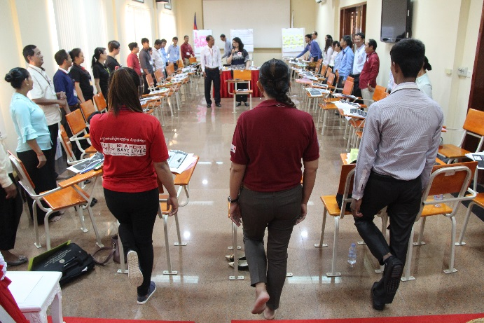
Based on the overall feedback from the participants, it was found that 90-91% was significantly satisfied with the workshop and facilitation team. Moreover, 76-81% was notably fulfilled with accommodations, foods, and avenue and organization of the event.
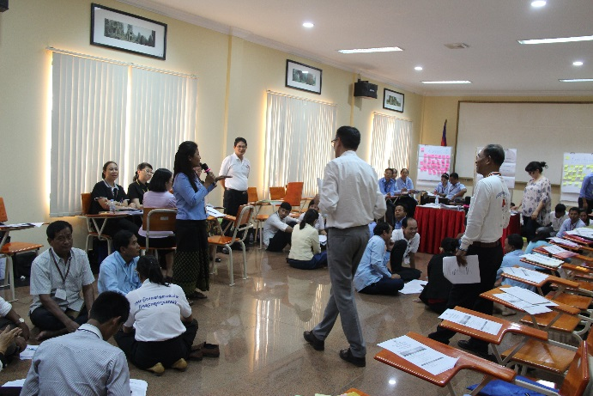
Meanwhile, 24-36 % was advised to the facilitation team in order to improve about “Khmer translation toolkit” and “Training Avenue and training rooms for small group discussion” and “training period should be organized in 5 days” and “TOT HA should be organized for 15-20 participants”.
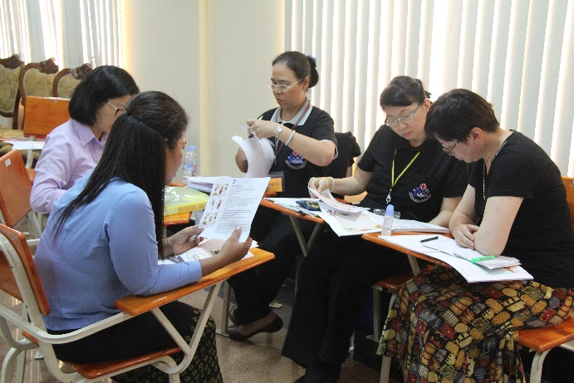
After this TOT HA, the pilot projects in three targeted provinces—Kampot, Svay Rieng and Prey Veng will be implemented the project activities to improve the quality of life of Cambodia elderly people in rural communities which will be reached at least 500 community members. Moreover, 90-100 Red Cross volunteers will be trained on Healthy Ageing—tentatively during 4-13 July 2017, 18 outreach education sessions on non-communicable diseases and health promotion in targeted communities at Buddhist pagodas will be conducted by trained volunteers, 3,000 healthy ageing booklets will be produced, and at least 2 case studies and stories and project review and lessons learnt reports will be developed.
The training packages for facilitators and community volunteers are available to download as the links provided:
- http://www.ifrc.org/Global/Documents/Secretariat/Health/Toolkit_MRC_092216.pdf
- http://www.ifrc.org/Global/Documents/Secretariat/Health/Facilitator%20guide_MRC_092216.pdf
- http://www.ifrc.org/Global/Documents/Secretariat/Health/Volunteer%20guide_MRC_092216.pdf
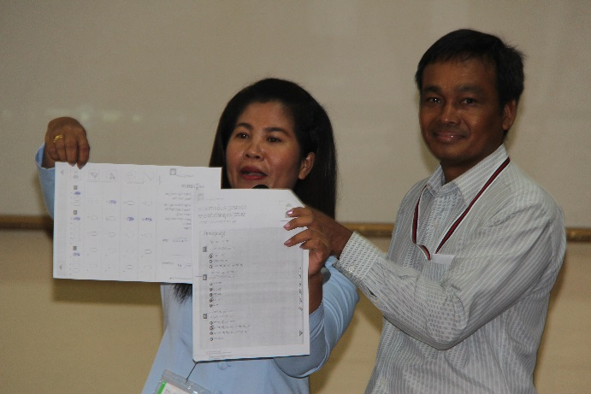
For more information, please contact:
- Mr. Va Sopheak, Head, CD/NCD Sub-department; Cambodian Red Cross; SV1970@online.com.kh
- Miss. Mom Chanthy, Deputy Director, Health Department, Cambodian Red Cross; mom.chanthy@redcross.org.kh
- Dr.Pornsak Khortwong, Mekong sub-region Health Officer, IFRC Bangkok; pornsak.khortwong@ifrc.org
- Dr.Bhanu Pratap, Team Lead (Acting) – Community and Emergency Health, Health and Care Department, IFRC Geneva; bhanu.pratap@ifrc.org

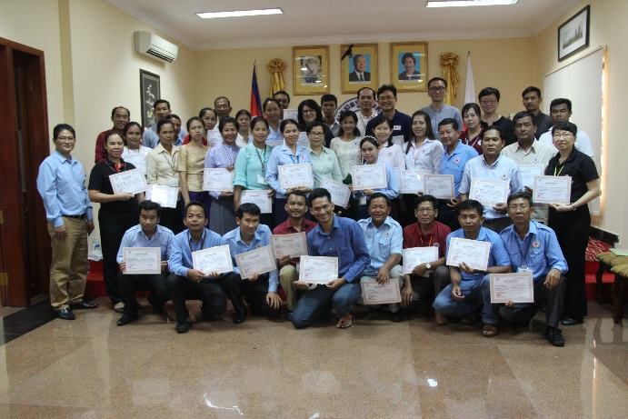
****************************

Aged dependency ratio is a ratio of people above working age (65+) to workforce of a country, estimated based on the latest demographic and social statistics by UNSD, 2017

