Youth Facilitator Training for school safety – SBDRR project
Location of mission: | Yangon, Myanmar
Date(s): | 5 – 8 December 2016
Person(s) traveling: | Rommanee Klaeotanong and Kum Ju Ho
Person Completing Report: | Rommanee and Kum Ju
Purpose of Mission: | Facilitate Youth in School Safety Facilitators’ training for Myanmar Red Cross
Key People Met (not necessary to list all): | - Prof Dr.Daw Mya Thu, President of Myanmar Red Cross  - Khim Mg Kla, Secretary General  - OD and DM Representatives from Myanmar Red Cross  - RCY representatives  - Jesper FRIDOLF, Program coordinator – IFRC
Summary of activities/Key Outcomes: | Background  The Myanmar Red Cross Society (MRCS) has been implementing the “School Based Disaster  Risk Reduction” (SBDRR) program since 2010. In 2015, MRCS has received funding from Hong Kong Red Cross(HKRC) through IFRC Bangkok office to implement the SBDRR project which the pilot testing of Handbook that developed by IFRC. MRCS has completed the activities as planned in 8 schools, in 3 Townships of Yangon by September 2016. HKRC has extended the project implementation till Dec 2016.  In order to add value to the SBDRR project, IFRC CCST Bangkok proposed the Youth in School Safety Facilitators training for a purpose of integration between DM and OD/Youth as the Youth empowerment initiative. DM and OD Divisions of MRCS as well as the IFRC Country Delegation, Bangkok CCST are expected to work together for this matter.  The training objective;  - To enhance the capacity of MRCS School Safety with meaningful involvement of youth volunteers to be facilitators in order to roll out school safety initiative into all schools over the country through the Regional YSS tool  - To provide an opportunity to youth and volunteers to expand RC Youth clubs and junior RC youth members to join the RC programmes with a children friendly training module  Summary of activities  The training took 3.5 full days; 2-day practice and preparation followed by a 1-day hands on experience at school and half day wrap-up and plan development of implementation.  The training consists of 7 sessions (session 3 was cancelled) ; 1- opening and introduction of participants, 2 - School Safety and Red Cross Movement, 4 - Group work and preparation (task force), 5 - Group activity (demonstration scenario), 6 - welcome parent (to join and support the school safety action), 7 - action plan, and 8 closing.  Key Outcomes of training;  - Clear understanding of school safety framework with 3 pillars, and the concept of school safety action.  - Become the first time facilitators in school safety through the demonstration at school and build a confidence to continue to be youth facilitators  - Developed its action plan to extend this programme at their communities/townships with their own resources and with the practice of guide.  Finally OD and DM department recognised the Youth facilitators as key players for their School Safety programme and appreciated the training module and would like to integrate this module into School Safety program from 2017 onwards.  (Please find the link for more details; RCRC SEAYN Facebook at https://www.facebook.com/groups/seayn/ )
Comments and Follow-Up required: | Next step:  - MRCS- DM and OD will mobilize the trained Youth facilitators to roll out the school safety program in their township and others.  - The pilot programme will be carried by trained Youth and Red Cross branch from Takeda Township in January 2017. MRCS will monitor this activity and follow up the next steps .  - IFRC CCST will continue to provide the technical support if needed.

Pictures
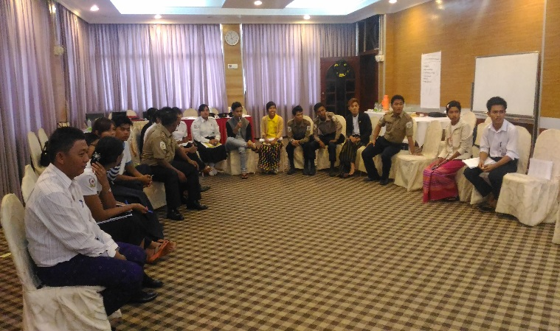  Figure 1Introduction | 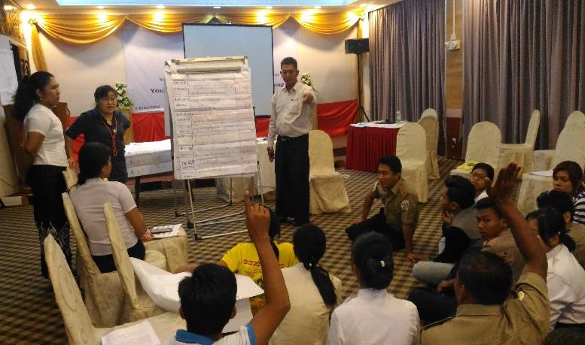  Figure 2 Divide role and responsibility of facilitator
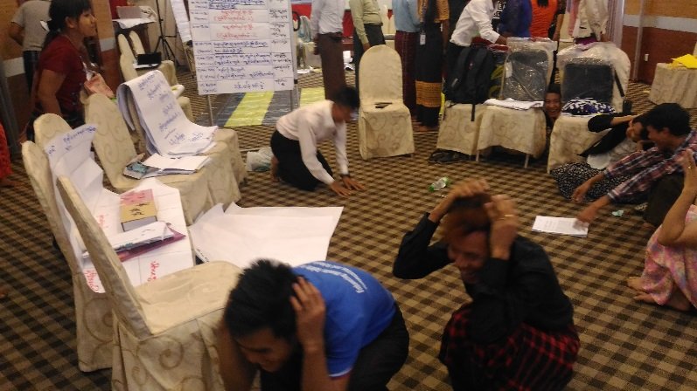  Figure 3Facilitator practice - Fire evacuation | 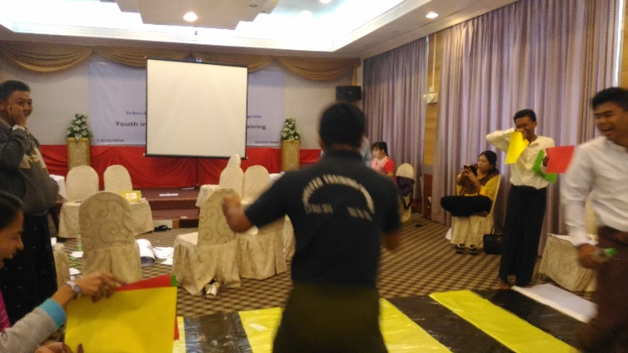  Figure 4 Facilitator practice - Road safety
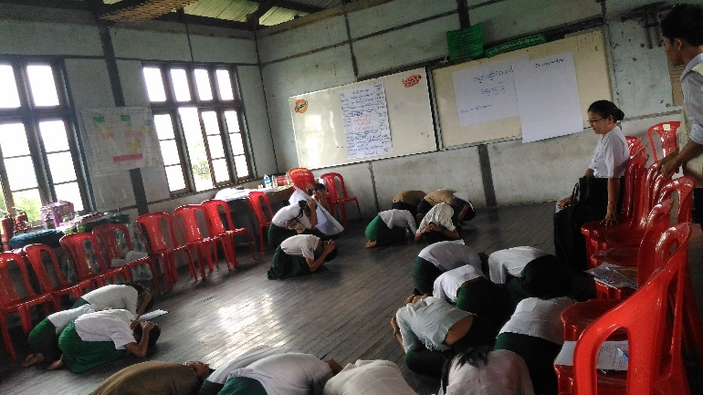  Figure 5School practice - Fire evacuation |  | 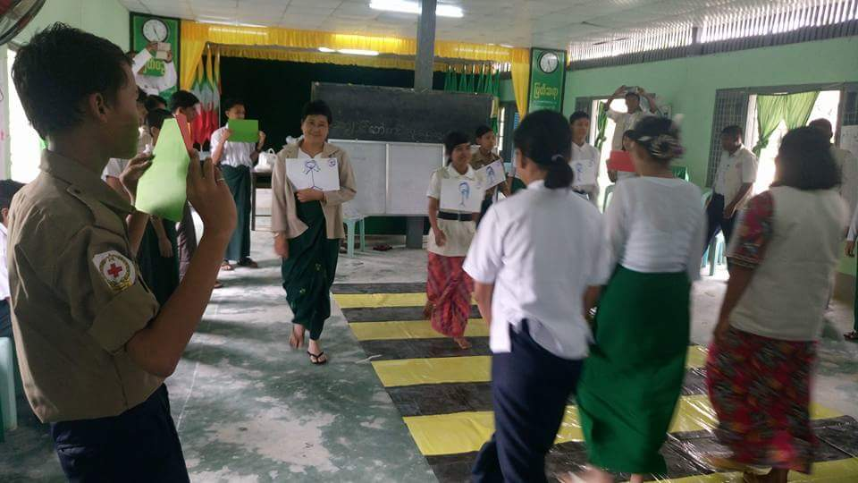  Figure 6 School Practice - Road Safety

