International Federation of Red Cross and Red Crescent Societies
EVENT EVALUATION

Dissemination Workshop and Training on Gender & Diversity
On 13-15/12/2016 at CRC/NHQ

National Society

CRC currently has a Gender and Diversity Policy, which was enacted in 2003 and is in the process of review and update. The review process is being conducted by a team consisting of: Head of Organizational Development, Head of Human Resources and the Head of Communications.

During a scoping mission in December 2014, after discussing the needs of a strategic gender and diversity approach to guide all policies, programs and tools with CRC senior management, it was agreed that such an approach is needed by CRC. The Disaster Management department of CRC also agreed that a gender and diversity perspective and an approach to promote gender and diversity equality is needed within CRC. The following recommendations were made: CRC needs to advocate for gender concepts more broadly in society; a standard Gender and Diversity regulation and policy should be integrated across CRC; as auxiliary to the government CRC should encourage the endorsement and implementation of the Gender Policy - CRC should promote awareness of gender within government and help them to promote their policy more widely.
With technical and funding supports from IFRC/BKK office the Cambodian Red Cross organizes 3days Dissemination Workshop and Training on Diversity to all 25 Red Cross Branch Directors, staff and programme managers in total 47 persons.

Objectives
- To promote gender and diversity policy among Red Cross staff, volunteers and youth in CRC /NHQ and 25 Red Cross Branches.
- To improve the knowledge and capacity of CRC NHQ/ Branch staff in their work to reduce Gender and Diversity inequality.
- To promote the gender and diversity work, engage with other actors as well as establish linkages with other networks.
- To disseminate gender and diversity policy to all branch Directors, staff and programme managers.

Expected result and measurements for success
- Understand clearly on the terminology between sex, gender and diversity
- Expected to gain more knowledge and skill on the gender and diversity in the program and project integration planning approach
- Continue to disseminate key information of gender and diversity policy to CRC’s network and stakeholders
Pre-Post Test:

Description | Poor |  | Fair |  | Good |  | Total Participants
 | # | % | # | % | # | % | 47  (12 females)
Pre-test | 08 | 17.02 | 25 | 53.19 | 14 | 29.78
Post-test | 01 | 2.12 | 27 | 57.44 | 19 | 40.42

Highlight Activities and Achievements

Opening remarks:

To formulate to consultative workshop Ms. Pum Chantinie, Secretary General of the Cambodian Red Cross is welcomed to honor guest from the Ministry of Women Affaire, representatives of IFRC, ICRC and all participants who are attending in the workshop. Firstly, she is referring the role of the Cambodian Red Cross is auxiliary to the local authority (government) on the humanitarian field which include disaster management, health care promotion of humanitarian value and organizational development, she informed to all participants that the Gender

And Diversity is more considering at current stage of the relief assistant as well as for long-term development plan of the humanitarian organizations and government strategic plan (2014-2018).

Secondly, she raised that SEA pacific countries is facing with the national hazard to disaster including seasonal flood, fast flood, sunder-storm and drought, and the most significant impacts from those disasters were affected to most vulnerable community particular children (boy and girl) and women. Cambodia is considered one of the world’s most vulnerable to natural disasters and ranks 9th in the 2016 UN University World Risk Index. In addition, she shared good practices and lesson learned to participants at global and regional inclusion of gender and diversity in the core areas of the national societies particularly in disaster response, response preparedness plan as well as in disaster mitigation and prevention.

Lastly, she encourages to all participants to continue disseminate this policy to Red Cross staff, volunteer, youth network as well as community people and include gender and diversity in the planning development of the CRC’ cores programming. In addition, she acknowledge the support from the Ministry of Women Affaire for their support by providing the resource person to facilitate this workshop , and she thanks to the IFRC/BKK office for providing the technical and financial supports to have dissemination workshop and training today.

Presentation power points:

MoWA:
Gender Based Violence (GBV)
- Definition of violence against women
- Definition Gender based violence
- Definition Domestic violence and the Intimate partner violence
Based on Cambodian Demographic and health Survey (2005) CDHS show that:
Physical, mental and sexual violence = 22, 3%
Physical violence between husband and wife =13, 7%
Sexual violence between husband and wife = 3%
66% of women had an experience of physical and mental violence impact and most of them are falling into drinking, smoking, unpredictable pregnancy and suicide.
Presentation on Policy and Framework
The constitution of Cambodia have recognized that genders equality in Article 35 and Article 45
Article 35: Khmer citizens of either sex shall have the right to participate actively in the political, economic, social and cultural life of the nation.
Article 45: All forms of discrimination against women shall be abolished. The exploitation of women in employment shall be prohibited. Men and women are equal in all fields especially with respect to marriage and family matters. Marriage shall be conducted according to conditions determined by law based on the principle of mutual consent between one husband and one wife.

The participants gains more knowledge and information with regards to different kinds of violence in Cambodian context, National Strategic Plan 2014-2018 of gender balance and empowerment for women, and the key activities to address on gender and diversity mainstreaming approach included behaviors, practices and attitude by focusing on methodology and target audience.

CRC presentation:
Understanding the concept and issues
- Gender, Diversity and GBV core concept explanation
  - Define the GBV definition, types, causes and how it affected
  - Model of multi-sector intervention of other NSs in the region and IFRC reporting mechanism.
  - Activities that NS/Project can mainstream to avoid GBV
  - To Serve with Pride video and 6 key principle outlined by UN that require all humanitarian actors to apply
- Gender and Diversity Resource Library
  - Highlight on the existing IFRC Gender and Diversity Resource Library website that can be sourced out tools, guideline, policy and frameworks as well as best practices from other NSs in the regions and across the world.
- Introduction of IFRC tools and Framework
  - Get through on IFRC tools such as Gender Policy, Violence prevention module, MSC guideline and IFRC Gender and Diversity Issues 2011-2020. We stressed on 2 Key tools, IFRC Gender and Diversity Issues 2011-2020 which was already translated in Khmer documents and it is mainly for strategic level. CRC also developed its Gender and Diversity policy based upon this guiding framework. Another key tool is Minimum standard commitment for Gender and Diversity for Emergency Programming, which is an operational tool that easy to mainstreaming in our existing project/program and branch operational plan which ensure the implementation are informed by Dignity Access Participation Safety framework whenever we deliver our services.
- Dignity Access Participation and Safety of Elderly
  - Identify vulnerability and benefit/resources of elderly in emergency setting as well as activities that project/branch can engage them in disaster management program.
- Dignity Access Participation and Safety of Disability
  - Differentiate impairment and disability concept by engaging participants in role play
  - Identify 4 major activities such as participation, knowledge improvement, support, and mainstreaming to ensure the need and interest of disability people in program/project.
  - The need and contribution of disability should be highlighted in all RCRC works.
- Dignity Access Participation and Safety of Migration
  - Define the cause of migration and its definition
  - Point out barriers that can be occurred during each stages of migration
  - Identify vulnerable factors of migrants and how RCRC can do to reduce those factors.
- Gender Analysis
  - To understand the different needs and impact of women, men, boys, girls before, during and after emergency
  - Define the gender analysis and important of using it in emergency/disaster assessment.
  - Identify the 6 key considerations that should be use when conducting gender analysis.
- Violence Prevention
  - Define concept, type, category and form of violence, vulnerable group and challenges
  - Guiding tools for implementation
  - 10 steps to create safety environments

Individual Branch Plan of Action
- Nomination G & D focal person in 25 Red Cross Branches
- Integrate G& D in all CRC’s core activities plan
- Strengthening data collection and report by dividing male, female, disability, elderly……..
- Promote Gender and Diversity policy through RCVs and RCYs networks
- Translate DEAPS (minimum standard of Gender and Diversity)
- Conduct meeting for CRC Gender and Diversity focal person
- Conduct refresher course for Gender and Diversity
Plenary session:
This policy is reviewing and editing by the working group early December to make sure the translation from English to Khmer version is easily understand. However, there are many commons and suggestions from participants to change some part on the introduction and obligation. To speed up the process of plenary session, the facilitator had asked the participants to read through the policy which include: Introduction, Scope, Obligation, Commitment and Responsibility. This policy will be printed and distributed to 25 Red Cross Branch later on.
Closing Remarks:
By You Lana, second deputy Secretary General of the CRC
Firstly, he is acknowledging respect to IFRC, ICRC representatives and facilitators from the Ministry of Women Affair who spent value time to assist and participate the event. Secondly, he is mentioning that it’s very important for CRC to be concentrated on the gender and diversity issue because these will bring benefit for organization to consider following plan such: 1, Incorporate gender and diversity into program, services and tools. 2, improvement of gender and diversity compositions at all organizational levels. And 3, reduce gender and diversity based inequality discrimination and violence through the active promotion fundamental principal and humanitarian value. And at the end, he encouraged the department directors, branch directors, program/project managers to take action on the gender and diversity for mainstreaming approach whenever in the planning process or emergency relief ( separate list of the beneficiary by: men, women, disability, elderly, HIV/AIDs, chronicle diseases, boy and girl…)

Media Coverage
The workshop and training activities were broadcasted through the two different TV channels namely National TV (TVK) and Cable TV Red Cross channels.

Government Involvement
The facilitators were invited from the Ministries of Women Affair, to present Gender Based Violence (GBV), Gender and Disaster in Cambodia, and presenting on Policy Framework

Partner Involvement
IFRC/ Country Support plan Coordinator
ICRC representative
Danish Red Cross Representative (absent)

ASEAN Involvement:
N/A

Social Media
Broadly public dissemination of this workshop activity through the two different of TV channels namely National TV (TVK) and Cable TV Red Cross channels. The facilitators and participants posted the pictures of this workshop in their respective Facebook accounts and web-site of Cambodian Red Cross, www.redcross.org.kh, as well.

Gender of Participants
The total participants were 47 (12 females) from 25 Red Cross Branches which include (Branch Directors, Head of Administrators, staff) and CRC-NHQ (Program Managers and respective Department Directors).

Other Information
For coming year 2017, the Cambodian Red Cross is expecting to get addition fund from RRI to continue to develop the Gender &Diversity mainstreaming frame work into CRC’s core area.

Photographs & Stories

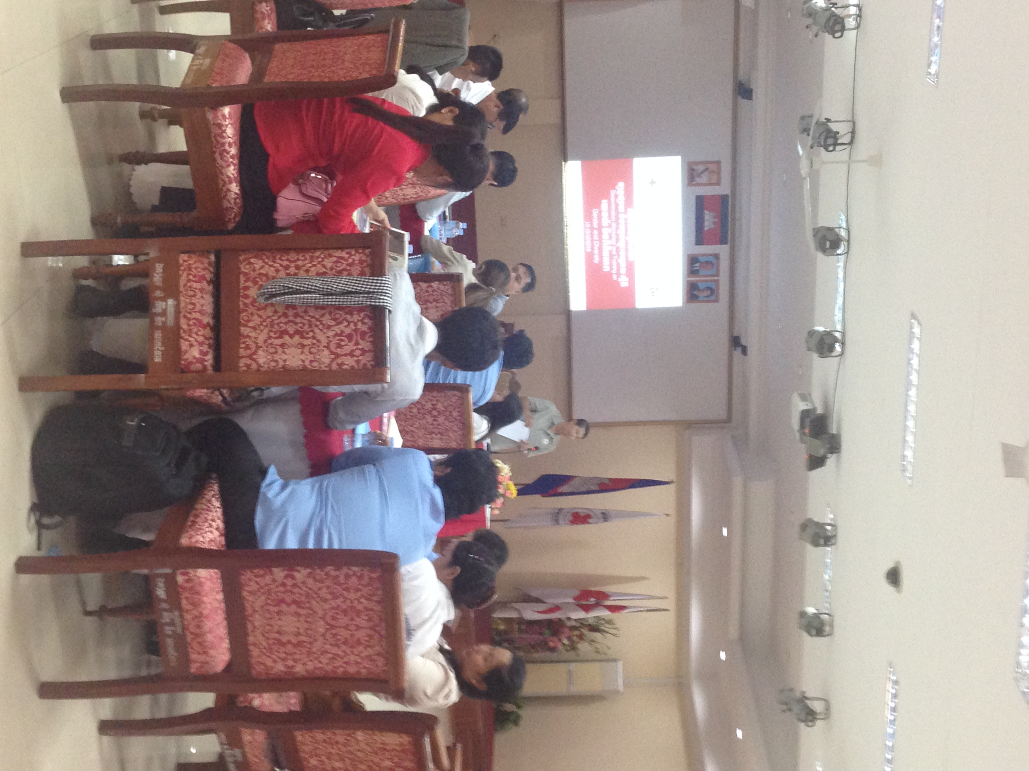
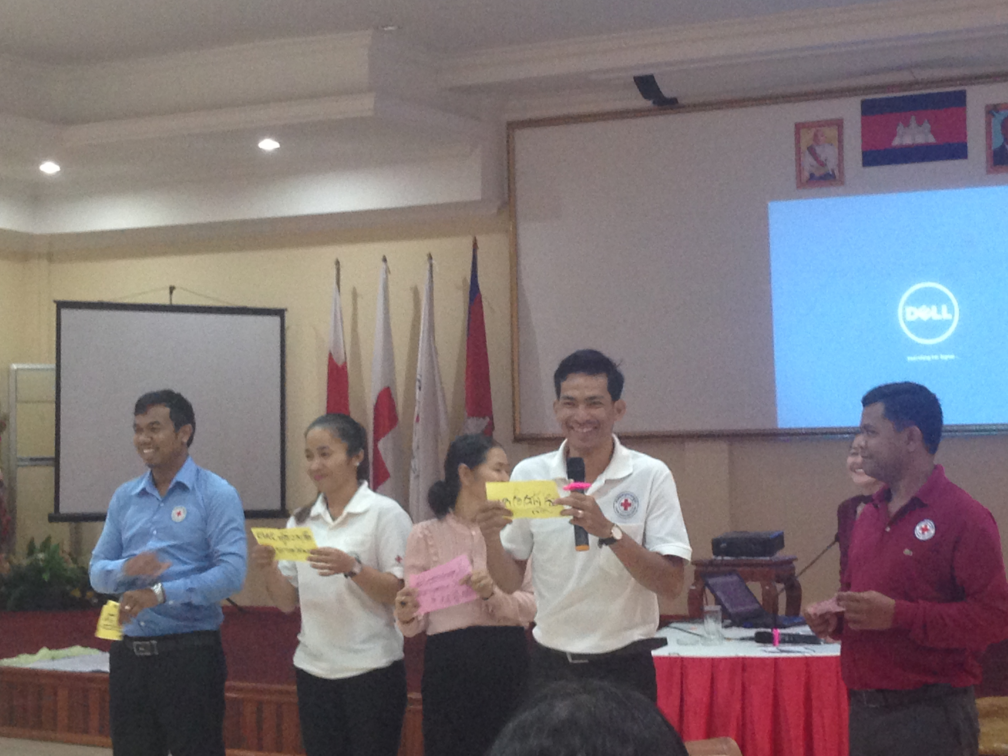
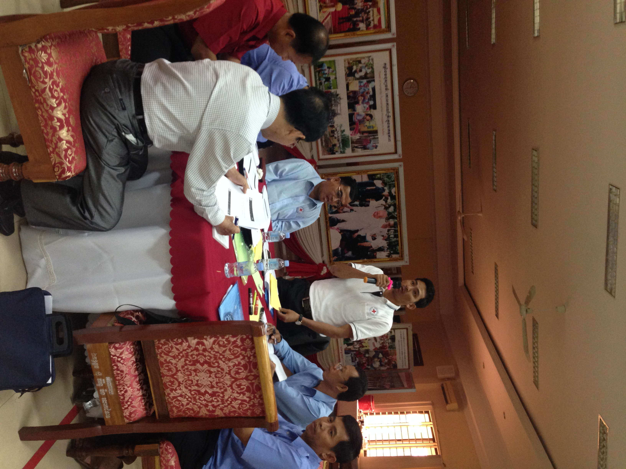
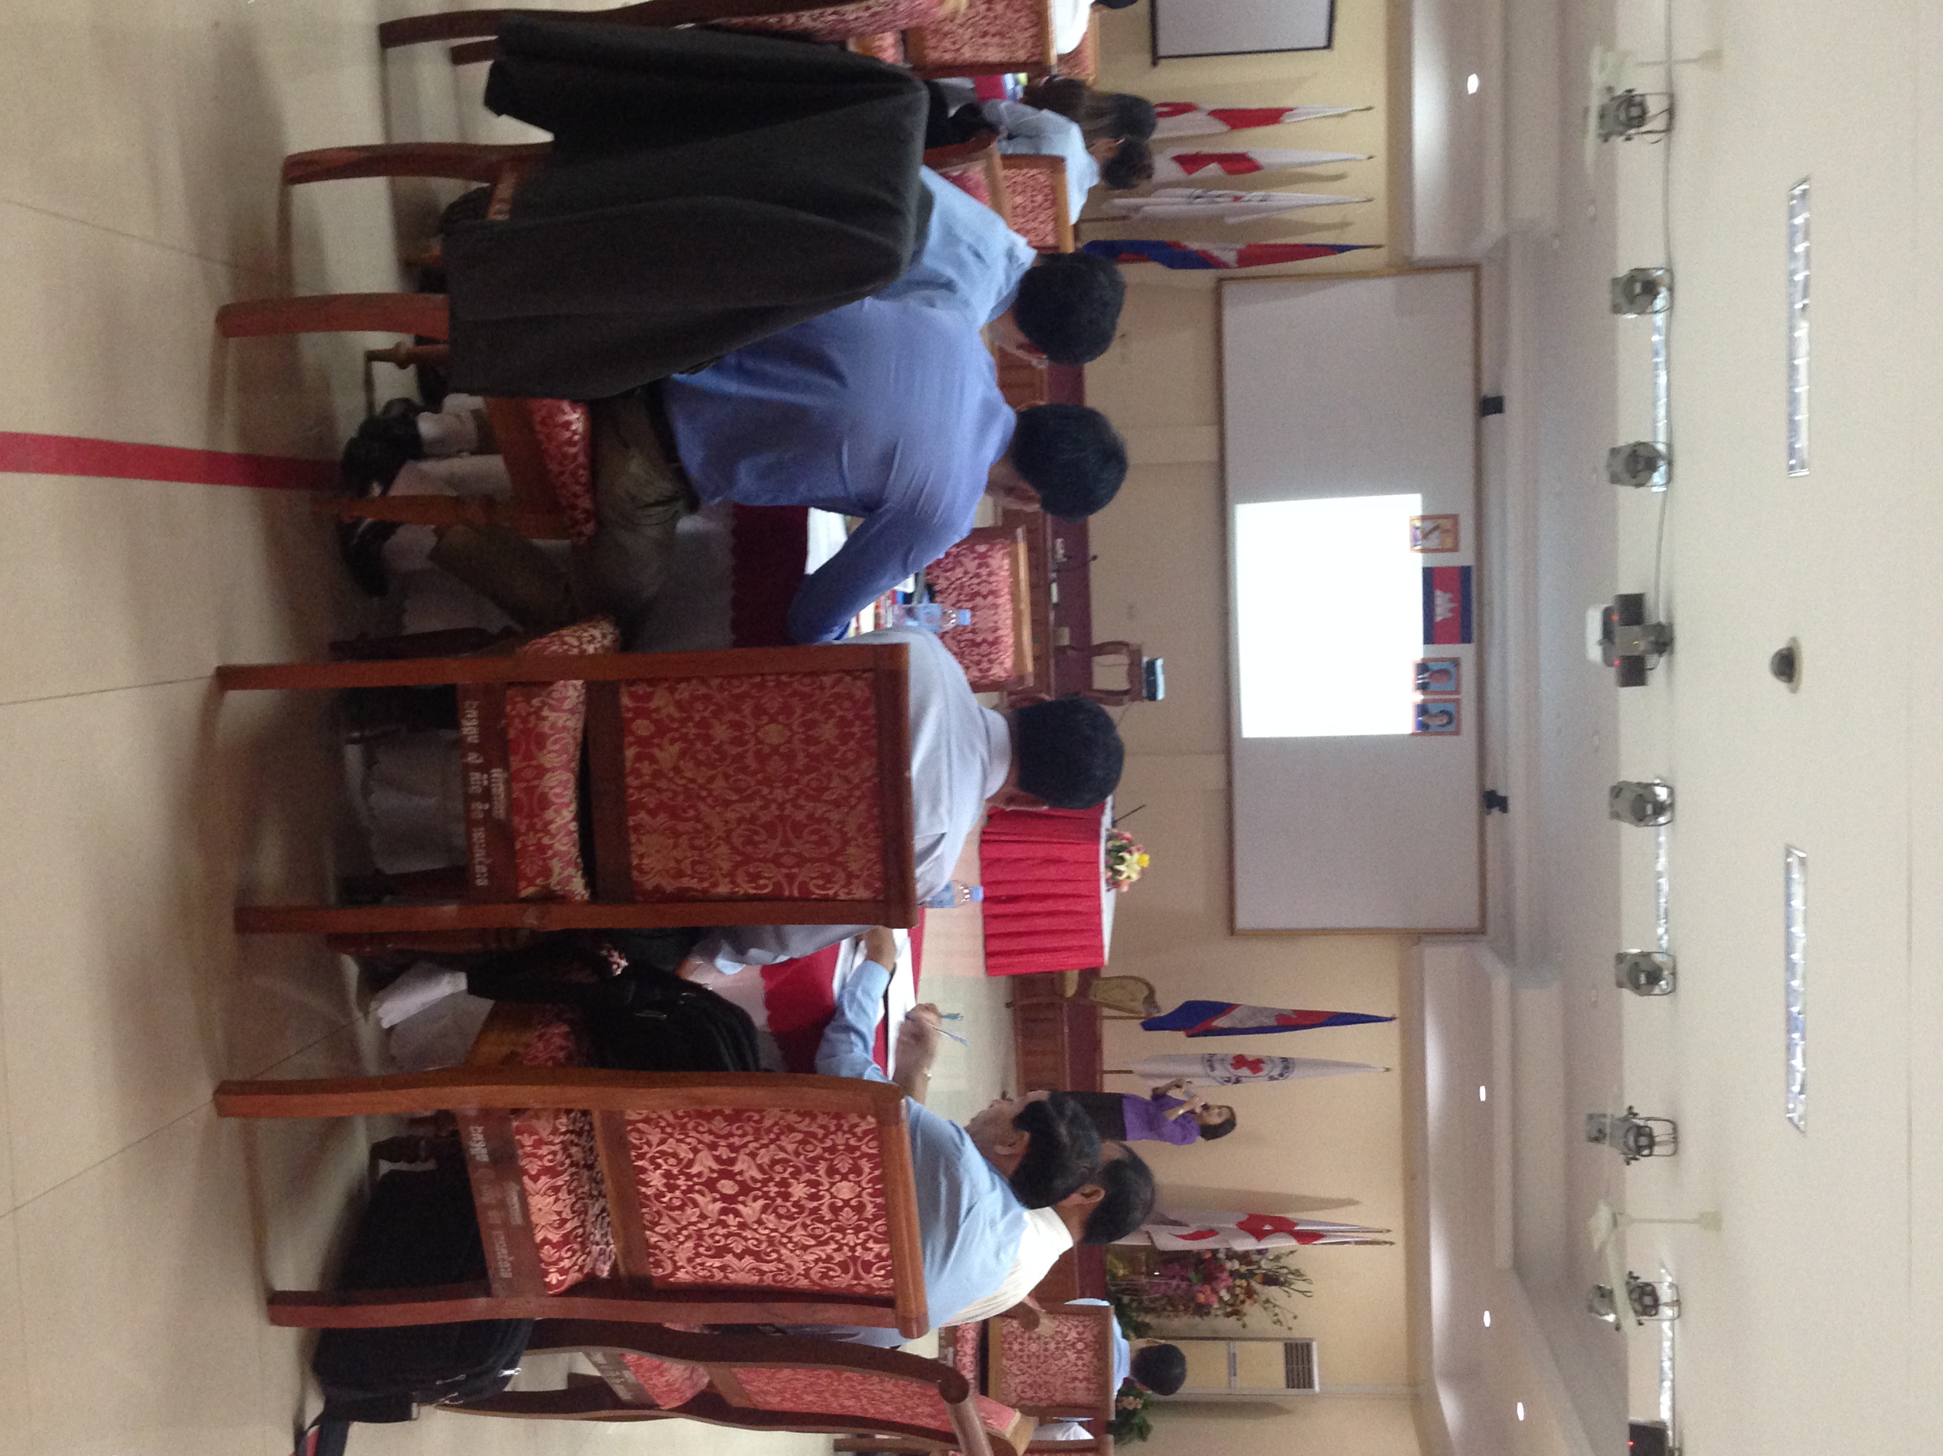

Feedback to IFRC
The IFRC should continuously build the capacities of the national societies, through piloting target branches for gender and diversity mainstreaming in to existing program/project’s activities.
Reporter:
Dr. Uy Sam Onn
Deputy Director of Disaster Management Department

Contact information
For further information, please do not hesitate to contact:
Ms. Christina Haneef
Southeast Asia Regional Gender and Diversity Officer
IFRC South-East Asia Regional Delegation
E-mail: christina.haneef@ifrc.org
Phone: +66 2661 8201 (ext. 104)

