Minutes
10th SEAYN Online Meeting
12 January 2016, 3pm - 6pm, Bangkok Time

Attendees:
- Lai Wai Keat, Malaysian RC
- Rouert Sokhon, Cambodian RC
- Pisey, Cambodian RC
- Kolab, Cambodian RC
- Khunsameng, Cambodian RC
- Exkuwin, Indonesian RC
- Tri Priyanto, Indonesian RC
- Doddy Alfitra, Indonesian RC
- Hnin Phyu Phyu Myint, Myanmar RC
- Sahari Ani, Singapore RC
- Tilynn Low, Singapore RC
- Muhammad Zaidi, Singapore RC
- Daphne Goh, Singapore RC
- Trinuch Suntikul, Thai RC
- Ryan J Jopia, Philippines RC
- Elcy Debildos, Philippines RC
- Vidiana Xareal, Timor Leste RC
- Vphuong, Vietnam RC
- Kumju Ho, IFRC Country Cluster Office (Moderator)
- Naomi Akamatsu, IFRC AP regional Office
- Lak Mony Rasmey IFRC Cambodia
- Ahmad Husein, IFRC Indonesia

Absent with Apologies:
- Laos RC and Brunei RC

Objectives of the Meeting: Bi-monthly online meeting
Attachment: Master Calendar, Spreadsheets of Action plans

No | Items | Presenter | Follow up
1 | Welcome and opening remarks  Lai Wai Keat was introduced to members as the SEAYN Chair and He welcomed members’ participation and briefed the agenda of the meeting.  Agenda for the meeting:  - National Society Youth Action Plan and Event Calendar  - Youth representation in Statutory Meeting  - SEAYN Coordination Team monitoring and support mechanism  - AoB | Lai Wai Keat  Kumju
2 | National Societies’ Youth Action Plan, Regional Action Plan and Calendar of Events  - Sharing by Cambodian Red Cross Society  - Sharing by Myanmar Red Cross Society  - Sharing by Indonesian Red Cross Society  - Sharing by Malaysian Red Crescent Society  - Sharing by Philippine Red Cross  - Sharing by Singapore Red Cross  - Sharing by The Thai Red Cross Society  - Sharing by Timor-Leste Red Cross Society  - Sharing by Vietnam Red Cross  Refer to a master calendar | Khunsameng  Hnin Phyu  Exkuwin  Lai Wai Keat  Elcy Debildos  Sahari Ani  Trinuch Suntikul  Vidiana Xareal  Vphuong
3 | Youth Representation in the Statutory meetings  Statutory Meeting in Geneva from 3rd to 10th December 2015. The Statutory Meeting facilitated a discussion within 190 National Societies, with the focus on Mid-term Review and Strategy 2020.  Youths form part of the delegation with the Secretary General of each National Society, where Youths are given the opportunity to be involved, to raise points during plenary and open sessions. Youths are also given the opportunity to attend the workshops during breakout session, and to discuss on what Youths can bring to the workshops with regards to Strategy 2020.  SEA Leadership Meeting  Zaidi shared about SEAYN, SEAYN newsletter, plan of action and youth update to SEA NS Leader during the meeting  Youth Engagement for a better world Pledge  Refer to http://rcrcconference.org/2015/11/18/youth-engagement-for-a-better-world/ for detailed information  Singapore RC and Myammar RC have signed the pledge. Zaidi encourages the other NS to sign the pledge  New Youth Commission  Chair  Mr. Bas Van Rossum, The Netherlands  Asia  Ms. Pearl Li, Australia  Ms. Lama Srour, Lebanon | Zaidi
4 | SEAYN CT Monitoring and support Mechanisms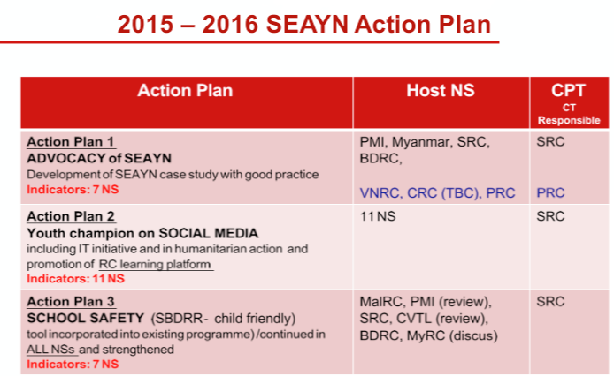  · 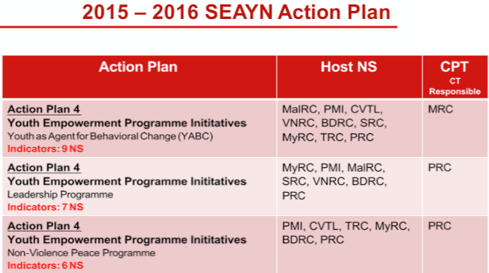  bb 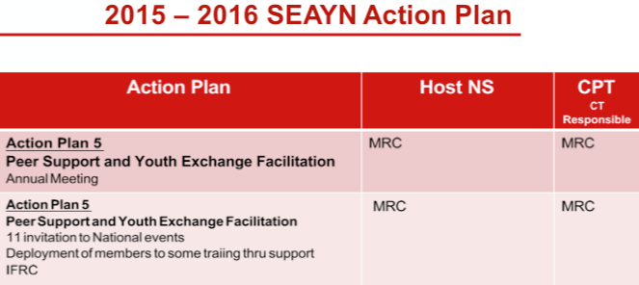  SEAYN Action Plan - Coordination & Updates  Each NS to appoint one focal person to collate updated information (including any experiences, challenges or issues faced with their key action) within a month before the online meeting. CT to facilitate the presentation by providing a guidance before the meeting.  Communication Team  Singapore Red Cross will be heading the Communication Team for 2016 Terms of Reference in February.  - Focal Person in each NS to provide Communication Team with updates and activities to be shared in the SEAYN Facebook  - Communication Team from Singapore RC will follow up with the focal person in each NS  - SEAYN Logo design to be launched by end February. NS to encourage their members to submit design  - SEAYN Website: will be used as a resource for all SEAYN members to share their best practices and programmes  Focal points means SEAYN members | Sahari Ani
5 | YABC Training  SEAYN CT will need to look into allocating resources such as Funding and Trainers for YABC training in each NS.  School Safety  School Safety toolkit will be shared with the NS for their’ references  Communication Team ToR  - Appointing of focal points means the SEAYN members. They are the responsible for communication, advocacy, coordination between SEAYN and each NS.  - APYN page merging up  SEAYN FB is official FB well known to all Networks. How to make it function is the responsibility of CT and communication team. Communication ToR will be drafted and circulated to members in Feb | Kumju
6 | Closing  · Recommendation: To have a master calendar for all to be updated with the activities of various NS  IFRC will support with the implementation of the Action Plans discussed in this meeting | Lai Wai Keat

END

