International Federation of Red Cross and Red Crescent Societies
Southeast Asia Climate Change Master Training
Session Plan of Module 10: Public Awareness Public Education for Disaster Risk Reduction and Climate Change / SEARD Bangkok / 2014

Session Plan of Module 10: Public Awareness Public Education for Disaster Risk Reduction and Climate Change

Objective: Participants enhance their knowledge on strategies, methodologies and tools to inspire communities, general public and youth on climate change.
Duration: 1,5 Hours

Outcome:
- Familiarity with PAPE Guide
- Familiarity with PAPE key messages
- Sharing experience about RCRC or other organizations contributing in public awareness

Reference Materials:
- IFRC_Public Awareness Public Education for DRR 2011
- IFRC_Key Messages Short Version_Public Awareness Public Education for DRR 2013
- IFRC_Key Messages_Public Awareness Public Education for DRR 2013

Key Point to be delivered to Participants:
- The PAPE Guide and key messages, is offered as a tool for practitioners internationally to use in a consensus-building validation process.
- The need to contextualize the key messages based on their own context in close collaboration with others, important to identify key stockholders.
- The need to have knowledge sharing amongst national societies to support the Public Awareness and Public Education initiative.

Timing Session | Purpose/ Objective | Methodology | Material/Facilitator
*From when to when  (min) | What the activity aims at | How the activity is conducted, including the methods to be used (e.g. brain storming, group discussion, role play, etc.), questions, time duration, expected information, what the participants should do, etc.  If case study or role play will be used, explanation or information should be provided as well. | What materials, facilities, equipment are required to conduct this activity (e.g. flip charts, marker pens, colour cards, etc.)
5 minutes | Participants are aware of the objectives | Facilitator opens the session with delivering the objectives of the session | Presentation slide 1-2
25 minutes | To train participants to tailor key messages according to different stakeholders | Group Work 1  - Facilitator conducts Group Work 1 by:  - Dividing participants into Groups of stakeholders (Family, RC Branch, Academic, Local Government and Disaster Management Agency)  - Asking each participants to visit each post (there are five posts as described above, and each post has different questions based on the role of each stakeholder)  - Asking each participants to answer the 5 questions (the questions are available in Session 1A_Exercise on Public Awareness Public Education_Community” and “Session 1B_Exercise on Public Awareness Public Education_Stakeholders” and writing the answers in the metacard in each post… and each question should be answered within 2 minutes- No talking with each other.  - Facilitator conducts plenary discussion by using fishbone method. In this activity, the participants should discuss:  - What is the difference between the answer from family with other stakeholders (RC Branch, Local Government, Academic Institution, Disaster Management agency? (refer to the fishbone diagram below)  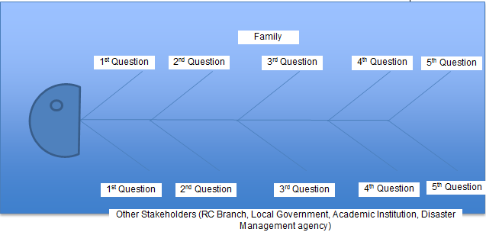  (b) What will happen with the community if they receive different key messages from different key stakeholders?  (c) How can the RC have better role to build consensus on key messages from local level to Global Level? | Presentation slide 3-4  Discussion  Flip chart  Markers  Word documents: “Session 1A_Exercise on Public Awareness Public Education_Community” and “Session 1B_Exercise on Public Awareness Public Education_Stakeholders”
25 minutes | To familiarize participants to PAPE guide and tools | Presentation:  - Facilitator continues delivering power point presentation about PAPE Guide: (a) Planning; (b) Four Key approaches; (c) Four Principles; (d) Tools; (e) Ensuring Qualities;  - Facilitator shares experiences about translating Global Campaign to Local Level and emphasize the importance of having key messages from global level to be translated into local languages in coordination with local government.  [OPTIONAL subject to availability of time] Facilitator delivers a presentation a success story of raising public awareness (see Earth Hour presentation) as an example.  - Facilitator introduces PAPE-Key Messages :  - The global workshop and consultation process to develop the messages;  - The importance of the key messages;  - Key messages structure: family and hazard specific. | Presentation slide 5-32  Discussion  Flip chart  Markers  [OPTIONAL] Presentation and video of Earth Hour
20 minutes | To familiarize participants to the different context specific key messages | Group Work 2 :  - Facilitator lead group work 2  - Step 1: Facilitator divides the participants into 3 groups and assign one set of hazard key messages to each group (drought, flood, and tropical cyclones).  [Please note that these 3 sets of key messages are available in IFRC_Key Messages_Public Awareness Public Education for DRR 2013 in the Resource folder].  [Facilitator and participants can use the table indicated in the presentation slide 34].  - Step 2: Participants identify 2-3 key messages you will use to deliver to the target group (target group refers to the community)  - Step 3: Participants add “Climate Change perspective” on the context-specific details  - Step 4: Participants decide which medium of dissemination they can use (example: radio, brochures, etc.)  - Step 5: Participants decide with whom they need to coordinate about the content of the Key Messages. | Presentation slide 33-34  Discussion  Flip chart  Markers  Pdf document: ‘IFRC_Key Messages_Public Awareness Public Education for DRR 2013’, for key messages for drought see page 29, floods see page 38, tropical cyclones page 46.
5 minutes | To familiarize participants to resources available on PAPE | - Facilitator continues with the Presentation. | Presentation slide 35-39  Discussion  Flip chart  Markers
10 minutes | To elicit participative thinking on PAPE tools | - Facilitator asks questions to the plenary: How can we use the existing tools in a better way?  - Summary | Presentation slide 40-41  Discussion  Flip chart  Markers

