Long Term Planning Framework 2013-2015
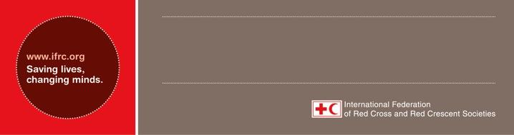

Philippines country office

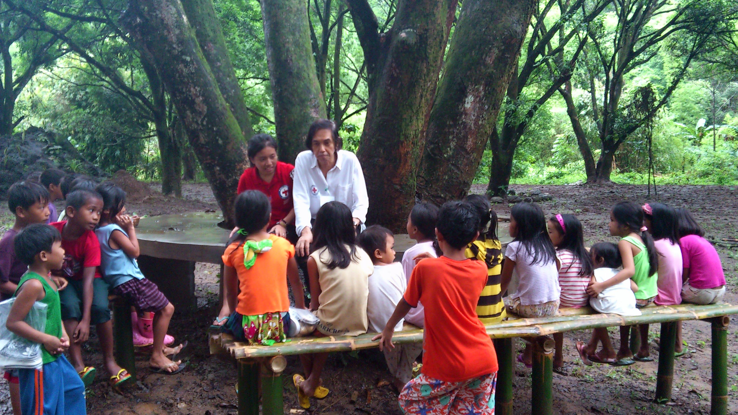

Health volunteers reach out to families in targeted areas and conduct hygiene promotion sessions.
Photo: Philippine Red Cross

1. Who are we?

In ‘normal’ times, IFRC is represented in the Philippines by a country representative, with a safety and resilience coordinator covering the technical aspects. The two are backed up by a small team of national focal persons for administration, finance, communications, reporting, logistics, programme and organizational development. The team supports the Philippine Red Cross (PRC) in developing, implementing and monitoring long-term programmes. Following the effects of major disasters, delegates specializing in operations coordination, shelter, relief, recovery, field support, finance and administration, logistics are engaged – based on the technical support most needed on the ground – to scale-up IFRC’s support to PRC. The country office is supported by IFRC’s Southeast Asia regional office, based in Bangkok, as well as relevant units of the Asia Pacific zone office.

On the National Society’s part, a chairperson who doubles as the chief executive officer, a secretary general and directors of various departments provide leadership. In delivering services, PRC relies on a team of skilled, trained and experienced staff and volunteers. Currently, it has approximately 1,000 staff at the national headquarters and its 100 chapters as well as approximately one million volunteers and supporters, around 500,000 of them active. Professional administrators – who are managers in charge of operations, administrative and representation functions – oversee each chapter.
2. What is our mission?

The mission of the IFRC Philippine country office is to support Philippine Red Cross in enhancing the scale, quality, and reach of its services to the benefit of vulnerable people.

3. Where have we come from and what have we done so far?

The Philippines – comprising 7,000 islands – are considered a middle-income country, ranked 112 out of 187 in the human development report 2011, with a human development index value of 0.644. Poverty is predominant in rural areas and in informal urban settlements. This Southeast Asia nation is one of the most disaster-prone in the world and is hit by an average of 20 typhoons every year and related natural disasters such as landslides and floods. Furthermore, diseases, including tuberculosis, malaria, dengue, measles, HIV and AIDS, continue to pose significant challenges. The country’s population density and extreme poverty worsen the situation, making residents more vulnerable to man-made disasters, natural disasters and health emergencies.

Given PRC’s response to frequent disasters in the country, for years now, IFRC has been supporting the National Society in implementing relief and recovery operations. Capacity building and organizational development components have formed part of the operations, albeit on a small scale. Over time, the National Society has gained extensive experience and knowledge in undertaking massive relief and recovery programmes.

Though significant funding is received for emergency response, only modest funding is obtained for initiatives aimed at enhancing PRC’s capacity to deliver long-term programmes. In this regard, the IFRC launched its first annual appeal for the Philippines in 2008. Since then, the National Society has undertaken several long-term programmes, albeit on a small scale. These include programmes aimed at strengthening disaster response and preparedness capacities at the institutional level, and disaster preparedness, mitigation and risk reduction at the community level. Health and care programmes have focused mainly on first aid, community health, HIV and AIDS, and hygiene promotion.

Organizational development support has extended to financial management, leadership development, and volunteer management – the latter, through an initiative dubbed ‘Red Cross 143’, through which PRC targets
to have at least 44 skilled, trained and well-equipped volunteers [1 team leader and 43 members] in each of the 42,000 barangays (villages) of the nation. Exposition of the Red Cross Red Crescent Fundamental Principles and humanitarian values is integral to all programmes.

While long-term programme work relies heavily on international support, IFRC’s long-term appeal for Philippines has elicited little interest from donors over the past years, with the modest resources available for organizational preparedness and development being carry-over funds from previous emergency appeals. Scaled-up long-term programming and organizational development support is necessary for the sustainability of PRC’s capacity to fulfill its mission and to deliver on its humanitarian mandate.

4. Who are our stakeholders?

The ultimate stakeholders are the community members – vulnerable people – whose lives the programmes aim to improve. To deliver on the programmes, however, we work closely with other actors whose roles are complementary to the successful fulfilment of outcomes. As well as partner national societies, the national and local authorities are some of these key actors. These include the national disaster risk reduction and management council (NDRRMC), local disaster risk reduction and management councils, local government units (LGUs), department of health (DoH), department of social welfare and development (DSWD), department of education (DepEd), overseas workers welfare administration (OWWA) and Philippine overseas employment administration (POEA). Non-governmental actors with whom we collaborate are hospitals and medical centres, foundations, non-governmental organizations (NGOs) and other humanitarian organizations working in the Philippines.

Thus far, financial support to long-term programmes has been made possible through funds carried over from previous emergency appeals. Potential funding opportunities are being pursued – at regional level – with the Australian Agency for International Development (AUSAID) and the Canadian International Development Agency (CIDA). The partners who have provided consistent support funding support to PRC are listed in the table below.
Table: Current support from Red Cross Red Crescent and other partners to PRC

Partners | Disaster Response | DRR | Health | Watsan | OD | RFL
Multilateral partner National Societies through IFRC:
American RC | 
Australian RC | 
Austrian RC | 
British RC | 
Canadian RC | 
Danish RC | 
Finnish RC | 
Hong Kong branch of the RC of China | 
Icelandic RC | 
Irish RC | 
Japanese RC | 
Luxembourg RC | 
New Zealand RC | 
Norwegian RC | 
RC of the Islamic Republic of Iran | 
RC of Monaco | 
Swedish RC | 
Netherlands RC | 
Republic of Korea RC | 
Other multilateral partners through IFRC:
DFID |  |  |  |  | 
USAID/OFDA |  |  |  |  | 
DG ECHO | 
Bilateral partner National Societies:
Australian RC |  |  |  |  | 
Finnish RC |  |  | 
German RC |  | 
Japanese RC |  |  | 
Netherlands RC |  | 
Singapore RC | 
Spanish RC |  |  |  | 
Qatar RC |  |  | 
Other bilateral partners:
AusAID |  |  |  |  | 
DIPECHO |  | 
ICRC |  |  |  |  |  | 
USAID | 

DIPECHO |   |   |   |   |   |  
ICRC |   |   |   |   |   |  
USAID |   |   |   |   |   |  

5. Where are we going and how are we going to get there?

Over the next couple of years, IFRC will scale up its support to PRC as regards delivering services as mandated by the ‘Philippine Red Cross Act of 2009’. In a bid to enhance focused support for longer-term programmes, starting May 2012 the country office was bolstered with a safety and resilience coordinator. The coordinator is working closely with PRC in developing a resilience framework, which will promote an integrated approach to programming, with the view of growing Red Cross Red Crescent services for vulnerable people.

The steering framework for PRC will be ‘Philippine Red Cross Strategy 2012-2016’, whose theme is working together to do more, do better, and reach further. The vision outlined in that strategy is for PRC to be the foremost humanitarian volunteer organization, in services provided and number of people served. In its new strategy, the National Society identifies four goals:

- Significantly reducing the impact of disasters, climate change, public health emergencies and illnesses on the most affected families and communities;
- Improving health and well-being at the individual, family and community levels;
- Reducing unnecessary suffering from armed conflict and from other forms of violence, and;
- Ensuring that the Philippine Red Cross is a well-functioning National Society.

In adopting the New Strategy, PRC is demonstrating the relevance of its promise to be always first (to plan, predict, prepare and practice), always ready (with trained volunteers, supplies and logistics) and always there (present nationwide, to deliver at the time the assistance is needed). IFRC support to PRC will be based on actual needs of the National Society and communities.

Through IFRC support, the National Society will strive to realize the strategic aims, enabling actions and the business model relating to IFRC Strategy 2020, consistently with the Secretariat objectives. Through the inter-linked components, the National Society will not only bolster its capacity to deliver services, but also strengthen local communities and their coping mechanisms, thereby contributing to the three outcomes of Strategy 2020: save lives, protect livelihoods, and strengthen recovery from disaster and crises; enable healthy and safe, and; promote social inclusion and a culture of non-violence and peace.

Business Line 1 – “To raise humanitarian standards”
Outcome 1 (Competence enhancement): Qualifications and competences of leadership and staff improved to establish a sustainable organization.
Output 1.1: Senior managers access management training opportunities.

Target: By 2015, 75% of directors and senior managers have accessed management-training opportunities available in and/or outside the country.

Business Line 2 – “To grow Red Cross Red Crescent services for vulnerable people”
Outcome 1 (Business continuity planning): Capacity of PRC to anticipate and plan for exposure to internal and external threats developed.
Output 1.1: PRC develops a business continuity plan that identifies internal and external threats and highlights ways of ensuring effective prevention and recovery.

Target: By 2015, the National Society has put in place a business continuity plan and set out to establish an ‘alternative’ operational base.
Outcome 2 (Disaster management planning): Ability of PRC to anticipate and plan for disasters, to mitigate their impact on vulnerable communities, improved.
Output 2.1: Standard operating procedures of PRC updated, adopted and pre-tested.

Target: By 2015, the National Society has finalized and operationalized its standard operating procedures and disseminated them to all existing chapters.
Output 2.2: PRC prepares contingency plans and strengthens response capabilities at chapter and community levels.

Target: By 2015, the National Society has finalized and operationalized its national contingency plans and all existing chapters have prepared chapter-level contingency plans on their basis.
Outcome 3 (Organizational preparedness): Capacity in skilled human resources and relevant material resources for effective delivery of disaster, health and welfare services improved.
Output 3.1: Adequate, diverse, gender-balanced staff and volunteers for emergency, disaster, health, and welfare action recruited, trained, retained and managed.

Target: By 2015, the National Society headquarters and all existing chapters have an adequate number of staff and active volunteers who have received relevant orientation.
Output 3.2: Minimum-standard equipment, facilities and items for immediate delivery of disaster, health and welfare services provided and managed.

Target: By 2015, the National Society headquarters and 12 chapters supported to obtain essential equipment (including search and rescue equipment) and well maintained supplies (including pre-positioned stocks).
Outcome 4 (Integrated community disaster preparedness): Local communities and institutions are better prepared for, mitigate, and respond to disasters.
Output 4.1: Communities, teachers and students provided with knowledge on hazard awareness and assisted to translate hazard maps produced by early warning institutions.

Target: By 2015, local communities, and teachers and students in learning institutions in 12 chapters are able to conduct vulnerability capacity assessments.
Output 4.2: Communities supported to develop action plans and to implement basic mitigation activities at local community level.

Target: By 2015, local communities in 12 chapters develop disaster action plans, establish ordinances advocating families to have survival kits, conduct drills on the hazards identified in the plans and ensure that families are reached with information campaigns on what to do before, during, and after disaster.
Output 4.3: Teachers and students in selected schools assisted to develop action plans and to implement basic mitigation activities at school level.

Target: By 2015, teachers and students in learning institutions in 12 chapters develop school-level disaster action plans, advocate for their families to have survival kits, conduct drills on the hazards identified in the plans and reach other teachers and students with information campaigns on what to do before, during, and after disaster.
Outcome 5 (Community health): Increased capacity of communities to respond to health and injury priorities during disasters, health emergencies and normal times.
Output 5.1: Communities improve knowledge and practices related to five common causes of morbidity and mortality as identified during assessments.

Target: By 2015, local communities in 12 chapters are able to conduct baseline assessments, identify priority health problems, develop community health action plans, and undertake health education sessions and activities on what to do before, during, and after identified health problems.
Output 5.2: Targeted communities supported to develop epidemic preparedness plans and to implement basic mitigation activities.

Target: By 2015, local communities in 12 chapters are able to conduct baseline assessments, identify potential health epidemics, develop epidemic preparedness plans, present the plans to respective rural health units, and link the plans to their community disaster action plans.
Output 5.3: Awareness of health emergencies in targeted communities improved.

Target: By 2015, local communities in 12 chapters have undertaken health in disaster and emergency (HIDE) education sessions and organized activities – relating to their epidemic preparedness plans – on what to do before, during, and after HIDE problems.

Business Line 3 – “To strengthen the specific Red Cross Red Crescent contribution to development”

Outcome 1 (Resilience framework): PRC develops and adopts a resilience framework for programming.
Output 1.1: A resilience framework integrating relevant programming components developed

Target: By 2015, PRC supported to develop a resilience framework outlining the organization’s approach to resilience programming.
Outcome 2 (Cash-based programming development): Capacity of PRC to implement programmes using cash-based methodologies developed.
Output 2.1: National society provided with technical support, enabled to pilot and assisted to institutionalize cash-based programming.

Target: By 2015, PRC supported to develop and adopt cash-based programming standard operating procedures and guidelines, and to establish a cash-based programming working group.
Outcome 3 (Support service development): Structures, systems, processes and mechanisms necessary for delivery of services and accountability improved.
Output 3.1: Capacity of PRC’s communications unit to project a positive image, messaging and brand of the National Society enhanced.

Target: By 2015, PRC supported to update its communications plan/strategy, obtain relevant basic equipment at the national headquarters and 12 chapters, and organize six photography/news-writing training sessions for targeted staff and volunteers.
Output 3.2: Financial management systems, procedures and guidelines of PRC improved.

Target: By 2015, PRC updates/produces its financial management procedures, guidelines and manual, and rolls out the use of Microsoft Dynamics NAV to major departments and pilot chapters.
Output 3.3: PRC reviews and develops job descriptions for critical positions in accordance with its staffing needs.

Target: By 2015, PRC has reviewed/developed job descriptions for 100% of its critical positions.
Output 3.4: Capacity of PRC in logistics core areas of procurement, warehousing, transport and fleet management improved.

Target: By 2015, PRC has updated/produced logistics (procurement, warehousing, transport and fleet management) procedures, policies and manuals, computerized logistics processes, refurbished main warehouses and improved on warehouse management.
Outcome 4 (Chapter development): Base units of PRC strengthened to deliver services during disasters, health emergencies and normal times.
Output 4.1: Selected PRC chapters upgraded.

Target: By 2015, 12 PRC chapters supported to go at least one grade higher in the National Society’s chapter grading scale.
Outcome 5 (Governance support): Governance of PRC supported to uphold integrity.
Output 5.1: Members of PRC governance receive ongoing support related to performing their role.

Target: By 2015, PRC governance commissions and completes a mid-term review to determine progress relating to implementation of the National Society’s Strategy 2012-2016.

Business Line 4 – “To heighten Red Cross Red Crescent influence and support for our work”

Outcome 1 (International disaster response laws, rules and principles): Legal preparedness for international disaster relief and initial recovery assistance enhanced.
Output 1.1: Continued engagement with the authorities strengthens domestic laws and policies relating to regulation of international disaster relief and initial recovery assistance.

Target: By 2015, the authorities have strengthened domestic policies and regulations relating to international disaster relief and initial recovery assistance, thus enhancing assistance to vulnerable people.
Outcome 2 (Advocacy): Access to safer land by communities living in disaster-prone areas promoted and increased.
Output 2.1: Continued engagement with authorities and stakeholders leads to availability of land to resettle communities living in disaster-prone areas.

Target: By 2015, continued engagements with national and local authorities enable allocation of land sites for disaster-displaced communities that lived in disaster-prone areas, thus better outcomes for vulnerable people.
Outcome 3 (Principles and values): Awareness of the fundamental principles and values of the International Red Cross Red Crescent Movement contributes to building inclusion and tolerance.
Output 3.1: Dissemination of fundamental principles and values of the International Red Cross Red Crescent Movement contributes to positive behaviour change among the people reached with services.

Target: By 2015, the International Red Cross Red Crescent Movement principles and values are integrated and promoted across all programmes, contributing to increased tolerance and respect for diversity.

Business Line 5 – “To deepen our tradition of togetherness through joint working and accountability”

Outcome 1 (Coordination): Cooperation mechanisms that take into account the contributions, complementary capacities and resources of partners enhanced.
Output 1.1: PRC supported to fulfill its commitment to the Federation-wide planning and reporting system.

Target: By 2015, the inputs of PRC into Federation-wide planning and reporting system are done within deadlines and have no data inconsistencies.
Output 1.2: Plans and actions of IFRC-supported programmes coordinated with Movement partners and external actors to achieve higher value from Red Cross work.

Target: By 2015, through better coordination with Movement partners and external actors, PRC has accessed and used best practices and latest tools to strengthen programmes, services and capacities.
Output 1.3: The IFRC country office fulfills its emergency shelter cluster coordination commitments.

Target: By 2015, the IFRC country office has a national shelter cluster focal person to collaborate and build synergies with external cluster actors, including in preparedness for response.

6. What are some of the key risks/assumptions?
PRC management and board commitment: The decision-making process in PRC is multi-stepped. Changes in procedures, systems and structures need to be approved first by respective committees, and then endorsed by the board. This framework has been discussed with PRC and their input sought. It is expected that the board will approve all products as the outcomes of this framework are in line with the National Society’s strategic direction.

There is no major disaster: Considering that Philippines is hit by an average of 20 typhoons every year, and the threat of earthquakes, volcanic eruptions, landslides and health epidemics is always looming, an occurrence of such would prompt PRC’s national headquarters and chapters to re-focus most effort towards response. Nevertheless, strong collaboration and integration across programmes as well as between the national headquarters and chapters will be maintained to ensure that development work progresses alongside possible relief and recovery efforts.

7. How much will it cost?

Long Term Financial Projections 2012-2015

Philippines | 2013 | 2014 | 2015 | Total
BL 1. Humanitarian Standards | 25,000 | 25,000 | 25,000 | 75,000
BL 2. Disaster Management Services (total) | 215,000 | 215,000 | 215,000 | 645,000
BL 3. Sustainable Development | 150,000 | 150,000 | 150,000 | 450,000
BL 4. Humanitarian Diplomacy | 10,000 | 10,000 | 10,000 | 30,000
BL 5. Effective working and accountability | 50,000 | 50,000 | 50,000 | 150,000
Total Budget | 450,000 | 450,000 | 450,000 | 1,350,000

International Federation of Red Cross and Red Crescent Societies
10 I Long Term Planning Framework 2012-2015

How we work
All IFRC assistance seeks to adhere to the Code of Conduct for the International Red Cross and Red Crescent Movement and Non-Governmental Organizations (NGOs) in Disaster Relief and the Humanitarian Charter and Minimum Standards in Disaster Response (Sphere) in delivering assistance to the most vulnerable.

IFRC’s vision is to inspire, encourage, facilitate and promote at all times all forms of humanitarian activities by National Societies, with a view to preventing and alleviating human suffering, and thereby contributing to the maintenance and promotion of human dignity and peace in the world.
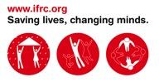

IFRC’s work is guided by Strategy 2020 which puts forward three strategic aims:
1. Save lives, protect livelihoods, and strengthen recovery from disaster and crises.
2. Enable healthy and safe living.
3. Promote social inclusion and a culture of nonviolence and peace.

Find out more on www.ifrc.org

Contact information
For further information specifically related to this plan, please contact:

• Philippine Red Cross:

• Gwendolyn Pang, secretary general; email; gwendolyn.pang@redcross.org.ph, phone: +63 2 525 5654; fax: +63 2 527 0857.

• IFRC Philippines country office:

• Selvaratnam Sinnadurai, head of country office, email: selvaratnam.sinnadurai@ifrc.org; phone: +63 2 309 8622, mobile: +63 917 880 6844

- Niels Juel, safety and resilience coordinator, email: niels.juel@ifrc.org
phone: +63 2 309 8622, mobile: +63 919 514 0601

• IFRC Southeast Asia regional office, Bangkok:

• Anne Leclerc, head of regional office; email: anne.leclerc@ifrc.org; phone: +662 661 8201, fax: +662 661 9322

• IFRC Asia Pacific zone office, Kuala Lumpur:

• Alan Bradbury, acting head of operations; e-mail: alan.bradbury@ifrc.org;
mobile +60 3 9207 5775;

• Chris Staines, acting head of resource mobilization and PMER; email: chris.staines@ifrc.org; mobile: +60 19 62 00 357 and fax +603 2161 0670.

Please send all pledges of funding to zonerm.asiapacific@ifrc.org

