RDRT Induction Course
Asia-Pacific



FINAL

March 2013

Description:
A course to orient and select RDRT members for Regional Disaster Response Team deployment

Rationale: The course aims to give a general orientation to the disaster response process and allow for selection of suitable RDRT members.

Course Sessions:
- Day 1
  - Day 1 Welcome
  - What is an RDRT
  - Introduction to RCRC policies
  - DM terminology
  - Day 1 Putting It All Together
- Day 2
  - Day 2 Welcome
  - Global Response Tools
  - ERU - SPHERE
  - Response mechanism
  - Day 2 Putting It All Together
- Day 3
  - Day 3 Welcome
  - Assessment
  - Data Synthesis & Plan of Action
  - Emergency Health
  - Day 3 Putting It All Together

- Day 4
  - Day 4 Welcome
  - Logistics & Distribution
  - WatSan
  - PMER
  - Cluster Approach
  - Day 4 Putting It All Together

- Day 5
  - Day 5 Welcome
  - RDRT alert & deployment
  - Beneficiary Communications
  - Day 5 Putting It All Together

- Day 6
  - Day 6 Welcome
  - RCRC Movement Coordination
  - Security
  - Stress, Self-Care & PFA
  - Day 6 Putting It All Together

- Day 7 Field Guidance

- Day 8
  - Day 8 Welcome
  - Do No Harm
  - Media
  - Finance
  - Putting It All Together

Course Materials
- Session folders. Each course session has a dedicated folder, with all required materials. Videos embedded in the powerpoint presentations are included additionally in a separate folder with each session folder in case of issues with playing on specific machines. All videos are saved in mp4 format.
- USB stick (> 500 MB capacity)
Each participant and facilitator should receive a USB stick pre-loaded with the following documents – as contained in the ‘Docs for RDRTs’ folder. These files are required reference materials for the course:

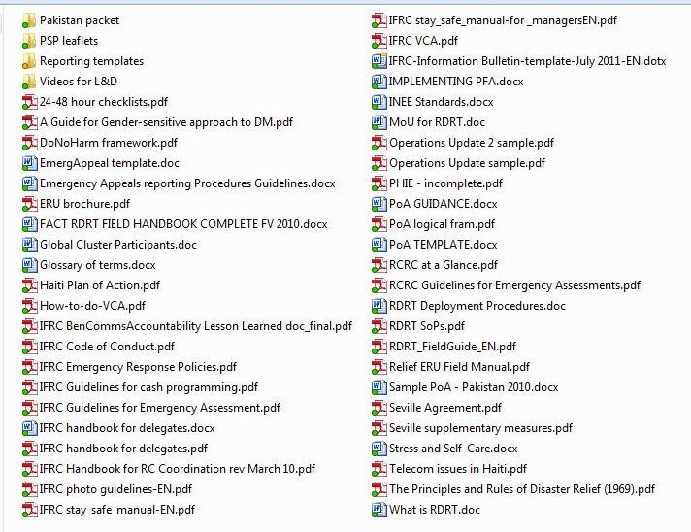
- Posters: The course materials include a folder with images and key graphics that should be printed to poster size and displayed around the room during the training. These posters can be printed inexpensively and re-used for subsequent courses. ALL of the posters should be posted from the first day of the training until the end – not just when the specific content is being introduced. This pre-exposure to the content aids in retention of the materials when it is finally presented.
- Course Evaluation forms. The evaluation forms apply to Level 1 evaluation. A post-test may be given at the discretion of the facilitators – it is not required.

- Participant Evaluation sheets – these are the forms used to regularly assess and evaluated the progress of each participant. Progress should be shared with the participants daily, See the Evaluation guidance sheet for further information.

Time Required:
64 hours (non-inclusive of breaks)
7 days of classroom instruction; 1 day field work

Target audience:
National Society professionals and volunteers selected by NS teams to learn the skills of disaster response

Group Size:
25 participants

Objectives:
By the end of the course, learners will be able to:
- Define the competencies of an effective RDRT member during a disaster response.
- Demonstrate accountability to beneficiaries during a response.
- Demonstrate understanding and applicability of common standards.
- Discuss the importance of deployment procedures and readiness.
- Demonstrate ability to interact appropriately as an RDRT member with others in an emergency setting.
- Demonstrate ability to conduct and/or assist in conducting an assessment of a disaster.
- Demonstrate ability to prepare an adequate and feasible plan of action based on analysis of assessment data.
- Demonstrate ability to distribute relief to beneficiaries in an appropriate and humanitarian way.

Note that every course session contributes to the successful completion of these learning objectives. There are no additional objectives - every session in the course is a build-up of knowledge, skills and behaviours towards these stated objectives.

Overall Course Design
The course consists of 8 days of instruction. This is a standalone course. The suggested Course outline is below.

Day 1
Session | Content | Time
1 | Welcome  Learning objectives  Course agenda | 8:00 – 9:00
2 | What is an RDRT | 9:00 – 10:00
 | BREAK | 10:00 – 10:30
3 | Introduction to RCRC Policies for RDRTs and other Relief Staff  Intro to RCRC... (continued) | 10:30 – 12:30  LUNCH  12:30 – 13:30  14:00 – 15:30
4 | DM terminology | 16:00 – 17:00
5 | Putting it All Together  Review | 17:00 – 18:00

Day 2
Session | Content | Time
1 | Welcome back  Learning objectives review  Course agenda | 8:00 – 8:30
2 | Global response tools: FACT, ERU general, RDRT, DREF | 8:30 – 10:00
 | BREAK | 10:00 – 10:30
3 | ERU – SPHERE  ERU – SPHERE (continued) | 10:30 – 12:30  LUNCH  12:30 – 13:30  13:30 – 14:30
4 | Response mechanism | 14:30 – 16:00
5 | Putting it All Together  Review | 16:30 – 17:30

Day 3
Session | Content | Time
1 | Welcome back  Learning objectives review  Course agenda | 8:00 – 8:30
2 | Assessment | 8:30 – 12:00  (includes tea break)
 | LUNCH | 12:00 – 13:00
3 | Data Synthesis & Plan of Action | 13:00 – 15:00
 | BREAK | 15:00 – 15:30
4 | Emergency Health | 15:30 – 17:00
5 | Putting it All Together  Review | 17:00 – 18:00

Day 4
Session | Content | Time
1 | Welcome back  Learning objectives review  Course agenda | 8:00 – 8:30
2 | Logistics & Distribution | 8:30 -10:30
 | BREAK | 10:30 – 11:00
3 | WatSan | 11:00 – 12:30
 | LUNCH | 12:30 – 13:30
4 | PMER | 13:30 – 15:00
 | BREAK | 15:00 – 15:30
5 | Cluster approach | 15:30 – 17:00
6 | Putting it All Together  Review | 5:30 – 6:30

Day 5
Session | Content | Time
1 | Welcome back  Learning objectives review  Course agenda | 8:00 – 8:30
2 | Beneficiary Communications | 8:30 – 11:30  (includes 30 minute tea break)
3 | RDRT Alert & Deployment | 11:30 – 12:30  LUNCH  12:30 – 13:30  13:30 – 17:00  (includes 30 minute tea break)
4 | Putting it All Together  Review | 17:00 – 18:00

Day 6
Session | Content | Time
1 | Welcome back  Learning objectives review  Course agenda | 8:00 – 8:30
2 | RCRC Movement Coordination | 8:30 – 10:30
 | BREAK | 10:30 – 11:00
3 | Stress, Self-Care & PFA  Stress, Self-Care & PFA (continued) | 11:00 – 12:30  LUNCH  12:30 – 13:30  13:30 – 14:30
4 | Security | 14:30 – 16:00
 | BREAK | 16:00 – 16:30
5 | Putting it All Together  Prep for tomorrow’ s field visit | 16:30 – 18:00

Day 7 Field Practice

Day 8
Session | Content | Time
1 | Welcome back  Learning objectives review/self-evaluation  Review / analysis of field visit | 8:00 – 9:30
 | BREAK | 9:30 – 10:00
2 | Media | 10:00 – 11:30
3 | Do No Harm | 11:30 – 12:30
 | LUNCH | 12:30 – 13:30
4 | Finance | 13:30 – 14:30
5 | Putting it All Together  Final score distribution / Eligibility determinations | 14:30 – 16:30 (approximately)

Course Evaluation
The course evaluation would consist of:
- Level 1 Evaluation – given at end of course
- Level 2 Evaluation – cumulative participants evaluation scores (that the facilitators completed) from Days 1-7
- Level 3 Evaluation - Post-training evaluation form

Pre-Course Requirements Before Attending RDRT Induction Training:

All trainees must take the following e-learning courses as offered on IFRC’s Learning Platform. For each course, a certificate of successful completion is sent to each participant. This certificate of completion must be sent to the course coordinator prior to arrival at training.

To access and take the course, it is necessary to use Internet Explorer:

- Go to http://ifrc.org/en/get-involved/learning/.
- Click on Learning Platform. If you are already registered, sign in. If you are not yet registered, click on ‘Create your profile’.
- Once you access the welcome page, click on ‘Browse for Training’. Click on ‘Go to search’ and enter the course name.
- Click on the course name. The course will be included as one of your courses. Click on ‘Launch’ in the far right column to start the course.
- You may start and stop the course as necessary. Only when you finish the course, will you receive the certificate. E-mail the certificate to the RDRT course coordinator before departing for the training.

The RDRT Induction’s prequisite e-courses:

- Code of Conduct for the International Red Cross and Red Crescent Movement and NGOs in Disaster Relief
- Gender equality in programme planning – “Different needs, equal opportunities”
- Stay Safe – Personal safety
- SPHERE Handbook in Action

