Indonesia DRR Profiles
JOKO: A 24-YEAR OLD man
Joko is a nurse, he’s 24 and lives in a flood prone neighbourhood. He has recently told his family and friends that he is gay. Most of his family have supported him however some people in the community were not so accepting. Since he has spoken out about his sexual orientation, members of the community have begun to ostracise him and he has stopped going to church.
“I feel more alone” John-Paul said “I do not feel as much a part of the community. All my male neighbours avoid me and I do not feel very safe, some people have threatened to beat me, or worse, and my patients have been asking that I take an HIV test.”

Indonesia DRR Profiles
AYU: A 15-YEAR OLD GIRL
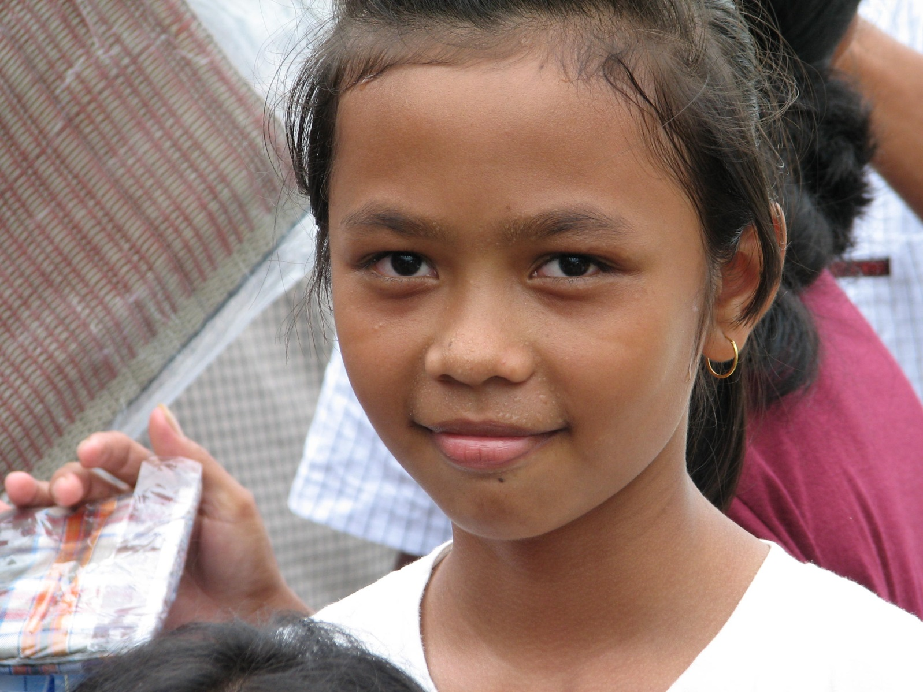Ayu is 15 and lives with her mother, father and younger brother. She has been blind all her life. She has learnt to navigate her surroundings over the years and can move around un-aided in her house and the area close by. However if Ayu travels further from her house or goes to a new place she needs a family member to assist her. She is concerned that should an earthquake hit her community, she is worried about what she will do if she has to evacuate.

Indonesia DRR Profiles
SAIFULLAH: A 70-YEAR OLD WOMAN WITH FOUR GRAND-CHILDREN
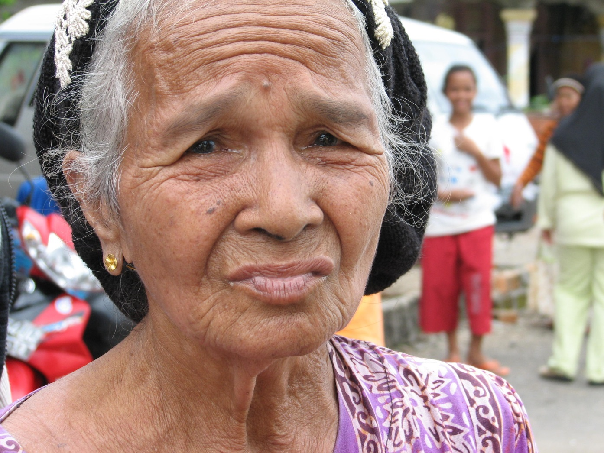Saifullah lives with her four young grandchildren. During the last earthquake her daughter and son-in-law passed away and she now is the primary caregiver to her grandchildren. Saifullah’s house was also damaged and she has not managed to fix the water supply. Saifullah does not work anymore and relies on other family members and her eldest grandson (who is 15) to financially support the family. She would like to contribute to her family’s financial situation and participate more in the community but her health is not as it used to be and she has trouble walking to community meetings and she cannot take her grandchildren.
Indonesia DRR Profiles
WISNU: A 35-YEAR OLD MAN WITH THREE YOUNG CHILDREN
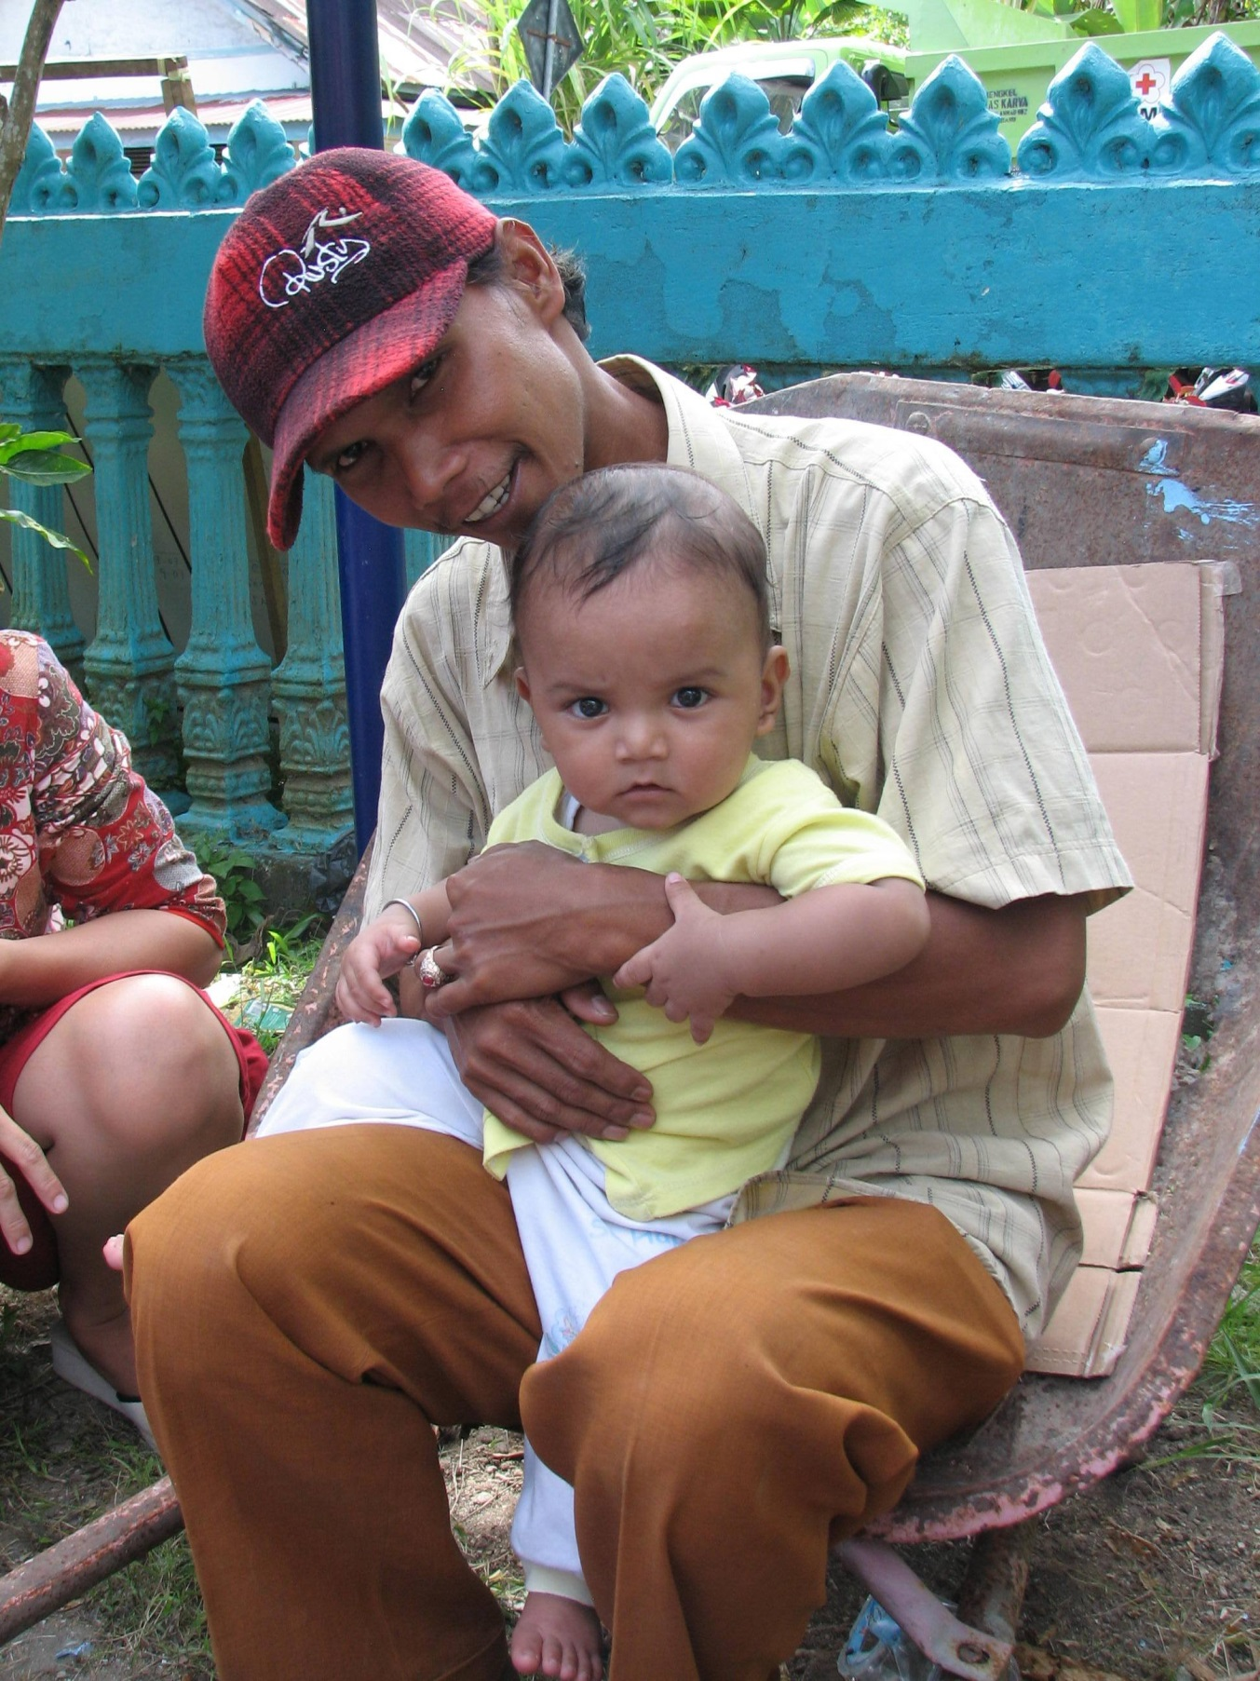
Wisnu is a single father of three young children, Lina aged nine, Wisnu junior aged six and Agatha aged two years.
The last time an earthquake hit, his wife passed away. The youngest two were particularly traumatised. As a result Wisnu moved his family from their rural community to the city to start a new life. Wisnu works long hours every day to ensure he has just enough money. He leaves Agatha with his neighbour. Wisnu still worries about his children’s mental health should another disaster hit. He is also new to the community and to the city and is still finding his place, and fit in with local customs and way of life.

Indonesia DRR Profiles
PUTRI: A PREGNANT WOMAN IN HER THIRTIES WITH TWO OTHER CHILDREN
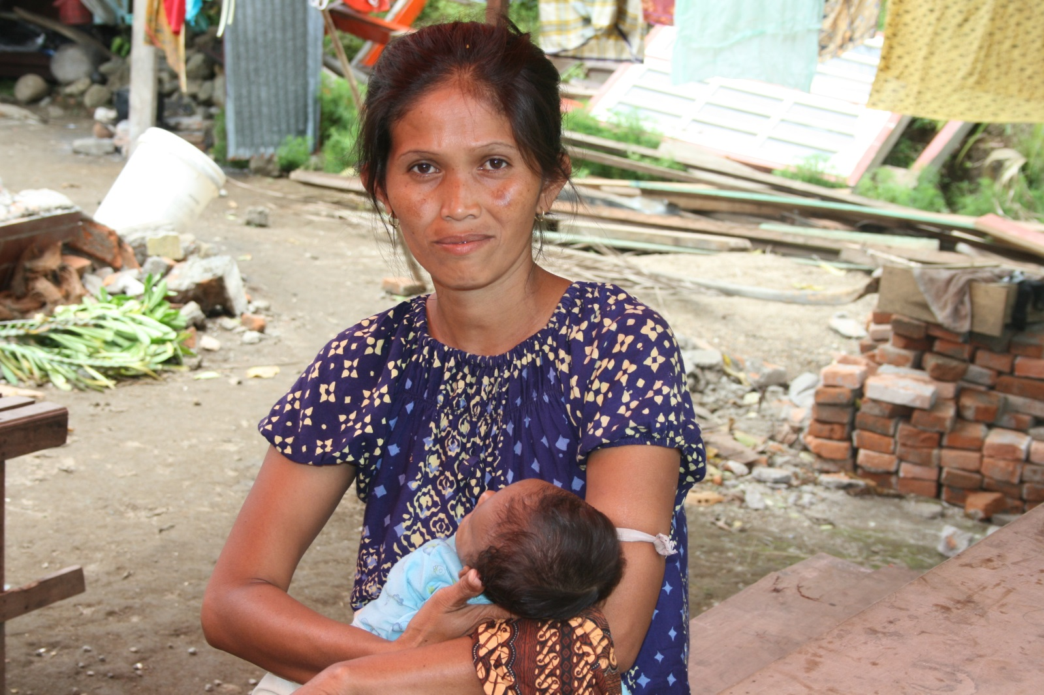
Putri is 31. She has an infant daughter, who she is breast-feeding, two other daughters and is pregnant with her fourth. Putri works part time in a shop and has help from her mother who supports with the child care. Putri knows her house won’t survive if there is another earthquake. She has been trying to repair it but simply cannot afford the supplies. Putri is aware of stories in the community of violence against girls happening during the last disaster, especially in evacuation centres where she knows she will have to go. “Having four girls I am concerned that I will not be able to protect my children or respond should something happen to them, especially while I am still pregnant.”

Indonesia DRR Profiles
HILMAN: 40-YEAR OLD MAN WITH A DISABILITY
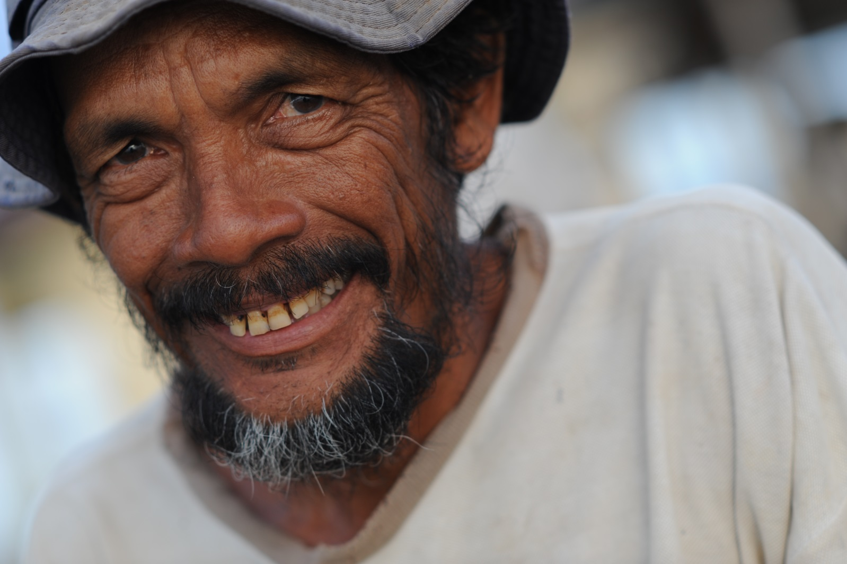Hilman lost his left leg a few years ago due to diabetes. He works in a bicycle workshop and has crutches to support him moving around. Hilman has no immediate family left and no extended family living nearby. He is, however very engaged in his community and is part of a number of committees. Hilman also runs the local youth group.

