International Federation of Red Cross and Red Crescent Societies
Joint action plan
Technical Cooperation between RCRC and AHA Centre / Bangkok / 13 October 2014

In September 2014, representatives from Southeast Asia Red Cross and Red Crescent (RCRC) National Societies (NS) gathered in Bangkok as part of the Community Safety and Resilience Forum to enhance their integrated approach for community resilience building and strengthen the regional cooperation among and between members. Participants included Department Heads for Disaster Management, Health and Organizational Development as well as a representative from the ASEAN Humanitarian Assistance (AHA) Centre.
During technical discussions, it was agreed that IFRC, RCRC National Societies and the AHA Centre should continue building on the positive collaboration undertaken so far and explore opportunities for further technical cooperation in the form of a ‘joint action plan’.
This plan was discussed at a subsequent technical meeting held on 8 October 2014 at the AHA Centre (Jakarta, Indonesia), where participants agreed to undertake collaborative efforts for the following activities:

1/ Sharing information

What | How | When | Who
NSs and IFRC to provide updates about response operations | Identify modalities to share information from NS Operation Emergency Centers and IFRC DMU to AHA Centre | 2014 and 2015 | NS  IFRC / DM Unit in Zone Office
AHA Centre to send updates to NSs and IFRC  (emergency / non-emergency updates) | AHA Centre will include NS and IFRC identified key focal points in its mailing list | 2014 and ongoing | IFRC Regional Delegation Bangkok  AHA Centre  NS

2/ Operational response frameworks

What | How | When | Who
Move towards improved coordination of RDRT and ERAT | - AHA Centre to invite RCRC participants in ERAT training  - IFRC to invite AHA Centre participants in RDRT training  - Potential RDRT secondment to a ERAT deployment (and maybe vice-versa) in a response operation  - Organizing pre-disaster meetings / enhancing joint procedures | Starting in 2015 | AHA Centre  IFRC  Selected NS
Enhance compatibility of SASOP and RCRC field manual | - Invite RCRC representative in any SASOP review process  - NSs can learn from SASOP when designing their internal field manual  - Revised SOP for RDRT could link better with SASOP | 2015-2017 | AHA Centre  IFRC  Selected NS
Discuss procedures in preparation of disasters (logistics, customs, early-warning…) and undertake joint efforts where possible | Reflect on recent experience such as Haiyan response | 2015-2017 | AHA Centre  IFRC / KL Zone office
Identify IDRL-related operational challenges to support RCRC advocacy for improved disaster laws in the region | - Share information on Disaster Law / IDRL issues  - Highlight / test IDRL issues at simulation exercises  - IFRC to invite AHA Centre at a regional Disaster Law training  - IFRC and AHA Centre jointly promote Disaster Law development and effective implementation of AADMER | Ongoing  2015 (second quarter) | AHA Centre  IFRC Regional Delegation Bangkok

3/ Learning from each other

What | How | When | Who
RCRC to participate actively in simulation exercises | AHA Centre will ensure NSs and IFRC are invited in the preparatory meetings as well | ongoing | AHA Centre  IFRC  NS
IFRC and PMI to provide expertise to the 2015 edition of the ACE Programme | IFRC and PMI will facilitate a week-long session in Indonesia and technical sessions in Malaysia | 2015 (April/May in Indonesia and June in Malaysia) | AHA Centre  IFRC  PMI
AHA Centre to allow NS representative to participate in selected ACE Programme modules as trainees | AHA Centre, IFRC and NSs to jointly select modules and participants | 2015 (Feb to August) | AHA  IFRC  PMI

How we work
Strategy 2020 voices the collective determination of the International Federation of Red Cross and Red Crescent Societies (IFRC) to move forward in tackling the major challenges that confront humanity in the next decade. Informed by the needs and vulnerabilities of the diverse communities with whom we work, as well as the basic rights and freedoms to which all are entitled, this strategy seeks to benefit all who look to Red Cross Red Crescent to help to build a more humane, dignified, and peaceful world.
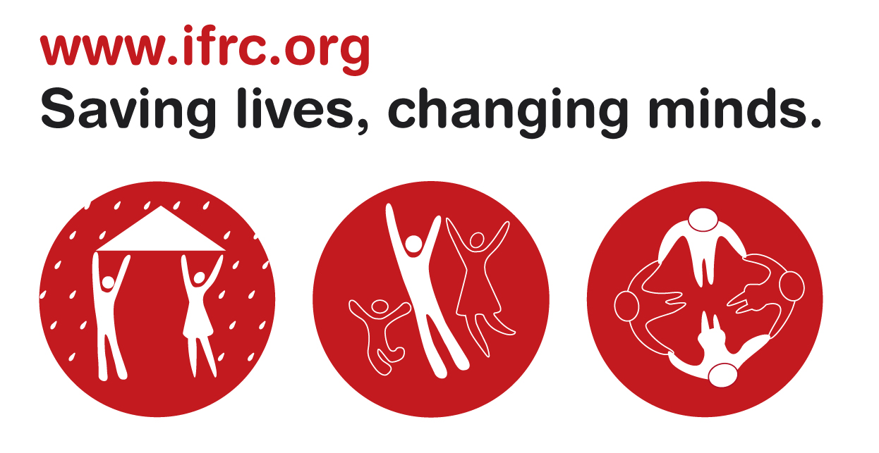

Over the next ten years, the collective focus of the IFRC will be on achieving the following strategic aims:
- Save lives, protect livelihoods, and strengthen recovery from disasters and crises
- Enable healthy and safe living
- Promote social inclusion and a culture
of non-violence and peace

Contact information
For further information, please contact:
IFRC Southeast Asia Regional Delegation
Red Cross / Red Crescent National Societies

