International Federation of Red Cross and Red Crescent Societies

Consultation and Revision of the Principles and Rules for Disaster Relief
– Project Work Plan 2012-2013 –

Principles and Rules of Disaster Relief / Geneva / March 2012
Purpose of this document
This work plan describes the process of consultation and revision of the Principles and Rules for Red Cross and Red Crescent Disaster Relief (P&R) during 2012-2013. It outlines a) how the consultations will be undertaken b) how revisions to the document will be done c) and how consultations will be done on the draft revised document. The work plan focuses on consultation and revision activities in 2012-2013 with the aim of resulting in a revised P&R document by the Governing Board and General Assembly in 2013. However, it does not cover activities beyond 2013 or activities which are not directly linked to the consultation or revision of the P&R (e.g. establishing a compliance mechanism).
Contents
1. Background 2
2. Purpose of the Consultation and Revision Project 2
3. Priority Areas for Consultation and Consultation Modalities 2
4. Consultation Schedule 4
5. National Society Consultation Workshops 5
5.1 Methodology 5
5.2 DCMAB members’ role 5
5.3 Secretariat role 5
5.4 Agenda 6
6. Incorporating Consultation Feedback into the Revision of P&R 6
7. Consultation on the Draft Principles and Rules Document 7
8. Project Communication 8
9. Summary Project Timeline 9
10. Project Budget 9

Background
The Principles and Rules for Red Cross and Red Crescent Disaster Relief (P&R) were first developed in 1954 for the League Board of Governors. They were adopted by the International Conference in 1969 and later amended in 1973, 1977, 1981 and 1995. The current version, from 1995, is the result of a thorough revision of the 1969 version and of subsequent amendments.

The Principles and Rules is an important document regulating procedures and the roles and responsibilities of the Components of the Movement in disaster response. It establishes procedures for preparation for, and cooperation in, international disaster relief operations. The Statutes of the Movement as well as the Constitution of the Federation make reference to the P&R and stipulate that disaster response has to be conducted in line with the Principles and Rules.
In 2007, the Governing Board took note of the outcomes and recommendations from the Learning from the Tsunami process and end decided to review and revise the Principles and Rules (decision 07/02/16). During 2008-2009 a review and consultation process explored the revision of P&R and produced a draft to the Governing Board in September 2009. The Governing Board decided not to proceed with presenting the revised P&R to the General Assembly and instead requested the Secretary General to continue consultations with National Societies.

Purpose of the Consultation and Revision Project
The purpose of this proposed consultation process is to engage the Movement components (National Societies, ICRC and the International Federation) into a constructive exchange on the Principles and Rules for Red Cross and Red Crescent Disaster Relief, resulting in a relevant revised version of the P&R approved by the Governing Board in 2013.

This consultation process will build upon the previous revision process (2009) and its useful outputs (the different analysis undertaken and the revised P&R drafted). The consultation and revision will focus on key areas identified by the Governing Board as requiring further clarity and consultation as well as contextual changes and developments which influence the P&R. Overall, the consultation process will ensure that a broad range of National Societies are consulted and their views taken into account in the revised P&R.

Priority Areas for Consultation and Consultation Modalities
The consultation process aims to reach a large number of National Societies and collect their inputs on priority topics for revision. Since some of the priority topics require National Society leadership discussions and others require more technical inputs, two main consultation modalities are required:

- National Society consultation meetings organized through the five Zones, with a broad representation of National Societies (five zones with approximately 20 NS/ meeting, totalling 100 NS).

- Consultations through current expert groups with National Society participation, such as Disaster Management Working Group (DMWG) and the Finance Commission.

- Separate ICRC GVA consultation to be confirmed

The below table (Table1 ) summarizes the priority topics for consultation, drawn from the Governing Board feedback on the 2009 draft, and the respective consultation modalities.
Consultation/Revision  Objective | Indicators of Success | Consultation Modality
- To provide clear and consistent language and reference to relevant policy, commitments, standards and accountability measures. | P&R language is consistent, with clear definition of terms. | - No separate consultation, Secretariat drafting group to ensure consistency and clarity of language.
 | P&R reflects current DM policy or “pillars of the Movement” such as the Sphere standards, the Code of Conduct and the Seville Agreement.
 | Language on accountability is strengthened.
- To clarify the field of application of the P&R | Roles of the different components of the Movement are clear in the P&R and the field of application is clarified. | - National Society Consultation  - Consultations with ICRC  - DCMAB consultation
 | P&R is aligned with S2020 and an extension to cover crises has been considered. | - National Society Consultation
- To include or refer to guidance on relations with external partners | Relations with external actors (private sector, civil protection, military, UN bodies, the clusters) are elaborated or references to appropriate guidance are included in the P&R. | - National Society Consultation, to be closely linked to the ‘Movement relations with external actors initiative’.
- To further elaborate on the transition from emergency to early recovery | Extension to transition to early recovery is reflected in the P&R. | - National Society Consultation  - DCMAB consultation (linked to a discussion on recovery policy)
- To clarify the roles and responsibilities regarding the use of unspent funds | Decision making over unspent funds between a donor NS and the Federation Secretariat as well as for bilateral operations are clarified in the P&R. | - Finance Commission
- To consider emerging operating modalities | New NS working internationally in disaster response – including bilateral ways of working (e.g. surge support offered supplementary to established tools and mechanisms) are considered in the context of P&R. | - National Society Consultation  - Consultations with Disaster Management Working Group (DMWG)
 | Situations where a National Society wants to make a direct international appeal are considered in the context of the P&R. | - National Society Consultation  - Consultations with the Disaster Management Working Group (DMWG)
Table 1. Summary of the priority topics for consultation and consultation modalities

Consultation Schedule
The National Society consultations through the Zones are planned to take place between April 2012 and December 2012. Most of the consultations will be linked to other regional or zonal meetings planned for 2012, in order to drive cost effectiveness and to ensure synergies with relevant discussions. Detailed consultation dates and locations can be found in the below table (Table 2).
The Expert group consultations will be focusing on the Finance Commission and the Disaster Management Working Group meetings during 2012. The expert groups are meant to be consulted on specific topics on P&R in relations to their area of expertise. Detailed consultation dates and locations can be found in the below table (Table no 2).
Other relevant disaster management discussions might take place as part of Federation meetings during 2012. These consultations will not be part of the formal P&R consultation process but may bring additional expert inputs to the consultation and revision process.

Table 2. Consultation schedule

National Society Consultation Workshops

The National Society consultations are a key part of the consultation process. They should provide National Societies an opportunity to reflect how the Principles and Rules need to be adjusted to fit the current context of humanitarian work. In order to ensure coherence between the different zonal and regional consultation workshops a standardized agenda and methodology is made available to all workshops. The agenda and methodology are further described below.

Methodology
The consultation workshops are not planned to be drafting sessions where final text for the revised P&R is formulated. Rather, specific parts of the P&R or topics relevant to the P&R are discussed and where possible common positions are sought. In practice this means facilitated plenary discussions as well as group working sessions.

DCMAB members’ role
The Disaster and Crises Management Advisory Body will have an important oversight role in the consultation and revision process. They will function as a steering group for the consultations as well as senior reviewers of the revised text (e.g. ensuring that NS feedback is properly addressed). The individual DCMAB members will be “champions” of the consultation process in their respective regions. This “champion” role will include facilitating consultations and liaising with National Societies.
The DCMAB members will serve as co-facilitators and/or as resource persons at the National Society consultation workshops in their respective regions. The members will also be communication focal points in their regions and ensure that National Society leadership is well informed about a) purpose of the P&R consultation and revision b) the opportunities to participate in the consultations c) progress of the revision. Further information on the communication plan for the P&R consultation and revision project can be found under section 8.

Secretariat role
The IFRC Secretariat in Geneva and in the Zones will be responsible for practical arrangements, developing the agenda and co-facilitating the National Society consultations. Where Zones are unable to provide an appropriate co-facilitation, the Geneva secretariat will provide a resource person.

Agenda
The below agenda outlines the main content and objectives of the National Society consultation workshops. More detailed programme and documentation will be developed for each workshop.

 |  | Objective of the session
9.00 - 10.30 | - Welcome & Introductions  - Brief presentation on the Principles and Rules of Disaster Relief and the consultation and revision process. Includes a reflection on main changes affecting the P&R.  - P&R extension to early recovery | - Establish a common understanding on the purpose of the P&R and the process to revise them  - Receive feedback on to what extent recovery should be included in the P&R and how to best link it with relief (transition from relief to recovery)
10.30 - 11.00 | Tea/coffee break
11.00 - 12.30 | - International disaster response, new operational modalities and changing roles and responsibilities of NS – implications for the P&R | - Receive feedback on if the modalities described in the P&R are still relevant and if the described roles and responsibilities are correct  - Receive inputs on what possible changes would be required
12.30 - 14.00 | Lunch
14.00 - 15.30 | - Movement relations with external actors – how to reflect these in the P&R | - Present the latest developments on this topic (e.g. CoD resolution and follow-up)  - Receive feedback on the minimum elements to be included on P&R regarding different external actors
15.30 - 16.00 | Tea / coffee break
16.00 - 17.30 | The field of application of the P&R – consultation (disasters and crises) | - Receive feedback on the P&R application to crises (or complex emergencies) and possibly ICRC role
17:30 -18:00 | - Conclusions and wrap-up | - Summarize the main outcomes of the consultation

Incorporating Consultation Feedback into the Revision of P&R
As described above, the consultation process will collect National Society and other expert feedback but the consultations will not be drafting sessions where a revised P&R is produced. The consolidation of feedback and the drafting of a revised P&R will be done by a dedicated Secretariat working group and a drafting group.
The Secretariat working group will summarize and analyse the consultation feedback as well as agree on the key revisions to the P&R. The working group will be comprised of the following members:

- Head of Disaster and Crisis Management Department
- Senior Disaster Policy Advisor
- Representative from the Core Group of the previous revision process (preferably from Governance Support)
- Representative from Community Preparedness and Risk Reduction department
- Representative from the Legal department
- Representative from the Strategic Partnerships and International Relations Department (with expertise in the Movement Relations with External Actors process)
- Experts of specific topics invited as necessary (e.g. finance, audit etc.)
- Representative from ICRC

The drafting group will draft, according to the guidance given by the working group, the revisions to the P&R text. The drafting group members are as follows:
- Head of Disaster and Crisis Management Department
- Senior Disaster Policy Advisor
- Experts of specific topics invited as necessary (e.g. finance, audit, external relations etc.)
- A consultant/ style editor ( depending on funding available)

The below figure (Figure 1) illustrates the process from consultation to a revised P&R (draft 1).
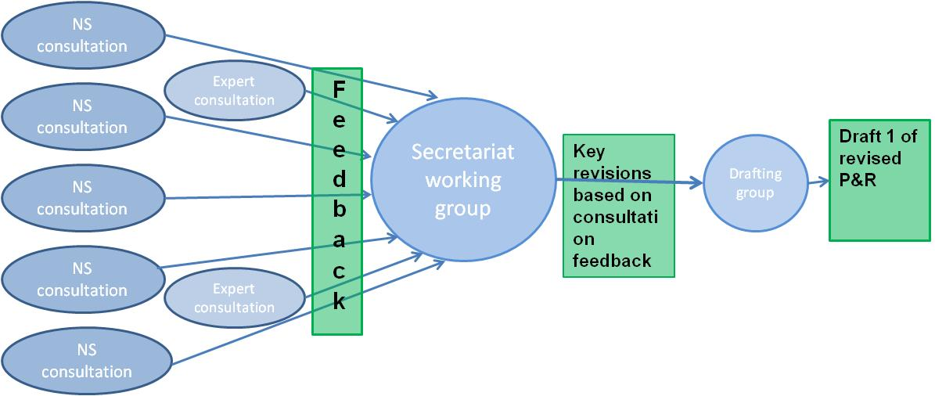
Figure 1. Process description from consultation to a draft 1 of the revised P&R

Consultation on the Draft Principles and Rules Document
After the first draft of the revised Principles and Rules has been produced it will be shared with all National Societies for feedback. Based on the feedback a revised draft (draft 2) will be developed and shared for final comments to the Disaster and Crisis Management Advisory Body and the Global Senior Management Team at the Secretariat. This will lead to a final draft which will be then submitted to the Governing Board for approval. The below table (Table 3.) summarizes these consultation steps.

Time | Consultation step | Audience
Q4 2012 | Consultation on draft 1 P&R | Draft 1 to be sent to all National Societies
Q1 2013 | Consultation on draft 2 P&R | Disaster and Crisis Management Advisory Body and Global Senior Management Team
Q2 2013 | Submission of the revised P&R to the Governing Board | Governing Board
Table 3. Consultation steps for the draft P&R

Project Communication
For the consultation and revision to be successful, effective communication with the different stakeholders is required. Therefore, communication activities will be undertaken as part of the P&R consultation and revision project. The key parts of the communication plan are outlined below.
Audience: The priority audience is RCRC National Society leadership globally. Secondary audience is the IFRC and ICRC management and disaster management staff. Later on in the process (possibly beyond 2013) Governments will be also considered as a key audience for communication.
Expected Outcomes:
- National Societies are well informed about the P&R and the on-going consultation and revision process
- Wide range of National Societies participate in the consultations (target at least 100)
- The revised P&R is widely accepted among the National Societies, IFRC and ICRC

Key messages: key messages will be developed in a phased manner to support the different steps in the consultation and revision process.

Communication Tools:
- IFRC President’s letter
- IFRC Secretary General’s letter
- Peer networks where the Disaster and Crisis Management Advisory Body members communicate to National Society leaders in their region
- Dedicated pages on FedNet
- Info sheets and other printed materials

Summary Project Timeline
The consultation and revision process is expected to result in a revised Principles and Rules approved by the General Assembly in 2013. The below timeline (Figure 2) presents the key steps and milestones of the process. The consultation and revision project timeline reaches only until the end 2013. However, further activities in dissemination, consultation with Governments (towards International Conference 2015) and on a possible development of compliance mechanism are foreseen beyond 2013.

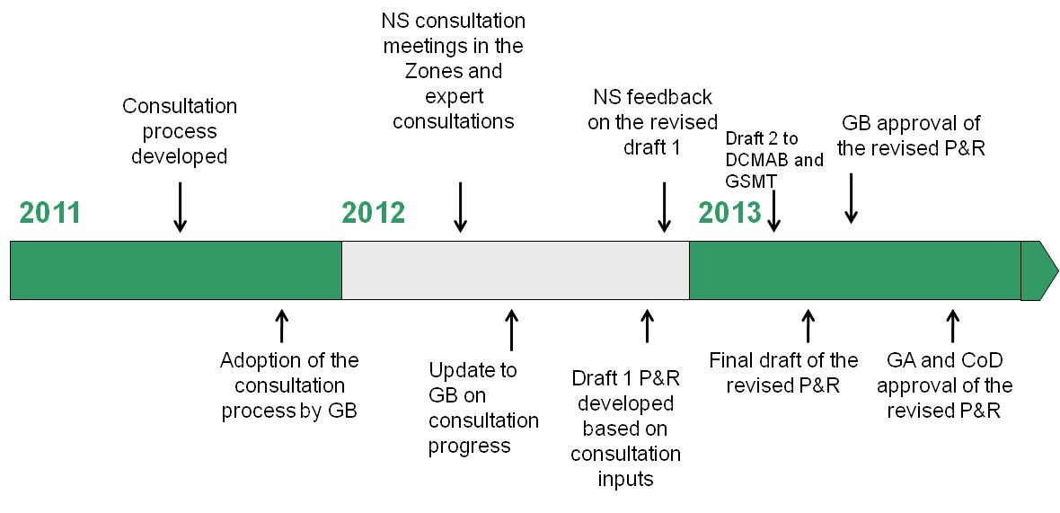
Figure 2. Summary timeline for the project 2011-2013

Project Budget
The below tentative budget (Table 4.) reflects estimate costs of the Principles and Rules consultation and revision process:
Regional NS consultations through the five zones (5 workshops) – contribution of CHF20,000 per Zone | CHF 100 000
Document translation, editing and publication | CHF 25 000
Staff cost (Senior Officer for the period of April 2012 – Dec 2013) | CHF 312 000
Staff cost (Intern for 9 months) | CHF 15 000
Travel (for the consultation meetings) | CHF 20 000
Total | CHF 472 000
Table 4. Estimate budget for the P&R consultation and revision project 2012 - 2013

