

Learning and Organisational Development

www.ifrc.org/learning

13/07/2011



Learning solutions for National Societies

# Introducing the Learning platform

**The IFRC learning platform consists of a decentralized web-based service allowing intensive use of new learning techniques. We are glad to offer to all National Societies staff, volunteers, and partners and to the general public, free unlimited access to courses that have been produced by the IFRC for anyone to access quality material and learn wherever they are, whenever they want.**

**The Learning platform in a few words**

In 2009, the International Federation implemented a Learning Management System to: host and distribute online courses, manage classroom training registration, track progress and keep an online training record for all staff, and allow virtual communities to exchange ideas and documents.

The solution that was chosen is offered by Cornerstone, and follows the “Software as a Service model”: the solution is not hosted, customized or maintained by the client, but a unique solution, hosted on more than 61 000 servers worldwide, is shared by clients and it can be easily configured online. It is a flexible, reliable and complete solution, capable of answering to the present and future needs of our organization.

The platform is now available in 5 languages: English, French, Russian, Spanish, and Swedish.

It is available to all: volunteers, members, staff, partners, or even to the General Public interested to know more about the International Red Cross and Red Crescent Movement. Anyone can self-register from the login page: [www.ifrc.org/learning](http://www.ifrc.org/learning)

**Encouraging the use of e-learning**

E-learning implies the use of computer technologies to deliver learning materials.

E-learning is less subject to the constraints of space: one can theoretically learn from anywhere on earth, as long as there is an internet connection and a computer.

E-learning also releases from time limitations: one can learn at anytime, there is no need to wait for a session to be organized in a few months, or take leave from work. One can also study at one’s own pace, independently of other students.

E-learning also offers unprecedented possibilities of economies of scale: once a course is developed, it costs virtually nothing to distribute it to one, a hundred or one million persons, thus **making learning accessible to all.**

*In February 2010, after 4 months of use and little communication, the Learning platform had already been used in over 140 countries, on all continents. By 1 January 2011 students from 185 countries had taken over 12 000 courses.*

# Standard solutions for all National Societies

1. **Self-registration of your users**

The Learning Platform provides free and easy access to ALL users. Anyone can create a profile for free on the Learning platform, from the welcome page in 5 languages (English, French, Russian, Spanish and Swedish): [www.ifrc.org/learning](http://www.ifrc.org/learning)

1. **Free courses**

A selection of online Red Cross and Red Crescent courses are provided for free. More will be added to the catalog once they are developed or shared by National Societies or Partners.

Courses currently include:

**The World of Red Cross and Red Crescent – WORC.**

This 20 hours orientation module (10 modules covering history, Fundamental Principles, components, cooperation, emblem,…) is the first tool presenting all the core dimensions of the International Red Cross and Red Crescent Movement available to all National Societies. It is the first element of international staff training, and will be part of the induction process of all new staff. Some National Societies make it compulsory for all their staff, e.g. the Irish Red Cross or the Monaco Red Cross.

*Over 3 500 students have registered for this course by July 2011*

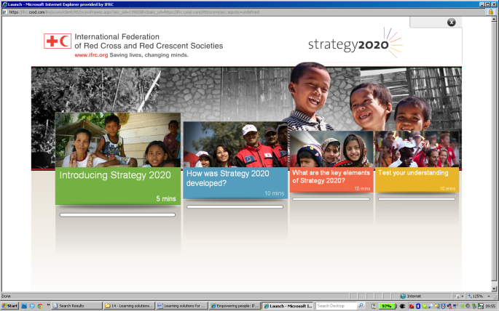

**Strategy 2020**: an introductory module, explaining the IFRC’s strategic aims for 2020 and enabling actions.

*1 200 students had taken the S2020 course by July 2011*

**Staff Code of conduct**: an introductory module, explaining the major concepts of the IFRC staff code of conduct, the reporting process as well as the disciplinary procedures. Completed by a final test. This course is part of the IFRC induction package for all new staff.

**Stay Safe personal security and Stay Safe security management** (developed by the Security unit and distributed through the Learning platform).

Those two interactive courses introduce all the essential principles of security in the field. The completion of each course is validated by a test. The course is compulsory to all IFRC staff, and it is also used by many National Societies. Some UN agencies and NGOs are also using it as such (WFP, UNHCR, World Vision).

*1140 IFRC students had completed the Stay safe personal security course, and 380 IFRC students the security management course, by July 2011.*

**Influenza Pandemic Preparedness course:** a very dynamic and interactive course introducing what the pandemic is, how to take care of infected persons, and how to prevent the disease. The course is completed by a simulation and a quiz.

**National Society Statutes:**

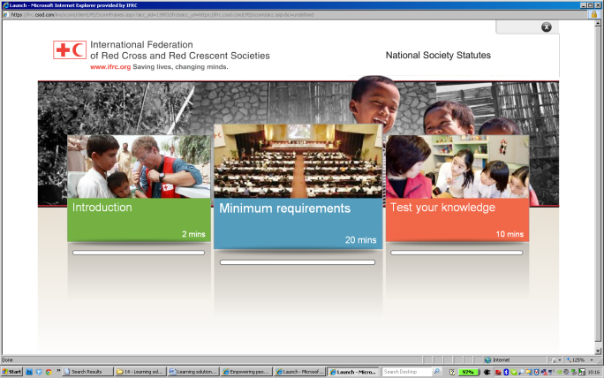Strong Legal base is one of the main ingredients of a strong National Society. This e-learning is to introduce and allow you to become familiar with the ”guidance for National Societies Statutes”. The guidance document lays out the elements for National Societies to have a strong and sound legal framework. In this module, you will learn which minimum elements need to be part of the society’s statues in order to ensure a strong Legal base.

1. **Connect – Linking communities of learning together**

Linking communities of learning together is an important dimension of the Learning platform. The tools available allow learners from all over the world to gather in virtual communities to…

* Exchange ideas, debate (forum, blog,)
* Share information (videos, documents, websites…)
* Submit ideas to a votation
* Collaborate on projects (through wikis)
* Find people sharing similar interests
* Exchange contact details

1. **Communication material / brochures**

A range of brochures and presentations are available to National Societies who want to communicate about the Learning platform to their staff and volunteers. You can also, at anytime, contact the Learning and Organisatinal Development Department in Geneva: [support.learning@ifrc.org](mailto:support.learning@ifrc.org)

You can download all brochures from:

<http://dl.dropbox.com/u/478374/Learning%20platform%20-%20NSs%20Communication%20package.zip>

A PowerPoint presentation of the Learning platform can be downloaded from:

<http://dl.dropbox.com/u/478374/Learning%20platform%20-%20NSs%20Communication%20package/Learning%20platform%20presentation%20%2B%20notes.ppt>

# On-demand solutions

1. **Additional courses: course catalog**

The International Federation Secretariat has contracted some of the leading providers of online courses, making available hundreds of courses in different languages to its staff. National Societies can enjoy similar conditions if they wish to make the same online courses available to their own staff and volunteers. We can offer access to the same rates to National Societies, without the minimal annual commitments clause.

Those courses include:

* Languages skills: the most modern online learning tool, provided by Auralog (Tell-Me-More **Corporate). A 12 month license fee to have full access to the most comprehensive online language** learning package.
* Personal Development, by Cegos: a selection of 50 courses on many subjects covering Communication, management, administration, coaching, facilitation skills, They are available in English, French, Spanish (and for some also in Chinese, German, Portuguese and Russian). Available on pay per title basis.
* Computer skills: over 50 courses on Word, Excel, PowerPoint, Outlook, Internet Explorer, for all levels. Theses courses are aligned on the ICDL curriculum (International Computer Driving License). Thus they can prepare for an official certification (provided in most countries around the world). A 12 month license fee to have full access to the whole learning package.

The Learning Platform has a Shopping Cart functionality which enables National Societies and students in general to pay for courses using credit card payment.

Contact the Learning and Organisational Development Department for course prices and further information on the Shopping Cart.

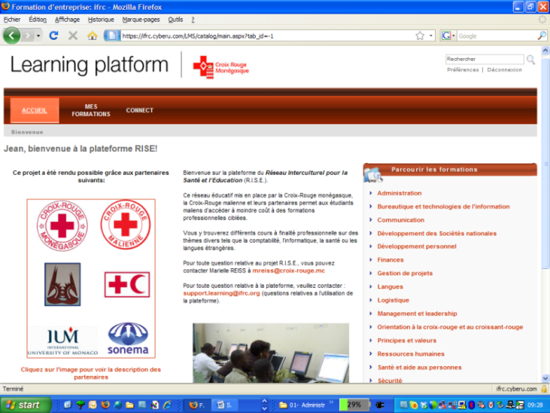**The RISE project:** The Monaco Red Cross provides visioconferencing and e-learning for Capacity building of the Mali Red Cross and local youth. A broadband satellite connection and high tech visioconferencing have been installed in a local education centre. This project will constitute an interesting case, and will help the development of a catalog of courses (basic and advanced) for National Societies and IFRC nationally recruited staff and communities who do not have access to training centres/universities.

1. 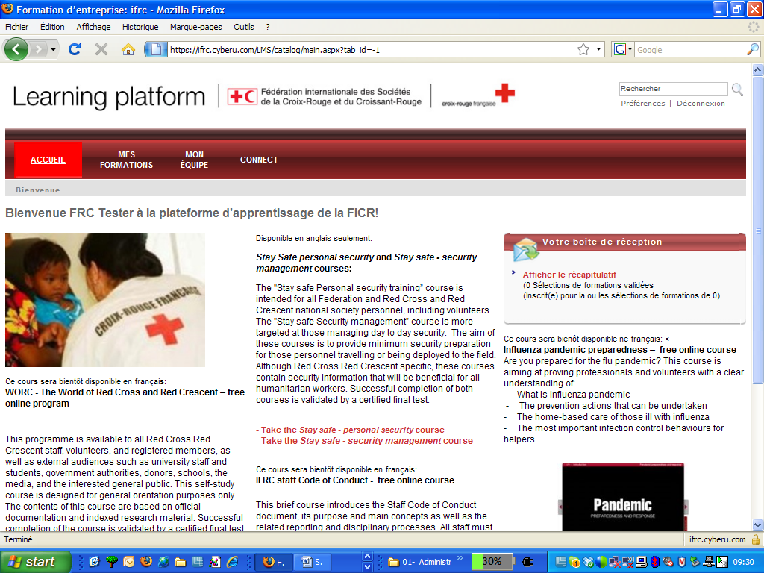**Custom page design**

It is possible to highly customize the Learning platform to your needs. We can add your logo, pictures of your choice, change the design, add or remove functionalities, tailor the catalog, add welcome text of your choice, add approval processes, automate emails triggered by specific actions…

and this in the language of your choice: English - US (default),

English – UK, Spanish – Spain,

Spanish – Latin America,

French – Canada, French – France,

Portuguese – Brazil, *Example: the French Red Cross benefits from a customized page*

Portuguese – Portugal, German – Germany, Italian – Italy, Japanese – Japan, Dutch – Netherlands, Russian – Russia, Thai – Thailand, Turkish – Turkey, Chinese (Simplified) – China, Polish, Czech, Latvian, Lithuanian, Norwegian, Swedish, Danish, Korean, Greek, Bulgarian, Ukrainian, Romanian, Bahasa  (Indonesian). As of 2012: Arabic and Hebrew.

1. **Hosting of online courses**

If you want to host additional courses, you can contact the Learning and Organisational Development Department, whether you have developed those courses or got them from other sources, whether you agree to share them with other National Societies or want to restrict the access.

1. **Access to reports**

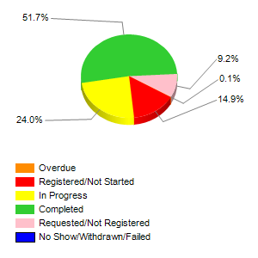The Learning platform offers extensive reporting functionalities. You can monitor in real time how many people are taking courses, which courses are most followed in your region, what is the profile of users based in your country. It is possible to report on all information contained in the system.

*Example: All staff of the International Federation have been requested to take the “Stay Safe – personal security” course. Reports have been programmed to monitor in real time, region per region, how many people have registered, started or completed the course. This overall report is dated 29 July 2011.*

1. **Support for translation of online courses**

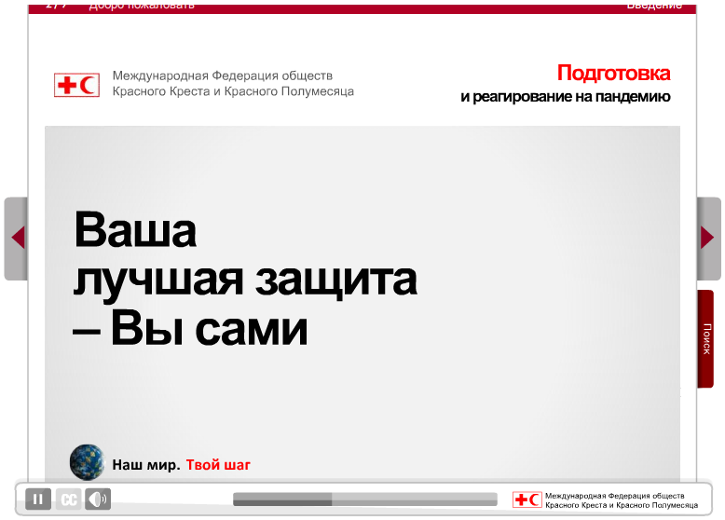All courses developed by the International Federation use a technology which allows rapid translation, through an online translation system. If you are interested in getting a course translated into your national language, please contact the Learning and Organisational Development Department.

*Example: the IFRC Europe Zone office in Budapest translated the influenza pandemic preparedness online course into Russian.*

1. **E-learning course development advice**

**Sharing e-learning content: a code of good practice**

Creating quality e-learning content can be costly. But once an e-learning is developed, it costs virtually nothing to distribute it to one, a hundred or a million users… Therefore we have a common interest in ensuring that all the material we produce can be shared with partners.

This can be achieved by making sure that:

1- The developing organisation owns all copyrights and can share the content (copyrights on content and on the use of the technology)

2- Content can be easily customised or translated into other languages (can be easily achieved with the right technology)

3- Content follows technological norms which ensure a high level of compatibility, allowing distribution through most Learning Management Systems, websites or CD Roms.

For more information on the code of good practice and technical requirements to achieve sharability, flexibility and compatibility – please contact the Learning and Organisational Development department of the IFRC secretariat: [support.learning@ifrc.org](mailto:support.learning@ifrc.org)

If you are interested in developing a course, the Learning and Organisational Development (LOD) Department is glad to provide you with guidance.

A comprehensive “your e-learning course development toolkit” has been prepared for you.

**Getting involved**

**in the Learning platform development**

The Learning platform provides learning solutions to all National Societies.

All National societies can access the Learning platform and contribute to it, by participating to forums, sharing content and information, supporting translations of courses, financing course developments, or sponsoring.

1. **The Learning platform partnership: accessing extensive on-demand solutions**

Your National Society is interested in some of the “on demand solutions” provided by the Learning platform. Based on an agreed partnership, your National Society will be provided with a customized package, ensuring that your staff and your partner National Societies will benefit from all the functionalities of the Learning platform. Your National Society will voluntarily contribute financially to the overall sustainable development of the Learning platform, with a minimum amount covering the costs of the “on demand solutions” provided through the partnership agreement.

The partnership of your National Society and its own partners will be mentioned in selected pages ensuring high visibility.

Your National Society will be regularly provided with specific reports illustrating the various solutions included in the partnership.

1. **The Learning platform sponsorship: supporting the development and sustainability of the project**

If your National Society recognizes the added value of the Learning platform and its contribution to its own learning and development efforts, your National Society can decide to sponsor the Learning Platform activities by voluntarily contributing financially to its overall sustainable development.

**The sponsorship of your National Society and its own partners will be mentioned in the login page, ensuring high visibility and recognition of your support.**

Your National Society will be provided with regular reports illustrating the on going development of its various learning activities and the activities related to the users registered from your country.

***For more information, you can contact us directly at the Secretariat,***

***Learning and Organisational Development Department:***

Sylvie Gelin Reda Sadki

Snr Officer Learning Platform Snr Officer Learning Systems

[sylvie.gelin@ifrc.org](mailto:sylvie.gelin@ifrc.org) [reda.sadki@ifrc.org](mailto:reda.sadki@ifrc.org)

+41 22 730 4977 +41 22 730 4426