A Road to Resilience in Southeast Asia

Regional Community Safety and Resilience Unit (CSRU)

Concept note / January 2013

Introduction

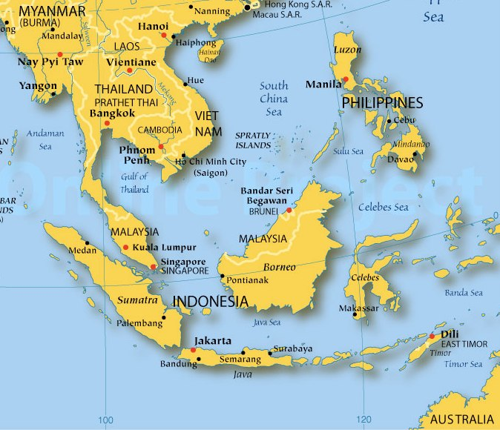
The Red Cross Red Crescent has achieved remarkable results in saving thousands of lives every year by harnessing our network of volunteers to prepare for and respond to disasters. However, preparing for and responding to disasters is essential but not sufficient. Every year, droughts, floods, cyclones, earthquakes, wildfires and other hazards affect over 267 million people around the world. Climate variability is expected to increase the frequency and severity of natural hazards, thus heightening the vulnerability of communities to cope with the devastating impact of disasters. Furthermore, increased urbanization is slowly changing the nature of risk thus necessitating the adaptation of existing risk reduction strategies and tools. Widespread environmental degradation exacerbates existing vulnerabilities limiting people’s ability to cope with and recover from disasters.
Southeast Asia

In response to above challenges, while we save lives, we must do everything we can do to invest into strengthening the resilience of vulnerable people and their communities and to contribute to eradicating the underlying causes of vulnerability.

We see resilience as the ability of individuals, communities, organizations or countries exposed to disasters, crises and underlying vulnerabilities to anticipate, reduce the impact of, cope with, and recover from the effects of adversity without compromising their long term prospects. While the Red Cross Red Crescent is known for its humanitarian work around the world, it has for a long time been equally involved in development activities. In reality the distinction between these two does not really exist for the people affected by crisis.

Resilience is therefore not just an immediate ability to respond to negative ‘events’ but rather a process of positive adaptation before, during and after adversity. At its core, the resilience approach is an attempt to protect development gains in the longer term and to reduce the dramatic decline in development that disasters and crises often cause. For the Federation this highlights the overlapping nature of preparedness, relief, and recovery work and bridging these to more developmental work.

Regional Community Safety and Resilience Unit

In line with our global commitment to resilience the South-East Asia Regional Delegation Community Safety and Resilience Unit’s (CSRU) key task is to provide an additional capacities and resources for country delegations and National Societies to effectively meet the growing needs of vulnerable communities in reducing their exposure to risk by strengthening safety and resilience clearly focusing at community level.

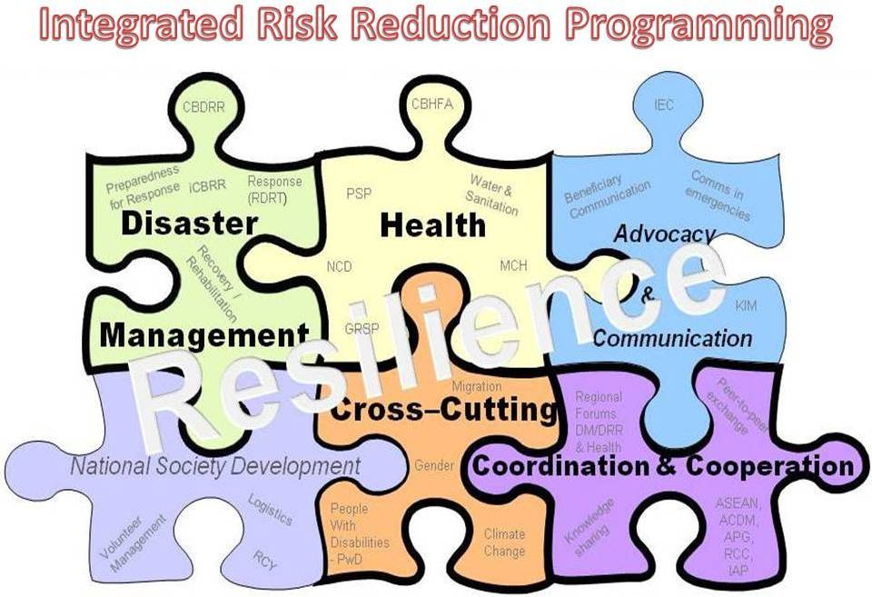
The CSRU seeks to provide integrated technical expertise that can accompany South East Asian National Societies, together with other Red Cross Red Crescent Movement actors’ to map, acknowledge, improve existing systems, procedures, tools, technical knowledge and capacity in order to achieve better quality impact at vulnerable community level in line with Strategy 2020 aligned goals. CSRU will do this through a process of long-term technical support to the National Societies.

The CSRU’s objective is, through Country Delegations and Partner National Societies, to provide National Society-focused technical advisory support in three priority areas:

1) Improve preparedness for response capacities through strengthening local, national and regional capacities to respond to health emergencies, disasters and crises;
2) Strengthening community safety and resilience through promotion and development of an integrated cross sectoral community-based programmes that incorporate all cross cutting issues such as climate change, gender, migration, people with disabilities, psycho-social-support and other relevant issues and,

3) Reducing the burden of public health issues through strengthening National Society capacities in their auxiliary role to government.

The CSRU serves as a conduit for regional coordination of Community Safety and Resilience activities in order to maximize the impact of the available resources, both within the RCRC Movement (including Partner National Societies) and with external actors and donors. It seeks to facilitate the management of knowledge through identification, documentation, translation, adaptation, sharing of lessons, best practice knowledge and experience for the benefit of the region’s National Societies and the vulnerable communities they serve as well as the wider Movement. The CSRU will also facilitate the preparedness and mobilisation of regional tools, especially regional disaster response teams (RDRT), for disaster response.

The support is manifested through the provision of technical assistance at both regional and national level.

Activities:

At a regional level and in close collaboration, coordination and support with/by the AP Zone Disaster Management and Health Unit:
- Community Safety and Resilience Unit (CSRU) will continue to support National Societies in their efforts to move from Project Approach to Programme Approach through continued promotion of an integrated approach and provision of necessary technicial skills/tools/consultations/facilitations necessary for the process to be successful.
- CSRU will keep focusing its efforts on building and leading the regional and multi-sectoral technical team (Community Based DRR – CBDRR and Community Based Health – CBHFA) to work on promotion and development of integrated programmes to assist National Societies in strengthening impact in communities in close collaboration with country delegations, SEARD regional team and the Zone.
- Organizing annual SEA regional forums such as RDMC, ART network, VNRBD, Health (CBHFA, Non-Communicable Diseases NCD, and PSP) and Community Resilience together with SEARD team.
- Create and develop a regional pool of specialized health and disaster preparedness/risk reduction experts.
- Ensure the Federation policies, strategies and operational standards are well understood and implemented.
- Support peer process and encourage NS exchange visits/trainings/knowledge sharing/transfer.
- Continue to lead the process of identification and documentation of lessons learnt and best practice, and facilitate sharing, dissemination of knowledge and experience through our online library for the benefit of the Movement.
- Facilitate the development, mobilisation, preparedness and review of regional tools, especially regional disaster response teams (RDRT), for health emergency and disaster response.
- Promote coordination of wider risk reduction (disaster management and health activities) in the region and beyond in order to maximise the impact of the available resources, both within the RCRC Movement (including Partner National Societies) and with external actors and donors. This would include various ASEAN bodies such as AADMER Partnership Group (APG), ASEAN Committee on Disaster Management (ACDM), AHA Center, ASEAN Ministerial Conference on Disaster Risk reduction (AMCDRR), ASEAN Health Ministers Meeting (AHMM), RCC and IAP among others.
- Support implementation of regional frameworks and strategic approaches that support National Society programming such as Mekong River Basin Plan of Action and the RDMC Road Map.
- Explore possibilities for harmonization of regionally applicable technical guidelines, tools and training resources.
- Identify, pursue and coordinate on (including Country Delegations and Partner National Societies) regional funding opportunities that support the community safety and resilience programming and priorities of National Societies and Country Delegations.
- Continue to stimulate opportunities for increased cross border collaboration, coordination and sharing of knowledge, experiences and common approaches in Risk Reduction among four countries of the Mekong River Basin who share similar characteristics in terms of geography and vulnerability to hazards. Support development of strategic partnerships with key stakehodlers such as Mekong River Commission, ADPC, NDMA and others interested to support Mekong River Basin countries in risk reduction.
- Engage with and advocate to regional, zonal and global networks as the programming representative of the National Societies of the region.
- Using international days (like World blood donor day, International Disaster Risk Reduction day, First Aid, HIV/AIDS and others) to advocate about the community safety and resilience work of NSs, together with country teams. Assist NSs to position them better to national authorities and partners.
- Maintain an overview of the key community safety and resilience needs and capacities; and of the main activities and available resources of RCRC Movement actors and external organisations.
- In addition to above a momentum on Migration is building up among South-East Asia National Societies for which CSRU will scale up its engagement in providing support on issues related to Migration & CCA; Migration and natural disasters, Migration & health: Labour migration; Gender, Human trafficking.

And at a country level, depending on the needs and capacities of the NS and support provided by the Country Delegation, the CSRU will accordingly continue providing technical support where gaps are identified:
- Through Country Delegation teams, assist NS in monitoring disasters and health risks and assess vulnerabilities and capacities at community level in order to identify priorities for disease prevention and disaster preparedness strategies and programs along with early warning and early action.
- Support NS to effectively utilize and adapt already developed Red Cross Red Crescent tools for integrated programming approach.
- Work with National Societies in identification and training of CBDRR/CBH staff and volunteers.
- Facilitate the establishment or improvement of existing contingency plans at community and National level and regular update of Standard Operating Procedures (SOPs) along with other available response system and tools in disaster response and epidemic control.
- Support the review of logistic systems in case of disasters or epidemics.
- Together with the SEARD communication and advocacy unit, assist NSs to provide better service to beneficiaries and in return to enhance the quality of CSR work at the community level.

- Advise and assist SEA NS to share and report on progress and achievements against Asia Pacific Zone DM Plans in line with priorities outlined in the Strategy 2020, Amman Declaration/AP Conference (10/2010), Jakarta Declaration, SEA Leadership Meeting (7/2012) and Hyogo Framework for Action (HFA).
- Facilitate the provision of technical support and capacity building to individual National Societies and Country Delegations in the areas of organizational disaster preparedness in cooperation with the National Society Development Team (including strategy / policy development; disaster / contingency planning; pre-disaster season coordination meetings; physical, organisational and human resource capacity building);
- Strengthen community safety and resilience (including integrated/cross-sectoral Vulnerability and Capacity Analysis assessments with both community-based health and first aid and community-based disaster risk reduction which incorporates climate change adaptation; gender, community-level early warning and early action systems and impact measurement using community based PMER toolkit) and reducing the burden of public health issues (including strategy / policy development in line with agreed IFRC commitments like Global Alliance on HIV).
- Support the local adaptation/translation of standardized technical guidelines, tools and training resources and to advise on their effective and efficient implementation.
- Where requested by the National Society / Country Delegation in consultation with the Asia Pacific Zone Disaster Management Unit and Health Team, provide additional surge or technical advisory capacity for disaster responses. This will include the provision of technical input to the emergency appeals, operational plans of action and longer-term programming aspects of the response. This particularly relates to the IFRC’s General Assembly’s decision advising that at least 10 percent of any emergency appeal should be allocated for strengthening of resilience work.
- Through Country Delegation teams, assist NS in adapting and utilizing new technologies (such as First Aid phone app) and guide NSs in integrating international recommendations and guidelines at programme design (for example, increasing the interventions targeting key affected populations in HIV) in order to contribute to achieving MDGs and international strategic goals (such as Melbourne declaration, HIV getting to zero by 2015).

Some achievements to date…

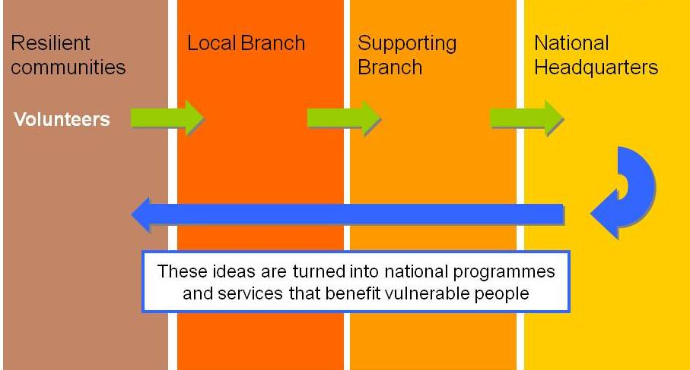
Bearing in mind that the Red Cross Red Crescent assessment often starts at the community level and focuses on community resilience, comprehensive cross sectoral assessment requires developing understanding about the diverse underlying causes of vulnerabilities, disasters and crises for implementation of sustainable community safety and resilience initiative.

The CSRU has shared its expertise across the Asia Pacific Zone, in particular with South Asia (Sri Lanka) and East Asia (China) regions by facilitating Disaster Risk Reduction (DRR) Field Sessions in order to develop understanding of our members on comprehensive cross sectoral assessments, planning and implementation. A total of five DRR Field Sessions have been conducted so far and experiences are being shared through the case study and a video footage that can be viewed at http://ifrc.org/news-and-media/meetings-and-events/rio-20/.

The 16th Regional Disaster Management Committee (RDMC) meeting, held in June-2012 was adjourned with finalizing Road map for the period of 2012 to 2015. Road Map has clearly shaped the scope of response preparedness as well as RDMC’s targeting to have an integrated country plan by 2014. It is expected that this process for development of integrated country plan will facilitate to promote integrated planning and implementation practice at national society level by including health, disaster preparedness and risk reduction activities. Whereas response preparedness initiative keeps supporting to identify the gaps in order to strengthen NS response system further. There will be number of challenges for that including human resources, guiding documents, volunteer management, and limited capacity of Red Cross branch and funding to bring all things forward.
There are several other important outcomes from this RDMC meeting that spell out NS’s request for support from the CSRU:
- The RDMC has been restructured by the RDMC members. Thai Red Cross, Dr. Amnat Barlee has been nominated as the first Chairperson of the RDMC.
- The RDMC Members decided to hold RDMC meetings before and after the Leadership Meetings in order to ensure more consistency, inputs and timely follow up on recommendations of the leadership. The next RDMC meeting will be held in early 2013 in Phnom Penh, Cambodia.

- The members finalized the Road Map for the RDMC for the period from 2012 to 2015. The Road Map defines the ways forward with clear roles and responsibilities for each RDMC member, including IFRC and SEARD.

- Need and commitment for a holistic approach to community resilience focusing on integrated cross-sectoral planning came out very strongly by the RDMC members.

- Participation of key Health department representatives from each National Society (NS) in the future RDMC and other technical meetings addressing risk reduction.
- Following on successful participation of the Executive Director of ASEAN AHA Centre who provided update on current status of play of AHA centre and opportunities for cooperation with RCRC in the region, the RDMC expressed their interest to get more involved with ASEAN disaster management bodies including the AADMER Partnership Group (APG). CSRU is requested to support such development of cooperation in order to facilitate and secure better positioning and more involvement for NSs in the region with regards to the implementation of AADMER program – which would further contribute toward signing of the Cooperation Framework.
Mapping of tools and other documents related to Disaster Risk Reduction (online library) continues to be updated and can be found at the following link: https://sites.google.com/site/drrtoolsinsoutheastasia/ This exercise helps to provide the overall picture of already exisiting materials/tools, facilitates peer learning between and among the NS and most importantly encourge the national societies to use the existing tools, adapt and translate them to fit their own needs as opposed to developement of new. A full time KIM (Knowledge Information Management) Officer is part of CSRU. An initial communication has already been established to link this exercise with Global Disaster Prepredness Centre(GDPC) based in Washington D.C. and FedNet to ensure the access for all partners of the movement. Currently process of mapping of Health related tools is underway.

Way ahead…

The Community Safety and Resilience unit (CSRU) is comprised of a multidisciplinary team dedicated to support country delegations and member National Societies in helping vulnerable households and communities to increase their safety and become more resilient in the face of new and existing threats and risks.
Instead of looking at new areas of work the CSRU is looking at possibilities for building on, enhancing and adapting what National Societies have already been doing and will continue to do in the future – with specific focus on NS priorities through a focus on community resilience by putting greater emphasis on what communities can do for themselves and how to strengthen their capacities, rather than only concentrating on their vulnerability to disasters or their needs during an emergency.
The CSRU will continue to analyze and review what has effectively worked with ultimate aim to develop more systematic and holistic approach and operational tools that would ensure the basic objectives of safety and resilience are being addressed. A periodical capacity mapping/update will be carried out.
The Well Preparedness National Society (WPNS) checklist will be considered further to enhance NS capacity. The Organization Capacity Assessment and Certification (OCAC) checklist will also be adapted with the support of National Society Development Unit/SEARD wherever possible. CSRU is exploring to support pilot CSR initiative with different NS in the region. Currently initial steps have been taken with the national societies in Laos and Thailand. The experiences will be further replicated for peer learning and revised accordingly.
National Society Health and DM managers will be encouraged to jointly participate in regional forums/meetings/workshops to enhance their skills, knowledge and cooperation/coordination to develop an integrated country level plan as per RDMC Road Map. This will contribute to further strengthen the NS collective cross sectoral planning and implementation practice which ultimate should support strengthening of resilience at community level.
A workshop has been planned in last quarter of this year to support the Mekong Cooperation agreement signed by Lao, Cambodia and Viet Nam Red Cross. The representatives of three NS of different levels along with other partners including Mekong River Commission will be invited to develop the common understanding and outline the scopes to implement the agreement.

The CSRU together with the National Society Development (OD) and Communication department continues to support the Thai Red Cross in its effort to further expand the flood and tsunami preparedness programmes throughout the country focusing on capacity building of disaster management and emergency health staff and volunteers, improvement of volunteer management systems, community based risk reduction, increasing logistical capacity, warehousing and emergency response stocks, improvement of communication systems and coordination. Support will continue into 2013.

Budget

Total Budget in CHF: 7,478,593

For further information, please contact:

Anne LECLERC Head of IFRC Regional Delegation for Southeast Asia, Email: anne.leclerc@ifrc.org
Indira KULENOVIC, Head of Community Safety and Resilience Unit (CSRU), IFRC Regional Delegation for Southeast Asia, Email: indira.kulenovic@ifrc.org,

Safe and Resilient Communities do not exist in a vacuum. There is no community with an absolute resilience as there is no community without any resilience. We need to build on existing capacities, replicate it, scale up, and ensure local ownership and long term sustainability in order to reduce the impact of any future disasters…
“… an integrated and coherent Red Cross Red Crescent vision and approach to resilience requires further mindset shift and persistent and long term work. Credible implementation of the resilience approach demands of the Red Cross Red Crescent to make – within our means and expertise – significant contribution to eradicating poverty, reducing inequality, and achieving equity and dignity, while respecting the limits of our resources” (IFRC discussion paper on resilience)

In countries where there is no country presence of IFRC, Regional CSRU team provides direct technical support to implementation of activites with respective National Societiy (i.e. current implementation in Thailand, Laos, Malaysia etc)

