***TITLE OF SUCCESS STORY:* Malaysian Red Crescent: Practice Makes Perfect**

***Agencies names, address and focal contact person: Kate Roux, Communications and Advocacy Manager, IFRC Southeast Asia Regional Delegation, Bangkok katherine.roux@ifrc.org***

*IMAGES OF THE STORY: Please share as attachment separately high resolution  
(above 1 MB) images to support the success story.*

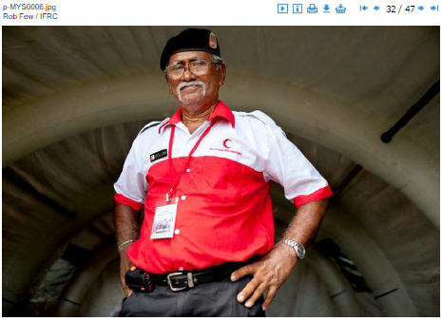

Abdollah Bin Ibrahim is from Johor Bahru. He is 73 years old, has been an MRCS volunteer since 1985. After taking part in a Malaysian Red Crescent drill, he said, “Emergency exercises like these, held each year someplace new, help to build teamwork among colleagues from across Malaysia.”

"These drills help us show the community what we do and how important it is for them to become involved as volunteers for the future." Kaman Osman, who has volunteered with MRCS since 1982 and travelled 12 hours by car to participate in the exercise.

**THE PROBLEM:**

In the small Malaysian village of Kampung Tra Disa Lembah Keriang in the northern state of Kedah, more than 100 trained Malaysian Red Crescent Society (MRCS) volunteers gathered to test their readiness to respond to a large-scale disaster.

The volunteers had come from all across the nation, from as far away as Sabah and Johor Bahru to demonstrate their skills and to test their abilities. Exercises like this one help volunteers and partners to be fully prepared before emergencies occur.

**THE ACTIVITIES**

The Malaysian Red Crescent Society holds exercise drills every year in locations throughout Malaysia to test their readiness to respond to a large-scale disaster.

In addition to providing practical learning, the exercise drills help to forge stronger ties with government and other partners in emergency response.

The MRCS focused on coordination, triage, first aid and the transportation of the injured to hospital. The exercise was conducted in collaboration with local police, the fire and rescue department and other public officials and MRCS in preparing and organizing a scenario that would challenge all of the participants and inspire in them a sense of what such an emergency (in this case a crashing airplane) might really be like and train for their preparedness in disaster response.

When the exercise started, a loud explosion and a dark plume of smoke were created to emulate a crashing airplane, subsequently sirens could immediately be heard, and within moments, fire-fighters, police and more than 100 Red Crescent volunteers were on the scene. Tents were erected within minutes, mock coordination meetings were held, the injured were seen and triaged by Red Crescent volunteers and trained first-aiders provided immediate support to dress pretend wounds, splint imaginary broken bones and counsel those who acted out their grief with extreme enthusiasm.

*IMAGES OF THE STORY: Please share as attachment separately high resolution (above 1 MB) images to support the success story.*

|  |
| --- |
| **THE OUTCOMES**  The exercise was conducted well, and while it had only lasted a short time, it was clear that its intensity had taken a toll on those who played roles.This would help prepare the communities and authorities alike in disaster response and preparedness. |

**WAY FORWARD**

Red Cross and Red Crescent National Societies around the world are called upon to provide immediate humanitarian support to affected communities following disasters. Exercises like this one help volunteers and partners to be fully prepared before emergencies occur.

Source: http://www.ifrc.org/en/news-and-media/news-stories/asia-pacific/malaysia/malaysia-practice-makes-perfect/#sthash.XYzqQEMX.dpuf

IMPLEMENTING AND PARTNER AGENCIES LOGOS:

