***TITLE OF SUCCESS STORY:* Typhoon Bopha: How Communication can Save Lives – A Story of Success in Disaster Risk Reduction from the Philippine Red Cross**

***Agencies names, address and focal contact person:* Roderic Salve, Disaster Management Unit, Philippine Red Cross HQ, Manila, roderic.salve@redcross.org.ph**

*“We want to know where we can find clean water and get information on landslides” Community members living on a hillside above Andap, Mindanao*

*IMAGES OF THE STORY: Please share as attachment separately high resolution  
(above 1 MB) images to support the success story.*

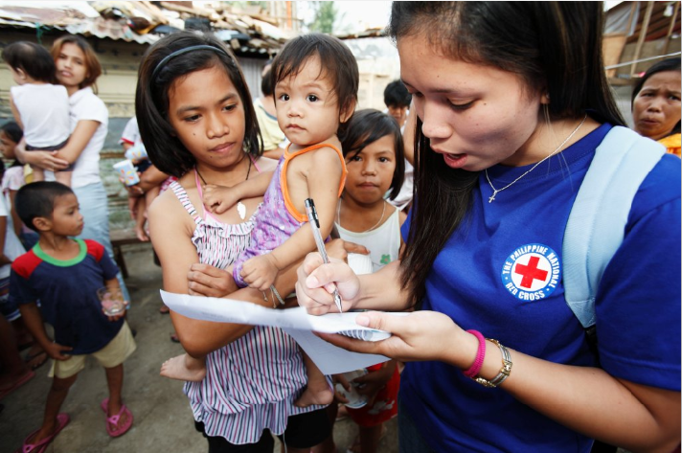

© Phillipine Red Cross

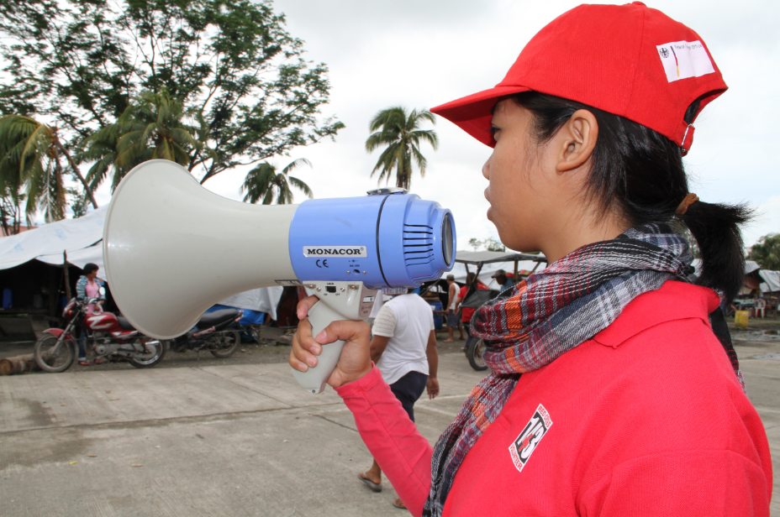

© Phillipine Red Cross

**THE PROBLEM:**

On 4 December 2012, Typhoon Bopha (local name: Pablo) made landfall in Davao Oriental, on the eastern coast of Mindanao Island, Philippines. Its passage across the country took five days and with multiple landfalls, it left extensive damage and devastation in its wake.

Three months later, with over 6 million people affected by the disaster, there were close to one million who were still living in damaged homes and makeshift shelters.

*IMAGES OF THE STORY: Please share as attachment separately high resolution (above 1 MB) images to support the success story.*

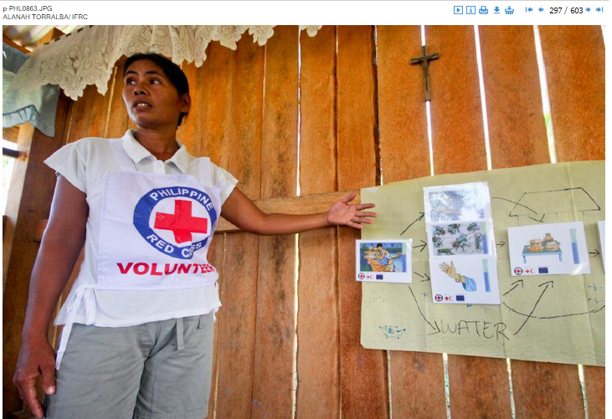

**THE ACTIVITIES**

From the onset of the disaster, the Philippine Red Cross, with support of its partners, provided relief and recovery assistance to affected communities, including search and rescue efforts, first aid, food, clean water, hygiene and shelter repair kits.

The extent of destruction left vast needs in communities across the island of Mindanao. It also disrupted standard methods for giving and receiving information, increasing the challenges for both communities and Red Cross staff and volunteers.

These teams bring a critical component to response: communication with communities, also known as beneficiary communications.

Operating 24 hours a day, the Philippine Red Cross Operations Centre provides critical information nationwide to Red Cross staff and volunteers and partners before, during and after a disaster. Communication primarily takes place through the use of SMS or phone calls (landline) to key focal points within the Philippine Red Cross field operations. Back-up generators allow teams to reliably receive critical information between headquarters and the field if there are power interruptions.

This is complemented by information from monitoring of the media and other secondary sources - confirmed through the Red Cross’ extensive network of contacts on the ground. The information is analyzed, and fed into the resulting humanitarian operation on an ongoing basis. All the information is then used to directly communicate to communities. With severe flooding in the regions of Mindanao following Typhoon Bopha, the Red Cross Operations Centre analyzed information from the weather agency (PAGASA – Project Noah), National Disaster Risk Reduction and Management Committee, television, as well as Red Cross branches and chapters, to provide consistently updated and instantaneous reports on rainfall and flooding. The information was shared with the Red Cross tent cities and larger community, helping alleviate fears in a time of shock and high insecurity.

|  |
| --- |
| **THE OUTCOMES**  Conducting face-to-face messaging with affected communities, the work of the Red Cross staff and volunteers, was particularly significant when widespread damage to electricity networks made communication difficult.  During the Typhoon Bopha response, information reached remote areas of the worst-hit municipalities of Mindanao because of this direct contact between Red Cross field teams and typhoon survivors.  Yet the impact of their work stretched farther than those who the staff and volunteers met directly. Red Cross teams communicated with community leaders, which not only reinforced the accuracy of information, but they also provided a vital link to disseminating information among the wider community and served as a key resource for critical feedback. |

**WAY FORWARD**

The value of communication with communities during an emergency is beneficial not only for affected communities but for the Red Cross Red Crescent Movement as well.

The face-to-face communication of community-based staff and volunteers places the Movement in a unique position to assess needs in communities, to share critical information including the relief and recovery operations, and it also provides a mechanism for important feedback to improve programmes.

IMPLEMENTING AND PARTNER AGENCIES LOGOS:

