***TITLE OF SUCCESS STORY:* "Begins with Me" - Integrating Disaster Risk Reduction into School Education in Indonesia. A Success Story from Indonesian Red Cross (Palang Merah Indonesia)**

***Agencies names, address and focal contact person:* ARIFIN M. HADI Head of Disaster Management Division, Indonesian Red Cross National Headquarter Ph: +62 21 7992325 E-mail: Arifin_mhadi@pmi.or.id**

*"It was exciting! We went all-out and it felt real even if it was just a drill," recalled Syarifuddin, CBAT member of Jintung Village. "CBAT and Red Cross Youth were practicing emergency response activities, such as first aid and evacuation.”*

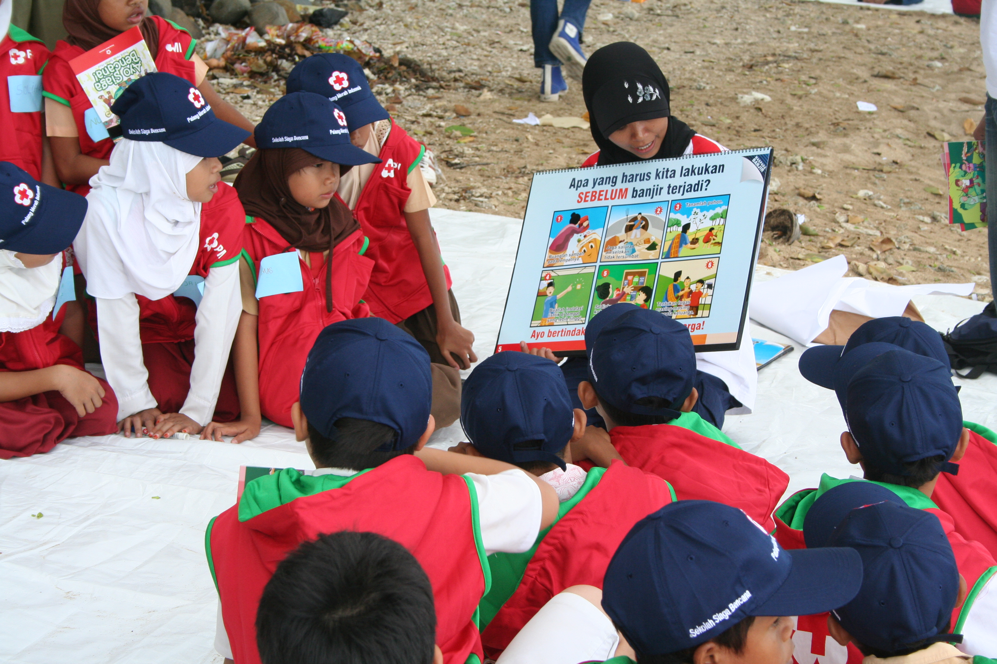

Advocacy for School based Disaster Risk Reduction by Indonesian Red Cross

**THE PROBLEM:**

Jintung Village in Ayah sub district of Kebumen municipality located between beautiful hills and a strech of beach, is at risk of tsunami, earthquake, and landslide. To reduce its vulnerability, the community must be equipped with knowledge on disaster risk reduction.

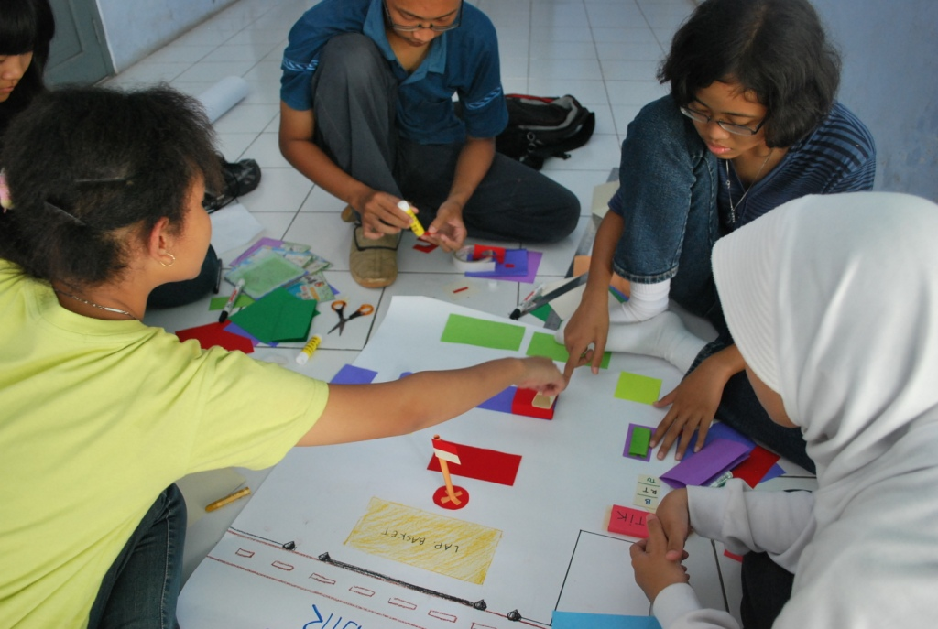

School based disaster risk reduction in Senior High Schoo SMA 3 Semarang, Central Java.

**THE ACTIVITIES**

One of Indonesian Red Cross’ (PMI)'s main activities is mainstreaming disaster risk reduction into school education. This initiative mobilises the National Society’s nationwide network of about two million youth and volunteers who are familiar with Red Cross Red Crescent humanitarian values and principles.

In October 2006, the Consortium for Disaster Education (CDE) was jointly established by a network of disaster education experts and institutions in Indonesia. The CDE acts as a forum to allow stakeholders to share best practices and lessons learnt, and to ensure the coordination of stakeholders when integrating disaster education into the Indonesian education system. PMI is a prominent member of the CDE's steering committee, and takes a lead in mainstreaming and advocacy activities at both national and grassroots level.

In late 2006, PMI started a campaign called "Begins with Me", also known as "Sekolah Siaga Bencana" (disaster preparedness awareness in schools), to promote the concept of DRR among school children. It took an extracurricular and peer education approach by mobilising members of the Red Cross youth from elementary school and high school. Peer educators from PMI trained students to pass information to their friends and families.

|  |
| --- |
|  |

**THE OUTCOMES**

The policy and strategy for peer education was developed, and awareness materials made available by PMI.

As part of this peer education strategy, 5,000 handbooks for awareness of DRR in schools have been distributed to eight pilot schools in West Jakarta and Yogyakarta.

In addition, PMI has advocated for integrating DRR into the standard school curriculum, particularly at the district level.

IMPLEMENTING AND PARTNER AGENCIES LOGOS:

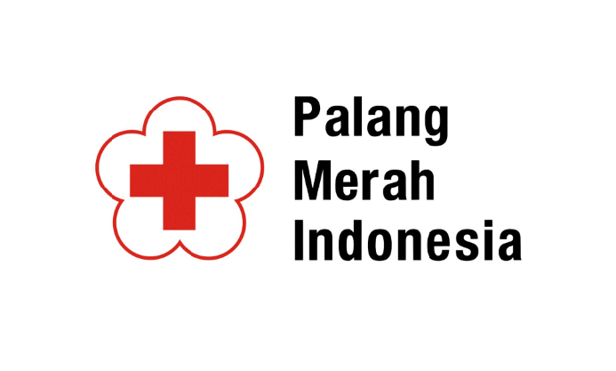

**WAY FORWARD**

Lessons learned in the "Begins with Me" ("Sekolah Siaga Bencana") campaign?

* Strengthening the role of young Red Cross volunteers is a starting point. Youth act as peer-to-peer educators to improve awareness on disaster risk reduction within their school environment.

* Advocacy to integrate disaster risk reduction into school curricula should be in place, to ensure it can be replicated in a wider area, though with necessary adjustments in line with the local context (and its specific type of hazards).

Source: Page 142, 'Light Up: Indonesian Red Cross contribution towards the Hyogo Framework for Action 2005-2015'