***TITLE OF SUCCESS STORY:* Debunking Myths, Preventing Malaria – A Story of Success in Protecting a Community from Malaria, from the Indonesian Red Cross (Palang Merah Indonesia)**

***Agencies names, address and focal contact person:* ARIFIN M. HADI Head of Disaster Management Division, Indonesian Red Cross National Headquarter Ph: +62 21 7992325 E-mail: Arifin_mhadi@pmi.or.id**

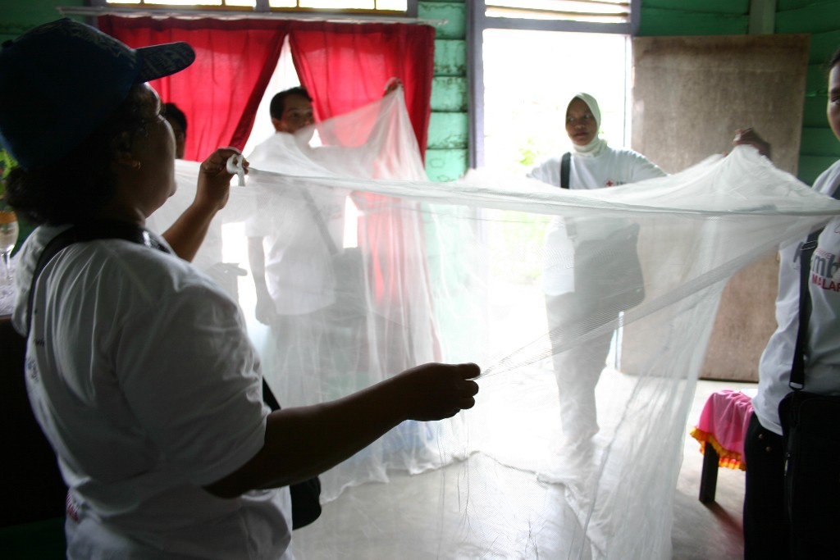

Using mosquito nets © Anggun Sidiq, Indonesian Red Cross.

*"Now they understand that not all fever is malaria, and that fever is only a symptom. Fever itself could be a symptom of many diseases. Thus they should first find out whether it is malaria or not through blood testing before consuming malaria medication." Chaerani, a village volunteer of Paya Pasir Putih village in Sukajaya sub-district in Sabang, Aceh, Indonesia.*

**THE PROBLEM:**

Sabang, Aceh, is an endemic area for malaria.

Two coastal villages of Keunekai and Paya Pasir Putih in Sukajaya sub-district were recording two malaria outbreaks.

The community's knowledge on malaria prevention and medication was unfortunately surrounded by misconceptions .

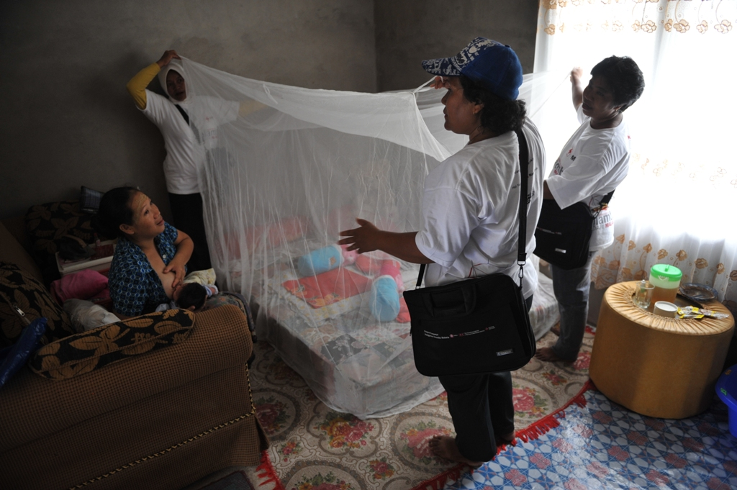

Using Mosquito Nets, Indonesian Red Cross

*IMAGES OF THE STORY: Please share as attachment separately high resolution (above 1 MB) images to support the success story.*

|  |
| --- |
|  |

**THE OUTCOMES**

The face-to-face approach of the house visits played an essential role in making this program successful.

They enabled a more interactive environment to explore in detail the family's health issues and concerns.

The program gradually resulted in behavior changes among the community; for example, the target community stopped using hot water compress es for fevers, and instead, learned to use water at room temperature.

**THE ACTIVITIES**

In response to the problem, the Indonesian Red Cross (PMI) and American Red Cross trained 20 volunteers in each village to enable them to provide services to their community, such as first aid, malaria prevention and diarrhoea prevention.

After being trained, village volunteers carried out health education with their communities and with members of their government health office, discussing various topics regarding the health conditions and vulnerabilities of each village.

The village volunteers also conducted home visits to provide more personalised counselling for families. Each volunteer was in charge of 20 to 25 households, conducting monthly home visits to convey information in phases.

**WAY FORWARD**

One of the key learnings from this project was that changing people's understanding and behavior is not an easy task, as misconceptions can develop into myth, which in turn presents increased disaster risk.

However, the hard work of the volunteers proved that reducing risks by debunking myths is possible.

Source: Hand in Hand - A Collection of Disaster Risk Reduction Success Stories, PMI, 2012, 106-107

IMPLEMENTING AND PARTNER AGENCIES LOGOS:

