International Federation of Red Cross and Red Crescent Societies
Southeast Asia Climate Change Training
Session Plan of Module 1: Opening Session / Bangkok Country Cluster Support Team / 2016

Session Plan of Module 1: Opening Session

Objective: At the end of this activity, the participants are able to:
- Know the participants of the activity
- Establish rapport among fellow participants and facilitators
- Share their expectations
- Form host teams and establish ground rules
- Explain the training purpose and contents
Proposed Methodology:
Game and group discussion
Tips to Facilitator:
- Participatory management is an integral component of running community preparedness action planning. This approach creates ownership and encourages active involvement among the participants
- Specific Objectives indicate the expected outputs for each activity. Each activity contributes to attainment of each Modular Objective.
- While the first part of the Opening Activities can be formal with Red Cross delegates and host National Society giving messages, it is important to establish an atmosphere of openness and trust among the participants and facilitators at the start, to have an environment conducive to sharing and learning.
Reference Materials/reading materials: course design and schedule
Duration: 1 hour 15 minutes

Timing | Purpose/ Objective | Methodology | Material/Facilitator
*From when to when  (min) | What the activity aims at | How the activity is conducted, including the methods to be used (e.g. brain storming, group discussion, role play, etc.), questions, time duration, expected information, what the participants should do, etc.  If case study or role-play will be used, explanation or information should be provided as well. | What materials, facilities, equipment are required to conduct this activity (e.g. flip charts, marker pens, color cards, etc.)
10 minutes | Welcome and Opening address | - Welcome participants  - Introduce the invited Guest, Welcome address and officially open the training; (slides 1-2) | - SEARD, NS Representative(s), Training Facilitator
30 minutes | Introduction of participants | - Introduce session objectives (slide 3)  - Explain that before the workshop starts, participants and facilitators need to get to know each other first;  - Facilitator also explains we also need to match participants’ expectations against activity objectives.  Getting to Know You (Pick a corner)  - Show and explain to participants slide # 4 below  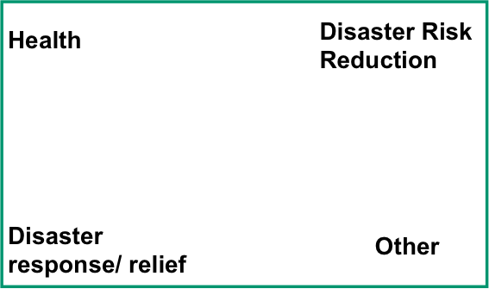  - Ask all participants stand up – and choose a corner in the room where they feel they most “belong”  - Show slide # 5 and invite each participant to present him/herself [name, National Society / IFRC office, Position, main experience (why in this corner) and hobbies, | - Training Facilitator  - Paper cut outs of “Pick a Corner” placed at four corners of the training room
20 minutes | Expectation check | Perception of Climate Change  - Show and explain slide # 6 below  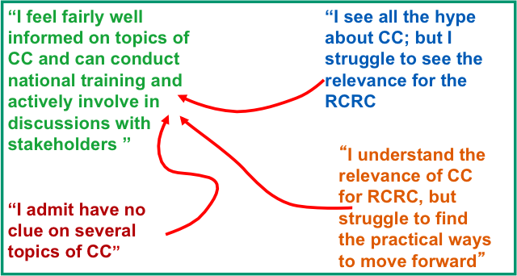  - Let participants distribute themselves into corners according to their general understanding of CC issues and implications in general  [Note: count the distribution for comparison at end-of- training (“Evaluation”)]  - Invite a few people from each corner to argue/explain why they have chosen to stand it that corner, and give examples  (Facilitators' objective: more people in upper left corner by the end of the training! We will repeat this at the evaluation/debriefing at the last day)  - Showing slide # 6, invite people to give their expectations of the 6-day training EXPECTATIONS can be about the following:  - Content  - Methodology  - Facilitators  - Participants  - Logistical arrangements  (OPTION: facilitator can give participants meta cards each where they can write their expectations in the card. They can then read these in plenary and the facilitator “groups” meta cards according to the criteria above)  - Facilitator summarizes the expectations | - Training Facilitator  - Paper cut outs of “Perception of Climate Change” placed at four locations in the training room
5 minutes | Training Purpose and Objective | - Summarizing the expectations from the above, facilitator presents the training purpose, objectives, methodology and schedule.  - Facilitator will refer to participant’s expectations mentioning which ones can be met or discussed in the training and which ones will not. (Slides 8 – 11)  - Facilitator asks for clarifications and explains further if needed | - Training Facilitator
5 minutes | Formation of Host Teams | Host Team Formation  - Explain to participants that the success of the training-workshop is everybody's concern. And since it is everybody's concern, management of the training-workshop is also everybody's concern. Thus, "host teams" need to be formed;  - Facilitator explains what are the tasks of host teams (slides 12–14)  - There are 6 days in the training, thus 6 host teams will be formed  - Facilitator can ask participants to count 1 to 6 and group participants as per their numbers (e.g. all number “1s” together) OR facilitator can suggest that each National Society to be the one host team  - Participants agree which group will be the host team for each day of the activity. | - Training Facilitator
5 minutes | Setting ground rules | Setting Ground Rules  - Participants will have different attitudes and views on certain behavior and topics in the training-workshop. For example, eating during sessions, smoking, different opinions, etc. Ground rules must be formulated to avoid possible arguments and irritants among participants. Such rules will be binding and would apply both to the participants and the facilitators. (Slide 15)  - Facilitator ask participants what they think should be the ground rules for the whole duration of the training-workshop  Examples of ground rules to be set are:  - Attend all sessions  - No smoking in the session hall  - Agreed session start and finish  - Be on time (agree on session hours)  - Respect of ideas of others  - Participation  - Facilitator also mentions a “parking section” will be established. These are questions or items that were raised by participants but are not covered in the current discussion (session). This may be covered in the succeeding sessions or can be given some time for discussion later. (Slides 16-17) | - Training Facilitator
2 minutes | Inter active discussions | - Facilitator shows slides wherein participants may be able to participate and get involved in the climate change discussions via the internet (slides 18-23)
End of Opening Activity

