Vulnerability and Capacity Assessment Report
Barangay Bakhaw Norte, Kalibo, Aklan, Philippines
October 2013

- Acknowledgement

We would like to express our sincerest gratitude to all individuals, groups, and authorities, who have in one way or another, contributed to the formulation, development and completion of this Vulnerability and Capacity Assessment profile of Barangay Bakhaw Norte, Kalibo, Aklan;

To the Ministry of Foreign Affairs of Finland and Finnish Red Cross, for their indisputable financial and founding assistance towards the execution of the Community-Based Disaster Risk Reduction Program in Aklan Province;

To the Philippine Red Cross, National Headquarters and Aklan Chapter, for their munificent and progressive implementation and holistically crafting the depth of the Barangay Bakhaw Norte core units and community people;

To Hon. Carlito S. Marquez and Hon. Joeben Miraflores, former and incumbent governors and PRC Aklan Chapter Honorary chairmen, for their gratifying up keep towards the CBDRR Program implementation;

To Hon. William S. Lachica, for his noble commendation for selecting Barangay Bakhaw Norte and his assistance in the program operation,

To Atty. Ronquillo C. Tolentino, Chairman of Board of Directors and the rest of his members, for upholding and supporting the schemes and activities of the project;

To Mrs. Arcely P. Pelayo, PRC Aklan Chapter Administrator, for her unequaled firsthand facilitation and guidance of staff and project community organizing works;

To the Barangay Bakhaw Norte Council, volunteers and community members, thru the leadership of Hon. Maribeth V. Cual, for the earnest accommodation and attesting enthusiasm, patience and optimism all throughout the program cycle; and,

Above all, to the Almighty God, who has been overseeing and sanctifying splendid breaks among vulnerable barangays and towards the productive implementation of Community – Based Disaster Risk reduction Project in Aklan Province and all individuals involved.

- Objectives of the VCA
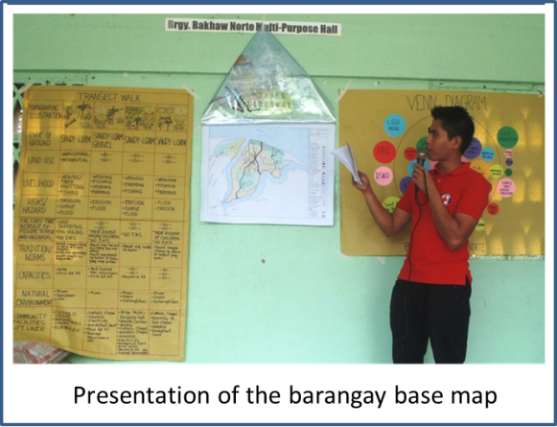
  - Primary objectives
The purpose of this inquiry is to identify and address the objectives of disaster risk reduction management promoting a disaster resilient community based on the standards set by the Finnish Red Cross CBDRRM project implemented by Philippine Red Cross.

  - Specific objectives
1. To clearly define the roles and responsibilities of the community in the management of disasters.
2. To identify the different capacities, hazards and risk factors in the barangay.
3. To formulate a barangay disaster action plan.
4. To be aware of the health related problems that may arise during disaster.

- Process
  - Approach
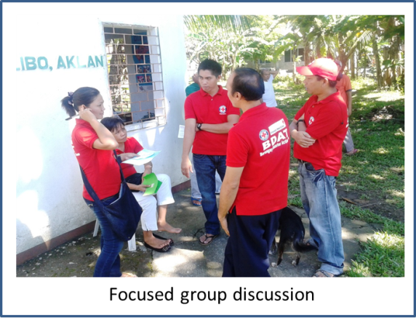
Prior to the actual conduct of the Vulnerability and Capacity Assessment update in Barangay Bakhaw Norte, Kalibo, Aklan, a series of training for facilitators have been undergone by the project team and chapter volunteers to effectively facilitate and guide the community people among partner barangays with the right approach– the Standard Disaster Risk Reduction and Management Training of Trainers was conducted on May 2013 in Tagaytay, Cavite, followed by the Vulnerability and capacity Assessment Training of Facilitators on June 2013.

The VCA update in the barangay was accomplished on October 2013 for four days. Both DM and health components were considered in executing the process and in updating and reformulating existing outputs.

Following methodologies used in the conduct of VCA in Barangay Bakhaw Norte:
1. Inter- active Lecture

Any activity in which participant work individually, in pairs, or as teams to answer questions or infer information about the subject could be implemented in an interactive lecture. An example for this in VCA Process is when the facilitator instructed the participant to make the VCA tools (Resource and Hazard Map, Seasonal Calendar, Historical Timeline and Venn Diagram) Participant can share and deliberate information with co-participant to be able to have a broader output.

2. Direct Observation

Direct observation is a useful research tool as it helps the VCA team to understand the context in which the information is being gathered. All members of the VCA team should be constantly taking notes on what they are observing. It is essential to provide as much detail as possible and to describe the circumstances and the context that lead to certain observations. This will allow others to assess the reliability of the information. When carrying out direct observation, you need to confirm that you have properly understood what you observe as it is easy to misinterpret what you are seeing.

3. Internal Facilitation

Using people who are part of the organization or activity, very often middle or upper level staff members who have skills in leading group discussions, and decision-making processes. Internal facilitators may or may not have knowledge or expertise in the technical/content issues that are being discussed. For this VCA Process in Valenzuela City the Project staff also let the members of the RC143 volunteers lead the discussion.

4. Semi-structured Interview (qualitative)

A form of guided interview in which only a few questions are decided upon ahead of time. The questions are open-ended, with the aim of stimulating an informal discussion on a given topic. This interviewing technique can be used both to give information (such as raising awareness of tuberculosis) and to receive information (such as finding out what people know about tuberculosis).

5. Work group Discussion

A group of people working together temporarily until some goal is achieved a common goal. Here in this VCA Process the Facilitator divided the participant into 3 (three) to 4 (four) groups and has different tools to work with and discussion will be made during the duration of the application of the VCA tools.

6. Focused Group Discussion (qualitative)

A focused group discussion is an organized dialogue between a selected group of knowledgeable individuals in a community to obtain their views on and experiences of a given topic. It is particularly suited to obtaining several perspectives on the same topic. Focus groups also provide insight into people’s shared understanding of everyday life and the ways in which individuals are influenced by others in a group situation. However, problems can surface when attempting to separate the individual view from the group view. It is very important that the facilitator has good group leadership and interpersonal skills in order to moderate such a group successfully.
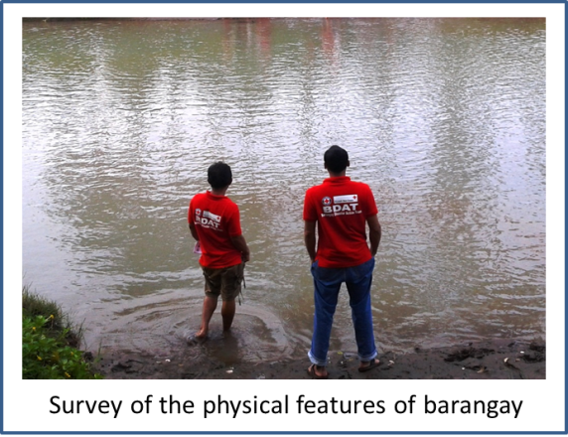
7. VCA Tools

VCA is a methodology for investigation. It is a means of gathering information through a participatory way. Its purpose is to increase community members’ awareness of risks and help them to plan activities for reducing vulnerability and increasing capacity before a disaster happens.

8. MAPPING (RESOURCE AND HAZARD)

Maps can be made by a community to indicate the position of risks and hazards. They can also be used to understand what a community has in the way of resources and where they are located. Maps are also useful for stimulating discussion among community members about important aspects of the community. They can help a community to analyze potential problems and solutions.

9. SEASONAL CALENDAR

For a seasonal calendar, a chart is created with the months of the year along the horizontal axis and the events and activities significant to the community listed in the vertical axis. Completion of the chart by the community helps the VCA team to see the hazards and risks in terms of when they occur. The analysis can help a community to rethink its living habits according to its vulnerability to hazards. 20 years of comparative analysis is prepared by the community.

10. HISTORICAL TIMELINE

With a historical profile, a community can build up a picture of past events, track changes in the environment and behaviors and understand causal links. Awareness of these patterns can influence the decisions that community members take when planning projects.

With historical visualization, the community creates a chart showing how key aspects of their lives have changed over time. It can show up changes in housing, trees, river levels, livestock and hazards and helps people to think about how their susceptibility to certain risks may continue to change in the future. It is a good starting point for a discussion on what projects would be relevant for the future. Indicators in this tool are events, effect, response and lesson learned.

11. VENN DIAGRAM

Venn diagrams are designed to collect social data by using circles to show the links or relationships between different parts of a community or institution. Because they reveal similarities and differences between institutions, partners, people and issues within a community, they can be useful in identifying problems and possible solutions. Venn diagrams are especially relevant for institutional analysis as they can help to identify specific organizations that could be involved in implementing a community action plan or specific risk reduction projects.

Source: Valenzuela VCA Report

Team Composition

Project staff

Chapter project coordinator and Community development officer hired by PRC, approved by the board of directors and recommended by the Chapter Administrator.

Core Volunteers

This consists of Chapter - based Volunteers with special skills and trained by/under the Philippine Red Cross, dedicated to facilitate and conduct VCA in the Community with minimum monetary allowance and benefits.

Core RC143 Volunteers

A group of Community based Volunteers and will serve as the eyes, the hand and the feet of the Philippine Red Cross, have undergone trainings and skills development.

VCA Team Composition

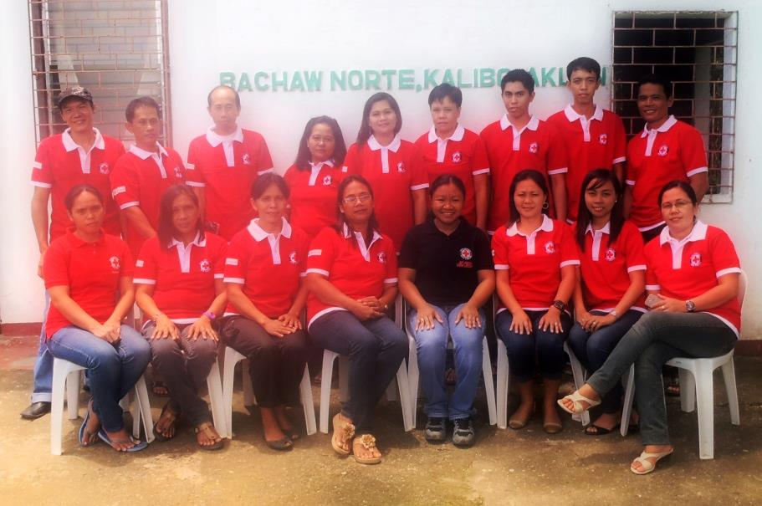
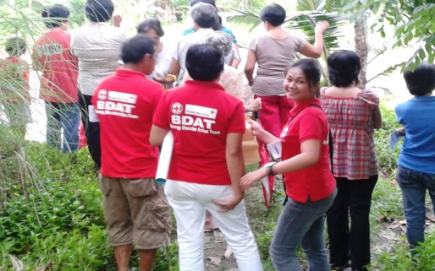
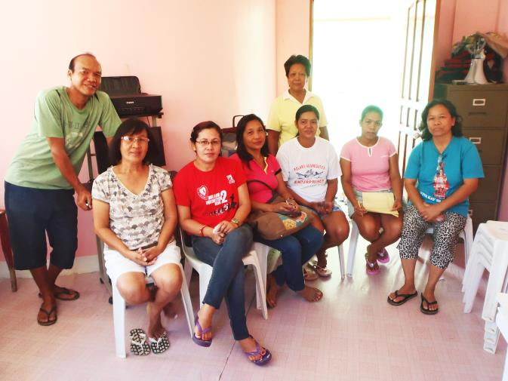
Name of Volunteer | Sex | Designation
Maribeth V.Cual | Female | Punong Barangay
Duvill V. Duran | Male | Kagawad/BDAT member
Charlie Magsisi | Male | Kagawad/BDAT member
Linda L. Magsisi | Female | Community health volunteer
Donna D. Tan | Female | Community health volunteer
Reysy M. Dela Cruz | Male | Kagawad/BDAT member
Jane I. Cavan | Female | BNS/Community health volunteer
Naneth M. Villanueva | Female | RC 143 volunteer
Arturo C. Yabut | Male | Tanod/ BDAT member
Grace M. Paroginog | Female | Community health volunteer
Edgar T. Marte | Male | Barangay Secretary
Delia Alberto | Female | Barangay Treasurer

- Barangay Profile

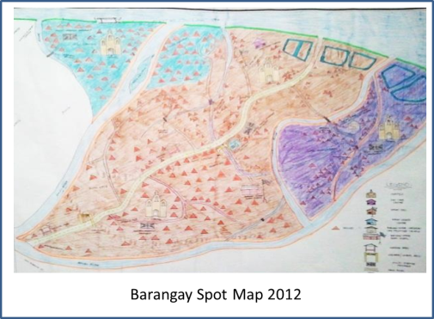
  - Geography and Topography

Bakhaw Norte is a coastal barangay bounded between the northeast of Poblacion Kalibo and on the east boundary of the Municipality of Numancia. It has a land area of 321 hectares as per cadastral survey conducted on 1990.
Bakhaw Norte was founded on 1760, taking its name due to the abundance of bakhaw trees. This barangay is divided into three zones or “sitios;”
Sitio Proper, further sliced into Ilaya and Ilawod, situated at the center of the barangay separating Sitio Libuton, located at its northwestern side facing the Sibuyan Sea with a piece separated by the Aklan River, and Sitio Karumahan, another zone isolated by the river, found at its southeastern portion, sharing a land portion with Sitio Pegado of Barangay Bakhaw Sur.
  - Demography

 | Population | Household | Senior Citizen | PWD
Sitio Proper | 1017 | 275 | 42 | 12
Sitio Libuton | 803 | 88 | 19 | 2
Sitio Karumahan | 408 | 99 | 13 | 4
Total | 2,228 | 462 | 74 | 18
Source: 2013 Barangay Survey

2013-2016 Bakhaw Norte Barangay Council

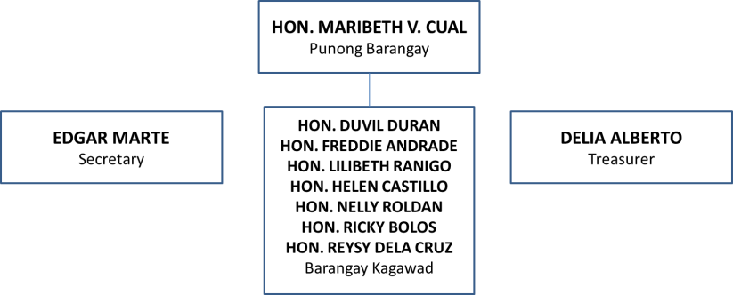

  - Socio-Economic

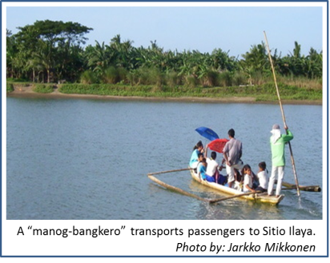
Among any other barangays in Kalibo, Bakhaw Norte is one of those with high number of families categorized within average and low socio-economic status. One presumable cause is their isolation by the Aklan River. The difficulty to access the outside civilization has caused deprivation to meet the people needs and delay the improvement and recovery into their society.
Since about 60% of residents are inclined into farming, fishing, traditional labors, and transient employment, most could not be able to send their children for scheming courses or even get into tertiary schooling, thus they eventually get to work ahead of time. This is also the predetermining attribution for the high record of early marriage and pregnancy in the barangay.
Bakhaw Norte is also a typical ground for major disasters. Its high level of predisposition to flooding has caused severe land erosion and damage among agriculture and housing structures and further exhausting business persons and certain small workers.

  - Livelihood opportunities

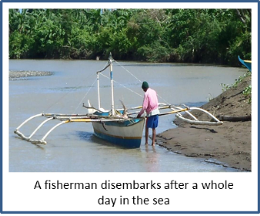
Approximately 65% of the reproductive age group (20-40 years old) is working outside the community – about 70% of them are into trades and businesses while the rest are skilled laborers.
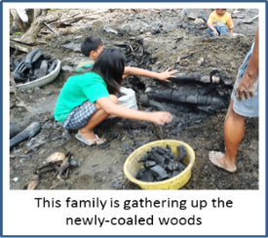
The barangay is as well largely graced with coconut, bananas and crops (singkamas, kamote, and mais) in which business individuals are investing into large scale production of it on seasonal basis. Several fish ponds along coasts of Sitio Ilawod and Karumahan can also be found. These are owned by families of business persons that hire laborers residing around the place during harvest. The rest portions are used for backyard and vegetable gardening and poultry for small trades and for family consumption by farmers inhabiting the area.
Among those residing near the sea, especially in Sitio Libuton and Karumahan, majority sources out fishing for livelihood. Approximately 20 families own boats for this living.

Also, periodic lumber production, most from coconuts, mahogany and gemelina, and “pag-uuling” (firewood making) are being done by small traders in the island. Upon reaching Kalibo, these are directed to contractors who will then manage to sell the products.
There have been at least thirty (30) “tiangge” or mini store in the Barangay providing snacks, some instant foods and beverages. This isn’t a much high-profit business for most owners depend on this for household consumption as well. Majority of them do not stay open late in the evening.

2013 Registry System for Basic Sectors in Agriculture (partial table)

 | No. of HHs with Farmers | Total No. of Farmers | No. of HHs with Farm Laborers | Total No. of Farm Laborers | No. of HHs with Fishermen | Total No. of fishermen
 | 158 | 165 | 10 | 10 | 106 | 131
Percentage vs. total Population and Household | 34.20 % | 7.41% | 2.16% | 0.45% | 22.95% | 5.88%

        - Most common agricultural products (ranking)
          - Root crops - “kamote, gabi, mani, singkamas”
          - Vegetables – “sitaw, upo, okra, sigarilyas, pepino”
          - Corn
          - Banana
          - Coconut
        - Most common livestock (ranking)
          - Chicken
          - Swine
          - Ducks
          - Cows
          - Goats
        - Other products (ranking)
          - Fish – “bangus, tilapia, liwit”
          - Charcoal/firewood
          - Knotted and weaved abaca

  - Education and health care situation

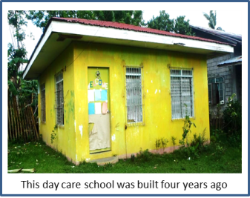
The Bakhaw Norte Elementary School is the only education facility in the barangay which has existed for more than 85 years. Previously, it had only catered students for primary education until in 1980s in which intermediate level was started. The usual number of enrollees in every school year ranges from 240-280 students. Apart from this, two classes for daycare pupils are being hold every day – one is done at the daycare building situated next to the old barangay hall in Sitio Proper while the other one is at the boundary of Sitio Ilaya.
Since it there is no establishment yet of secondary and tertiary schools in the barangay, graduates take the risk and opportunity of continuing education outside the barangay consequently necessitating extra stratification for more income and work among parents and pressure among students. Only few families, about 5%, receive supports for sustaining schooling from relatives outside the community.
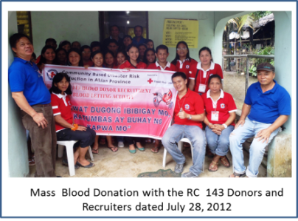
There is also no operational medical facility that could provide 24/7 assistance for emergencies in the barangay. The midwife, based in the Kalibo RHU, only visits the center for two to three times a month for immunization and during health programs. However, there are barangay health workers and trained volunteers (RC 143 members) in the community that service first aid management, and promote health programs, supporting Philippine Red Cross projects and implementation.
Along with this, the limited medical facility and personnel is also a provenance for cases of infants and maternity-related deaths, and options for traditional and supernatural pursue and interventions believed and practiced by more or less 90% of the community.

Barangay Bakhaw Norte Health Center Personnel
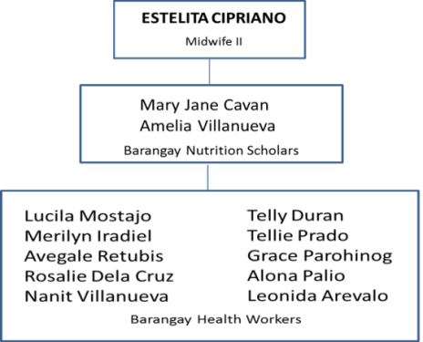

  - Religion and ethnic groups
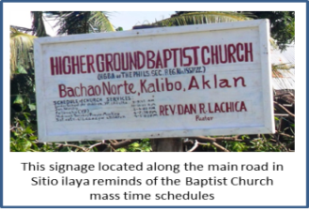
Predominantly, almost 90% of the inhabitants in the barangay are Roman Catholic in which masses are weekly celebrated in all four churches located in every sitio. About 10 families are members of Christian Baptist and another around 10 families are affiliated with Assemblies of God. The rest belonged to the Iglesia ni Cristo.

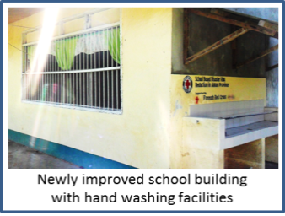
  - Infrastructure, basic services and utilities
The eldest existing buildings in the barangay were the ones located in the school. It has hosted different gatherings, aside from the usual school programs, such as assemblies, elections, and masses. It has as well improved more thru their modeling projects of the Department of Education – establishment of formal water facilities and vegetable and floral nurseries which have notably enhanced the learning atmosphere of the students. Indeed, it is a child-friendly zone.
All in all, there are thirteen structured buildings in the school. Presently, Mr. Elnor T. Luna, Head Teacher I, leads the pool among all other thirteen teachers.
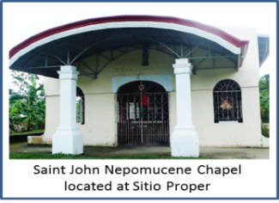
The main chapel, one of the four in the barangay, is located at Sitio Proper. Its grounds have been developed on year 2000s thru donations of different private people and individuals abroad. Just like the school, it has also served many purposes – drills and evacuation points and as for lecture and campaign venues. Other Christian religions also hold masses here on occasional basis. All these chapels have interchanging schedules for Sabbath events.

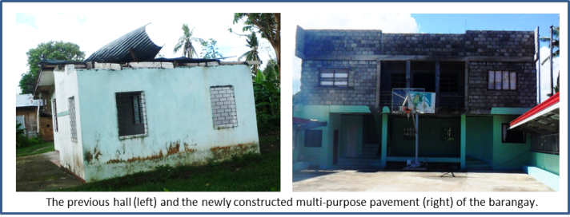
The former barangay hall of the council (shown on the right, first picture) has been unoccupied since February 2013 as the new multipurpose pavement became feasible for holding office works. Aside from the gymnasium provided that could handle mass gathering in the barangay, it has been fitted out for possible evacuation and could accommodate as much as 200 persons as a preemptive collection point. Compared to the first building, this office could assure the security of both the assets and lives of vulnerable people during times of flooding since it has already been one meter elevated.
There is no garbage collection and disposal system ruled by the barangay. However, residences took the initiative of practicing backyard disposal of decomposable items, reusing of plastics and cans, and trading of used bottles.
Barangay Tanod, now composed of 12, maintain peace and order to their constituents for a whole week.
  - Condition of roads and bridges
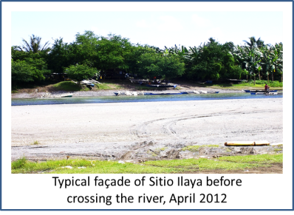
The major road in the barangay extends from the waiting shed, upon crossing to the island, reaching until the Sitio Ilawod - at about 2.5 kilometers is concreted 30 meters after passing thru the barangay marker.
A new hanging bridge connecting Sitio Karumahan and Sitio Ilaya has also been completed on January 2013 – timely as when the previous bamboo bridge, standing beside it and which was provisioned with the support of PRC CBDRR Project, was totally wrecked by flooding brought by Typhoon Quinta on December 26, 2012. Other repaired bamboo bridges are located in Sitio Centro and Sitio Libuton.

Distance to major points:
          - Provincial Capitol 3kms
          - Provincial Highway 2 kms
          - National Highway 1.5 kms
          - Regional Center 450 kms
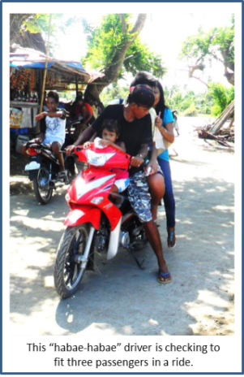
  - Source of electricity and water

Presently, nearly 100 percent of the household population subscribes to Aklan Electric Cooperative (AKELCO) for their power supply. As of 2011, approximately 75% of the population of the barangay has already accessed to Kalibo Water District. At least 5 percent consumes purified water being sold out in Poblacion Kalibo and by some private individuals within Bakhaw Norte, while the rest still depends on deep wells for their drinking water. Water-Sealed type is toilet facility utilized by approximately 420 houses.

  - Transportation and communication means
Aside from the typical tricycles, “habae-habae” or motorcycles (most are unregistered) is also a major transportation mean within the island. Not more than 20 units of them share passenger trips daily. Most people during working days prefer commuting these for aside from being able to penetrate smaller passages they don’t need to get filled before driving out of the posts.

Other boats (non-motorized) are utilized for transportation to cross the Aklan River on both sides of the island barangay for usual days– two of these are paid by the Kalibo LGU. The rest are private-owned and are being commuted by the residents during flood or when they have bicycles or motorcycles to cross.

  - General Climate Condition

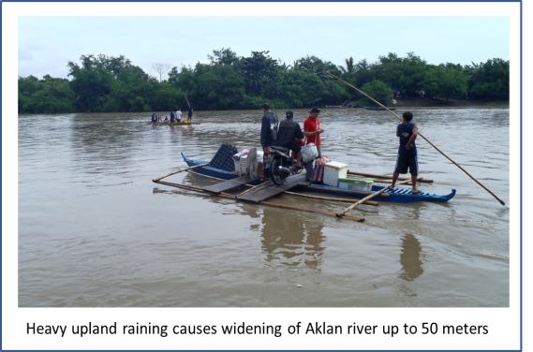
Generally, rainy seasons start from July until mid-March. However in the barangay, there has been unpredictable raining days even during summer times. The end of the second until third quarter of the year is often the peak of good agricultural harvest while fishing can be done every three to four months and ahead strong typhoon seasons.
June is as well the official start period of Typhoon passing through the barangay until March and in which flooding may be anticipated.
Compared to climate experienced at least thirty years ago, the extent of summer days presently has shortened and irregular weather changes happen. More and stronger typhoons occur within a five-year span eventually leads to more flooding incidences.

- Vulnerability Conditions
  - Natural and environmental

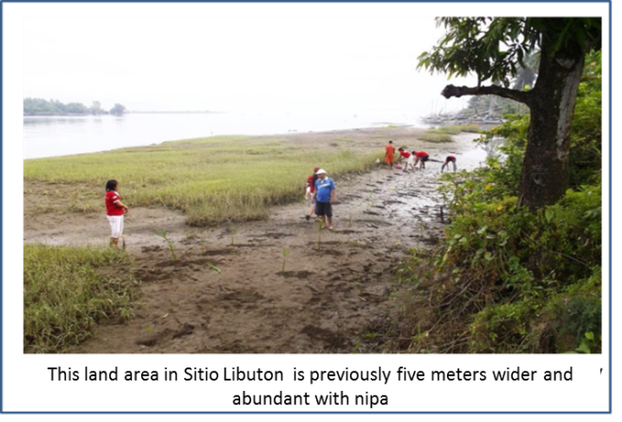
Barangay Bakhaw Norte has high level of predisposition to flooding due to its very low topographic placement and serving as one of the catchment basins of the Aklan River. The entire surrounding coast, which has already eroded four to ten meters, is now part of the watercourse causing extensive gradual decay of trees and farmstead damage. Since 2005, two to three incidence of flooding is experienced by the barangay every year. At least two in every five years are highly destructive.
The absence of bridge to between the barangay and Poblacion Kalibo has always been a problem and threat as well among residents, especially to those who cross at night or when the river water rises. During this condition, delay access during emergency situation is anticipated.

Below is the list of the major disasters in the community history:

1980s-Typhoon Claring. This resulted to flooding and tolerable damage among agriculture. No record of assistance received is known.
1984-TyphoonUndang.Apart from the houses and crop fields that were affected, approximately 20% of the community had acquired upper respiratory tracts infections. This has been attributed to the cold environmental condition intensified by recurring raining days after the hit of the disaster
June 21, 2008-Typhoon Frank. This has brought severe psycho-emotional trauma among many residents of the island community - first time in their disaster history that the flood water has covered the entire land of Bakhaw Norte. Not less than 50 percent of the crops were useless, 100% of banana plantation was down, about 65% of livestock animals died and no fishpond harvest was made. Within a month, skin problems and upper respiratory tract infections have been recorded along with some minimal water-borne diseases acquired. Major assisting organizations are the local and National LGU, PRC, World Vision, Tzu Chi Foundation, ABS-CBDN, Phil. Army, DSWD, PMA and the rural health unit of the municipality. From then on, many houses were been improved and constructed with second floor.
December 26, 2012-Typhoon Quinta. Another high flood water level has also been noted washing out the bamboo bridge, a PRC-FRC project, connecting Sitio Ilaya to Sitio Karumahan. Access, particularly of students, was compromised to reach the Centro of the barangay. Minimal damage to crops and livestock has also been recorded. There was no known injury and casualty during this event due to the advance evacuation activity headed by the RC 143 team among vulnerable groups and individuals in the barangay. The local government of Kalibo and province of Aklan were amongst the responders for food assistance.
November 8, 2013 – Typhoon Quinta. In terms of wind strength, this typhoon is the strongest. Despite of the tolerable level of flooding among lower areas, the entire barangay has acquired severe damage among trees, particularly banana and coconut. Power lines were also out of purpose for more than 6 six weeks. The barangay, municipal, national LGUs, PRC, German Humanitarian Society are assisting organizations in the community.

  - Health
Despite of the limited health care facilities in the community, apparently, there is a low prevalence of any diseases for the last five years. Most recorded are typical upper respiratory tract infections yet these are highly manageable at the household level. One water-borne disease- incidence on August 2012 has been rampant causing hospitalization of not more than ten individuals.
Records of infant (one, still birth), and maternal (one, due to the delay seek for health care intervention) death, have also been noted for 2013.

Below is the 2010 top leading causes of mortality and morbidity in the barangay.

Five Leading Causes of Mortality (2010) |  | Five Leading Causes of Morbidity (2010)
Causes | Number | Causes | Number
Asthma | 3 | Parasitism | 25
Cardio Vascular Arrest | 2 | Gastro-Enteritis | 21
CRA- COPD | 2 | Acute Respiratory Infection | 12
Acute Myocardial Infarction | 2 | Fever | 10
Multiple Masses (wrist & ankle joint) | 1 | Skin Problems | 7

  - Socio – Economic

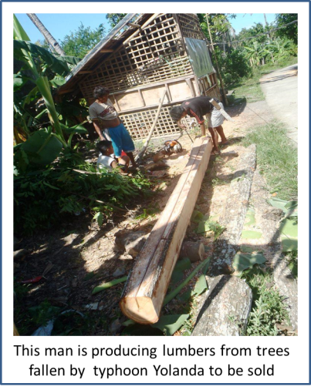
There had been a high risk of impediment for agricultural and fishing activity, especially among the lower areas in the barangay, due to the subsequently occurring disasters. However, people were still been able resume on farming among areas which were not affected by flooding. Particular to banana production which has been down since the last quarter of year 2013, crops growth may be distressed due to the erratic raining patterns. Fish ponds have also been losing harvests for many incidences of water rise.
Meanwhile, majority could still sustain for the basic needs of their families depending on members working outside the barangay. Livestock, which isn’t much affected, is also a big help for trades and their food sources.
Barangay Bakhaw Norte has now almost recovered from the hit of November 2013 typhoon in terms of public facilities and activities. Most of the 44 destroyed houses have been rebuilt while others have been staying temporarily among their relatives until this time.

- Capacity Conditions and Coping Mechanism

  - Natural and environmental
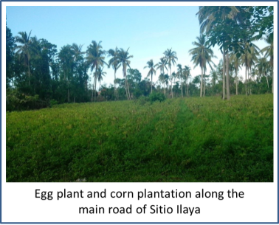
Known to many people, the barangay has been a producing large scale and good class of banana, coconut, vegetables and root crops for the last years. The soil condition favors the quality - growth of most land yields which are in demand for business in Kalibo.
Aside from fish harvests, the coastal areas of the Barangay also produces crabs, shells, shrimps and prawns, which offer good incomes among small individuals engaged into this work on different seasons. The nipa and bakhawan (mangroves) portion from Sitio Ilawod until part of Bakhaw Sur has been a nursery of different aquatic products and help in controlling erosion and flood current along the site. Until now, Bakhaw Norte and Bakhaw Sur Agri-Fishing Association (BAFA) has been providing seedling among farmers and fishermen in the community.
Good timbers were produced by some individuals from fallen trees left by the typhoon and are being sold out in Kalibo.

  - Health
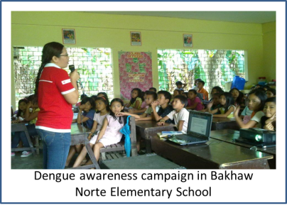
The barangay has a highly dependable and active RC 143 group composing of 48 members. Aside from their usual function as embedded in the council and health cluster, they are as well trained and mobilized during cleanup drives, blood donation, health promotion campaigns, school activities and response during disaster emergencies.
The health team group is dynamic in doing house to house survey, immunization and reporting in all their designated zones. They are as well equipped with first aid materials and kits for manageable conditions.

  - Socio – Economic / Governance
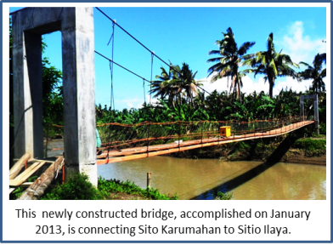
Despite of the extensive damage brought by the recent typhoon, the community has sets of reliable individuals and offices for the recovery of the people - most are regular donors and assisting offices. The Lind’s Dry Good Store has been generous in supplying clothing and financial assistance. Lending organization, likewise, are highly dependable for long years – USWAG, Big 8, Dungganon, HAMPCO, and Life Bank. Different schools and other private organizations have brought food and non-food items among residences.
The Department of Social and Welfare Development thru its 4Ps programs is consistent with its financial, educational, livelihood assistance and different community programs among the most deprived and vulnerable groups.
The construction of new multipurpose pavement and hanging bridge is an indication of a good progress of the barangay economy and leadership along with the increase of their Internal Revenue Allotment (IRA) for 2014.Access and partnership to higher offices, and different NGOs - Philippine Red Cross for instance, has helped to develop plans and putting up preparation strategies for disasters.
The plan for improving barangay programs, health and educational facilities will as well open more opportunities among many individuals for employment, knowledge and skills development and enhancement and strengthen their own identified capacities. Community members are now more motivated in participating assemblies and programs.

- Actions to Build Resilience
  - Prioritized hazard
    - Flood. This hazard regularly visits the community people. About at least 2 flooding incidences in a year is anticipated. The recent Typhoon Yolanda has also caused the overflowing of Aklan River and left high level of muds among the coastal parts.
    - Strong winds. Though only experienced during typhoon events, this primarily destructs banana tree plantations in the barangay. With the current visit of typhoon Yolanda on November 2013, disruption of electric power supply has lasted for more than 6 six weeks due to the fallen posts and trees among power wires and cables.
    - Land erosion. Vast coastal land areas of the barangay have already been eaten by the Aklan River. This is aggravated by flooding events uprooting the large trees along the grounds of the barangay.
    - Sea swells. This hazard is further resulting to erosion of the land and damage among plantation along areas facing the Sibuyan Sea. Change in the watercourse near the sea is also one of the effects of water swelling.
  - Activities to reduce the risk and increase the resilience
    - Tree planning. Time after time, larger parts of the barangay land are getting softer and this opens for further threats in the long run. Despite of the ongoing tree planting activities, the barangay still needs more effective and comprehensive strategies in implementing it. For not more than a decade, wide fractions of coastland have been displaced and there has never been effective large scale intervention executed to mitigate this phenomenon. Mangroves and wild bamboos are among of the good recommendations.
    - River dredging. The previous diggings made in Sitio Libuton have not caused much improvement with the course of flood and seawaters and prevent land erosion. The disturbed natural behavior of the flowing river has yielded into collateral and wider spread of it. Better dredging approach is thought to be needed.
    - Provision of flood controlling barriers. Apart from dredging, the island barangay needs as well a flood controlling barrier that would abate the impact of raging water along its coasts and avoid its further shrinking .Gabion bricks or river walls can be an option.
    - Regular flood and evacuation drills. Having series of drills conducted among other parts of the barangay could get other community members oriented with the proper evacuation process during flooding events and be made taught about sourcing out strategic locations and appoint leaders to be in-charged with.

- Process Feedback
  - Challenges and Lessons Learnt
- Constraint with the availability of the Red Cross 143 Volunteers to participate in the conduct of VCA
- Inaccessibility some sitios
- Unavailability of most council members and community people during presentation
- Scheduled dates were moved due to activities of other groups– 4Ps lecture, necessitating the mobilized volunteers’ presence
- Lack of cooperation of community members during the data gathering
- The start of VCA output formulation was made delayed, making it very difficult for the project team to reconsolidate all information brought out during the process

  - Best Practices
    - The team has been reiterated and made understood with the goals and objectives of VCA, thus despite of the limited support received, the activity has been completed as scheduled;
    - Activities have been monitored by team leaders;
    - Terminologies have been defined well- VCA, hazard, risk, vulnerabilities, and capacities;
    - Daily evaluation and feedback collection have been opened from both the leader and members;
    - Bureaucratic management has been applied;
    - The team has been assured to be provided with the necessary materials, foods and transportation allowances; and,
    - During presentation, all complains were accommodated, and concerned parties/individuals were given chances to speak

- Attachments

  - VCA tools

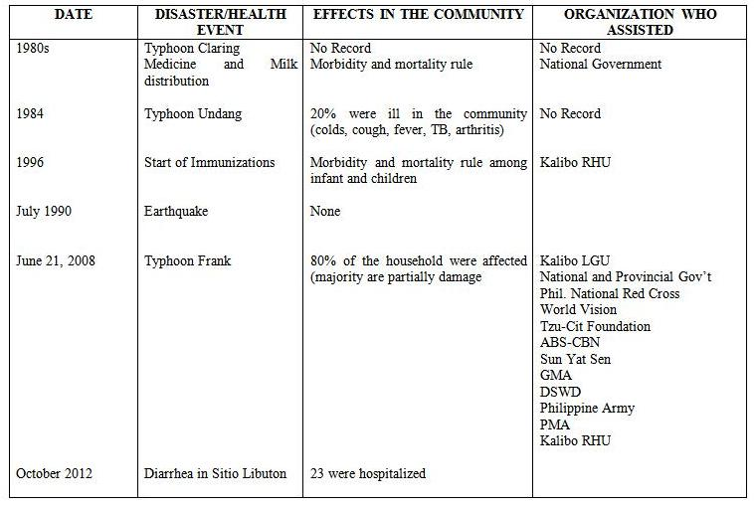

vi. 1 Historical Timeline, October 2013

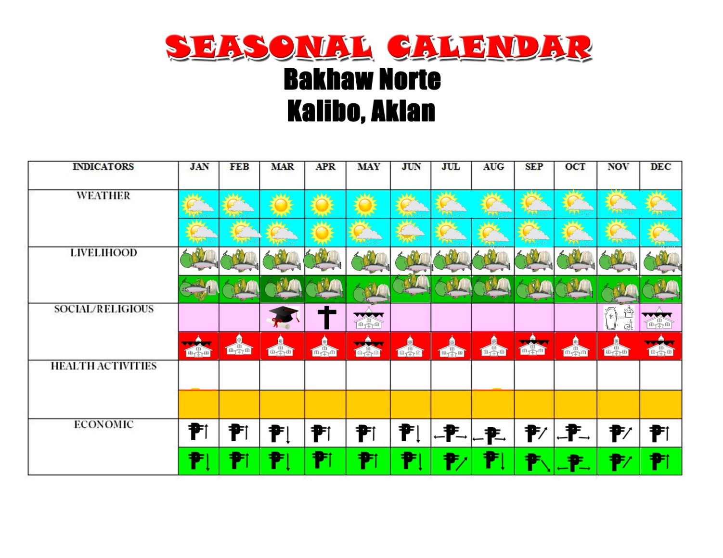

vi.2 Seasonal Calendar, October 2013

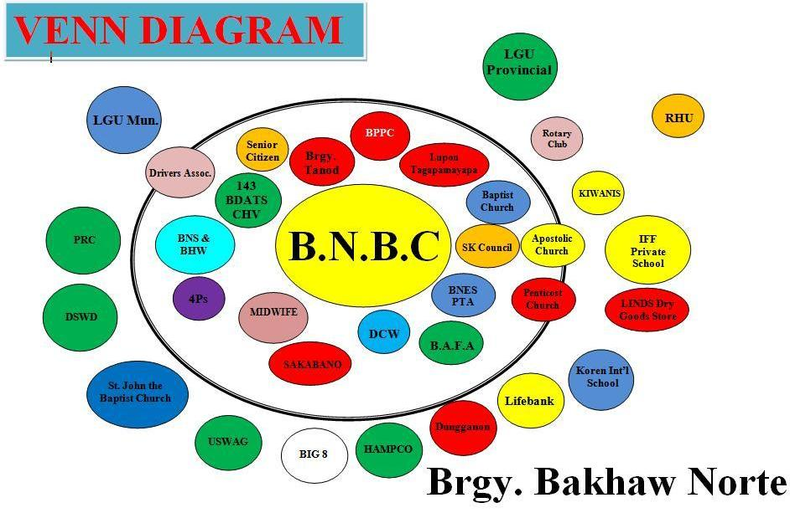

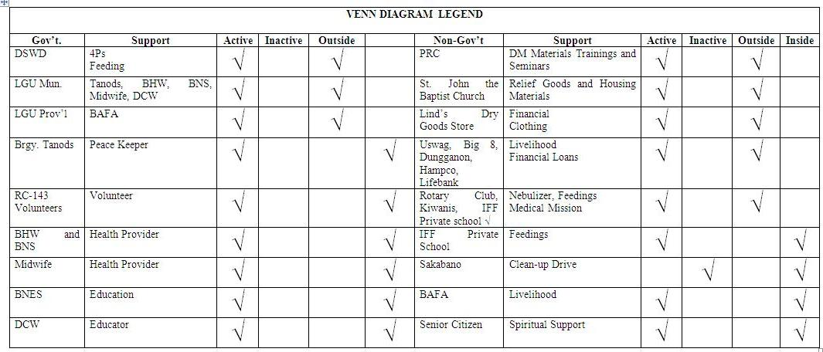

vi.3 Venn diagram and organizational category and their contributions, October 2013

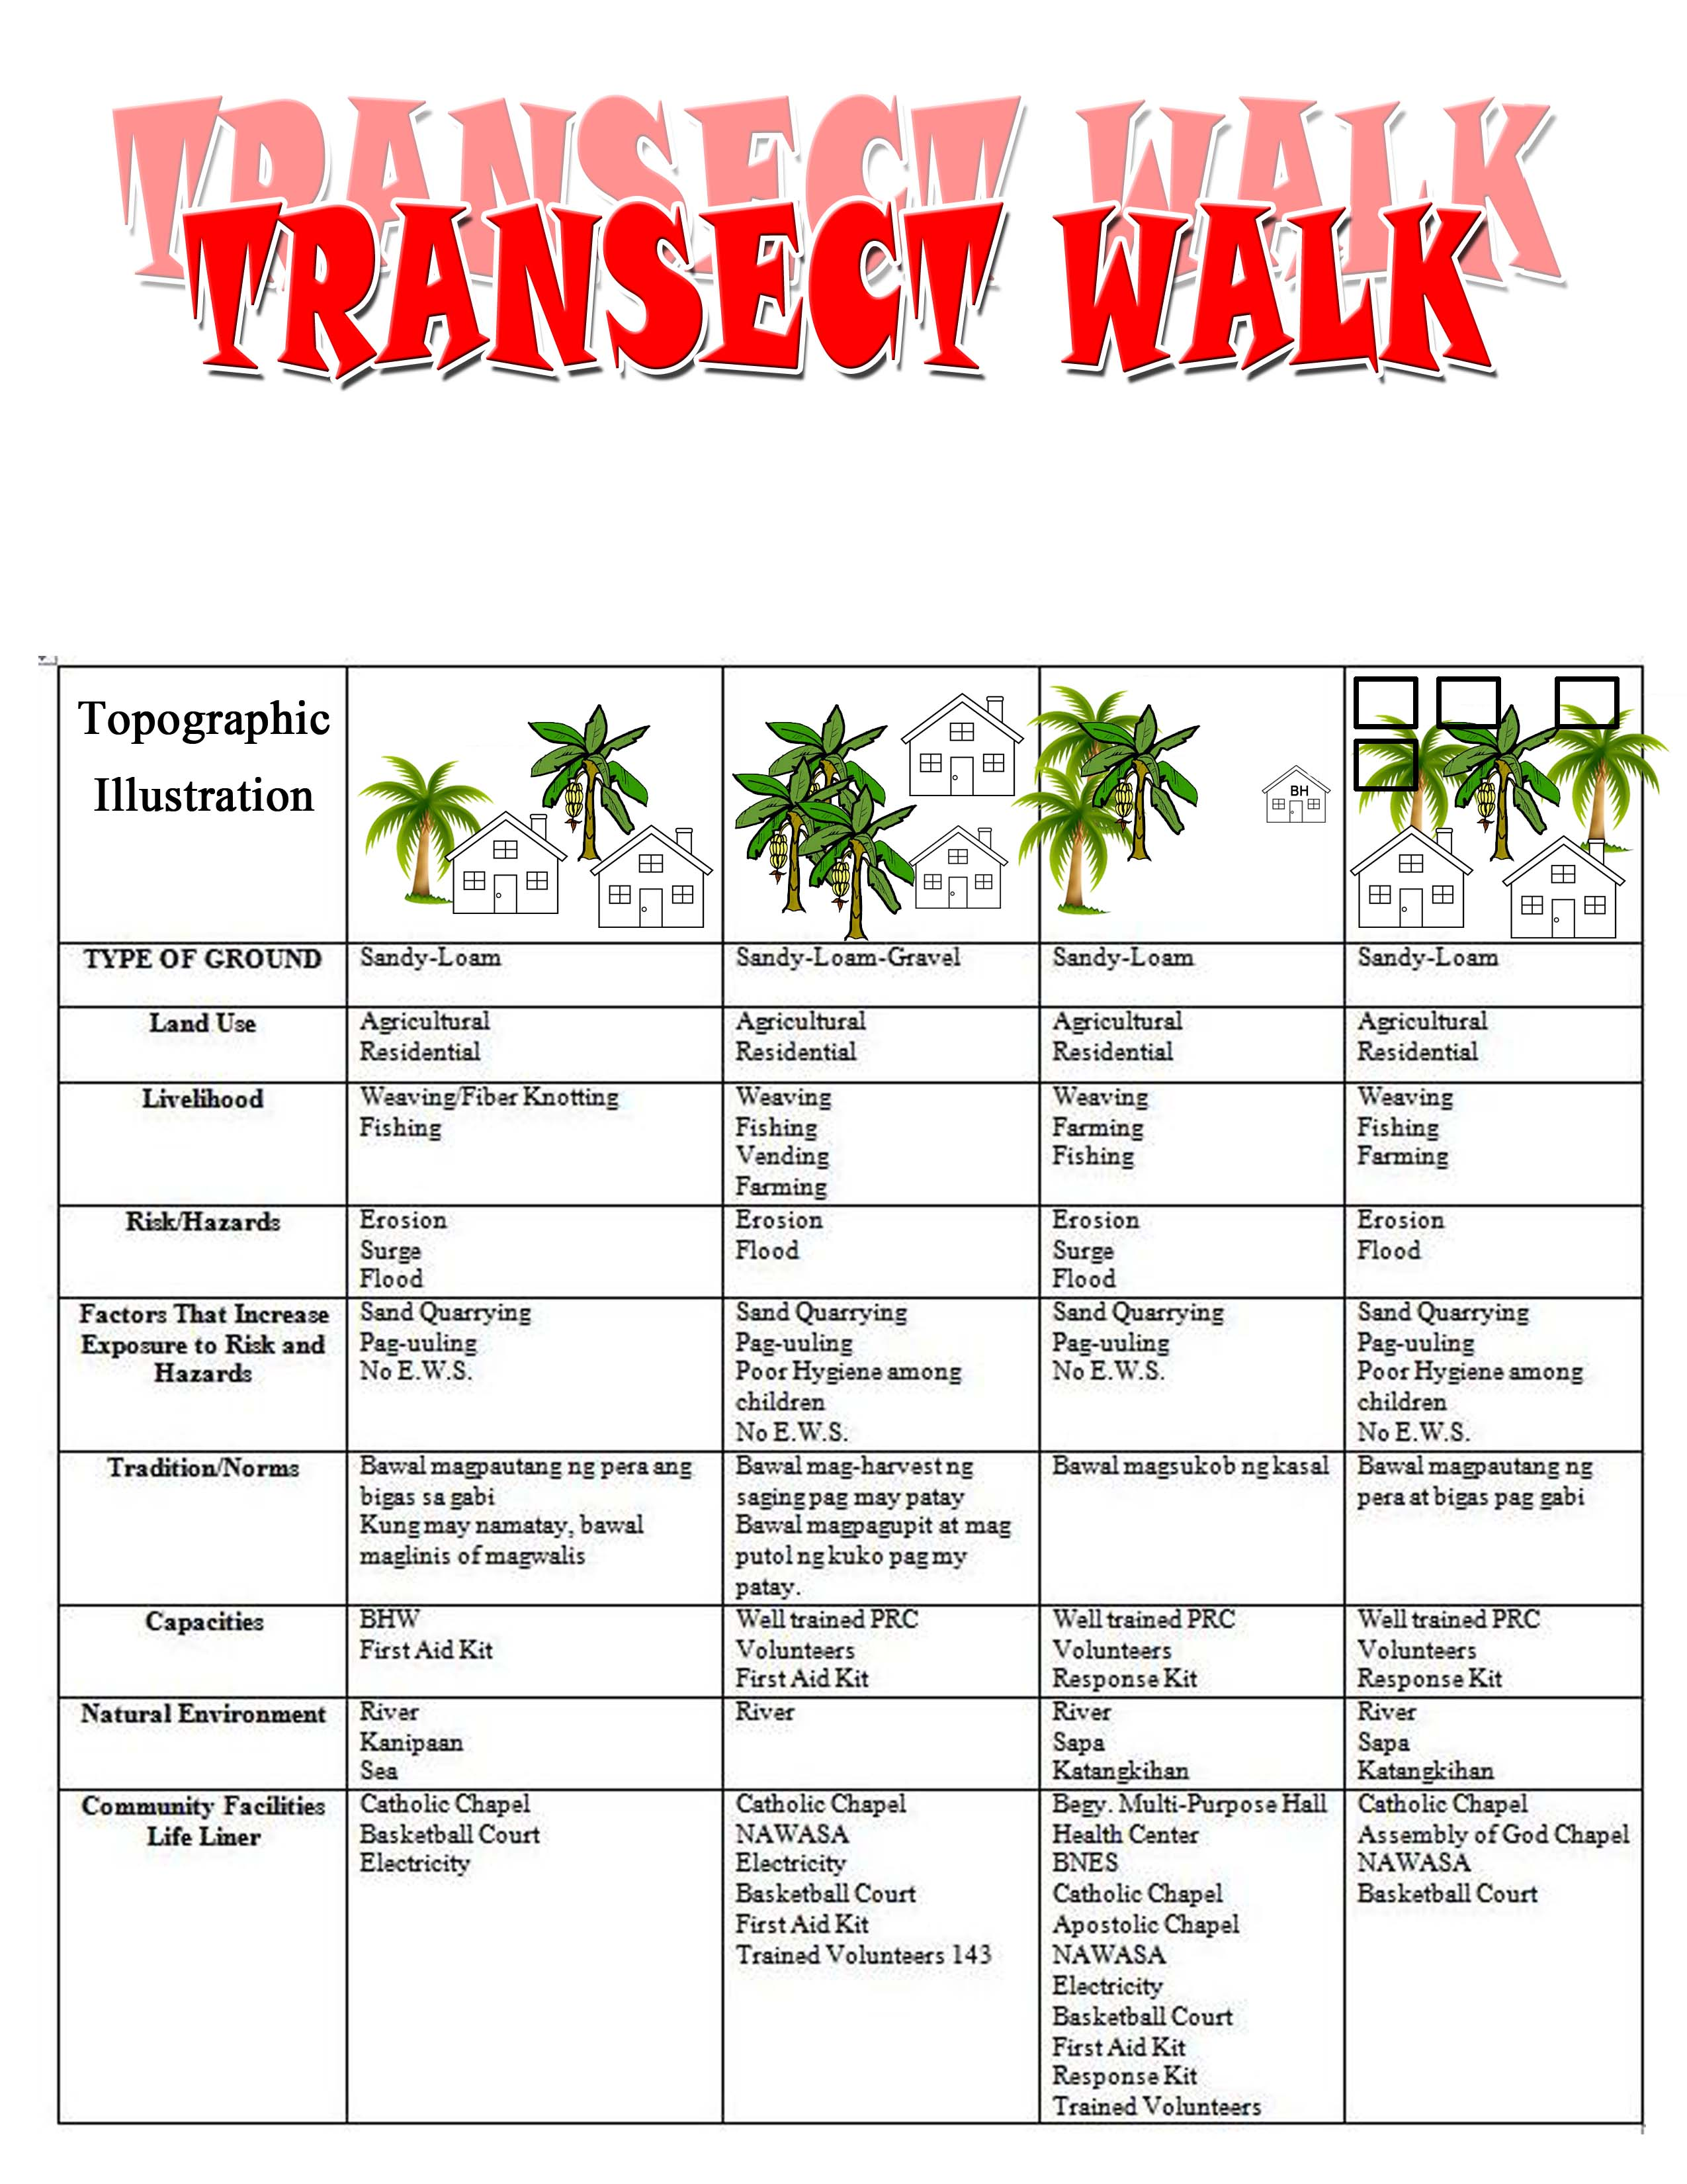

vi. 4 Transect walk, October 2013

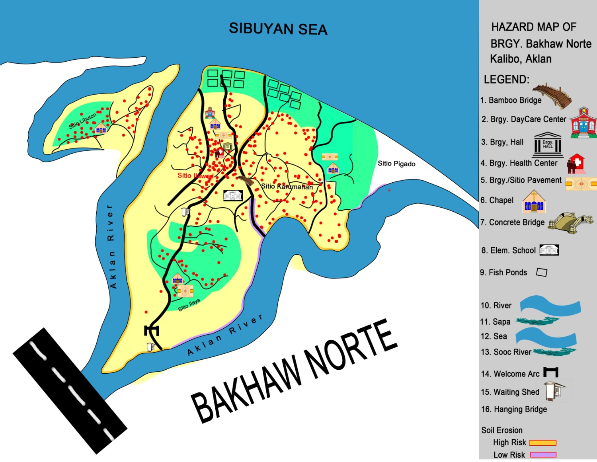

vi. 5 Base map, October 2013
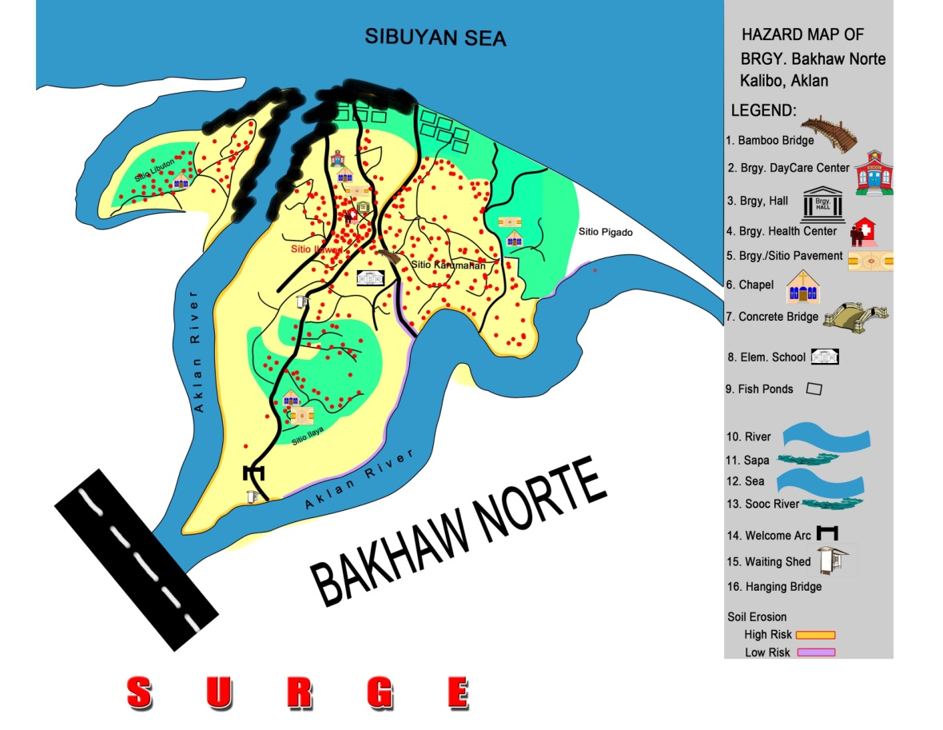

vi. 5First overlay – Hazard 1, Storm surge October 2013

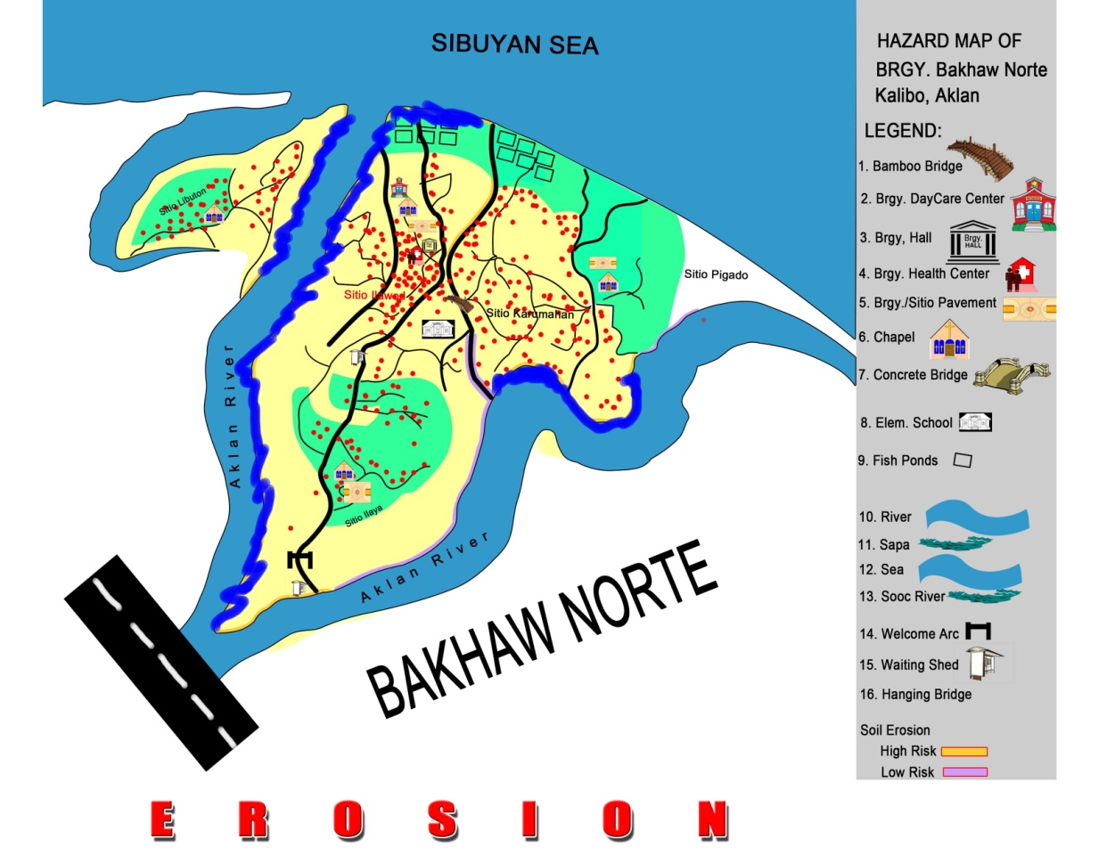

vi. 5 Second overlay – Hazard 2, Soil erosion, October 2013

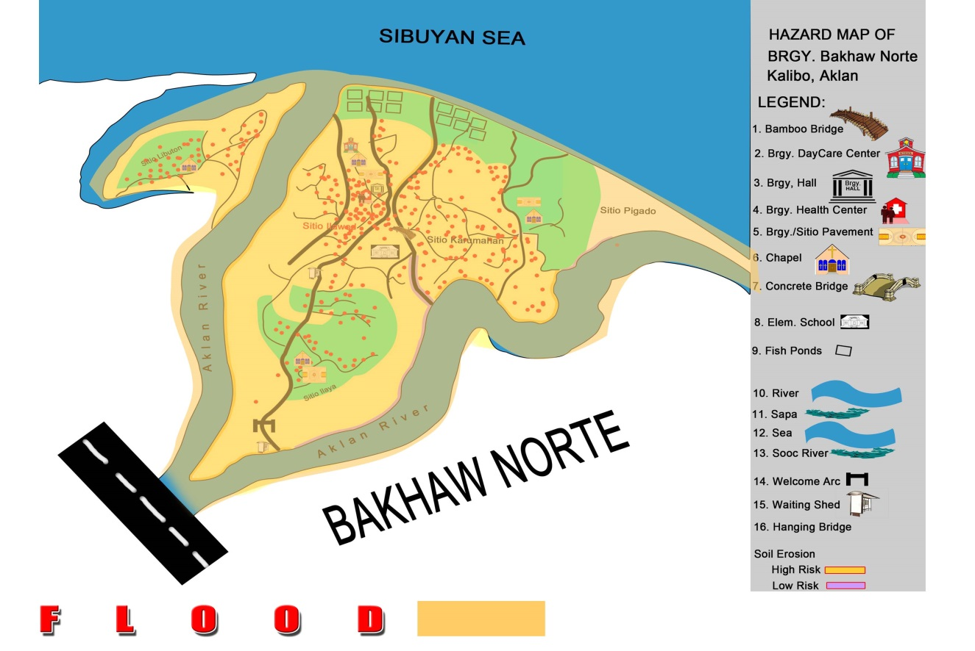

vi. 5 Third overlay – Hazard 3, Flooding, October 2013

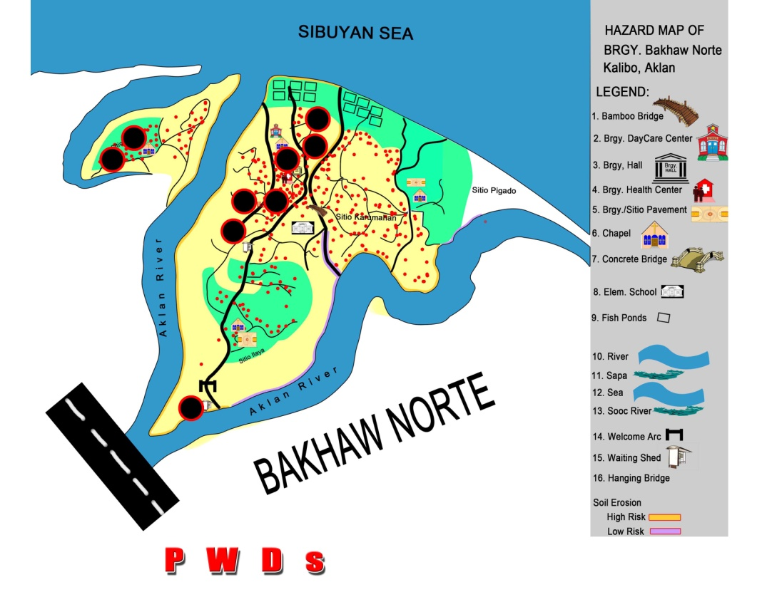

vi. 5 Fourth overlay – Elements at risk, October 2013

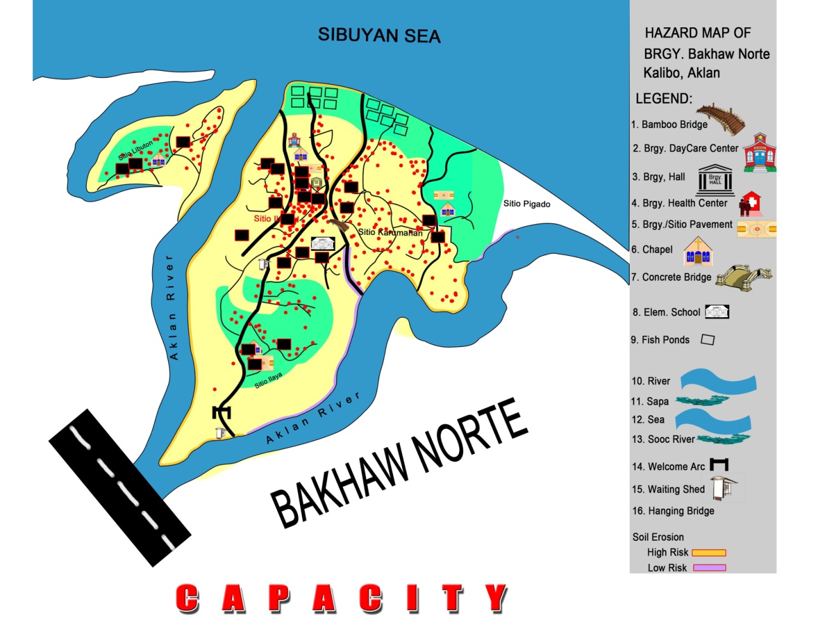

vi. 5 Fifth overlay – Capacities, October 2013

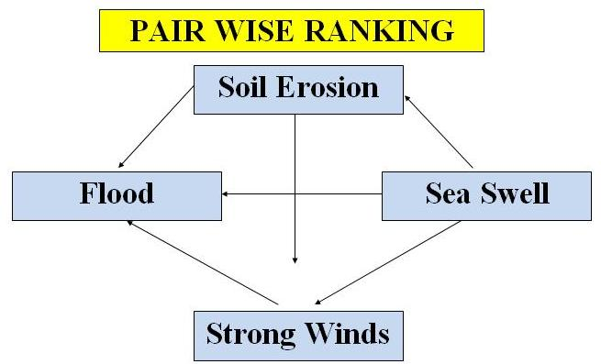

vi. 7 Pair-wise ranking, October 2008

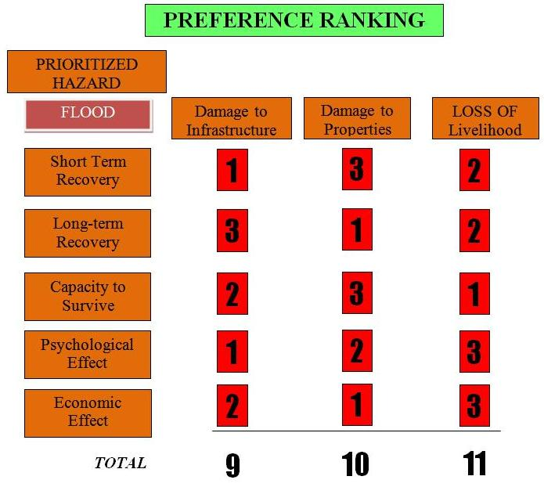

vi.8 Preference ranking, October 2008

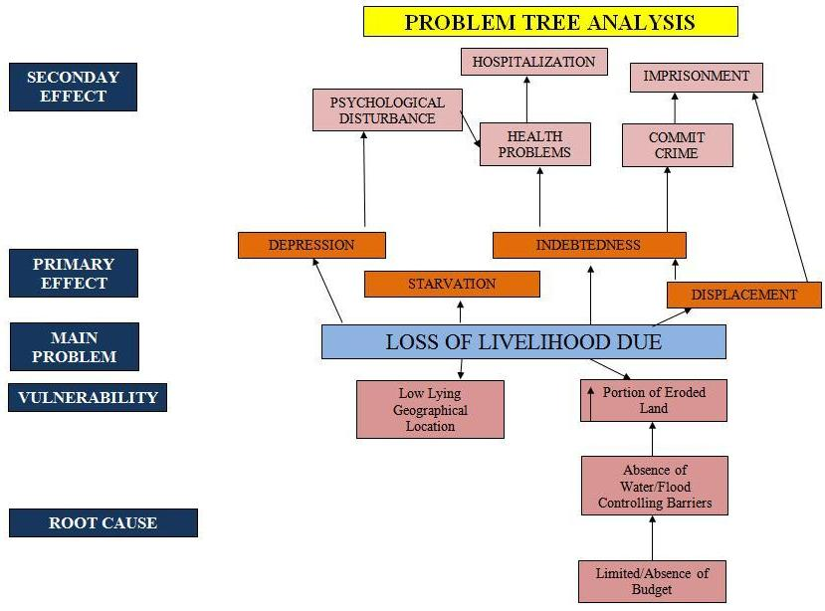

vi.9 Problem tree analysis, October 2008

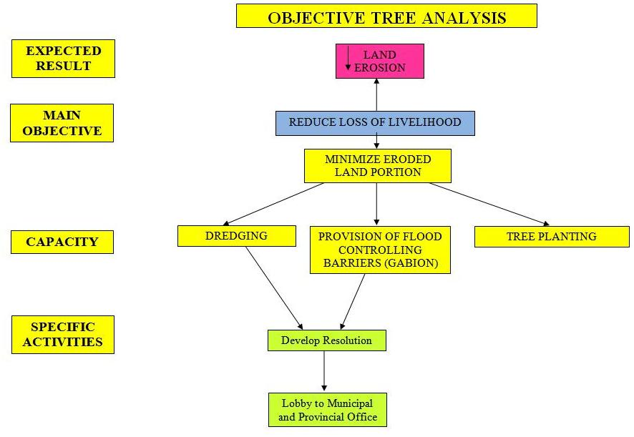

vi.10 Objective, October 2008

