International Federation of Red Cross and Red Crescent Societies

Regional Resilience Initiative

Mid-Term Retreat

Report

**1. Overview**

The **Regional Resilience Initiative (RRI)***, s*upported by the Canadian Government and Canadian Red Cross,seeks to reduce the impact of disasters on vulnerable communities in Southeast Asia. It focuses on the 11 Red Cross Red Crescent Societies in the region (Brunei, Cambodia, Indonesia, Lao PDR, Myanmar, Malaysia, Philippines, Thailand, Singapore, Vietnam and Timor-Leste) with the objective of enhancing their skills and capacities so that they may advocate more strongly at a national and regional level on behalf of communities. This is complemented by the strengthening of regional partnerships, both within our networks and with key partners such as the ASEAN secretariat and other bodies.

The 4-year initiative was designed to enhance ongoing programmes and strategies of the IFRC Southeast Asia Regional Delegation (now Bangkok Country Cluster Support Team - CCST), based on the dialogue with the targeted National Societies, as part of the Annual Southeast Asia Red Cross Red Crescent Leadership Meeting and [Community Safety and Resilience Forum (CSRF)](https://sites.google.com/site/drrtoolsinsoutheastasia/regional-csr-forum/regional-community-safety-and-resilience-forum-2015). It is also fully in line with the [IFRC Southeast Asia Long-Term Planning Framework (2012-2015)](https://www.ifrc.org/docs/appeals/annual12/SP351_LTPF12.pdf) as well as the 2016 Operational Plan of the Bangkok CCST.

After almost 2 years of RRI implementation (starting in March 2014), a mid-project review retreat was held from 3-5 February 2016 among the main project stakeholders to review achievements to date and identify factors of success as well as challenges, in order to guide the next 2 years of duration of the initiative. Furthermore, the retreat was an opportunity to reflect upon the changing environment post-2015 and allowed strategic discussions around needs and strategies in SEA in the coming years. Specifically, the objectives were to:

* + Review the past implementation and  identify challenges, key successes and opportunities in order to ensure outcomes are reached in a most effective and efficient manner by the end of the RRI early 2018 (including the no-cost extension under formalization).
  + Reflect on the strategies of the RRI and analyse opportunities for continued engagement beyond 2017 based on the current and expected gains under the initiative.

The main recommendations from the retreat were taken into consideration for the design of the AWP3 and will be discussed at the upcoming project steering committee meeting planned at the end of April 2016 in Bangkok.

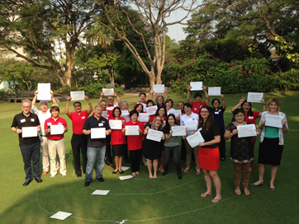**2. Meeting participants, structure, agenda and facilitation methods**

**Participants**

The key stakeholders of the RRI participated, including the Canadian Red Cross, SEA National Societies (leadership, technical staffs and volunteer), IFRC Bangkok Country Cluster Support Team, IFRC Jakarta Country Cluster Support Team and IFRC Country offices (Myanmar and Philippines) attended the meeting. The participants list is available in Annex 1 below.

The retreat was organized as follows:

* The two first days on 3-4 February 2016 with the full participants reviewed past achievements, identified factors and successes and challenges, which resulted in strategic as well as technical recommendations for the RRI implementation in the coming 2 years. This part was held outside of Bangkok at [Sampran Riverside](http://www.sampranriverside.com/).
* The third day on 5 February 2016 was held in Bangkok at [Column Hotel](http://www.columnbangkok.com/) with a smaller group. It was a strategic discussion around the evolving environment and opportunities for continued engagement post 2017. These also included discussions on the next steps to prepare a potential IFRC-CRC joint proposal to be presented to DFATD based on the strategic analyses of the previous days. Please find more details in the [Concept note](https://www.dropbox.com/s/umexzjkjktdqdam/2016%2001%2027%20Draft%20concept%20note%20for%20RRI%20Retreat.docx?dl=0) (includes a brief agenda).

**Preparation**

Prior to the meeting, key project documents were uploaded in a dedicated webpage of the online library ([here](https://sites.google.com/site/drrtoolsinsoutheastasia/meetings-and-workshops/2016-events/regional-resilience-initiative-retreat)) as pre-reading materials. In addition, participants were also asked to submit their Most Significant Change (MSC) before the meeting date (see below). Finally, a personal “learning log” (see annex 5) was provided to each participant to capture key learning and discussion points.

**Facilitation**

The two first days of the retreat were facilitated by Mr Gerard Witham, from Australian Red

Cross, with technical inputs from IFRC and CRC colleagues. The third day was managed by IFRC

and CRC colleagues.

**Funding**

CRC funded all costs related to the retreat as part of its share of the RRI budget.

**3. Key Discussions and Sharing – first two days**

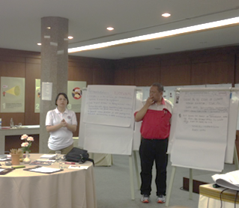**The first morning of the retreat was dedicated to reflect on past achievements**, remembering as a group the key milestones of the project, realizing the diversity of perceptions and expectations around RRI as well as identifying what has changed already and why such change has happened. This was done through a series of participative activities encouraging every participant to realize his/her contribution to the overall outcomes of the initiative.

**The Most Significant Change** (MSC) is a methodology that aims to capture significant changes in the lives of beneficiaries of the programmes or operations that RRI support: within National Societies that we provide support to, or with other key stakeholders of the project. These changes may be intentional or not, positive and negative.

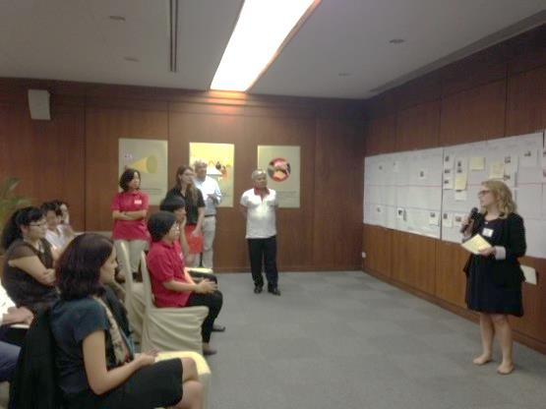The MSC story was an important exercise to bring our discussions closer to reality that the beneficiaries we aim to assist, and to bring our focus to changes happening as a result of our work. A total of 18 MSC stories were submitted prior to the RRI retreat, out of which 8 (chosen by the participants through a voting exercise) were discussed in more details in groups. Please see more details in Annex 2.

Below is the list of some key issues from the MSC stories.

|  |
| --- |
| **Key factors of success:** |
| * Design of the project; innovative resilience approach in DRR programming * Utilizing IFRC support and expertise * Relationship strengthening between the IFRC and National Societies * Trust building; equality in partnership; sense of togetherness * Presence of the management in meeting, event, field visit and so on to strengthen trust and generate mutual solutions * Participation and ownership of National Societies * Peer-to-peer learning; exchange of experience * Communication meant to overcome hierarchy difficulties and support from the management/leaderships * Home visits to hear the voice and better understand the beneficiaries’ needs |
| **Challenges/potential linkage:** |
| * Advocacy is challenging; how to share and voice NSs’ ideas. * Potential linking of national level to global platforms: Sendai, SDGs, COP21 * Working more closely in multi-stakeholder environments. * An integrated approach is more challenging and therefore requires efforts * Change of mind-set takes time but possible with leadership commitment * Cultural gap between youth and management in Asian context * Explore new avenues in mainstreaming social inclusion, migration, health, youth and volunteers * Linking youth with health, DRR programming, and social media |

**The first afternoon and most of the second day were then dedicated to five themes** which had been discussed among the project team prior to the retreat along with key questions to be discussed during the retreat. These are:

* Regional cooperation
* DRR advocacy
* Community Engagement and Accountability (CEA)
* Social inclusion
* Planning, Monitoring, Evaluation and Reporting (PMER)

See annex 3 for the list of themes and related questions.

Each theme was entrusted to a technical colleague who introduced the discussion and worked with the main retreat facilitator on the management of group discussions.

**4. Key Recommendations from the first two days of the retreat**

The last session of the second day was dedicated to agree on the main recommendations from the retreat. A small “drafting committee” (5 members with IFRC, CRC and NS representation) worked during lunch time and coffee breaks to compile the propositions from each theme above into an overall final document (see below and attached as annex 4).

|  |
| --- |
| **Regional cooperation** |
| * Continue investing on joint capacity-building for example in:   + Climate change with Red Cross Climate Centre   + Disaster Law (including IDRL and DRR law)   + School safety, etc. * Continue to ensure a cross-sector approach on resilience in National Societies and leadership * Invitations/communications to National Societies: pay attention to the wording in the invitations to ensure consistency in the involvement of various departments. * ASEAN: continue on DM/DRR/Disaster Law, AHA Centre (including school safety) * Expand to include climate change, youth, migration (diversity) gender * Beyond ASEAN: Mekong River Commission, ADPC, Kuwait DM centre, UNISDR, UNDP, UN Women, etc. |
| **DRR Advocacy** |
| * Continue to build NS capacity and understanding of Humanitarian diplomacy (HD), advocacy/influence and profiling, and the associated opportunities:   + Tailor tools and approaches to NS context   + Sharing knowledge   + Coaching/mentoring   + NS training on HD and broader legislative advocacy   + Advocacy plans and strategies     - engage at national level on Sendai, SDGs, COP21     - ensure community voice with NS on follow up Sendai/SDGs/COP 21 * Research/case study on “convener role” and “auxiliary role” of NSs to feed to leadership: development, capacity building, training and coaching. * Take action based on identified / targeted opportunities |
| **Community Engagement and Accountability (CEA)** |
| * Develop and pilot “minimum standards” guidance on CEA in PMER cycle starting from Myanmar RC experience (this includes school safety) * RRI learning and success on CEA to contribute to the 1 Billion Coalition for Resilience (1BC) and Federation wide reporting system * Raise awareness/knowledge on Disaster Law (dissemination) at community level (including other stakeholders) * CSR Forum to include session on CEA * Harnessing the power of social media |
| **Social Inclusion** |
| * Follow up Joint Action on Sexual and Gender Based Violence (SGBV) with NSs and governments: invite for signature, or support monitoring and implementation. * Continue including migration issues in RRI, using gender and Diversity as an entry point * Promote the regular network on Gender and Diversity and empower through the “taskforce” approach * Regular recognition in NS achievements in gender and diversity, through newsletters and public forums * Continue promoting youth engagement in RRI   1. Document youth engagement in school safety as a key entry point   2. Capacity-building   3. Research about marginalized youths and RC engagement   4. Work with ASEAN youth programme on competition/stories |
| **Planning, Monitoring, Evaluation and Reporting (PMER)** |
| Planning   * Use the opportunity to have a consultative process within NSs * More integrated planning process, both internally to NS and with key stakeholders * Share more the plans among NSs for peer to peer support, to avoid duplication, and sharing of good practices * Connect RRI to international agenda, such as 1BC and emerging humanitarian trends * Connect RRI with the Netherlands RC led Partnership for Resilience Phase 2   Monitoring and evaluation (M&E)   * Decide as early as possible on the final evaluation methodology for RRI (within 2016) – how do we measure our impact * Collect SADD throughout activities * Link with OCAC * Be accountable to the leadership meeting   Report   * Complete the communication strategy around RRI, including audience mapping and tools, as part of the planning process – by April 2016. * RRI dashboard for leaders |

**5. Key discussion points from the last day of the retreat**

Note: participants on this day included only IFRC and CRC colleagues. It was designed as a brainstorming session so that the enclosed agenda in annex 6 in indicative and was not strictly followed.

A first plenary discussion reflected upon the two previous days of the retreat and analysed the key **RRI added values** as follow:

* Ownership of NS: they are in the demanding seat, and this is increasing year after year. The planning process with the “menu of options” supports this ownership.
* The way it is set-up, acknowledging every NS is different, has different needs for capacity-building, while meeting at certain points. Often, we want to engage similarly in different countries. It is about being available and flexible for support when and where needed.
* Other projects support NS to do activities, which is important, and then eventually increases the quality of the cooperation with stakeholders. This RRI actually “flips back” and looks at the relationship with stakeholders as the entry point
* Regional platforms are also clear wins of the initiative
* Flexibility in the budget, not imposing artificial timelines, is also key
* Flexibility is also beneficial to our partnership with external stakeholders. Being able to be reactive
* SEA is the right coverage, with opportunities for regional cooperation while not too wide and diverse like Asia-Pacific.
* The extent of what has happened so far, in just 2 years, is impressive.

Based on the discussion, two **short presentations** on the [SEA RCRC online library](https://sites.google.com/site/drrtoolsinsoutheastasia/) and the [One Billion Coalition for Resilience](http://www.ifrc.org/one-billion-coalition) (1BC) provided insights to participants as to potential emerging ways to link the RRI to wider efforts, also capturing such best practices and disseminating the knowledge in our networks.

Representatives from CRC also shared experience about their **current engagement with DFATD / GAC** and ways to increase the quality of such partnership. A clear emphasis was made on the importance of reporting on progress towards outcomes as well as the stories of change among project stakeholders, as ways to demonstrate achievements. There is also a need to adapt our communication about RRI to various audiences, in SEA and in Canada. A matrix will be finalized in the coming weeks based on initial discussions during the retreat.

Finally, an initial **concept note for engagement beyond 2017** was presented to all participants. Due to lack of time, rather than initiating discussions on the contents of the document, the participants focused on the next steps towards the formulation of a new project proposal, with key points agreed as follow:

* The importance to identify early the “selling points” with GAC, which will be based on the key achievements of the current phase (properly evidenced) and an analysis of the evolving environment
* The primary role of CRC to engage with GAC at various levels (Ottawa, Jakarta, Bangkok and so on)
* The fact that Bangkok CCST remains the entry point for discussions with CRC on the proposal development
* The need to involve multiple stakeholders within IFRC and maybe to form a smaller working group on the planning process

**6. Feedback from participants on the retreat**

A questionnaire was distributed to each participant at the end of the retreat to measure the level of satisfaction among the colleagues, as well as to which extend the retreat meet individual and collective objectives. 19 out of 26 participants answered the questionnaire, with the main comments as below:

The participants found good overall value of the retreat. It was a good team building exercise to review the project goals and objectives, to discuss, share experiences and learn from one another from many different levels/perceptions to move forward. It’s also very helpful to hear from NSs for each thematic area and better identify connections between technical areas. The facilitation was excellent and diversity of working sessions was great to allow everyone to contribute to the sessions. The participants stated that they will apply the learning and knowledge from the retreat to their work. Overall, the participants were very satisfied with the arrangements as shown below.

Please find below the feedback and suggestions from the participants to improve this retreat in the future.

* Documentation of best practices from NSs should be shared
* It would be good to hear challenges and suggestions from RRI team
* More participants from NSs and from other divisions (i.e. OD, youth)
* This kind of retreat should be conducted more frequently; one can learn a lot and be updated on various issues.

**7. Annexes**

1. Participant list

2. Most Significant Change (MSC) stories

3. Themes and questions

4. Key recommendations from the RRI mid-term retreat

5. Learning log

6. Detailed agenda for the 3rd day of the workshop

**Contact information**

For further information, please do not hesitate to contact:

**Mr. Hervé Gazeau, DRR Manager**

IFRC / Bangkok

**Ms. Deborah Cote, Program Manager Asia**

CRC / Ottawa

**Annex 1. Participant list**



**Annex 2. Most Significant Change (MSC) stories**

|  |  |
| --- | --- |
| [From Strangers to Partners – Flood Resilience](https://www.dropbox.com/s/dpkzu7rjmnwtrv1/RRI%20CCST%20indonesia.docx?dl=0) **by Giorgio Ferrario, IFRC** | [Disaster Law and the Lao Red Cross](https://www.dropbox.com/s/2o1ufc1k2d6eson/MSC%20story%20of%20Amb.Thongphachanh.docx?dl=0)  **By Amb. Thongphachanh Sonnasinh, Lao Red Cross** |
| The partnership between Zurich International and Indonesian Red Cross (PMI), went a long way, from mutually highly suspicious to mutually supporting and trusting. When trust is in place, real partnerships can take place, with better outcomes.  Key factors of success: equality in partnership, not based on a beneficiary-recipient model. Doing field visit together would give opportunities to share skills, experience and mutual appreciation. Having specific roles. Talking to one another to reduce polarized views. | Through its work in Disaster Law in Laos, the Lao Red Cross (LRC) has raised its profile and build a more significant role in disaster preparedness and management, as well as in influencing and partnering with government, partners, and donors, to the benefit of vulnerable people in Laos. Furthermore, the exchange of experience has as well strongly benefited the participating National Societies.  The key factors of success are: Ensuring that LRC is at the center of dealing with disasters. Combining disaster and climate change in a law, which represents the first in the region to do so.  Key challenges are being an intermediary between 2 ministers involved in disaster management, which could be both a challenge and an opportunity; Ensuring the LRC is mentioned in the law like in Vietnam. Potential linkage in advocacy work. |

|  |  |
| --- | --- |
| [Dissemination of Disaster Law – Malaysia](https://www.dropbox.com/s/3tzcxxy20b873qw/DISSAMINATION%20OF%20DISASTER%20LAW%20%E2%80%93%20MALAYSIA.docx?dl=0)  **by Saiful Izan bin Nordin, Malaysian Red Crescent Society** | [Opportunity knocks for typhoon survivors](https://www.dropbox.com/s/zxcdea017z8a76f/MSC_RRI_kari_isomaa_IFRC_philippines.docx?dl=0)  Panitan, Philippines, **by Kari Isomaa, IFRC** |
| Dissemination of disaster law results in a signed agreement between Malaysian Red Crescent Society and the Ministry of Women, Family and Community Development.  Key success factors are using IFRC support and expertise, as well as using the critical moments which could open an opportunity to get to an intended change. For this, it is necessary to be ready, flexible and responsive to use the momentum.  Potential links should be made to 3 different global platforms: Sendai Framework, Sustainable Development Goals and COP 21. | Livelihood beneficiary stories across the Haiyan affected area: ’I spent the money on seeds for my proposed livelihood. I used to have debt and pay 5% interest. Now the crop I grow is all mine and I have more time with my family. All the hard work is for my family, especially the education of my children. Because of this (Red Cross) intervention, our community will soon be debt-free.’ Key factor of success: Beneficiary selection method conducted by home visits; Implementation: installment basis encouraging the beneficiaries to spend the received cash the intended way. This could be linked with gender and diversity mainstreaming. |

|  |  |
| --- | --- |
| [Growing together, learning together](https://www.dropbox.com/s/agfnl6fd819w7lc/My%20RRI%20Most%20Significant%20Change%20Story_Lucia%20Cipullo.docx?dl=0)  Location: Southeast Asia, **by Lucia Cipullo, IFRC** | [Change for a “Change”](https://www.dropbox.com/s/8b0mqwcgulgdebt/RRI%20MSC%20MRCS.pdf?dl=0)  **by Shwe Cin Mint, Myanmar Red Cross Society** |
| The most significant change is something that can’t be measured in numbers or values – but it is nevertheless something that is so crucial to success: a sense of togetherness, working together, learning together and growing together.  Key factors of success: Design of the project; Innovative resilience approach in DRR programming; Investment into teamwork, interacting with strong commitment and trust, within and outside the team.  Key challenges: Not easy to balance between integrated and silo approach; Embracing is not an easy process, it requires patience and maintaining constant dialogue and interaction. Thinking together is needed.  Potential linkage: change of mindset to allow exploring new avenues in mainstreaming social inclusion, migration, health, youth and volunteers. | Ensure gender and diversity consideration at institutional level and mainstreaming in program: Change of paradigm, as well as commitment, continuous and collective effort at all levels in Myanmar Red Cross Society as well as in communities (of programmes).  Key challenge was time needed for mindset change, however, this is achievable with the leadership commitment, and that the operational level should engage the leadership.  Possible linkage : This change could be linked with disability inclusion in briefing for volunteers who will ensure this gradual, intentional and sustainable change through awareness raising conducted by volunteers with integrated approach. |

|  |  |
| --- | --- |
| [Regional sharing and learning through online library](https://www.dropbox.com/s/qcpcuutsoktyt19/My%20most%20significant%20change%20story%20on%20regional%20sharing%20and%20learning%20through%20online%20library.docx?dl=0) **by Angeline Tandiono, IFRC** | [Shall We Change Ourselves?](https://www.dropbox.com/s/2926jt3ykkt004c/My%20RRI%20Most%20Significant%20Change%20Story%20Kumju%20Ho.docx?dl=0)  **by Kumju Ho, IFRC** |
| Focus on the gender and diversity library component of the online library which has attracted most views in 2015.  Key factors of success: Having a good selection of resources for reference. Partnership with academics to provide summaries to render the resources easy to find and use. Ensuring the target audience, in this case Gender and Diversity network, uses and shares the resources. Cross promotion via web links. Complementarity with existing tools and emphasis on value of regional-global collaboration within IFRC.  Key challenge: participation and gradual ownership of National Societies, this is where strong dissemination process needs to be in place. | Youth engagement in DRR: School safety. Now youth leaders called upon all youths at grass-root level to join the school safety activities as being agents of change at their schools.  Key factors of success: Communication method to overcome hierarchy difficulties and supportive management/leaderships.  Key challenges: Cultural gap between youth and management; lack of involvement in community work with the exception of Singapore; Youth are involved in implementation but not the design or projects.  Potential replication: In Myanmar and other places, dissemination of non-violence and peace.  Potential linkage: linking youth with health, DRR programming, and social media; Call for university students to submit proposals for community engagement activities. |

More MSC stories:

|  |
| --- |
| [The ’A-Ha’ moment – SEA gender and diversity network and beyond](https://www.dropbox.com/s/6059e0t67ol2jl4/2016%2001%2022%20My%20RRI%20Most%20Significant%20Change%20Story_Christina%20Haneef.docx?dl=0) by Christina Haneef (IFRC) |
| [Progress on Gender and Diversity](https://www.dropbox.com/s/sb9zz84d11x8zv0/2016%2001%2022%20My%20RRI%20Most%20Significant%20Change%20Story_Suchada.docx?dl=0) by Suchada Meteekunaporn (IFRC) |
| [Global connectivity for local change](https://www.dropbox.com/s/abkjblz2qb9edy6/2016%2001%2022%20My%20RRI%20Most%20Significant%20Change%20Story_communications.docx?dl=0) by Kate Roux and Kate Jean Smith (IFRC) |
| [Nursery and Waste Management, Aceh, NTT, West Java, DKI](https://www.dropbox.com/s/jcgopc6zm8c160h/2016%2001%2022%20My%20RRI%20Most%20Significant%20Change%20Story_IDON.docx?dl=0) by Mujtahiddin (Indonesian Red Cross Society - PMI) |
| [Confidence, Trust Journey](https://www.dropbox.com/s/vw74unrbuuis9wb/AL%20%20My%20RRI%20Most%20Significant%20Change%20Story.docx?dl=0) by Anne E. Leclerc (IFRC) |
| [RRI Organizational Matrix](https://www.dropbox.com/s/z148z07b7ehqpjk/CRC-1%20My%20RRI%20Most%20Significant%20Change%20Story.docx?dl=0) by Debby Cote (Canadian Red Cross) |
| [RRI Communications that work](https://www.dropbox.com/s/ol2x538l2727exe/CRC-2%20My%20RRI%20Most%20Significant%20Change%20Story.docx?dl=0) by Debby Cote (Canadian Red Cross) |
| [Partnering with AHA Centre – a two-way learning experience](https://www.dropbox.com/s/vb89nix9ge6ku5t/RRI%20Most%20Significant%20Change%20Story%20-%20Herve.docx?dl=0) by Herve Gazeau (IFRC) |
| [RRI Life Changing story](https://www.dropbox.com/s/gzkwy499o2fs5dd/RRI_Life_Changing_Story.docx?dl=0) by Elena Nyanenkova (IFRC) |

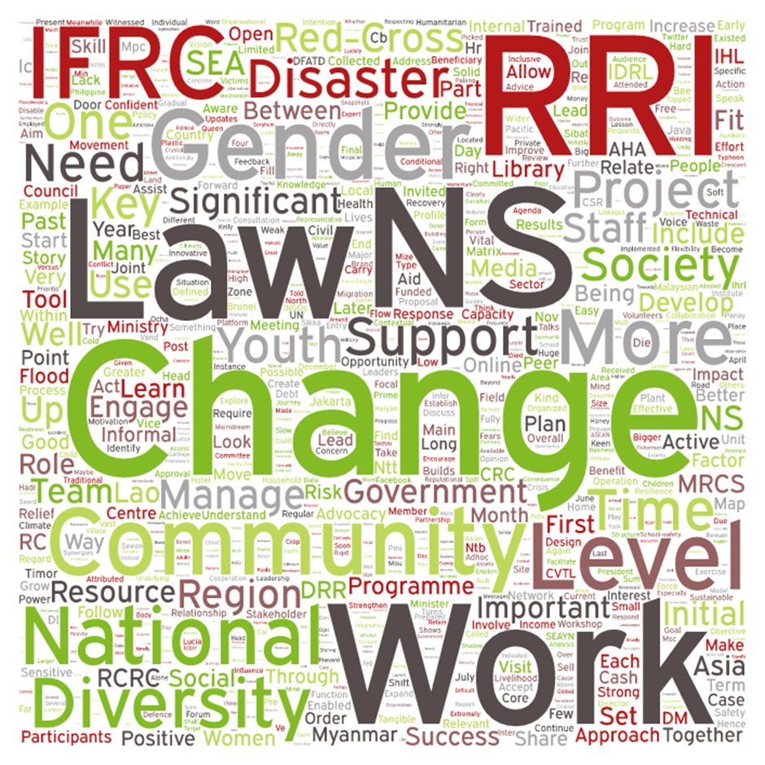

All the Most Significant Changes stories were put in a word cloud, so the more a word is mentioned, the bigger it gets. This word cloud represents what the Most Significant Change of RRI is all about.

**Annex 3. Themes and questions**

|  |  |
| --- | --- |
| **Theme** | **Key questions** |
| **THEME 1 – REGIONAL COOPERATION (within RCRC and beyond)**  ***Maximizing the regional networks in support of the prioritized needs in countries towards community resilience…***  **Introduction by Sanjeev** | 1/ Which domestic (DRR) priorities should be connected to the regional cooperation agenda? How can we best ensure this?  2/ What are the challenges and opportunities to ensure our regional networks are effectively adding value to the domestic priorities of NSs?  3/ In terms of country and regional partnerships (outside RCRC), which partner / process should be prioritized?  4/ Identify 3 main recommendation for future engagement |
| **THEME 2 – DRR ADVOCACY (including Disaster Law, positioning of NSs with NDMO and National Platforms, cooperation with regional partners such as ASEAN, UN, etc.)**  **Introduction by Lucia** | 1/ What advocacy means to you / your NS? What are the DRR issues that your NS wish to advocate for? Who are we advocating with?  2/ / What are the key examples of success in DRR advocacy, profiling / positioning? (for your National Society and / or in the region) This can include DRR, disaster law/IDRL or other types of advocacy.  3/ What are some of the challenges and opportunities around DRR advocacy (both country and regional level)?  4/ How do we support / learn from each other in this advocacy (regional / country events, networks, exchange trips, etc.)…?  5/ Identify 3 main recommendation for future engagement |
| **THEME 3 – COMMUNITY AND BENEFICIARY ENGAGEMENT AND ACCOUNTABILITY**  **Introduction by Kate R.** | 1/ To what extent are we ensuring the voices of the most vulnerable are well represented in our advocacy work? How are we communicating the work? What language and messaging is most effective for our audiences? What are some of the challenges?  2/ How are we using new technologies and partnerships to provide innovative solutions?  *We can often equate technology with innovation and place all of the emphasis on new tech for answers; however technology is only one aspect of new solutions to challenges. Sometimes very low tech solutions are the most innovative*  3/ How are we demonstrating our beneficiary accountability? To our funders? To the beneficiaries/communities? What are the differences?  4/ Identify 3 main recommendation for future engagement |
| **THEME 4 – SOCIAL INCLUSION (Gender and Diversity*, Youths, People on the move)**  **Introduction by Christina**  **\*The term ‘Diversity’ is inclusive of age groups (the elderly and the youth), people with disabilities, migrants, LGBTI, ethnic, religious and social minorities.** | 1/ Where do we stand with the roll-out of gender and diversity strategies and plans in both IFRC and NSs?  2/ What has changed in IFRC and NS understanding and buy-in of such issues? What has enabled such changes? What more is required to increase buy-in and positive change? What are some of the challenges?  3/ How can we ensure that these changes will bring about the greatest impact on the implementation of activities in the communities? Any examples of this already been seen?    4/ How can we maximize the potential for youth and the SEAYN to be more involved in resilience building?  5/ Identify 3 main recommendation for future engagement |
| **THEME 5 – RRI MANAGEMENT (PMER)**  **Introduction by Debby and Herve** | 1/ How can we improve our planning processes, in particular the annual in-country planning?  2/ How should we evaluate our impact at the end of the timeframe (end 2017)? Do we have sufficient monitoring systems / data collection tools to allow such evaluation? Are mechanisms in place for future monitoring beyond end of initiative?  3/ Are we sharing enough / too much information about the initiative? (to NS, IFRC teams, external stakeholders, etc.) To what extent the stakeholders understand about the initiative?  4/ To what extend are we accountable to both donors and communities…? How do we measure accountability to beneficiaries…? Are we communicating the changes made as a result of feedback received from beneficiaries back to those beneficiaries and communities?  5/ Identify 3 main recommendation for future engagement |

**Annex 4. Key recommendations from the RRI mid-term retreat**

|  |
| --- |
| Key recommendations from the RRI mid-term retreat  *Draft prepared by the drafting committee and presented at the last session on 4 February 2016* |

**Regional cooperation**

* Continue investing on joint capacity-building for example in:
  + Climate change with RC Climate Centre
  + Disaster Law (including IDRL and DRR law)
  + School safety, etc.
* Continue ensure cross-sector approach on resilience in NSs and leadership
* Invitations / communications to NSs: care about wording / recipients (“disasters”)
* ASEAN: continue on DM/DRR/Disaster Law, AHA Centre (including school safety)

Expand to climate change, youth, migration (diversity) gender

* Beyond ASEAN for example: Mekong River Commission, ADPC, Kuwait DM centre? UNISDR, UNDP, UN Women, and …

**DRR Advocacy**

* Continue to build NS capacity and understanding of Humanitarian diplomacy (HD), advocacy/influence and profiling, and the associated opportunities:
  + Tailor tools and approaches to NS context
  + Sharing knowledge
  + Coaching/mentoring
  + NS training on HD and broader legislative advocacy :
  + Advocacy plans and strategies
    - engage at national level on Sendai, SDGs, COP21
    - ensure community voice with NS on follow up Sendai / COP 21/ SDGs
* Research / case study on “convener role” and “auxiliary role” of our NSs to feed to leadership: development, capacity building, training, coaching.
* Take action based on identified / targeted opportunities

**Community Engagement and Accountability (CEA)**

* Develop and pilot “minimum standards” guidance on CEA in PMER cycle starting from Myanmar experience (this includes school safety)
* RRI learning and success on CEA to contribute to the 1 Billion Coalition for Resilience (1BC) and Federation wide reporting system
* Raise awareness / knowledge on Disaster Law (dissemination) at community level (+ other stakeholders) including under Disaster law.
* CSR Forum to include session on CEA
* Harnessing the power of social media

**Social Inclusion**

* Follow up Joint Action on Sexual and Gender Based Violence (SGBV) with NSs and governments: invite for signature, or support monitoring and implementation.
* Continue including migration issues in RRI, using gender and Diversity as an entry point
* Promote the regular network on Gender and Diversity and empower through the “taskforce” approach
* Regular recognition in NS achievements in gender and diversity, through newsletters and public forums
* Continue promoting youth engagement in RRI
  1. Document youth engagement in school safety as a key entry point
  2. Capacity-building
  3. Research about marginalized youths and RC engagement
  4. Work with ASEAN youth programme on competition/stories?

**PMER**

Planning

* Use the opportunity to have a consultative process within NSs
* More integrated planning process, both internally to NS and with key stakeholders
* Share more the plans among NSs for peer to peer support, to avoid duplication, and sharing of good practices
* Connect RRI to international agenda, such as 1BC and emerging humanitarian trends
* Connect RRI with the Netherlands RC led Partnership for Resilience Phase 2

M&E

* Decide as early as possible on the final evaluation methodology for RRI (within 2016) – how do we measure our impact
* Collect SADD throughout activities
* Link with OCAC
* Be accountable to the leadership meeting

Report

* Complete the communication strategy around RRI, including audience mapping and tools, as part of the planning process – by April 2016.
  + RRI dashboard for leaders

*********************************************

**Annex5. Learning log**

International Federation of Red Cross and Red Crescent Societies

Regional Resilience Initiative Retreat

Learning Log

2-4 February 2016

Thailand

Name:

…………………………………………………………………………………………………………

Contents

**Introducing your learning log**

Going on a retreat is about taking some time away from your normal day to day life and situation. It is about stepping back from your normal work patterns and responsibilities and having some time to reflect on how things are going for you and those around you. It may be more about listening and writing some of your thoughts down, rather than sharing every thought going through your head. It is a time to learn about yourself and others, explore new ideas or revisit old ones from another perspective. It is about becoming more self-aware, opening yourself up to possibilities and new ways of thinking and doing. It is about appreciating those you have around you and getting to know them at a deeper level. It is not about finding neat answers to every question, but about taking some risks, wrestling openly with issues, sharing and being open to new ideas and opportunities.

This learning log gives you some ideas about areas you might like to consider during this RRI Retreat and spaces to make notes. You may want to change the questions, draw pictures or write important quotes or actions down. The log doesn’t provide you with answers, but gives you some spaces and structure to your reflective time. It is your learning log. It is confidential and won’t be reviewed or shared by anyone unless you ask someone else to do this for you or choose to share something from your learning log.

The Contents are as follows:

A] My doodles page [ongoing]

B] Starting from where I am [20-30 minutes activity]

C] Working effectively with others [20-30 minutes activity]

D] How do people learn? [10 minutes activity]

E] Session journals [ongoing]

F] Networking [15-20 minutes activity]

G] My RRI Retreat Action Plan [ongoing]

H] My suitcase … Taking yourself home again [10 minutes]

I] My favourite quote from the RRI retreat [2 minutes]

It’s your learning log and how you use it is your decision. You don’t need to complete every activity, but hopefully there are some activities in the log that will support you during this retreat.

I’d like to wish you all the best for your RRI retreat!

Ged Witham

**A. My doodles page …☺ (write/ draw/ doodle away...)**

**B. Starting from where I am … (approx. 20-30 minutes needed)**

1. What can I do to make the most of this RRI retreat?
2. What is going to stop me from participating fully in this retreat? What can I do to address these issues?
3. Is there any work that I have to do over these few days, other than attend this retreat? Really? If something absolutely cannot wait, when will I do this work, so that I can relax and participate as fully as possible?
4. Is there a personal issue or pressure I am carrying to this retreat? What can I do to lessen or manage these issues while on this retreat?
5. Do I need to phone home to my family, children or friends? If so when will I arrange to do this so that I manage my time well?
6. Can I take some time to exercise each day? E.g. Go for a walk, do some stretching, go for a swim or go to the gym…When?
7. How can I ensure I get enough rest and sleep during this retreat?
8. How can I help myself to relax during this retreat?

**C. Working effectively with others (approx. 20-30 minutes needed)**

1. What are my strengths?
2. What are my weaknesses?
3. How do I work most effectively with other people?
4. How do I work least effectively with other people?
5. What frustrates me when working with others?
6. How can I be the best ‘me’ during this retreat?

**D. How do people learn? (approx. 10 mins needed)**

There are many theories about how people learn. We are all unique and learn in different ways, but from research there are some common themes about our learning styles – how we process information.

**Learning Styles:** A model for this presents 3 types of learners:

**Visual learners** – see it 

**Kinaesthetic learners** – do it 

**Auditory learners** – hear it 

A person may have a preference for one style or a combination of these.

1. What type of learner do you think you are? Why?
2. How can you best use your preferred learning style during this retreat?

**E. Session Journals… (Ongoing commitment throughout retreat)**

**Wednesday 3/2/16**

**Session 1: Introductions & Setting the RRI scene**

1. What are my expectations for the RRI Retreat?
2. What can I do to ensure that I have a good RRI retreat?
3. What is my motivation for working within the Red Cross Red Crescent Movement?

**Session 2: Our Stories**

1. How was the experience of writing your Most Significant Change story?
2. Which stories did you want to know more about?
3. Which stories inspired you? Why?
4. Which stories made you think about something differently? Why?
5. Could you take a moment to thank someone for sharing their story?
6. Draw an image below to remind you of your favourite story …..

**Session 3, 4, 5, 6, 7: Theme sessions 1 – 5**

|  |  |
| --- | --- |
| **Theme** | **My Notes** |
| 1. Regional Cooperation |  |
| 2. DRR Advocacy |  |
| 3. Community/ Beneficiary engagement & Accountability |  |
| 4. Social Inclusion |  |
| 5. RRI Management (PMER) |  |

**Session 8: Prioritisation of group recommendations**.

1. Which are my top 3 recommendations? Why?
2. Which recommendation was my least favourite? Why?
3. How can I best support these recommendations?

**F. Networking (approx. 15-20 mins needed)**

* 1. Who did I get to know better?
  2. How can I build on this relationship?
  3. How will this help me to work more effectively?
  4. Who do I want to thank?
  5. Who do I want to keep in contact with?

**G. My RRI Retreat Action plan (ongoing)**

|  |  |  |
| --- | --- | --- |
| **Action** | **By whom?** | **By when?** |
|  |  |  |
|  |  |  |
|  |  |  |
|  |  |  |
|  |  |  |

**H. My suitcase ….Taking yourself home again …. (approx. 10 mins needed)**

1. What did I learn?

______________________________________________

1. What will I always remember?

______________________________________________

1. What will I do differently?

**I] My favourite quote from the RRI retreat**….

**Annex 6. Detailed agenda for the 3rd day of the workshop**

|  |  |  |  |
| --- | --- | --- | --- |
| Time | Description | Objective | Speaker |
| 09.00 – 09:30 | **Welcome and brainstorming**  impressions from the retreat, changing environment and opportunities for future engagement | To highlight our key “selling points” for a future project | Anne and Debby |
| 09.30 – 10.00 | **Presentation** from CRC on ways to engage with GAC for future funding | Understanding about the pros and cons of various approaches (expanding current project vs. applying for a new project) | Debby |
| 10.00 – 11:00 | **15mn Presentation o**f a concept note for engagement beyond 2017 with 3 potential themes for a new project  Followed by a short **plenary discussion** to have more propositions of themes. | . | Herve |
| 11.30 – 12.30 | **Strategic engagement with GAC – redefining the partnership concept**  Joint networking and advocacy  Linkages and synergies with other projects (such as ADB and IOM) | CRC experience with CAC on visibility and communication issues  How to contextualize to operational context? (country and regional levels) | Nathan |
| 13.30-15.00 | **Next steps** (CRC/ IFRC)  **Closing**  **Evaluation** of the week | Agree on next steps for engagement with GAC (at all levels) and proposal development | Herve and Carla  Anne and Debby  Suchada |