7th SEAYN Online Meeting
21 April 2014, 15:00 – 16:30 (BKK Time)

Attendees:
- Azmi, Malaysian RC
- Zaidi, Singapore RC
- Khamla Phomphakdee, Laos RC
- Sahari BA, Singapore RC
- Edlynna, Singapore RC
- Ryan, Philippines RC
- Kumju Ho, IFRC SEA Regional Office (Moderator)
- Naomi Akatsu, IFRC Zone Office
- Ahmad Husein, IFRC Indonesia
*PMI RC team apologies (had a sudden meeting invitation from the new Governing Board)

Objectives of the Meeting: Bi- monthly online meeting

Attachment: Agenda, presentations

PRELIMINARIES:
- Welcome Address was given by Zaidi, APYN SC member for SEAYN
- Introduction
AGENDA
- SEA Leadership outcome/Action Plan no. 1: National Youth webpage opening/newsletter information collection
- WCDRR Framework and Youth Role
- Regional violence prevention proposal/youth event
- Project update: Action Plan 2, Healthy school safety programme presentation (PMI)
- AoB

1. SEA Leadership outcome/Action Plan no. 1: National Youth webpage opening/newsletter information collection – Zaidi (SRC)
- The meeting invited SEAYN, youth became part of the meeting, gave our voices and suggestions
- Outcome from SEA Leadership meeting (see the attached ppt):
  - Principles in action
  - Promotion of culture of Non-violence and peace
- Report on SEAYN – champion on social media; represented by Zaidi (SRC) and team (Louie/PRC and Khamla/LRC)
  - 1st newsletter printed and distributed during SEA Leadership meeting. Good response from SEA Leader participants. Ask SEAYN to do more on Second Edition.
  - Facebook Page revived but not yet fully utilized
- Still yet to track on NS Youth social media activities

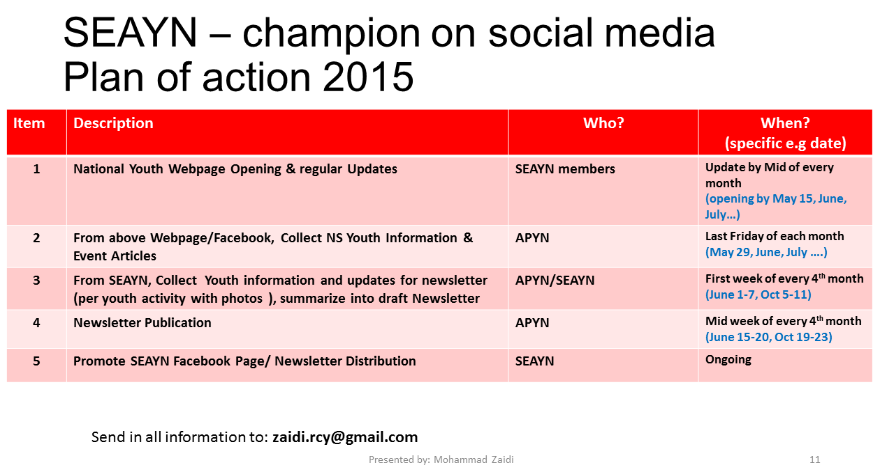

2. WCDRR Framework and Youth Role - Postponed to next SEAYN online meeting
3. Regional violence prevention proposal/youth event (see attached ppt) - Kumju
- Background: part of SEA Leadership meeting outcome
- Existing data on violence to children/youth
- Part of Strategy 2020 SA 3. This regional project has goal to reduce violence related death, losses and injuries by promoting a culture of Non-Violence and Peace (NVP) through Youth actions in RC programmes and services for building safer and more resilient communities
- Project outcome: a) a culture of NVP by SEAY at all levels promoted and violence reduced; b) Youth-led NVP activities into RC programmes and service delivery with an integration of NVP components (selected countries)
- The activities from include:
  - Module developments (YABC-VP)
  - Training of target group
  - Design youth-led intervention(YABC-VP)
  - Integration into programmes
- Encourage SEAYN member in each NS to participate. Due date to confirm the interest will be on 24 April 2015.
- There is a questionnaire needs to be filled for those who has interest in this project. Please send back to IFRC by 5 May 2015
QA:
- Indonesia: already initiated the violence prevention programme by the VP Consortium consists of Canadian RC, Australian RC, Indonesian RC and IFRC. Interested to this project and how to incorporate Youth into this existing initiative? Can be discussed. There has been a discussion as well with CRC in Bangkok on VP initiatives in some countries (Myanmar, Indonesia)

4. Project update: Action Plan 2, Healthy school safety programme presentation (Indonesian Red Cross/PMI) (see attached ppt) – Ryan (PRC) and Ahmad Husein (IFRC Indonesia)
- The healthy school programme aims to reduce the spread of infectious diseases through health promotion and practices by students at elementary and junior high school ( including YRC Volunteer)
- The programme conducted from March to December 2014, extended to 2015, reaching 25,000 elementary and junior high-school students in 13 cities from six provinces in Indonesia (Great Jakarta, Yogyakarta, East Java, West Java, South Sulawesi and North Sumatera
- Supported by partners from RCRC (Italian RC, Singapore RC) and private sectors (Frisian Flag Indonesia, CMB-Niaga Bank)
- Activities in the programme include:
  - Socialization for teachers, students, community live around school
  - Healthy school campaign
  - IEC materials distribution
  - Strengthening Healthy School Unit (UKS) and make over the facility of healthy school Unit
  - First Aids activities
  - Provision trash bin
  - Provision hand washing facility
  - Personal Hygiene education
  - Progress:
    - 20 YRC facilitators (teacher) and 100 YRC volunteers become Peer Educators and actively participate to improve knowledge and develop capacity to promote safe and healthy school to peers( for each school )
    - 20 PMI volunteer (teachers and Youth Red Cross Trainer) received first aid training and able to use first aid kit that suit to the volunteer age ( for each school)
    - Socialization and promotion on healthy and school environment in school with “Kampanye aku anak cerdas” (I am a smart kid) to 25,000 students from 35 schools
    - Commitment between PMI, school community with related stake holder regarding healthy and safe environment
    - All activities documented and socialized to community through media
    - All Boards, staff and volunteers at Province and City/District levels have proper understanding on Red Cross
    - PMI Provinces has SoP on office management implemented in all City/Districts
  - Challenges:
    - How to incorporate existing youth development in sites through this healthy school programme
    - Still seeking consensus within internal PMI about the best way and approach to integrate the programme into PMI existing programmes
    - Sustainability: how the programme gets support from community and government for the continuation
Q&A:
- The number of schools is huge. How to organize them? Using PMI provinces and branches who carry out the programme involving volunteers. Headquarter serves as supervisor.
- Relation with School Healthy Unit (extra-curricula activity)? Rather than create a separate/new activity, the programme work with the units to strengthen their role in schools.
- Singapore RC: initiated the similar programme to support PMI in two provinces (Central Java, Aceh) 2015-2016, there is an open option to also implement the programme in other countries.
- How to share lessons learned/case study from the programme (programme in Myanmar, Philippines, Indonesia).

5. AoB – APYN SC/Coordination meeting – Zaidi
- APYN Steering Committee/Coordination meeting in KL, 26-28 April – the first time APYN leadership meeting. It aims to review the progress of RC APYN to date and set strategic priorities
- How to circulate information – NS join to APYN mailing list.
- Use APYN meeting to ask question and give suggestion – golden opportunity for SEA(YN)
- Naomi: bring suggestion and idea from SEA by providing concrete proposal.
- Any suggestions please contact Zaidi

6. Closing – Zaidi, Kumju

***

