**International Federation**

**of Red Cross and Red Crescent Societies**

**2nd SOUTH-EAST ASIA YOUTH NETWORK MEETING**

**(Youth Leaders Report)**

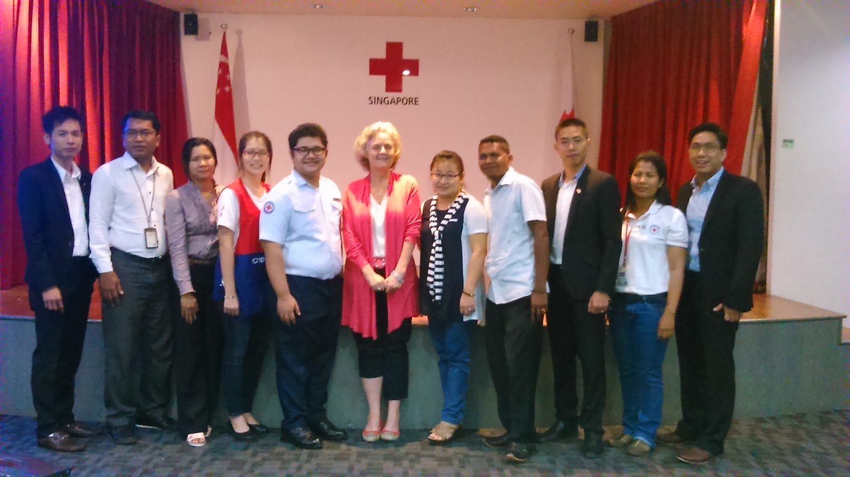

**December 12, 2014**

**Singapore**

# **introduction**

The South East Asia Youth Network(SEAYN) was developed as a sub-network linked to a zone-wide APYN in May 2013. It has a special characteristic as a youth network by ensuring equal participation of NS staff and Youth leaders in it. By nominating their NS youth staffs and youth leaders (volunteers) to be members of the SEAYN, each NSs in the SEA region follows the SEAYN terms of reference which was officially endorsed by the Southeast Asia Leadership Meeting held in Singapore in March 2014.

Following the Terms of Reference of Southeast Asia Youth Network, the SEAYN annual meeting has been held in Phnom-penh, Cambodia hosted by the SEAYN Chair and altogether 5 NSs such as Cambodia, Indonesia, Philippines, Singapore, Lao attended in this meeting and reviewed about 2013-2014 activities and developed a **draft 2015-2016 action** **plan** by looking at issues of Youth in each NS programming and by considering each NSs’ expectations and commitment to SEAYN for their youth engagement and development.

In the **2nd Asia Pacific Youth Summit** held from Oct 20-21 2014 in Beijing China under the theme of **“Young Humanitarians in Action”**prior to the 9th Asia Pacific Regional Conference, the rest of NSs with participation of 5 NSs (Cambodia, Myanmar, Singapore, Thailand, Timor Leste) have confirmed the SEAYN **action plan 2015-2016 conclusively** and further fully reflected them in the Beijing Youth Commitment 2014, a key document of the youth summit.

In order to follow up the Beijing Youth Summit and implement youth commitment in a close link with the Beijing Call for Innovation adopted in the AP regional conference, Singapore Red Cross, one key active member of SEAYN has kindly offered to host the 2nd SEAYN meeting before their Youth Symposium “Youth in action” by inviting youth leaders (SEAYN members) to highlight the significance of the Youth Summit and AP regional conference.

In a response to this call, SEAYN has decided to convene one -day meeting in Singapore and with the support of IFRC SEA and SRC, 7 NSs with 9 Participants from Lao, Myanmar (2 members), Philippines, Singapore (2 members), Thailand, Timor Leste, Cambodia(one observer), Head of IFRC SEA office and Youth focal point of IFRC SEA office joined in the meeting.

**Objective of SEAYN Meeting**

To engage youth leaders in a meaningful way in order to implement the SEAYN action plans in a close connection with the Beijing youth commitment and the Beijing Call for Innovation

# **2. COUNTRY UPDATES FOR 2015**

Pls see attached annex 2 for country updates

# **2.1 Beijing youth commitment and ap conference “call for innovation”**

Sasinat Chindapol, Thai RC youth leader

Nay Lin Aung, Myanmar RC youth leader

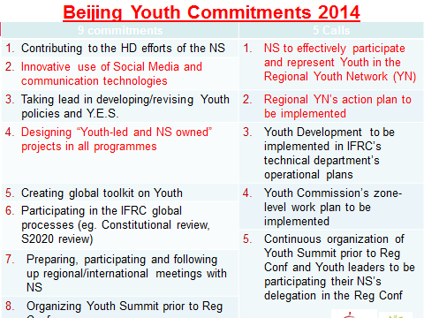

# **SEAYN Introduction and Key action plans**

Kumju Ho, IFRC SEA office

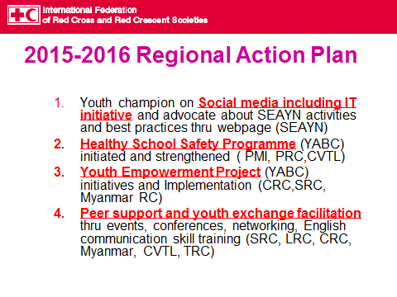

# 

***More Detailed action plan 2015-2016***

|  |  |  |  |  |
| --- | --- | --- | --- | --- |
| **No** | **IFRC Y.E.S** | **Tentative Plans** | **Hosting NS** | **Methodology** |
| 1 | Youth as Leaders | Invite NS youth leaders when organising any **events/conference** to learn the leadership skills and play a leading role in representation of RC | SRC | Youth Symposium |
| 2 | Establish **Youth Network at national level** to create youth-led structures that allow elected youth leaders to represent their peers | LRC | School youth network |
| 3 | Youth as Volunteers | **Youth** **Empowerment initiatives** into NS programmes | SRC | CLARE Project  (Community Led Action of Resilience for Elderly) |
| 4 | YABC implementation | PRC | YABC Training continuation |
| 5 | Youth activities in community level | CRC | Youth programmes in community |
| 6 | Youth to be **champion on social media including IT** initiative and advocate SEAYN activities thru recognising it as contributors to innovation | All | Open SEAYN page and update it with the support of all members every month |
| 7 | Youth as Beneficiaries | **Healthy School Safety** programme | PMI | SPLASH programme with the support of SRC |
| 8 | **Peer support and youth exchange** for peer to peer mentoring, skill sharing | LRC+SRC  CRC+JRC | Exchange visit |
| 9 | **English Communication Skill Training** | TRC | International Youth Friendship Camp |

# **3. DISCUSSION ON “ADVOCACY AND INNOVATION”**

*All participants*

***SEAYN challenges were presented as follows;***

1. Lack of Advocacy to NS leadership about Youth and Network activities
2. Short of information, no Database, no analysis, no Evidence for NS youths
3. Project Implementation and resources, Funding resources are getting limited and shrunk
4. Members leave and replacement
5. Limited engagement and involvement

* No nominations from some NSs
* CT members workload and poor engagement
* Poor participation in online meetings

All youth leaders were divided into two groups and had a discussion how to address /overcome these challenges to implement action plan 2015-2016 by following topics

1. How can we advocate SEAYN to leadership, NS Programmes by our own resources?
2. What are your innovations for strengthening Your Youths and Network in these challenging situations?

***Summary of discussion is as follows;***

|  |  |  |  |  |
| --- | --- | --- | --- | --- |
| **Challenges** | **What to do** | **Who** | **When** | **How** |
| **Advocacy** | To develop SEAYN Newsletter and circulate all leaders and Programme people by SEAYN members | Focal; Zaidi, SRC  Marlouize, PRC  Khamla, LRC | Four monthly  End of Feb before the NS leadership meeting, First Edition | -Design paper  -Collect information and pictures  - Compile and edit  -circulate to all members |
| **Innovation** | To develop a Country level online webpage for Country Youth Activities (in local language and English translation) and share with all members about link | All members | End of Jan  Constantly update on bi monthly basis | -Design page  -Collect information and pictures  - translate in English and share the link |
| To develop a SEAYN online webpage/site thru Facebook and share with all members about link | Focal; Zaidi, SRC  Marlouize, PRC  Khamla, LRC | End of Jan  Constantly update on bi monthly basis | -Design page  -Uploading Newsletters and Collect info from country level pages  - Compile and edit  - share the link |
| To create chat-box by using APPs, line and skype. | Focal; Marlouize, PRC  Zaidi, SRC  Khamla, LRC | First week of Jan | -Contact list and send an invitation to all members |
| To organise the online meeting on bi monthly basis among CT members and all | CT members with chair | Time:3PM  Date:  *CT*: last Tuesday of 1st Month  First meeting on Jan 27  *All*: First Tuesday of 2nd Month  First meeting on Feb 3 | -Webinar  - Agenda discussion thru chat-box  - confirmation in the CT official meeting |
| Another initiatives;   * Establish working group to support SEAYN by including Governance in Governing board * Bringing back SEAYN Action plans to NSs and interaction with Governing Board * Invite guest of honours to Youth events such as music and dance performances | | | |

\**All participants remarked that it was a good discussion to empower youths to advocate their activities to leadership and programmes.*

# 

# **4. SEAYN REPRESENTATIVES FOR ASIA PACIFIC YOUTH NETWORK**

*All participants*

* There was a briefing of APYN ToR which confirmed in the AP Youth summit in Oct Beijing and all participants had a discussion about what roles and responsibility of the SEAYN representatives for the APYN would add in a link with the SEAYN.

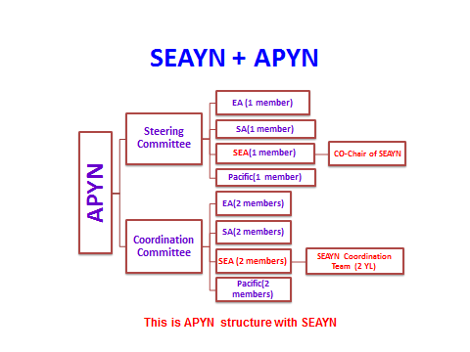

All agreed with the proposed draft Roles and Responsibility of SEAYN Reps for the APYN as follows;

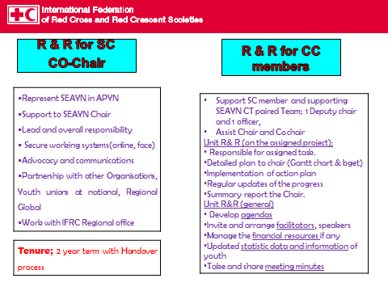

# **5. ELECTION AND NOMINATION FOR APYN**

*Youth leaders and other participants*

***Election Process***

* There were an election for SEAYN Steering committee member of APYN. First of all, eligible 4 candidates were selected among 9 participants as follows;
* Myanmar (1 youth leader)
* Singapore (1 youth leader)
* Thailand (1 youth leader)
* Timor Leste (1 youth leader)
* 2 Youth leaders from Lao and Philippines were declined from the election since they are already appointed as the Coordination Committee Representatives for the APYN according to SEAYN ToR; the SEAYN Coordination Team Youth leaders, 1Deputy Chair and 1 Officer become Coordination Committee members for APYN
* 3 Youth staffs from Cambodia, Myanmar, Singapore were also declined since they are not eligible to the criteria; youth volunteer leader under age of 30.
* Every candidates had an election commitment for the SEAYN and APYN after some preparation time.
* Altogether 7 representatives from 7NSs were eligible to have a voting to elect SC member
* The rest of participants calculated the votes and finally election was finished.

***Elected and appointed members***

The members of the newly nominated SEAYN representatives for APYN are as follows;

1. APYN SC member: Mohammad Zaidi Arffin, SEAYN CO-Chair

(Singapore Youth Council Member, President of SRC youth)

1. APYN CC member: Khamla Phomphakdee, SEAYN Deputy Chair

(Youth leader of Lao RC)

1. APYN CC member: Marlouize E. Villanueva, , SEAYN officer

(National Secretary and Area 6 Youth Coordinator, Philippines RC)

# **6. CONCLUSION**

All of the participants expressed their deepest thanks to the Singapore Red Cross Society for their kind hospitality in hosting the 2nd SEA Youth Network meeting for Youth leaders and enjoyed the Singapore RC peer to peer Youth Symposium on the next day.

Anne E Leclerc, Head of IFRC Regional Delegation Southeast Asia made a congratulatory speech for the youth leaders and elected members who attended in the SEAYN meeting and made concrete outcomes out of the meeting.

All participants never lost their energy and displayed their strong commitment, spirit and passion to the last minute.

Thank you very much for all participants in the meeting!

# Annex 1: Meeting Agenda and Abbreviations

**7th Southeast Asia Youth Network Meeting**

**(Youth leaders’ Meeting)**

**December 12 2014. Singapore**

**Agenda**

|  |  |  |
| --- | --- | --- |
|  | | |
| **Time** | **Item** | **Presenter/facilitator** |
| 10.00-10.30 | Welcome  Agenda briefing | * Hosting Chair * IFRC regional office |
| 10:30- 11:30 | 1. Updated Events /Calendar   Country level Youth events or  activities for 2015 (7 mins each) | * Lao * Myanmar * Philippines * Singapore * Thailand * CVTL * Optional- Cambodia, Indonesia, Malaysia, Vietnam |
| 11:30-12:00 | Beijing Youth Commitment in AP Youth summit  AP Youth conference “Call for innovation” | * Sasinat Chindapol, Thai youth leader * Nay lin Aung, Myanmar Youth leader |
| 12:00-12:30 | 2. SEAYN Introduction   * SEAYN Coordination Team * Functions, Working systems Challenges, link with APYN * Action plans | * IFRC regional office |
| 12:30-13:30 | Lunch |  |
| 13:30-15:00 | 3. Youth Leaders’ Discussion   * Implementation commitment for Action plan 2015-2016 * Solutions for challenges * SEAYN Advocacy and Innovations   (Innovative Youth Engagement -  Empowerment, Networking &  Technology ) | * All |
| 15:00-15:10 | 4. APYN ToR and SEAYN Link   * APYN ToR briefing | * IFRC regional office |
| 15:10-16:00 | 5. Youth Leaders’ Discussion  SEAYN + APYN (Roles and Responsibility)  Summary | * All |
| 16:00-17:30 | 6. Youth Leaders commitment from above   * Candidates commitments (7 min each) * Elections by all observers for APYN representatives * Wrapping up | * All * IFRC regional office |
| 19:00-21:00 | Dinner |  |

|  |  |
| --- | --- |
| YEP | Youth Empowerment Project |
| APYN | Asia Pacific Youth Network |
| APYS | Asia Pacific Youth Summit |
| CT | Coordination Team |
| SEAYN | South East Asia Youth Network |
| Y.E.S | Youth Engagement Strategy |
| APYN SC and CC | Steering Committee, Coordination Committee |
| ToR | Terms of Reference |

# **Annex 2; National Society Youth calendar with 2015 Plans**

IFRC SEA office added and completed a list of respective 2015 NS youth plans and calendar by incorporating all ppp slides from youth leaders and by communicating with other members

|  |  |  |
| --- | --- | --- |
| No | Country | Plans/Calendar 2015 |
| 1 | Brunei | * Youth Policy Update * FA accreditation system for Youth volunteers * YEP initiatives (TBC) |
| 2 | Cambodia | * Capacity building for youths and volunteers in terms of leadership skills and YABC * Culture of sharing project expansion * Resource mobilisation and Fundraising for youth project * My RC story and voice of youth campaign, FP promotion and HV * Exchange between JRC and CRC |
| 3 | Indonesia | * National Youth Gathering (possible invitation of network members) * Healthy Safe school project * Social media for Youth |
| 4 | Lao | * High school/University Youth network establishment both in capital and provincial levels * Appoint youth leaders in schools and elect the RC youth ambassadors as well Youth leaders in villages * Training: Disseminators FA (Free and Commerce) * Data base: develop, collect youth data and compile into one * Initial development of the Youth Policy, Guide lines and strategy and expected approval by the end of 2015. |
| 5 | Myanmar | * Junior Youth Project start- Jan- Dec * Integrated Youth empowerment through Community based Projects/program.( Jan-Dec2015) * Youth’s need assessment visit- Feb * YABC Training – March or May * RCV outstanding camp ( including RCY)- May * RC Youth leadership training- Oct * Exchange Program ( Oct- Dec) |
| 6 | Philippines | * Capability Building for Leadership Development Program (Youth Instructors’ Training Course) – three times per quarter * Implementation of Healthy Lifestyle and Prevention of Lifestyle Diseases Program * Mainstreaming YABC Approach   Calendars;   * Jan- Feb; 1ST Chapter Youth council presidents conference * March-Apr: chapter visits by area coordinators * May; 4th National Youth Council Executive meeting * June-Aug; IHL debaste for college RCY * Sep; 5th NYC meeting * Oct:19th National Youth Congress and elections for new National Youth Council Officers |
| 7 | Singapore | * Continuous Youth activities in chapters * New initiatives; opening new chapters (Entrants, RC clubs, Alumni) * YES Promotion * CLARE Project with YABC, * Leadership programme * SPLASH Project |
| 8 | Thailand | * First Aid Training in 5 camps * Annual FA competition on Aug 12 * Learn English initiative in English camps * Social media * YABC Training (TBC) |
| 9 | Timor leste | * Targeting young people for training healthy life style with tobacco banning * Youth Assembly in May 2015 * District Assembly in March and April * School Youth Programme Module development by Oct |

Annex 3; SEAYN Contact list updated in Dec 2014