Youth Empowerment in School Based Disaster Risk Reduction with a tool of Youth in School Safety (YSS)
- Introduction

The 6th Asian Ministerial Conference for Disaster Risk Reduction (AMCDRR) called upon all stakeholders to, by recognizing the meaningful role of youth and children in school safety, institutionalize participation of children, adolescents and youths in school based DRR activities including trainings, simulation exercises and other preparedness measures by giving them representing roles in disaster management committee.

The Sendai Framework for Disaster Risk Reduction 2015-2030 recognized Children and youth are agents of change and called upon all heads of the states and government, ministers and all stakeholders that children and youths should be given the space and modalities to contribute to disaster risk reduction, in accordance with legislation, national practice and educational curricula.

This case study; Youth empowerment in school based disaster risk reduction (SBDRR) captures a specific training and tool of “Youth in School Safety” (YSS) as one of Youth empowerment programme in Myanmar Red Cross carried out in July 2015 with the support of the IFRC Southeast Asia delegation.

This training is the first time “youth-led and owned” SBDRR training in Myanmar Red Cross Society by using a newly developed IFRC children friendly tool “Youth in School Safety”(YSS) and this training is one of the pilot youth empowerment programme in Southeast Asia region.

- Background
Myanmar has been rated 135th among the 179 countries in Human Development Index 2010. The country has a young population with 45.3 per cent under 25 years of age. This is also the case for volunteer composition of the Myanmar Red Cross Society (MRCS). A total of 50 per cent of Red Cross volunteers are youths under 30 years old. Youths are most effective group in awareness and education to change the minds, attitudes and behaviors of their peers and other community people including marginalized youths.
MRCs Youths under the organizational development division have positioned in 18 state/regional Red Cross Supervisory Committees and the youth teams in 119 universities are now forming Junior Red Cross youth teams at township branches and encouraging the Red Cross youths to take up leadership roles in NS service delivery as well as decision making level. MRCs Youths are engaging more in the community based programmes and trying to find their meaningful roles, meanwhile MRCs also pursues youth empowerment initiative in community programmes.
In history, Myanmar RC has been conducting SBDRR projects for many years with their own tool and mechanism which was not so children friendly and has not made so remarkable impact.
After youth as agents of behavioral change (YABC) peer educators’ training in April, Myanmar, those youth participants have challenged themselves by questioning what they are doing for community and schools and changed their mindset, attitude from being a “showcase to others” to taking up an ethical leadership role in inspiring a positive change of mind sets, attitudes and behaviours within themselves and their community and decided to lead the SBDRR programme as their own responsibility.
With the initiative of IFRC Southeast Asia Community Safety and Resilience Unit which pursues youth’s specific role in school based disaster risk reduction (SBDRR) of the National Societies, a children friendly tool for SBDRR programme named “ Youth in School Safety (YSS) tool” was developed in May and June and implemented as a pilot in Myanmar Takedo Secondary school.
The tool with a participant-centred, experiential learning approach relies on a non-cognitive methodology, meaning that feelings, experience, or the physical body, rather than intellectual analysis adopted from YABC toolkits and helps youth to gain the SBDRR knowledge by addressing/identifying specific gaps/issues and its root causes in their exiting knowledge and practice, giving all possible solutions to that by their own, through scenario based games, role-plays, simulation and visualization exercises, through a creative platform; theatre, dance, music, arts and sports activities. In a second phase, youths share experiences with their peers and reflect together and make a ‘from their heart to their mind’ learning journey to become ethical leaders for SBDRR. It combines with a delivery of technical knowledge on Comprehensive School Safety framework (CSS) and DRR.

Most peculiarity of the tool is that facilitators are not adults, but children and youths by themselves.

- Implementation
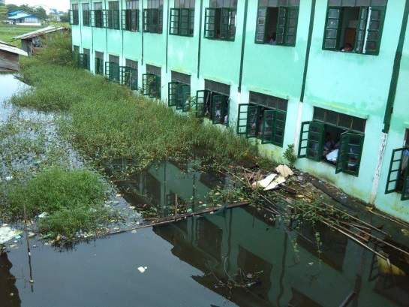
Taketa Secondary School selected by MRC is one pilot school of Myanmar SBDRR Programme. The school is affected by floods every year. In case of floods, all classes have to close until it drains out.

Overall objective of training is to develop a comprehensive and feasible SBDRR action plan in schools by engaging youths/students, parents, community leader and RC with a clear mechanism with their ownership.

Target groups were students, teachers and RC staffs/volunteers for this training.

Phase 1; YABC Peer Educators (PE) training and PEs
      - Master YABC PE training for Nationwide Youth empowerment programme has been taken place in Mawlamyine township, Mon State from April 5-9, 2015
      - “Four children and two teachers (here calls them as PE) from Taketa school attended the training and learned about skills and knowledge of peer education, facilitation, communication and motivation and gained hand-on experiences through different role plays, games and exercises.
      - The YABC training process aims to make youths and children to start to think critically by challenging themselves by questioning what they are doing for community and schools and what they can change for better society.
      - These PEs have undergone this process and took up an ethical leadership role in inspiring a positive change of mind sets, attitudes and behaviours within themselves and their peers and fully motivated to lead the SBDRR programme as their own responsibility. This is the beauty of the programme and right moment to use them as facilitators for SBDRR programme.
Phase 2; Preparedness to be YSBDRR facilitators
      - There held a preparation day for the PEs, with a coach of IFRC trainers, to be effective facilitators for SBDRR workshop by using the YSS tool and with the spirit of YABC. Those PEs made practice and practice by visualizing the activities, doing role-plays
Phase 3; YSBDRR Training coached by IFRC trainers(professionals)
      - From Day 1 to 3 of the workshop, all facilitators used a non-cognitive methodology, started with questions of feeling “How do you feel?” when the participants do their role plays and experience situations. And next question was always “what they can do better in real life, what they can change” by opening all possibilities or solutions for being ready for any disasters.
      - These PEs become role model facilitators in the training by conducting activities from YABC toolkit which addressing interpersonal skills such as empathy, non-judgment, critical thinking, dropping bias and personal resilience as well as thematic issues such as non- discrimination and respect for diversity and violence prevention and mitigation and response. After YABC activities, participants become awakened into a learning mode by questioning by themselves what they can do better/ change themselves for schools to prepare for disaster and reduce the risk of disaster.
      - It was the right moment to introduce concept of SBDRR,CSS, School based Hazard, Vulnerability and Capacity, roles and responsibility of SBDRR Task force to students by professionals.
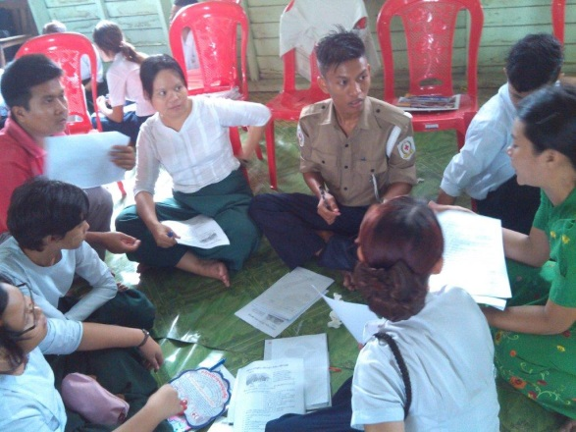
      - After introductions, the participants were formed into 4 task force groups based on 4 scenarios, and made preparation for mock drill exercise by using their knowledge and experiences.
      - In every mockdrill exercise, there always existed unforeseen obstacles (we call them obstacle cards prepared by the rest of groups according to training manual).
      - Each task force group took a responsibility of group to cope with emergency in different types e.g fire, earthquake, floods, cyclone by providing information, setting up early warning system, evacuation, rescue and search, first aid by using all innovative solutions/ways. The rest groups become obstacle cards(unforeseen risks) to block their exercises.
      - Once alarmed, they really demonstrated and displayed their group work according to their preparedness and after mock drill, they discussed/identified gaps, issues and found solutions for future activities followed by trainers’ feedback.
      - After all groups were done in mock drill exercise for different scenarios, they became ready to develop their action plans “School Disaster Management Planning” with monitoring and evaluation plan by reviewing all feedback on their exercises at pre, during and after disaster time. Finally they become ethical leaders to be responsible for saving lives of all their friends from disasters.
      - On the final day, they carried out the School Mobilization Activities through their performances; Music, Dance, Theatre and Visual arts and Sport group to motivate other students, teachers, parents and community to engage in SBDRR in a positive collaborative way. And final evaluation has been carried with following issues, challenges and outcomes
- Challenges and Issues
- This training specially requires YABC peer educators who ever joined the training once to be facilitators since the tool relies on non-cognitive methodology of YABC.
- Coaching process (English and local language) by trainers is also required before the training itself since this is really youth-led training.
- The training needs a lot of energizers to engage youths into more lively and funny learning mood.
- Translation is needed in local language about scenarios and introduction presentations.
- Their action plan should be monitored and evaluated by professionals and youth focal points with resources of funds and materials

- Impact and outcomes
Investment in youth-led activities aimed at building community resilience can offer more sustainable and much wider solutions for reducing community vulnerability to disasters. Through youth-led specific activities, gaps in the community programmes can be identified and the community concerns can be raised and addressed. Community resilience building will thus benefit from youth empowerment which plays a significant role.
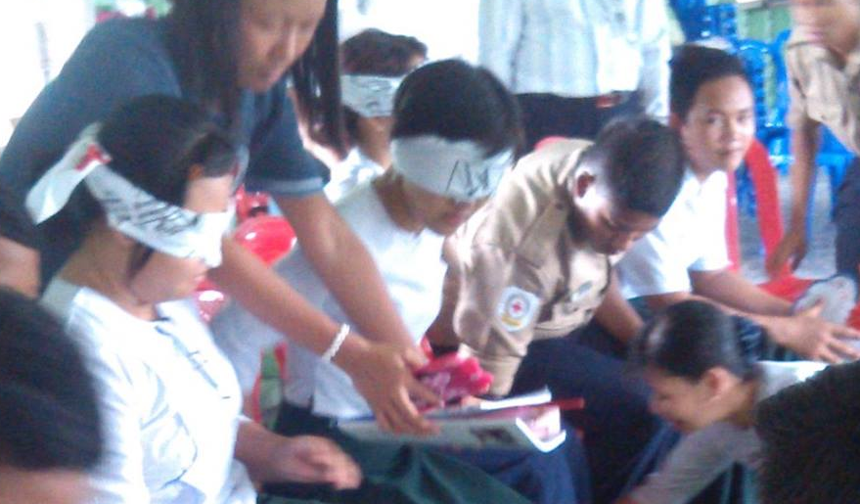Mony, 14 year old boy at Taketa school said after the training “ I didn’t realise I can prepare for disaster. Now I will write down emergency contact number first and stick to the wall of my classroom and explain to my friends about it. And if any emergency, I will evacuate disabled, heart-broken and frightened friends to the safety place first because I was so afraid as nobody saved me when I was in blind-folded in fire mock drill exercise. And after disaster, I will support my teacher to distribute water and food to my friends and count number of my classmates. I hope I can continue my study after disaster”

This training has sustainable impacts and outcomes.
- Students and teachers at school have a clear understanding what SBDRR means to them and become responsible members for this by changing mindsets and attitudes through the support of their peers
- It is sustainable since it is the reproductive hand-on peer training and peer support by RCY
- It is an integrated training between youths and DRR with children friendly tool.
- school action plan developed in the training is a real voice of children and youths living at schools by addressing the real issues of schools and solutions at their eye level.
- The training gives solutions to especially children with special needs in case of disaster/emergency, gender, violence in emergency by experiential learning.
The Southeast Asia NSs can participate in the evaluations of the YSBDRR project and share best practices and lessons through their platforms for others to consider/follow for their own initiatives.
- Conclusion
The RCRC Asia Pacific Youth Summit commitment mentioned designing “Youth-led and National Society-owned” projects across all programmes and services of National Societies, especially in the Disaster Risk Reduction and Safe Schools Framework.

This is one of the best examples for youth empowerment and development in DRR by taking up ethical leadership role in community safety and resilience and IFRC SEA delegation will continue to conduct trainings in SEA NSs for school safety.

- Contact information
For further information, please contact:
Sanjeev Kafley, CSRU Coordinator
Kumju Ho, Youth and volunteering officer
IFRC Southeast Asia Delegation

https://www.cia.gov/library/publications/the-world-factbook/

