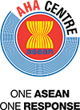

AHA Centre Executive (ACE) Programme 2015
Red Cross Red Crescent Induction
23-28 May 2016 – Bogor and Semarang, Indonesia

Activity report

Introduction

IFRC and Indonesian Red Cross (PMI) co-facilitated a Red Cross Red Crescent Induction training for governments of ASEAN on 23 – 27 May 2016 in Indonesia, as part of the batch 3 of the AHA Centre Executive (ACE) Programme. This training is part of the 6-month AHA Centre Executive (ACE) Programme aiming at enhancing the capacities of the future Disaster Management managers of ASEAN.

The training was held at PMI training centre in Semarang, Central Java, Indonesia, for 16 representatives of National Disaster Management Offices (NDMO) from 8 ASEAN Member States, as well as 3 participants from the AHA centre. The training included a one-day field visit to Bogor to learn about the community-based activities facilitated by Indonesian Red Cross (PMI) and a field exercise to test the learning of participants.

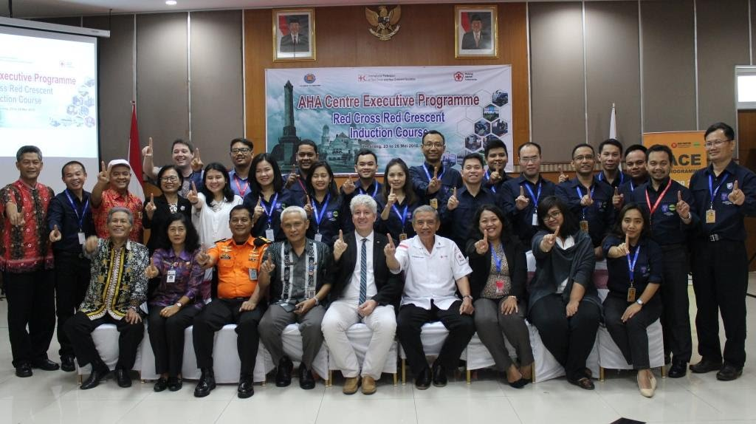

Objectives

This training was organized as part of the wider Red Cross Red Crescent contribution to the ACE programme, with the following objectives:

1/ Enhance RCRC engagement with ASEAN in the field of Disaster Management, through concrete collaboration with ASEAN’s flagship technical entity (AHA Centre), thus demonstrating the added value of RCRC as part of the “One ASEAN One Response”.
2/ Increase understanding of RCRC among ACE Programme participants: the “future DM Leaders” in the region, thus contributing to the strategic positioning of RCRC in their auxiliary status, and in particular for the National Society at the country level.

3/ Reinforce the linkage between NSs and their NDMO counterparts through joint capacity-building, which – beyond providing skills to individuals – is hoped to contribute to institutional relation-building.

Contents of the training

The training was organized around 5 main themes:

Day 1  Monday 23 May 2016 | Field visit to urban resilience activities in Bogor | Participants learned about PMI community-based work as well as the local partnership between PMI and local authorities
Day 2  Tuesday 24 May 2016 | Introduction to the Red Cross Red Crescent Movement | Participants gained a general knowledge about the Movement, in particular its components and principles. This included presentations from ICRC, IFRC, PMI and the Thai Red Cross Society.
Day 3  Wednesday 25 May 2016 | Preparedness, response and recovery | Participants were first introduced to the principles and rules for humanitarian assistance. Then, they learnt about local and national response mechanisms from PMI and TRCS. IFRC also presented the global tools available to support National Societies in disaster times. Finally, the day was ended with a participatory activity around the characteristics of resilient communities.
Day 4  Thursday 26 May 2016 | Cross-cutting themes: Disaster Law / Gender and Diversity | Both sessions provided the participants with a general understanding on the themes, guiding tools and strategies. Participants were involved in short exercises to put the theory into practice. An update of the progress made in ASEAN countries with these two themes was also presented.
Day 5  Friday 27 May 2016 | Field exercise | A field exercise was organized to provide an opportunity for participants to practice some of the tools provided in the previous days. The training team ensured specific injects relating to disaster law, principles and rules as well as gender and diversity were part of the simulation.

All presentations from the training are available on the online library here. They were also uploaded on the online platform (schoology) used by AHA Centre for the ACE Programme. This includes the list of pre-reading materials sent to participants ahead of the course.

Trainers

The training was co-facilitated by IFRC and PMI with support from ICRC and the Thai Red Cross Society

Pictures from the training

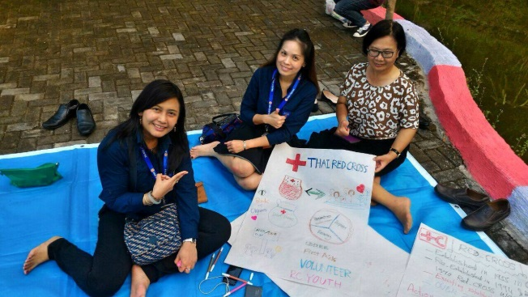 | 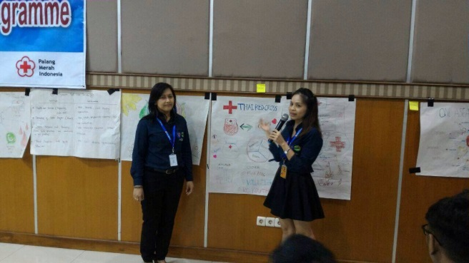
Participants from Thailand (Department of Disaster Prevention and Mitigation and Thai Red Cross) draw and present their poster of the TRCS.
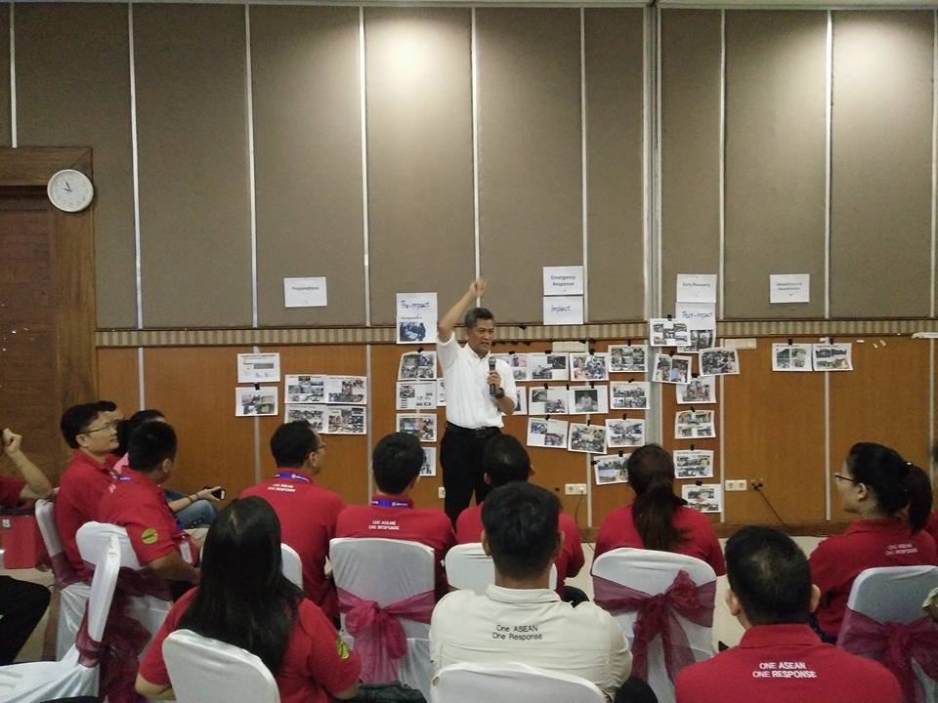 | 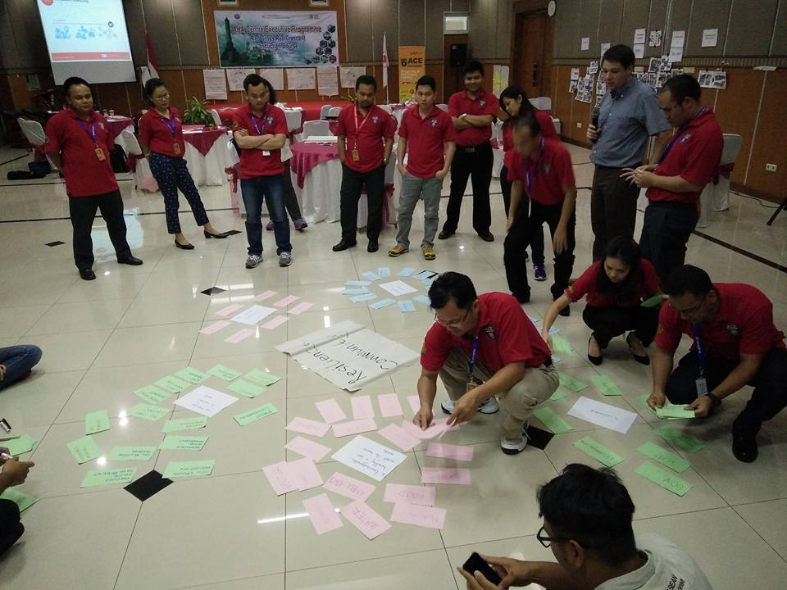
PMI sharing about their preparedness and response activities | Participants mapping the characteristics of resilient communities
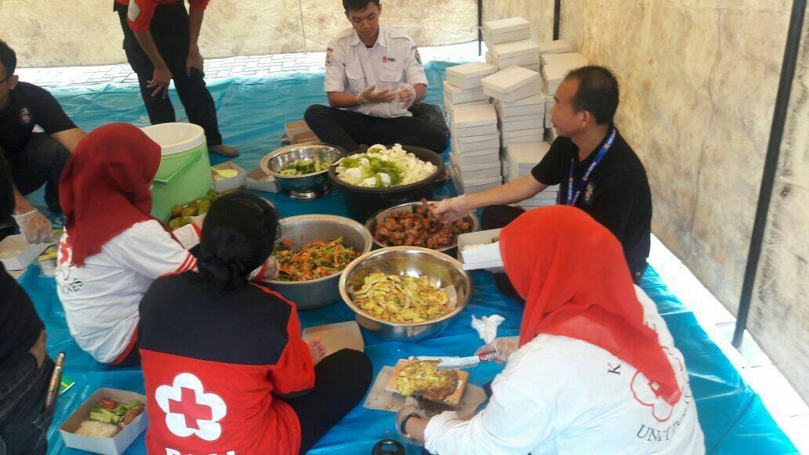 | 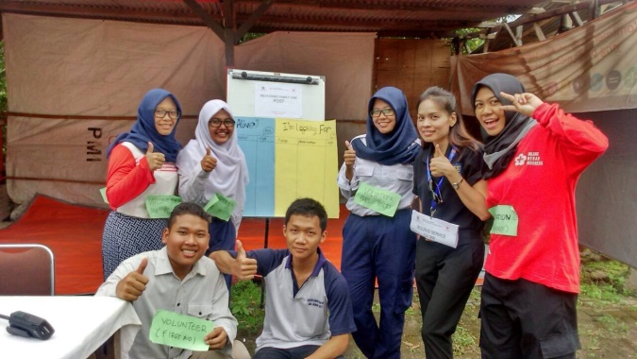
During the field exercise, ACE programme participants teamed up with PMI youth volunteers to provide services to communities: food distribution (left) and restoring family links (right)

Evaluation of the training

A 10mn test was conducted among the 19 participants prior to the training and after the end of the simulation exercise. It allowed to measure the progress made by the group in terms of knowledge linked with the various thematic sessions. Overall, there is an increase from 42% to 74% of correct answers which shows that most participants were able to understand the key points from the training.

Furthermore, a feedback form on the training was filled by the participants at the end of the workshop. Compiled results are annexed to this report. All participants rated the training as “excellent” (14/19) or “good” (5/19). The best session identified was the field exercise for 15 out of 19 participants and most of them stated that the learning would contribute to the improvement of their work once back in their respective countries

Annexes

- List of participants
- Agenda
- Compilation of the feedback forms

Annex 1: list of participants

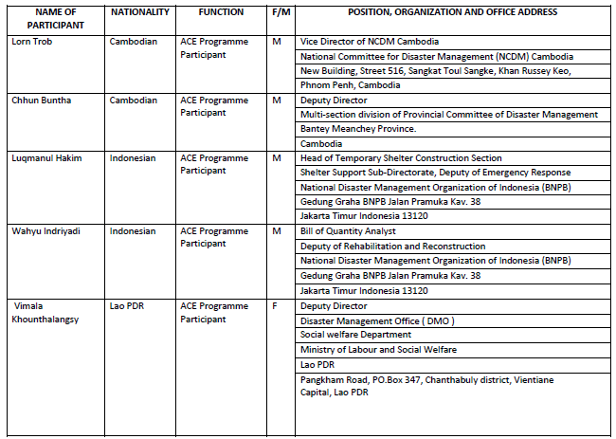
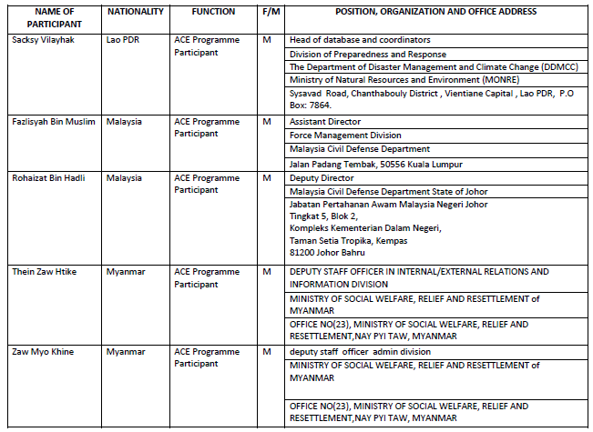
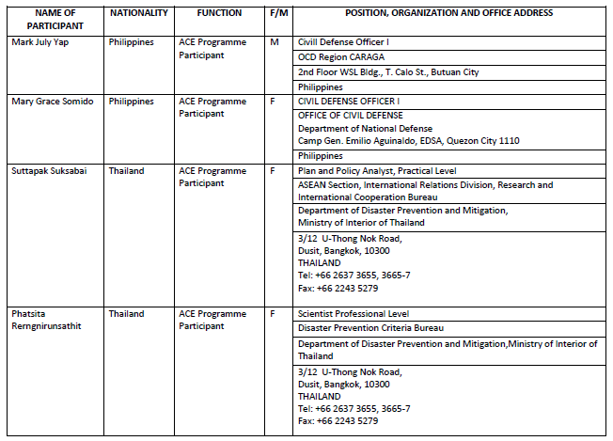
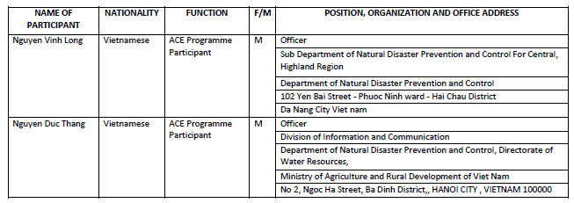

From AHA Centre:
- Ms Ririn Haryani, Officer for ACE Programme
- Mr Ady Bishry, Information and Communication Technology Officer
- Ms Grace Endina, Programme Assistant

Annex 2: Agenda of the training

Day 1 – Monday 23 May 2016: field visit in Bogor and travel to Semarang

Time | Description | Comments / speakers
08:00 – 9:30 | Travel from Jakarta to Bogor | Bus provided by AHA Centre
09.30 – 12.30 | Field visit in communities | Organized by PMI
12.30 – 15.00 | Lunch and interaction with community members, PMI staffs and volunteers as well as local authorities | Organized by PMI
15.30 – 18.00 | Travel from Bogor to Jakarta airport | Bus provided by AHA Centre
19.10 | Flight GA246 to Semarang | In Semarang, pick-up by PMI and check in at the PMI training centre

Day 2 – Tuesday 24 May 2016, introduction to the Red Cross Red Crescent Movement

Time | Description | Comments / speakers
09:30 – 10:00 | Opening session | - Central Java local government  - PMI  - AHA Centre  - IFRC  - ICRC
10.00 – 10.30 | Objectives, agenda, expectations and pre-test | Facilitator
Coffee break
10.45 – 12.00 | Introduction to RCRC Movement (history, components, principles, emblems) | IFRC and ICRC
12.00 – 12.30 | Example of a National Society: overview of PMI and Thai Red Cross Society | PMI and Thai Red Cross Society
Lunch
13.30 – 14.30 | Overview of RCRC in South-East Asia | IFRC and ICRC
14.30 - 15.00 | Questions and answers on the morning session | All presenters from the morning
Coffee break
15.30 – 16.30 | Group work by country : what do you know about your NS? | Participants create a poster of their NS based on their knowledge and experience
16.30 – 17.15 | Feedback from the group | Facilitator
17.15 – 17.30 | Recap / evaluation of the day | Facilitator
Free evening at the training centre

Day 3 – Wednesday 25 May 2016: preparedness, response and recovery
Time | Description | Comments / speakers
8:30 – 9:00 | Recap from day 2 | Facilitator
09.00 – 10.00 | Our approach to emergency response and preparedness  Overall introduction to principles and rules | IFRC
10.00 – 10.30 | PMI preparedness and response, from local to national | PMI
Coffee break
10.45 – 11.15 | Thai Red Cross Society preparedness and response, from local to national | TRCS
11.15 – 12.00 | Presentation of global response tools | IFRC
12.00 - 12.30 | Questions and answers on the morning session | All presenters from the morning
Lunch
13.30 – 14.00 | Visit of PMI warehouse in Semarang
14.00 – 14.45 | RCRC and (early) recovery initiatives – overall introduction | IFRC
14.45 – 15.30 | Examples of recovery operations from NSs | PMI and Thai Red Cross Society
Coffee break
15.45– 16.30 | Focus on Shelter Programming and the Cash Transfer Programming | IFRC and PMI
16.30 – 17.15 | The resilience approach, engaging communities before, during and after disasters and crises | IFRC and PMI
17.15 – 17.30 | Recap / evaluation of the day | Facilitator
Free evening / short visit to Semarang city centre

Day 4 – Thursday 26 May 2016 – Cross-cutting themes: Disaster Law and Social Inclusion
Time | Description | Comments / speakers
08:30 – 9:00 | Recap from day 3 | Facilitator (IFRC/PMI)
09.00 – 10:00 | Disaster Law - introduction: what is disaster law? Disaster Law themes and tools | IFRC
10.00 – 10.30 | IDRL exercise | IFRC / Facilitator
Coffee break
11:00 – 11:30 | Disaster Law, advocacy and partnerships: examples from the region | IFRC
11:30 – 12:00 | Disaster law: the experience of Indonesia. | PMI
12.00 – 12.30 | Questions, Answers and wrap-up | All morning presenters
Lunch
13.30-14.00 | An inclusive approach - introduction on Gender and Diversity | IFRC
14.00 – 15.15 | Role play on Gender and Diversity | IFRC / facilitator
Coffee break
15.30 – 16.00 | Feedback on the role play | IFRC / facilitator
16.00 – 17.15 | Presentation of the field exercise on day 5 and preparatory work in groups | PMI / facilitator
17.15 – 17.30 | Recap / evaluation of the day | Facilitator
Free evening at the training centre

Day 5 – Friday 27 May 2016: putting knowledge into practice (field exercise)
Time | Description | Comments / speakers
08.00 – 08.30 | Briefing for the field exercise
08.30 – 11.30 | Field exercise | IFRC and PMI
11.30 - 15.30 | Lunch and rest
15.30 – 17.30 | Debriefing of the exercise, post test and evaluation of the week | IFRC and PMI
Final festive dinner hosted by PMI and IFRC – handover of certificates to participants

Day 6 – Saturday 28 May 2016: back to Jakarta
Time | Description | Comments / speakers
09.00 | Transfer to Semarang Airport | PMI to provide bus
11.35 | Flight GA 237 to Jakarta

Anne 3: compiliation of feedback forms

Date / Location: Bogor and Semarang, Indonesia  23-27 May 2016. |  | Compiled feedback of 19 participants (13 male / 6 female)
 | Please tick the appropriate box – if you need more space, please use the back of the form or ask for more paper. |  | Excellent | Good | Average | Poor
 | - What was the training’s overall value to you? |  | 14 | 5
 | Comments/explanation:
 | - Will the training help you to be more effective in your job? |  | 7 | 12
Comments/explanation:
  - The simulation
  - Coordinate with government and RCRC
  - Similar job every year
  - Better understand DM
  - Know the RCRC system
 | - Would you recommend this training to your colleagues? |  | 7 | 11 | 1
Comments/explanation:
- Understand other system
- Connect with new people
 | - How was the balance of theory and practice? |  | 8 | 8 | 3
Comments/explanation:
- Need more practice (1)
- Add more exercise / simulation (1)
- Good that each module had its related activity (1)
- Well balanced (1)
 | - How was the length and timing? |  | 9 | 9 | 3
Comments/explanation:
- Well organized and effective
- On time
- Good arrangement
- Just perfect
- The timing is not sufficient enough to cover all materials and exercises
 | - How was the quality of the materials/handouts? |  | 8 | 11
Comments/explanation:
- Need more materials
- Very useful for me and back home I can use some of the guidelines
- Have less words in the presentations
 | - How were the logistics & admin arrangements? (see also hotel room & training facilities question on next page) |  | 8 | 10 | 1
Comments/explanation:
- Good: food, facilities, services
- Just the Wi-Fi, not that excellent, but food was excellent
- Manage to accommodate our needs
- Good food, smooth logistical arrangements, nice meeting room facility

- How were the facilities (training room, hotel etc)? | 7 | 10 | 2
Comments/explanation:
- Facilities are excellent, only toilets need renovation
- Bathroom is not new and make people think it is not clean
- Internet is not very accessible
- What was the best part of the training?
- Simulation exercise (15)
- Food (2)
- Hospitality
- Well-spaced training
- On time
- Icebreakers
- Role and responsibility of PMI, IFRC and ICRC
- Introduction
- DM Law
- PMI role in CBDRM
- What was the worst part of the training?
- None (16)
- Confusion during the exercise as the participants were acting as ERAT members which happens before the ERAT training
- Challenges during the exercise
- Any suggestions to improve this training in the future (e.g. on session timing, facilitation/presentation methods, practical issues, etc.)?
- Inter-connectivity of theory and practice (3)
- More examples for each topic
- More simulation exercises
- More jokes
- Concept note on the simulation
- This training provided me with knowledge, communication, team work and skills. I go back to my country to share experience, all good, thanks
- Invite more national societies within ASEAN to share their experience as well
- Time is too short
- Have more theory related to the simulation exercise
- For the simulation, better to have participants act as Red Cross rather than ERAT
- Have more time for community-based approaches and Disaster Law
- Please use the space below to provide any additional feedback.
- Very good food and good training
- Very good facility and food
- Overall good
- Simulation is excellent way to learn from experience, how to deal with unexpected and engage with the communities
- Thanks IFRC and PMI for facilitating this (3)
- Good arrangement, good food, good accommodation. Thanks to all of your support for this program.

