Terms of Reference
Regional Forum on Safety and Resilience

- Background

In the past few decades, natural disasters, outbreaks and man-made disasters, including conflicts and unrest in the region continues to show significantly increased both the frequency of occurrence and also magnitude of loss impact. Any losses incurred always resulted in prolonged impact of the decline in the quality of human life, especially to the most vulnerable. Overall, the evidence Suggests that a significant proportion of communities have changed in their attitudes and behaviors towards risk. Greater awareness and knowledge is Witnessed in many instances, resulting in better ability to manage and respond to the impact of shocks and stresses.

Disaster risk reduction (DRR) and related community based health program offers a major contribution to the building of safer, resilient communities. Responding to this gap, all of NSs must be focus to touch to the communities and specifically communities that are at risk from regular and new disaster impacts. We know that SEA NSs have been implementing DRR (including CBH program) for some years now, but with the world becoming increasingly unsafe, it is important that all of NSs in SEA region try to build on the foundations of previous endeavors and do more of what works and is effective.

The world recognizes that IFRC is as a global leader in strengthening community resilience. This is an honor. But it will also be a heavy burden to be borne by all members of the movement. It requires the increasing capacity and performance of NSs at all levels. NSs in SEA Region also need to be more systematic in what they do as well as enhancing what they are doing to ensure that the basic objectives of safety and resilience are being addressed. RC/RC in SEA Region should be able to touch down to grassroots its DRR programs and other related programs CBH program by empowering communities to be more safer and resilient.
CSR programs will not be effective, if the capacity, competence and performance of the organization is not strong enough to support and encourage the DM and Health services. So far, in many NSs, the performance of its daily services and CSR programs is not maximized due to the lack of organizational support and facilitation. On the other hand, is also a lack of coordination, communication and integration of the three components.

The results of Leader Meeting 2013 in Laos has recommended the need for integration between DM, Health and OD / Youth by set up regional forum for CSR. Establishment of Regional Community Safety and Resilience Forum (RFCSR) is expected to be the glue for integration forums DM, Health and OD / Youth to oversee the implementation of the regional road map and CSR programs refer to the strategic policies generated by the SEA Leader and IFRC CSR framework.

The formation SFCSR also to respond the needs of greater and effective coordination, communication, networking and partnerships within movement (IFRC, ICRC and NSs) in order to performing as a leading in the implementation of CSR program. By sincerity and high commitment in utilizing maximally productive this regional forum, as well as by the seriousness of all of NSs in improving the performance their services and CSR program, certainly surely desires will come true.

- Definition

Regional Forum on Community Safety and Resilience (RFCSR) is yearly forum for the representative of head/ manager of DM, Health and OD/ Youth Technical Working Group. RFCSR includes 4 type of forum, namely forum among TWG chair, Regional Forum (Plenary Regional forum), Technical Working Group (TWG) and Sub TWG Forum.

Establishment of the Regional Forum for Community Safety and Resilience is to enhance regional integration, coordination, communication and cooperation between SEA RCRC members. It tasked to translate the results of the strategic policy and direction decisions from leader into the operational action to promote the establishment of a safer and resilient communities. This forum is responsible for escorting the global agenda on CSR refers to the 2020 strategy IFRC, IFRC frame work of CSR and other agendas such as HFA and the MDGs.

Technical Working Group (TWG) is a forum meeting between the head / manager of each sector (DM, Health, OD) which will be implemented during the meeting of RFCSR. Each TWG meeting will be held separately as an integrated part of the meeting of RFCSR.
Sub-Technical Working Group is a thematic forum that established by the TWG in accordance with the need to support the programs of each TWG.

- Purpose

The terms of references are intended to be supportive to the needs of all of TWG (DM, Health and OD/Y) and individual National Societies, to ensure alignment with the Federation’s systems, and simultaneously to be ‘synchronized’ with the Road Map of Regional CSR and SEA RCRC Leader strategic policies.

A long standing purpose is to ensure CSR capacities of individual National Societies are being strengthened and the capability of the region to improve its capacity for CSR is being enhanced, through regional cooperation.

- Structure and Membership

1. Regional Forum for Community Safety and Resilience is the umbrella of all meetings / forums in the SEA Red Cross and Red Crescent consisting of 3 Technical Working Group, namely:
a. Disaster Management Technical Working Group,
b. Health Technical Working Group,
c. Organizational Development and Youth Technical Working Group.

2. Membership
a. Disaster Management Technical Working Group, composed of head / manager of Disaster Management Division
from 11 SEA RCRC.
b. Health Technical Working Group, composed of head / manager of Health Division from 11 SEA RCRC.
c. Organizational Development and Youth Technical Working Group, composed of head / manager of Disaster
Management Division from 11 SEA RCRC.

3. RFCSR and TWG Chair

RFCSR Chair will be elected among the TWG Chair for a period of minimum two years and up to maximum four years.

TWG Chair will be elected among the members of each TWG for a period of minimum two years and up to maximum four years.

RFCSR and or TWG Chair will represent the RFCSR at regional, global and other events that would be of benefit to all of SEA RCRC members.

TWG chairs are responsible for taking a lead in organizing TWG meetings and communicating with other TWG members and IFRC SEARDs CSRU in relation to their thematic area.

Choice of the chair and nomination of representatives from individual National Society is voluntary. However, the competence profile of each subgroup member shall be in line with the objectives and activity areas of that particular sub group

Flow of Communication and coordination
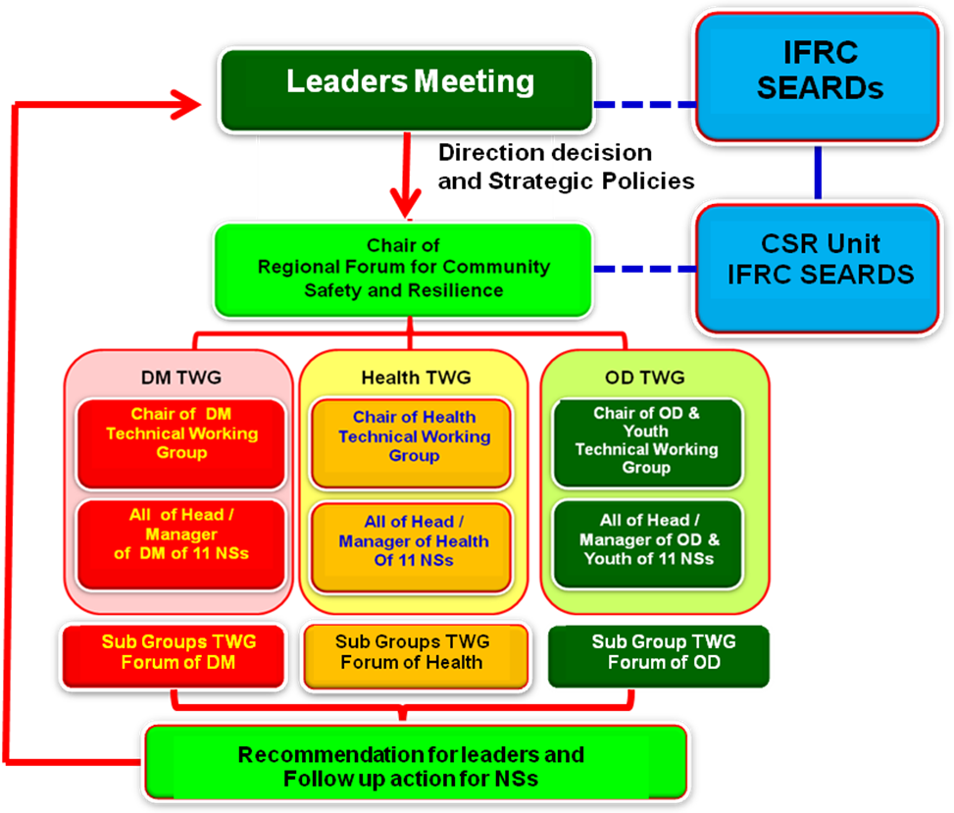

4. Role and Responsibility

RFCSR has role to ensure that strategic policy and direction decisions of the Leader meeting can be followed up and translated into operational plans. Operational plan that generated by RFCSR subsequently used as a reference for the NSs and it will be accommodated in the implementation of national CSR programs and services in their respective countries. Updated progress of implementation of the CRS program and service activities in each of NSs will be shared in the RFCSR and Leaders meeting. For this reason, in order to sustain better flow of decision making and implementation, then the meeting of RFCSR should be held in between the leaders meeting.

Each TWG can set up thematic meetings tailored to the needs via the various channels of communication including group email, conference call, skype, twitter etc..

The overall role and responsibility of the TWG / Sub TWG is to pursue, facilitate and implement activities in line with the various objectives and activity areas defined in the Regional Road Map which has adopted by each NSs.

On the basis of terms of references developed by TWG, each TWG formalises its work to the extent it deems appropriate.

- Operating Guideline

  - Type of Forum
a. Forum Committee (Forum among of TWG chairs)
b. RFCSR Meeting
c. TWG Meeting
d. Sub TWG Forum
  - Participants
- Forum Committee (Forum among of TWG chairs)
Participants are chair of RF-CSR, chair of DM TWG, Chair of Health TWG, chair of OD/Youth TWG serta IFRC SEARD’s Community Safety and Resilience Unit.

- RFCSR Meeting
- Each NS will be presented by 3 (three) per persons, namely Head/ manager of DM, Health and OD/Youth. They are from 11 NSs (Brunei Darussalam Red Crescent, Cambodian Red Cross, Indonesian Red Cross, Lao Red Cross, Malaysia Red Crescent, Myanmar Red Cross, Philippines Red Cross, Singapore Red Cross, Thai Red Cross, Timor-Leste Red Cross and Viet Nam Red Cross).
- Representative of IFRC South-East Asia Regional Delegation’s (SEARDs) Community Safety and Resilience (CSR) Unit will joint as facilitator, technical advicer or observer to discuss and decide on issues related to CSR in the region.

- Participants of TWG Meeting are member of each TWG.
- Participants of Sub TWG Forum are selected member who are recruited by each TWG.

  - Duration
  - Forum Committee (Forum among of TWG chairs) : 1 – 2 days or depend to the topics that need to be discussed.
  - RFCSR and TWG meeting will be conducted 3 (three) days, if needed it can be extent 1 day for field visit.
RFCSR will be allocated for first and third day, and TWG for the second day.
c. Duration and timing for Sub TWG will be decided by each Sub group TWG. For Sub TWG meeting does not
have to physically meet, but they can communicate through various channels such as Skype, conference call, email, facebook group, twitter etc.
.

  - Venue
- Forum Committee (Forum among of TWG chairs) will be conducted at IFRC SEARD’s office or Thai Red Cross office.
- Venue of RFCSR will rotate as per alphabetical order but with the possibility to opt out. In such case the next National Society in line will host the next annual RDMC meeting.
- The host National Society will make all efforts to support organization of the meeting including administrative and logistical issues. It will be assisted by the Secretariat.
- Sub TWG Forum will be held depend to the need. It should not be physically meeting. It can use any kind of communication channel, such as skype, email, conference call etc.

  - Agenda
- Agenda of Committee Forum (Forum among of TWG chairs)
- Determine topics of RFCRS meeting.
- Develop schedule of activities of RFCSR.
- Translate the strategic policies and decisions of the Leader into operational plan etc

- Agenda of Plenary of RFCSR :

The first day will be chaired by the chair of RFCSR. The topics are as below :
- Decision and strategic policies generated by the SEA Leader Meeting
- Presentation of updated progress from each CSR NS,
- Information and updpresentasi of IFRC, ICRC and other partners such as ASEAN, the AHA center, UN, International NGO's, etc as well as NDMA
- Other relevant topics proposed by the forum to be discussed in committee.
The second day will be chaired by the chair of each TWG (DM / Health / OD – Youth), the participants will be divided into three TWG, namely : TWG of DM, TWG of Health, and the TWG of OD / Youth.
- The issues / topics that have been identified in the plenary meeting at the first day as well as other relevant
thematic topics.
- The results of the discussion of each TWG will be formulated in the minute of the meeting and it will be presented to the plenary RFCSR.
Third Day, will be chaired by the chair of RFCSR. Each TWG will report to the plenary meeting. All of TWG member will give feed back and input/ recommendation. Follow up activities, suggestion and recommendation as well as other relevant inputs will be documented as the RFCSR report.

Flow of RFCSR meeting

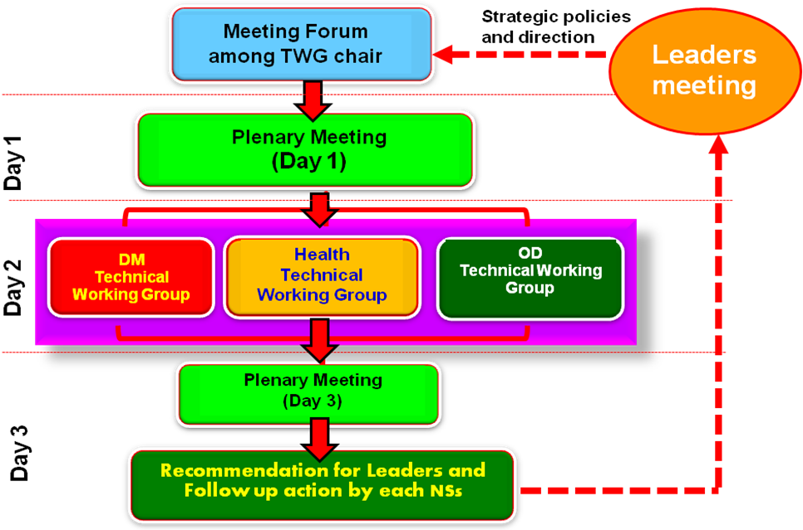

  - Frequency:
- Forum Committee (Forum among of TWG chairs) will be conducted a yearly. If possible, and required an additional meeting will be organized to follow up or prepare for the leadership meeting (subject to availability of funds).
- RFCSR and TWG meeting will only conducted annually (3 days) after leader meeting and Forum Committee..

  - Working language

The working language of the RDMC meeting will be English.

  - Budget and Funding
The funding for the cooperation related activities comes in principle from two sources: in part from the budgets of the Federation’s annual country/regional appeals, and in part from the budgets of the individual National Societies of the region. It is intended that the share coming from the National Societies will gradually increase over time.

- Secretariat

- South-East Asia Regional Delegation CSRU will act as the Secretariat for the annual RFCSR & TWG meeting as well as thematic meetings (if needed).
- The Secretariat, SEARD Community Safety and Resilience Unit, will provide necessary support in organizing the annual RFCSR & TWG meeting as per request of the RFCSR & TWG Chair and host National Society.
- The Secretariat will work as per the directions of the Chair of the RFCSR & TWG and host National Society.
- The Secretariat, on behalf of the Chair and the host National Society, will support and facilitate to follow-up on the decisions taken ahead of the next meeting.
- SEARD’s Head of Community Safety and Resilience Unit will be the focal point for the Secretariat in the SEARD.
- The SEARD will be responsible to cover the meeting’s related costs of the Secretariat.

- RFCSR main activity areas between the meetings

- Provide mechanism support to individual National Societies of the region in meeting their self-development needs in areas of Community Safety and resilience, as below :

- Risk assessment and identification and the establishment of community-based early warning and prediction
- Community-based disaster preparedness
- Advocacy, education and awareness-raising
- Strong auxiliary relationships with local and national governments
- Partnerships with international, governmental, non-governmental and community-based organizations

- Provide support to individual National Societies in disaster management.

- Assessment and mapping activities, on the basis of “characteristics of a well-prepared National Society”, for identification of development needs, as well as capacities available to meet these needs.
- Training related activities, such as sharing of syllabus, training materials and trainers, as well as provision/facilitation of training courses and management of training programmes.
- Provision of technical assistance in specific areas, such as Community Based Risk Reduction, etc.
- Support in development and/or quality improvement of overall Risk Reduction plans, policies and strategies.
- Promotion of study visits and staff exchange activities for exposure and knowledge sharing.
- Development of peer links between the Disaster Management units and staff of various National Societies.

- SEA regional disaster response and response preparedness capacity being strengthened (for the benefit of individual NS), and the understanding of and linkages to the Federation’s global response system being assured.

- Training and knowledge sharing, as well as application of, Federation policies, standards and operational procedures in disaster response, contingency planning, knowledge of the Federations appeal system, etc.
- Promotion of sub-regional/area cooperation and coordination measures in risk reduction including preparedness for response, early warning early action: for example within the context of the Mekong river basin.
- Provision of human, material and financial resources, from one NS to another, in times of disasters.
- Support in development of disaster contingency plans for each National Society.

- The RFCSR and TWG being maintained, sustained and further developed.

- RFCSR and TWG members will communicate via email and hold teleconferences at least once every quarter. Teleconferences will be focused on a specific topic of discussion, rather than an update of overall activities.
- Compilation and quarterly distribution of information updates/progress reports about the RFCSR and TWG, within the cooperation framework, to the SEA National Society leaderships, within the Secretariat structure, and among concerned Participating National Societies (PNS) and other stakeholders.
- Monitor the impact of the efforts of sub-groups contribution to RFCSR and TWG.
- Actively foster coordination, dynamic interaction and exchange among all members.

- Provide support to individual National Societies of the region in health related activities.

- Provide a platform to consolidate health network or groups so that their effectiveness improves, and existing individual stagnating networks receive a boost.
- Assessment and mapping activities, on the basis of “characteristics of a well-prepared National Society”, for identification of needs, as well as capacities available to meet these needs.
- Training related activities, such as sharing training materials and trainers, as well as provision/facilitation of training courses and management of training programmes.
- Support in development and/or quality improvement of long term planning framework (LTPF) as well as overall health-related plans, policies and strategies.
- Promotion of study visits and staff exchange activities for exposure and knowledge sharing.
- Development of peer links between the Health, Disaster Management and other relevant Departments of National Societies.

- Support to National Society governance: in legal base, statutory matters, branch development and partnership meetings.
- Organizational development: assistance to national society counterparts and stakeholders to assess, agree on needs and approach; and support to the implementation of development processes to improve the society’s relevance, performance and impact through sustainable services and programmes.
- Capacity Building: identifying with other core programme delegates/staff and PNS representatives the capacity building that is required; and develop plans to train such personnel to support these activities.

- Report and communication

  - RFCSR & TWG Chairs will submit short written reports on their work to the meeting and may be invited to give presentations on the outcomes.
  - Minutes of the meeting will be under the responsibility of the host National Society, with the support of the Secretariat of the meeting.
Relevant documentation will be made available in advance and posted on a specific SEA web page for easy access at least one month before the meeting. To access documentation for SEA Leaders Meeting 2013 please go to https://sites.google.com/site/seardbkk2013/

- Expected Result

  - Resilient Region – increased performance of National Societies in empowering community to be more safer and resilient to the impact of disaster, pandemic as well as climate change.
  - Region better prepared – increased response capacities of National Societies for any future disasters/shocks; enhanced cross-sectoral integration/integrated country level plans and resilience at community level.
  - Strengthened advocacy role - South-East Asia National Societies are able to influence policies and developments in the field of disaster management.
  - Effective regional networks - National Societies in the region gradually take the ownership of the RFCSR & TWG network increasing its effectiveness.
  - More responsive SEARD – National Societies can count on the advice, guidance from the IFRC SEARD Resilience Unit.
  - Increased mutual learning - National Societies benefit from mutual knowledge and experience sharing.

- Revision of the Term of Reference

A review of the Terms of Reference is suggested every year. Amendments to the Terms of Reference must be agreed by member National Societies.

