

***This certifiesthat***

**XXXXXXX**

*has completed the*

***Part A Training: Risk Knowledge and Monitoring***

***Within the framework of***

***C****ommunity-Driven* ***E****arly* ***W****arning* ***S****ystem* ***(CEWS)***

***Gambia, 19-24 November 2012***

***And thereby gained skills and knowledge in***

* *Disaster Risk knowledge (Terminologies and Principles of Disaster Risk)*
* *Foundamentals of Early Warning and its Components*
* *Understanding Data Management (Type of indicators and Statistical ones used in EWS)*
* *Designing Indicators Monitoring System (identification of EW indicators, use and collection of local data and maps)*
* *Tracking EWS indicators*

|  |  |
| --- | --- |
| **____________________________** | **_____________________________________** |
| Mr Momodou Lamine Fye  Regional Representative  Sahel Regional Representation  International Federation of  Red Cross and Red Crescent Societies (IFRC) | Mr Ebrima A.K. Sanneh  President  The Gambia Red Cross Society |

*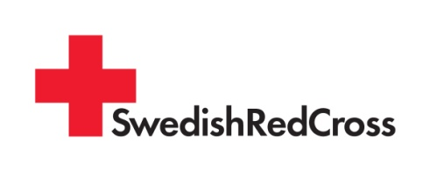with the support of*