11th Annual South-East Asia Red Cross Red Crescent Leadership Meeting 2014
Terms of reference: South-East Asia youth network (SEAYN)
TOR: SEA Youth Network / Singapore / 24-26 March 2014

Introduction/Rationale
Over the last couple of years youth networks have been mentioned in various high-level policy documents. Strategy 2020 stresses the importance of the Red Cross and Red Crescent Youth “acknowledging their skills as innovators, inter-cultural ambassadors and peer- to-peer facilitators”. Youth Policy (2011) also promotes national, regional, and international networks established by young people themselves as “an invaluable contribution to sharing knowledge and innovation across the Red Cross Red Crescent Movement”.
The Asia Pacific Youth Network (APYN) was reactivated in the Youth Meeting held in Solferino, Italy (2009) and formally recognised in the Asia Pacific Regional Conference in Amman, Jordan in 2010. The aim of the APYN defined by youth is to increase youth involvement at all levels in service delivery of National Societies (NSs) through its strategic functions of resource centre, advocacy platform, communication channel and think tank.

The South East Asia Youth Network(SEAYN) is developed as a sub-network linked to a zone-wide APYN . It has a special characteristic as a youth network by ensuring equal participation of NS staff and Youth leaders in it. The SEA National Societies participate and commit to the SEAYN by nominating their NS youth staffs and youth leaders (volunteers) to be members of the SEAYN.

The SEAYN establishes its Coordination Team in the Network and works with the Movement Youth Strategy and supports NS Youth Plans to allow for SEA National Societies to strengthen youth and to encourage youth initiatives through the SEAYN, while also gaining the ability to extend peer to peer support among the SEAYN.

Definition of the SEA Youth Network
The Network is consisted of 22 members: NS Youth staffs and Youth Leaders (volunteers) nominated from 11 National Societies: Brunei, Cambodia, Indonesia, Laos, Malaysia, Myanmar, Philippines, Singapore, and Thailand, Timor Leste and Vietnam.

Purpose of the SEA Youth Network
To enhance NS service delivery by mobilizing the resources of youth in the region and by developing the regional youth action in the aspirations for positive change.

Function of the SEA Youth Network
The Network contributes to SEA youth empowerment, engagement and development by representing the voices of volunteers, members and staffs regionally. It represents and advocates for the SEA Youth as a whole and reflects the opinions of Youth supporters in their activities. The Network is led by their Coordination Team and supported by IFRC Regional secretariat.

Main Key Functions of the Network are (OPD);

Opportunity: to explore opportunities to increase the capapcity of NS youth staffs and volunteers, peer to peer support through mobilizing the resources (financial, technical and human resources).

Project: to develop regional youth programme/project (calling projects) and implement them.

Platform: to provide platform for SEA Youth to share information, knowldege and best practices

Dissemination: to disseminate SEA Youth Network activities to NSs leadership and update zonal, global youth trends to SEA Youth communities.

Discussion: to identify the issues and concerns of youth network jointly and discuss for improving youth.

Structure of the SEA Youth Network
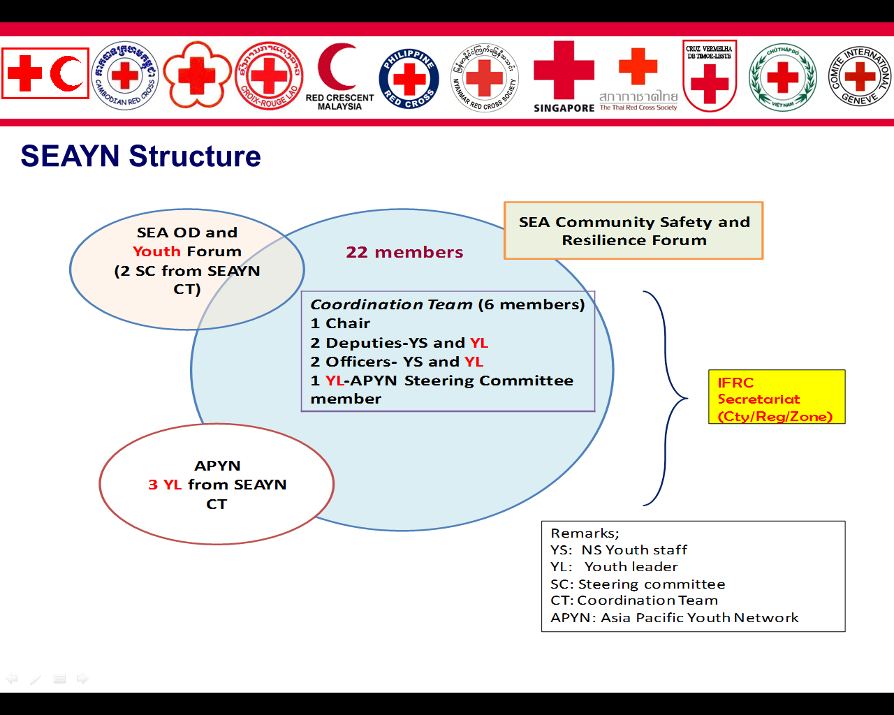

Coordination Team

Composition of Coordination Team
- The Coordination Team is composed of 6 Network members; 5 members from 3 NSs and 1 APYN Steering Committee(SC) member. Those include 1 Chair, 2 deputy chairs and 2 officers and 1 APYN SC member (who elected by Youth leaders and can be acting chair).
- Chair of the Coordination Team is the chair of SEAYN, who is from the NS hosting SEA Leaders meeting of the year
- Deputy Chairs are Youth staff and Youth leader from the NS, which will host the SEA Leaders Meeting in the following year.
- Officers are Youth staff and Youth leader from the NS which will host the SEA Leaders Meeting in the next following year (in 2 years)

Minimum Eligibility for canidates
- Red Cross Red Crescent experience is a vital characteristic for any candidates.
- Candidates must have a good command of English in understanding, speaking and writing.
- Candidates must be nominated and authorized by their respective NSs to engage and act in SEAYN.
- Youth Leader Candidates should be aged 30 or under at the time of first nomination in the SEAYN.

Link to other networks
- The Chair and one of Deputy Chairs will join the SEA Regional OD and Youth Steering Committee, representing the SEAYN.
- Two youth leaders in positions of Deputy and Officer will represent the SEA Youth in the APYN Coordination Committee(CC), together with one youth leader elected by youth leaders for APYN Steering Committee member.

Main function of the Coordination Team are (FAMO)
- Faciliation; To facilitate the network members to implement network activities with planning, monitoring, evaluation and reporting.
- Agenda: To provide SEA youth agenda at any meetings including bi-annual forums
- Memory: To provide a strong and sustainable institutional memory and mechanism for regional capacity, cooperation and partnership
- Organiser: To organise the various level of meetings and forums (face to face,webinar, skype, emails) and field trips when necessary

Pls refer this chart for Coordination Team

No | RC/Year | 2013 | 2014 | 2015 | 2016 | 2017 | 2018 | 2019 | 2020 | 2021 | 2022 | 2023
1 | Brunei | 1 Dep
2 | Cambodia | Chair/1Dep | Chair
3 | Indonesia | 2 Off | 2Dep | Chair
4 | Laos |  | 2 Off | 2Dep | chair
5 | Malaysia |  |  | 2 Off | 2Dep | Chair
6 | Myanmar |  |  |  | 2 Off | 2Dep | Chair
7 | Philippines |  |  |  |  | 2 Off | 2Dep | Chair
8 | Singapore |  |  |  |  |  | 2 Off | 2Dep | Chair
9 | Thailand |  |  |  |  |  |  | 2 Off | 2Dep | Chair
10 | Timor Leste |  |  |  |  |  |  |  | 2 Off | 2Dep | Chair
11 | Vietnam |  |  |  |  |  |  |  |  | 2 Off | 2Dep | Chair
 |  |  |  |  |  |  |  |  |  |  | 2 Off | 2Dep
 |  |  |  |  |  |  |  |  |  |  |  | 2 Off

Specific Roles and Responsibility of Coordination Team

Positions | Roles and responsibility
Chairperson and APYN SC member | - Lead the Network and the Coordination Team and be responsible for institutional filing and records of SEAYN for the next successor.  - Facilitate and assign projects to the team members  - Facilitate Coordination Team to;  - Finalize and circulate agenda in advance of any SEA Youth network events including the bi-annual SEA OD/Youth forum  - Keep the Network members updated on the key issues of the Network and facilitate the discussion as necessary (e.g. change of members)  - Develop and finalize the action plan (yearly basis) of the Network with the Network members and present the final plan with details to the Network members and stakeholders.  - Update the Network members and its stakeholders on the work of Network in annual meeting and bi-annual forum  - Work with IFRC Regional office on key issues, global agendas and capacity building activities to deliver the Network action plan.  - Manage the financial resources of the Network properly with the coordination of the IFRC regional office, and provide regular updates to the Network members
Deputy chairs and officers | Role and responsibility (on the assigned project);  - Take responsibility to implement assigned project(s) as specified in the Network Action plan.  - Develop a detailed plan (Gantt chart and budget if necessary) for its assigned project(s) and submit to the Chair  - Implement the assigned project(s) by mobilizing the Network members and by various methods.  - Provide regular updates of the progress of the assigned project(s)  - Provide a summary report on the progress of the assigned project(s) to the Chair.  General Role and Responsibility  - Assist and work with the Chair to organize the Network activities such as;  - Develop agendas in advance of any SEA Youth network events including the bi-annual SEA OD/Youth forum  - Invite and arrange facilitators, speakers in the SEA Network meetings and forums  - Collect and compile the updated statistic data and information related to youth from the Network members  - Take and share meeting minutes for any SEA Youth Network meetings and forums and be responsible for documentation  - Coordination and communication among the Coordination Team

Tenure of the Coordination Team
The tenure in each role is 1 year. The new Coordination team is nominated in the Network annual meeting. If any team member leaves the position, that specific NS nominates a successor following a certain selection process and makes sure that the successor will receive a handover and briefing session by the Team.

IFRC Regional Office
IFRC Regional office work as a secretariat to the SEAYN and Coordination Team;
- To support them to create enabling working environment for themselves
- To support them to arrange and hold their meetings in an efficient way
- To support them to build a partnership with other regional initiatives
- To support them to follow their ToR and keep updated.
Funding
The funding for the cooperation related activities primarily comes from three sources:
- Budgets of the Federation’s Regional /country plans
- Fund raising activities among the SEAYN and SEA Youth.
- Budgets of the individual national societies of the region
It is intended that the share coming from the national societies in the region will increase over time.

Review and Revisions of the ToR
Review and revision of the ToR will be based on the request of the majority of the network members. Revision request should be in consultation with the Coordination Team. This ToR is finalized by the NS Senior management, OD and Youth participants in the Southeast Asia regional OD and Youth forum in May, 2013 in Kuala Lumpur, Malaysia.

Structure: Youth leaders in the Coordination Team will represent the SEA Youth in the APYN.
Chart of coordination team; It indicates turn of NSs according to year, which should have roles in the coordination team. 2 Dep indicating Two deputy chairs, and 2 Off indicating Two officers. All are network members.
According to request of BRC, in 2013, the chair will be Cambodia Red Cross and the deputy chair will be Brunei Red Crescent.

