Regional Community Safety and Resilience Unit (CSRU)

Overview of activities for the month of May 2014

National Climate Change Master Trainer Workshop

SEARD extended its’ support upon the request of Finnish Red Cross Society to facilitate master training on Climate Change. The training was held in Kathmandu, Nepal from 1 – 5 May, 2014. This kind of cooperation aimed to promote cross regional cooperation as well as further strengthen working relation with partners at technical level. The training saw the participation of 25 participants from headquarter level and district chapters of NRCS. The training aimed to enable participants to provide technical support to plan and implement climate smart project activities at national, district and community level in addition to develop a core group of climate change trained personnel within the NRCS.

Research for Health in Humanitarian Crises (R2HC) Workshop

Health Officer attended Research for Health in Humanitarian Crises (R2HC) Workshop along with Health Advisor, SARD and Relationship Manager, AP Zone. The workshop was held in Bangkok, Thailand, on 15 May, 2014. The workshop gave details of the programme and the second call, and provided an opportunity to hear from successful applicants from the first call, and help connect the team with others in the region with an interest in humanitarian health research. The second call for Proposals is now open, with up to £4 million of research funding available for this call.

Building Regional Capacity and Collaboration for Community Resilience in Southeast Asia

A brief note was sent to the Leaders of the 11 National Societies throughout Southeast Asia about the “Building Regional Capacity and Collaboration for Community Resilience in Southeast Asia” initiative, in order to present potential activities that will be proposed to National Societies in the coming 3 years. In addition, CSR Unit is also following up with key national societies on two proposed activities for the coming months:
- A review of VCA data and recommendations in order to assist NS in identifying key advocacy messages for Disaster Risk Reduction and community resilience.

- A documentation of the Red Cross / Red Crescent contribution to the HFA and ASEAN Agreement on Disaster Management and Emergency Response (AADMER) since 2010.

These two activities would contribute to strengthen the visibility and recognition of NS work in the region as well as enhance their ability to advocate based on evidence from the field. CSR Unit also secured funding from the Global Disaster Preparedness Centre (GDPC) to support existing initiatives on knowledge management in the region. Due to the limited timing available (only 2 months), the funding will provide support to ongoing processes at both regional and country levels.

At regional level, technical expertise will design the architecture of a web-based system for the collection of key indicators of a National Society. A data management specialist will be hired to work with a group of decision-makers in the region (from IFRC and National Societies) to identify these NS key indicators and propose a strategy for data collection, storage and automated reporting, linked with ongoing processes such as the RMS development. Upon validation of such system, further funding would be sought beyond the end of this project to actually implement the system (either as a new module of RMS or as a stand-alone database) and deploy it in interested NSs.

A national level, the current deployment of RMS in the Viet Name Red Cross Society and the Myanmar Red Cross Society will be supported. In the region, Vietnam is the leading country in terms of RMS deployment and the support will include system customization, translation of modules, data verification and input, etc. As for Myanmar, the support will focus on mapping of DRR initiatives as a preparatory step to potential data upload into the RMS in the future. In parallel, some initial activities were held in May as follow:

24th ASEAN Committee for Disaster Management Open Session:

The SEARD Head of Delegation participated in the ASEAN Committee for Disaster Management (ACDM) Open Session with Partners of the 24th ACDM Meeting on 22 May 2014 in Bandar Seri Begawan, Brunei Darussalam. She was accompanied by the Thai Red Cross Director of Relief and Community Health Bureau as Chairman of the SEA/CSR Forum and the President of the Brunei Red Crescent Society. ICRC was also represented in the meeting. This was a good opportunity to promote the engagement of the RCRC Movement in support of the AADMER Work Plan.
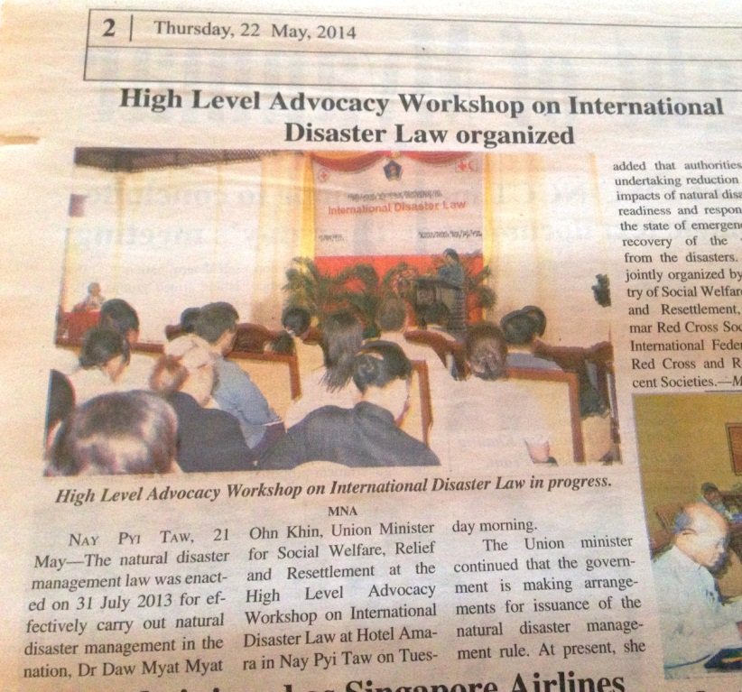
Advocacy workshop on Disaster Law:

From 20-22 May, Disaster Law training for Myanmar Red Cross Society was followed by a very successful high-level advocacy workshop with MRCS and the National Relief and Resettlement Department. Further discussions are now ongoing with MRCS to use the opportunity of the new DM Law in Myanmar (passed in July 2013) to jointly contribute to the policy development process in the coming months.

The Disaster Law unit is also preparing its side event as part of AMCDRR to be held at the end of June. During that event titled “Do laws make a difference?”, a global study of the role of the role of law in Disaster Risk Reduction will be launched, in collaboration with UNDP.

Gender inclusion in DRR:

The IFRC South-East Asia Regional Gender and Diversity Focal Person travelled to Myanmar during 18-23 May. He had discussions with the AP Zone IDRL Coordinator and the AP Zone Disaster Law Delegate on how to better address the vulnerabilities of women, children and marginalized groups during and after disaster through the scope of the Rules and Regulations of the new DM Law. These discussions proved to be valuable as all parties involved see the opportunity to strengthen the gender component of the this new law and they will continue to work together on this issue.

Thailand

Post emergency preparedness operation

TRCS learnt lesson from 2011 flood and is focusing to Improve its’ infrastructure as well as facilities like Warehouse, communication system and emergency operation room to make its’ operation further effective in future along with community preparedness initiatives. 95% of all renovation works have been completed to upgrade existing warehouse at TRCS/HQ. The renovation of warehouse at Relief Building of TRCS will improve storage facilities and quality. TRCS increased its’ PABX box size as part of telephone system improvement project at Relief and Community Health Bureau. This activity increased in analogue and digital number. Beneficiaries and others can call for help and get through easily especially during emergencies situation.

Tsunami Residual funding project

The activities under this project has been implementing as planned. First Aid components are getting better at volunteers and community level. Series of FA training were conducted to volunteers, youth. FA kits were provided to youth club and communities as well. TRCS is strengthening its’ partnership with local organizations at local level through the FA trainings.

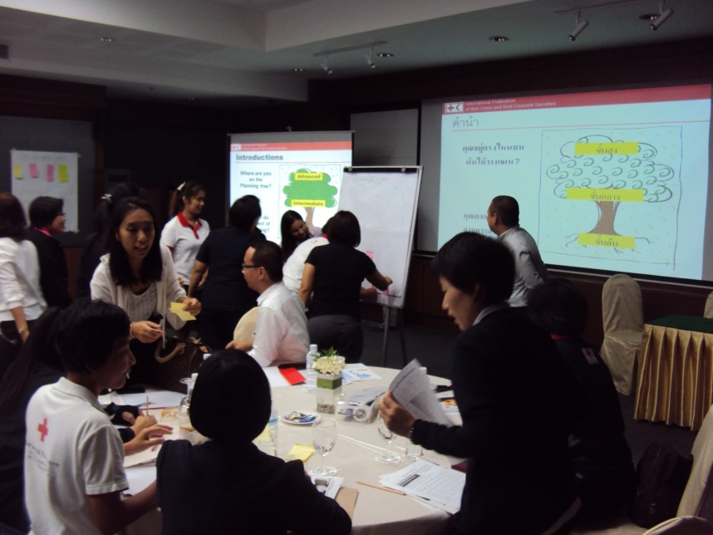
TRCS visited 10 different communities from Ranong and Phuket provinces in May which were affected by Tsunami in 2004. As of May, 25 out of 30 target communities have been visited by TRCS and provided the information regarding community level preparedness. All communities have disaster preparedness plan. Some communities are confident with their capacity to cope with disaster and sustain the community health care. They have been organizing simulation periodically to measure their preparedness. However some communities are still working hard to enhance their community preparedness and community health care activities. TRCS is planning to organize simulation exercise at those communities- who are struggling- in order to enhance their confident and ensure their engagement in community preparedness and community health care process.

PMER Training

SEARD/CSRU organized PMER training for program staff of Thai Red Cross from 21 – 23 May, 2014 in Bangkok, Thailand. The overall objective of the PMER training was to enhance the participants knowledge on programme planning, monitoring, evaluation and reporting with a special emphasis on the use of logical framework for programme design and management. The training saw the participation of Thai Red Cross 28 participants from both NHQ and branch level.

CBDRR program

Ubonratchathani health station conducted one day event named “Sharing knowledge of Study Visit” on 27 May 2014. The aim of this event was to share the knowledge and experiences that 16 participants from TRC obtained from Field study visit in Vietnam during March, 2014. The agenda was mainly focused on community level risk reduction. There were 53 people along with 7 teachers attended event from 5 CBDRR communities of Ubonratchathani province. Participants discussed the similarities and differences between the project components and implementation process as well as context of two different countries. This is worthy enough to mention here that community’s representative expressed the interests on school based risk reduction initiative. TRCS included schools of targeted communities into CBDRR program at Ubonratchathani province. They distributed IEC materials and engaged the students and teachers at different events at community level to raise awareness on risks and measures for preparedness.

Cambodia

Development of Violence prevention module

PSS delegate from SEARD visited Cambodia RC (May 5-9, 2014) to follow up on the development of a Violence Prevention module (based on the Violence Prevention module of the Canadian RC and IFRC CBHFA module). The module will be incorporated in the Health Club manual of the Community Based Health Development programme currently being implemented by Cambodia RC in two provinces. The module is now translated to Khmer and illustrations for the module have been completed. Training on the Violence Prevention module will take place in October, 2014.

Indonesia

Pilot Urban Risk Reduction project

PMI is making good progress with the implementation of the pilot initative. The initially planned activities have been completed so far. The project is progressing in paralel/alignment to similar nature project supported by AmCross which actually strengthens the components of the Urban Risk Reduction. A consultant hiring process is in progress in order to to identify evidence based advocacy material to advice government, other stakeholders and community in addressing the Urban Disaster Risk Reduction.

PMI and American Red Cross initiated collaboration with BBC Media Action (based in Jakarta) to translate the result of Vulnerability Assessment of Climate Change Impact along the Ciliwung River, produced by Bandung Technology Institute (ITB) into communication strategy. This pilot study project will consider the research methods, tools and questionnaire utilized on the BBC Media Action project-Climate Asia. The collaboration among PMI, AmCross, BBC Media Action and ITB has already been materialized. The research done by ITB has been utilized as a basis to develop key questions to community and local government for this pilot project study purpose. The key questions have already been drafted by BBC Media Action and shared amongst PMI, American Red Cross and ITB for feedback.

This Climate Asia Project was conducted on 2012 and applied quantitative and qualitative research study to identify public understanding of climate change in Asia. Climate Asia interviewed over 33,500 people across seven countries – Bangladesh, China, India, Indonesia, Nepal, Pakistan and Vietnam. The resulting comprehensive data set paints a vivid picture of how people live with climate change now.

Knowledge Information Management (KIM)

Online library (https://sites.google.com/site/drrtoolsinsoutheastasia/health-and-care/health-bulletins.) continues to be regularly updated to promote the knowledge sharing within and beyond the Movement. Number of uploaded documents related of DRR and Health is growing from day to day and it is only valuable if used by targeted audience. The fortnightly Health bulletin continues to be shared with respective colleagues of NS as well as AP Zone and country delegations in order to update knowledge and enhance communication. The site has been integrated into IFRC standard web-link as well.
Singapore RC (SRC) director of the SRC Training Academy visited the SEARD from 29-30 May, 2014. The aim of the visit was to discuss the possibilities of developing a psychosocial support training curriculum and training programme for the SRC Training Academy. The meetings were very constructive and fruitful and the CSRU – in collaboration with the IFRC Reference Centre for Psychosocial Support - is keen to support the process of curriculum development. SRC will develop a plan of action depicting the way forward. During the visit, the SRC director also had the opportunity to visit the Thai Red Cross headquarters upon the kind invitation of Director of the Thai RC Relief and Community Health Bureau.
Member of SEARD/CSRU attended ToT training on Disability organized by Australian Red Cross from 26-30 May, 2014 in Phnom Penh, Cambodia. The training saw around 20 people of the RCRC movement from the Asia Pacific region. The training aimed to create the pool of trainer on disability across the Asia pacific region.
Upcoming Events for June 2014

Date | Events | Venue
9-13 June, 2014 | NDRT Training | Thailand
12-13 June, 2014 | Training for Red Cross Volunteers on disaster preparedness | Thailand
13-17 June, 2014 | ASEAN Dengue day | Philippines
22-26 June, 2014 | 6th Asian Ministerial Conference on DRR | Bangkok
23-27 June, 2014 | Epidemic Control for Volunteer – Master Trainer workshop | Indonesia
TBC | IMEX Table top discussion | Phuket

For Further information please contact our CSRU team:

Indira KULENOVIC, Head/Coordinator- Email: indira.kulenovic@ifrc.org
Sanjeev Kafley, DRR Advisor- Email: sanjeev.kafley@ifrc.org
Hervé Gazeau, DRR Manager - E-mail: herve.gazeau@ifrc.org
Rommanee Klaeotanong, DRR Officer- Email: rommanee.klaeotanong@ifrc.org
Abhishek Rimal, Sn. Health Officer- Email: abhishek.rimal@ifrc.org
Zara Sejberg, PSS Delegate- Email: zara.sejberg@ifrc.org
Juthamanee Khotchasarnmanee (Fiat), Sn.Program Assistant, Tsunami Program Email:juthamanee.khotchasarnmanee@ifrc.org
Nutchapang Khowinij (Tum), CSRU Assistant- Email: nutchapang.khowinij@ifrc.org

