  - Regional Community Safety and Resilience Unit
  - Overview of activities for the month of May 2013

Thailand Red Cross Society- Review of CBDRR Initiative

Two members team from Canadian Red Cross visited at two communities of Ubonratchathani Province. One meeting was carried out with Thai Red Cross to review the projects and future plan. A long discussion took place within CSRU and Canadian Red Cross Team to review the overall progress of the project. After all discussion, Canadian Red Cross is positive to extend the project by six months. The Thai Red Cross team along with SEARD is working to review Performance monitoring framework (PMF), Log frame and plan of actions of the same project. The revised documents will be sent to Canadian Red Cross within June to formalize the legal process for extension of the project by six months.

Third ARF Disaster Relief Exercise (DiREx) 2013

The ASEAN Regional Forum members (26 countries), including ten ASEAN Member States, gathered for the third ARF Disaster Relief Exercise (DiREx) in Cha-am, Phetchaburi, Thailand from 7 to 10 May 2013. Using several scenarios: 8.9-magnitude earthquake, tsunami, chemical leak and rockslide the disaster management agencies and emergency responders from civil and military institutions of ARF members exercised their coordination and disaster relief mechanisms. Key actors in disaster relief operation in the Asia and Pacific region, including the ASEAN Coordinating Centre for Humanitarian Assistance on disaster management (AHA Centre), the United Nations Office for the Coordination of Humanitarian Affairs (UNOCHA) and the Red Cross and Red Crescent Movement, also actively participate in this event. The Thai Red Cross was involved as one of the major stakeholders with the support of IFRC/SEARD.
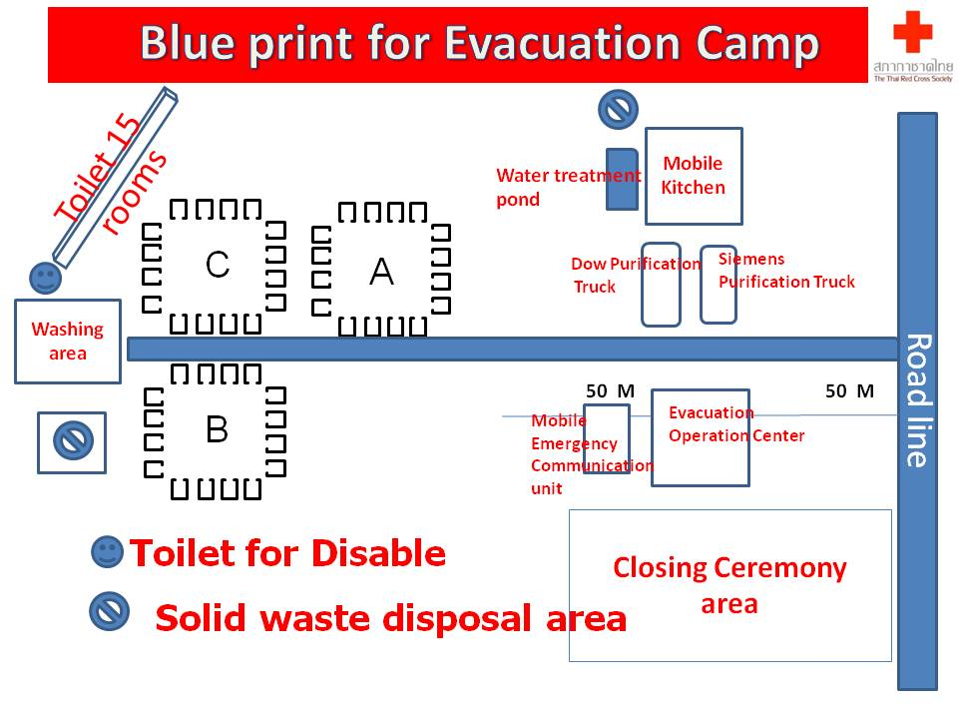
The Thai Red Cross involvement started with the planning stage and finalised with the implementation of the DiREx 2013 in close collaboration with several Thai governmental ministries and the army. During the DiREx exercise the Thai Red Cross run the entire Evacuation Camp (200 pax) with all supporting structures (mobile field kitchen, water purification trucks, mobile communication units, ambulance service, RFL, relief distribution, sanitation etc). This camp was also the only civilian structure during the exercise involving combined efforts of the TRC staff and volunteers from the NHQ and Provincial Chapter/Health Station demonstrating great capacities of the TRC to provide vital support to the most vulnerable and coordinate well with all key stakeholders in times of major disasters.
SEARD Community Safety and Resilience Unit, Korean Red Cross, Philippines Red Cross (seconded to AHA Centre as ERAT member), PMI staff member (seconded to Indonesian Government as Medical Doctor) as well as ICRC RFL staff joined the exercise. AP Zone IDL coordinator deliver lecture and moderated several table top-exercises.
National DRR, CCA and EWEA workshop in Thailand

SEARD has conducted a three days’ workshop on DRR, CCA and EWEA for staff members of Thai Red Cross Society and Lao Red Cross Society from 26-19 May, 2013 in Nakorn Sri Thammarat, Thailand . Total 41(35 women, 3 from Lao Red Cross and 1 from Meteorology department of Thailand) were attended the said workshop. The workshop has been designed with following below scopes:

- To further enhance the knowledge of the participants on climate related hazards and overall consequences as well measures to reduce the impact.
- To strengthen the participants existing capacity on DRR and EWEA in relation to changing risk patterns induce by climate change and variability.

The end of workshop, participants expressed their understanding on how to make DRR, Health and livelihood initiatives with “climate smart” aspects. Some participants still have a language barrier, as the document of the workshop didn’t translate in Thai. However by the end of the workshop, most participants were happy to have such a great opportunity to learn about the CCA, DRR and EWEA and understand how to apply in the community level.
Revision of LTPF and Logframe-2014

A product of revised LTPF and logframe-2014 has been finalized from CSRU after following the long process within CSRU Team and handed over to PMER focal person of the delegation. The Log-frame has been outlined the planned activities for 2014.
Regional DRR, CCA and EWEA workshop-Report

SEARD/CSRU and Thai Red Cross jointly conducted three and half day workshop in Bangkok from 26-29 March from the support of RCRC Climate Centre. Total 27 participants of ten National Societies (Except Singapore Red Cross) of the region were part of this workshop. A process report of the workshop has been finalized and shared to all concerned.
Coordination and Knowledge Sharing

Health bulletin continues to be shared with respective colleagues of NS as well as AP zone and country delegation in order to update knowledge and enhance communication. The bulletin includes- latest health related events in the region and around the globe, funding opportunities, on-going activities of CSRU and upcoming events in the region. You can find previous health bulletin on https://sites.google.com/site/drrtoolsinsoutheastasia/health-and-care/health-bulletins.

This above site is regularly being updated with DRR, health and other reference documents by SEARD/CSRU Team.

The PSS delegate met with the Director of Arts Therapy Services for the Ragamuffin Centre in Phnom Penh (May17). The centre provides courses and designs and delivers context specific training programmes (in particular in relation to PSS and Child Protection). The centre also provides Clinical Supervision and Therapeutic Retreats. The aim of the meeting was knowledge sharing; and to look at ways to collaborate should CRC wish to pursue more specialised trainings in the future.

A meeting was organized with DG-ECHO between team members of CSRU and DG-ECHO. Meeting mainly focused on different aspects of the on-going project and feedback of DG-ECHO. In addition, ECHO is working on drafting the HIP (2014- 2015), it is likely that Red Cross remains a key partner and important player in its implementation of the upcoming HIP.

CSRU has started internal consultations for the next round of proposals. A meeting has been planned for the first week of August (tbc – subject to availability of ECHO reps) with RCRC partners and ECHO representatives to speed up the consultation process for the next round of DIPECHO. Nonetheless, the final date will be shared in near future with concerned.

Psychosocial support service

- Agenda for the Basic Community Based Psychosocial Support (CBPSS) ToT has been developed and the final editing work on the Khmer and English IFRC CBPSS abbreviated manual completed. A date has now been set for the training which will be conducted by the PSS delegate for the Cambodian RC staff of the Community Based Health Development Programme (headquarter team and Preah Vihear and Kampot Branch teams) and government health staff on June 19-21.
- Concept notes have been developed on Youth as Agents of Behavioural Change targeting corporate donors in Cambodia and on building PSS capacity of SEA NSs to provide PSS in emergencies integrated community development programming.
- A brief PSS scoping exercise for project partnership with Lao RC and Danish RC/IFRC was carried out in May. The Lao Red Cross (LRC) Health Department has expressed interest in developing its PSS capacity both to IFRC during the Regional Health meeting and more recently to the DRC Regional Representative during a visit to LRC in March, 2013. DRC is keen to support LRC to build its PSS capacity - potentially through integrated programming - tentatively starting in 2014. The aim of the scoping exercise was to understand the PSS priorities and ambitions of the LRC Health Department and to explore the possibility of developing a partnership on PSS with DRC/IFRC. During the visit the LRC presented a PSS proposal to DRC and the two partners are now working on finalizing a proposal. Technical support will be provided to the proposal once it is developed by LRC.

17th RDMC Preparations

17 RDMC has been scheduled in Yangon from 11-13 June, 2013. All preparations regarding RDMC meeting are underway. RDMC meeting will be attended by senior DM Managers of The national societies from Southeast Asia region. For the first time, Health managers from SEA NSs will attend this meeting to find the common areas between health and DM to promote the concept of integration in order to maximize the resources to reach most vulnerable/high risks/severely affected people at the community. AP Zone health and DM colleagues will be part of the meeting along with SEARD/CSRU team. Representatives of AHA centre and DG-ECHO have been invited to participate in the meeting to share their respective presentation that would provide wider information to the members and enhance opportunities to build the better partnerships in the future. The agenda of the meeting is enclosed here with.

Asia Pacific Zone Health – WatSan Technical Coordination Meeting

Asia Pacific Zone Health – WatSan Technical Coordination Meeting was held from 14 to 16 May, 2013. Both Health and WatSan had two separate days for technical discussions and one joint day for integration issues and topics of common interest like – Resilience, assessment tools, etc. In health section of the workshop 5 IFRC staff from SEA participated, which includes – 4 Country offices and 1 SEARD. The objectives of the event were:
- To enable Federation country, regional and zonal colleagues in each Health and WatSan to update themselves on technical issues, approaches, plans and lessons learned in their respective sectors.
- To have a one day joint meeting with health and WatSan to look at integrated work among sectors, resilience as a concept and cover areas and plans of joint interest.

Recommendations
- Coordinate timelines in preparation of DOP 2014 (according to LTPF) and ensure drafts are shared/discussed with counterparts.
- Sharing of experience from Southeast Asia in operationalization of resilience approach across AP Zone
- Actively participate in on-going review of IFRC community resilience framework, naming ‘integrated programmes’
- Resource mobilization for implementation of NCDs, MNCH (first 1000 days of life), emergency health, etc – target corporate sectors and National Societies in Middle East.
- Actively participate in PMER toolkit revision process
- Explore ways to incorporate nutrition into NCDs, MNCH, livelihoods, food security and relevant programmes
- Document and disseminate best practices in form of case studies or multimedia
- Contribute in presenting RCRC movement work on HIV/AIDS in upcoming ICAAP in Bangkok.
- Mainstream health emergency preparedness and response, building on ECV toolkit roll out, into CBH and DP programmes

SEA HoD and PNS meeting

CSRU attended Southeast Asia HoD and PNS meeting in Bangkok, Thailand from 16-17 May, 2013. HoD meeting was scheduled on 16th May and PNS meeting on 17th May, 2013. CSRU team presented different sessions e.g. A Road to Resilience in SEA, psychosocial support programme in SEA and Non-communicable diseases- need to invest.

World Blood Donors Day – WBDD

Lao Red Cross (LRC) will celebrate WBDD in 14 June with the support of Southeast Asia Regional Delegation. The project agreement has been signed between LRC and SEARD.

The project objectives are:
- Celebrate and thank VNRBD donors for their gift of blood
- Encourage more people to become regular blood donors
- Raise public awareness on importance of VNRBD
- Increase number of VNRBDs
- Provide a focus for wider measures to improve blood safety and availability

It has also been agreed that LRC Blood transfusion Centre with technical support from SEARD will develop a case study on LRC blood programme.

A workshop on Building Urban Resilience

SEARD is working with Global Disaster Preparedness Centre (GDPC) and DMU/AP Zone to organize a three day workshop on Building Urban Resilience. The tentative date for the workshop is 30 July-1 August. Bangkok will be the venue for the workshop. It is expected that participants will come from the NSs of Southeast Asia and South Asia. Representatives from the government involved in urban planning/disaster management will also be invited to participate.

Workshop will set the scene for discussions, jointly creating a visual overview of the trends impacting communities in urban and semi-urban settings, the impacts and key strategic responses globally and across the Asia and Pacific region. A number of participants are invited to share examples – ‘short stories’ - from their own experience, concluding with a critical question for further exploration. The discussion starts in plenary and continues in small groups.

Upcoming Events for June 2013

Date | Events | Venue
11-13 | Regional Disaster Management Committee meeting | Myanmar
17-21 | Annual review of CBHFA+DRR program and NCD pilot meeting - Wonogiri | Indonesia
14 | World Blood Donors Day | NSs of the region
19-21 | ToT on Basic CBPSS in Cambodia for CBHD staff | Cambodia
25-27 | Presentation on Mental Health and Psychosocial Support at the Asia Pacific Emergency Health training | Hong Kong

