  - REGIONAL COMMUNITY SAFETY AND RESILIENCE UNIT (CSRU)

  - Updates for APRIL 2013

Final Planning Conference for the ASEAN Regional Forum Disaster Relief Exercise 2013 (ARF DiREx 2013), April 1-3, Cha-am, Thailand

The two previous ARF Disaster Relief Exercises held in 2009 and 2011 respectively have been widely recognized as landmark events in improving the capacity of region's disaster response mechanism in a multinational operation context.

During the 18th ARF, held in Bali in July 2011, the Ministers welcomed the recommendations of ARF DiREx 2011 to conduct joint field exercises on a regular basis. The Republic of Korea and Thailand offered to co-host the ARF DiREx in 2013, in Thailand, in a way to make substantive and tangible contributions toward disaster relief responses of the region, building upon the achievements made and the lessons learned during the two previous disaster relief exercises.

The main objectives and goals of the exercise are:
- to advance and build capacity of ARF members in the Civil-Military coordination in response to disasters reflecting on progress made during the last two exercises.
- to test the existing standard operating procedures/protocols/tools of ASEAN, regional, international and the affected (host) nation pertaining to multinational disaster relief operations;
- to advance the ARF participants’ ability to rapidly provide coordinated and effective disaster reliefs;
- to advance the affected (host) nation's ability to respond to humanitarian aassistance requirements caused by natural disasters.

Key Activities:
ARF DiREx addresses civil military coordination through a tactically (on-site) oriented Field Training Exercise (FTX) and operationally/strategically (national government/regional organizations) oriented seminar focused Table Top Exercise (TTX).
The overarching scenario for ARF DiREx 2013 is focusing on: an earthquake, rockslides, a tsunami and a man-made chemical disaster.

The Field Training Exercise will focus on two objectives: (1) Demonstrate Search and Rescue capability that integrates with medical, engineer exercise, chemical response requirements and (2) Incident Command System through the Multi-National Coordination Centre.

The Table Top Exercise will focus on those National and Regional coordination mechanisms that will address reception and integration of assisting nations’ capabilities, theatre transportation requirements, national’ limitations/requirements. The exercise itself will take place in Cha-am/Hua-Hin (Thailand) and areas in vicinity from 7 to 11 May 2013.

Participants are ccoming from 27 countries from among ARF Participants both from ASEAN and non-ASEAN countries, including European Union and UN-OCHA, IFRC.
During the ARF DiREx 2013 Initial Planning Conference (IPC), 14-16 January 2013, Bangkok where more than 215 participants from 27 countries from the region and beyond took part including the IFRC and the Thai Red Cross discussions were held in relation to preparation of the exercise, scenarios and venue as well a Site-Survey. In addition the participants:

- Reviewed the draft action plan based upon participants' comments
- Confirm the action plan that reflects civil and military assets mobilization plan of participants
- Assigned participants into each sub-exercise group and designate a facilitator (leading country) of each group

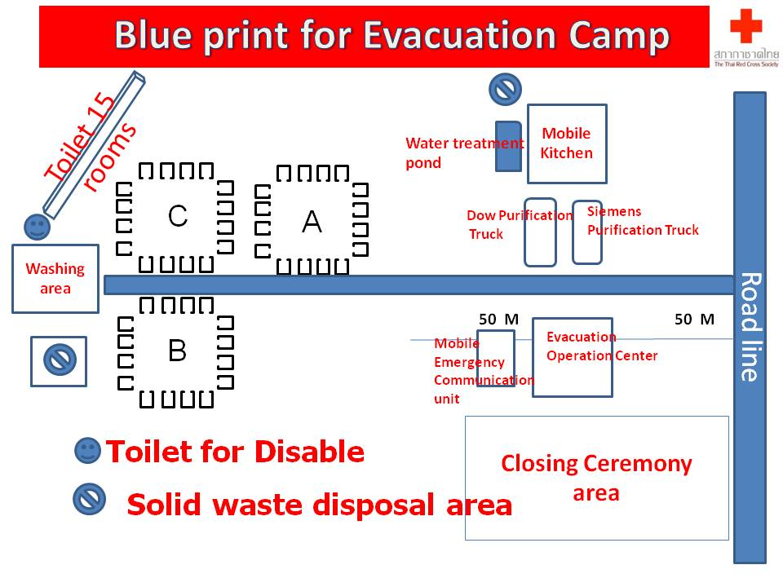
With support of the IFRC SEARD the Thai Red Cross has been fully involved in planning of the DiREx 2013 with several governmental ministries as well as the army – including DiREx site visit, meetings with MoFA, MoH. During the DiREx exercise the Thai Red Cross would run the entire Evacuation Camp (200 pax) with all supporting structures (mobile field kitchen, water purification trucks, mobile communication units, ambulance service, RFL, relief distribution, sanitation etc) during the DiREx exercise. This would also be the only civilian structure and would involve combined efforts of TRC staff and volunteers from the NHQ and Provincial Chapter/Health Station.

SEARD Community Safety and Resilience Unit team members, Korean Red Cross deputy head of international department as well as two ICRC RFL staff will join the Thai Red Cross during the DiREx field exercise. AP Zone IDL coordinator will deliver lecture during the table top-exercise.
For more info please visit: www.arfdirex2013

Thematic Seminar on Integration – Laos (DIPECHO)

From 25- 26 April 2013, the fourth Thematic Seminar on Integration was organized by Lao Red Cross in Vang Vieng district, Vientiane province of Lao PDR. The seminar was organized in conjunction with the field visit of DPR Korean Red Cross and Mongolian Red Cross as part of exchange visit from East Asia to South East Asia for cross learning. The seminar was attended by the Lao Red Cross (LRC) president together with more than ten technical staff from the NHQ and the hosting branch of Vientiane province and four staff from DPR Korean and Mongolian Red Cross.

The seminar was inaugurated by the LRC’s president and in his opening remarks and reflections he emphasized that such seminar is an important opportunity for both, the LRC staff and its branches and communities as LRC continues to vision itself to continue moving on the Resilience Road in which LRC need to find out its common direction toward vulnerable communities with all support from technical divisions and stakeholders taking into consideration community needs as the central point for intervention. In the mean time, to reach further and better LRC also needs to have more committed volunteers in the community as they are the first responders when incident occurs.

The seminar discussions were enriched by mutual learning and sharing from two national societies of DPR Korea and Mongolia and vice versa. All participants got a chance to review their existing programme’s approach where they can identify strengths and weaknesses and how to convert weaknesses into strengths; what resilience means to them in programming by identification of what are characteristics of a resilient community in Lao context and suggest appropriate activities to achieve it from LRC’s mandates and resources.
In conclusion of the Thematic Seminar the Lao Red Cross came up with five points “Way Forward” as follow:

- Review two processes of working groups and consolidate it into one comprehensive summary.
- Fine-tune Characteristics of a resilient community and suggest appropriate activities considering Lao context
- Selection of a existing community for piloting initiative
- Develop a detailed Plan of Action for that community taking into consideration of existing collected information or Plan of Action then try to fill the gap in an integrated manner where DM, OD and Health can work together to support that community. Pls refer to characteristics of a resilient community to develop the plan of action.
- Translations of files ensuring all files are bi-lingual in both Lao and English.

Development of Community Safety and Resilience Comic Brochures (DIPECHO)
Community Safety and Resilience Comic Brochures on various hazards of Typhoon, Flood, Drought, Tsunami, Earthquake and Hygiene Promotion is still under development with several consultations between the producer and the Community Safety and Resilience Unit on subject matter. It is expected to finalize them all in June this year before local printing in several regional languages.

Fortnightly Health Bulletin

Health bulletin continues to be shared with respective colleagues of NS as well as AP zone and country delegation in order to update knowledge and enhance communication. The bulletin includes- latest health related events in the region and around the globe, funding opportunities, on-going activities of CSRU and upcoming events in the region.

Global Pilot Healthy Life Style Master Facilitator workshop

Community safety and resilience Unit Health Officer attended the Global Pilot Healthy Life Style Master Facilitator workshop in Kuala Lumpur, Malaysia from 8 – 11 April, 2013. In the workshop 24 people participated, including participants from 14 National Societies and 10 IFRC staff (3 participants from Southeast Asia – 1 PMI, 1 CRC and 1 – SEARD).
The workshop objectives included:

- Master Facilitator Training on the IFRC Healthy Life Style module.
- Providing feedback on the module.
- Planning for 2013-2014 dissemination and implementation.

Reflecting on the learning from this workshop the way forward for the Southeast Asia is to:

- Piloting Healthy lifestyle module in one or two National societies in Southeast Asia (Wonogiri – PMI, is confirmed so far; resources need to be identified for Cambodia or either Myanmar or Philippines – to be decided after consultations with the NSs)
- Develop a concept note on roll out of Prevention of Noncommunicable Disease in Southeast Asia to be shared with the Global team

Psychosocial Support (PSS)

In Cambodia, the Community Based Psychosocial Support (CBPSS) IFRC manual (short version) is currently being translated to Khmer and should be completed by mid-May. In early February, the PSS delegate had a meeting with the Secretary General of the CRC who recommended that a simple and reader friendly version of the manual would be more useful for CRC staff and volunteers. The PSS delegate therefore made a summarized version of the CBPSS manual* and it is now being translated to Khmer along with a number of IEC PSS leaflets which cover subjects such as stress, coping with stress and psychological first aid. These leaflets are available in a number of different languages and can be downloaded at http://psp.drk.dk/sw47022.asp
The Khmer versions of the above will be ready in July, 2013 and will be made available on the IFRC South-East Asia website as well as on the IFRC PSS centre website.

The CBPSS manual consists of 7 modules: 1) Crisis events and psychosocial support; 2) Stress and Coping; 3) Loss and Grief; 4) Community Based Psychosocial Support; 5) Psychological First Aid and Supportive Communication; 6) Children; 7) Supporting volunteers and staff. It can be downloaded at http://psp.drk.dk/sw40688.asp

Psychosocial delegate continued to work on the Community Based Health Development (CBHD) training plan and psychosocial modules for the CBHD. In addition, Psychosocial delegate developed stress management module and conducted a session on stress management for newly arrived Australian Red Cross volunteers who will be working in Cambodia for one year.

French Red Cross and PSS delegate discussed possible ways of collaboration and support to the CBHD as the Cambodian Red Cross (CRC) Phnom Penh Branch, who has extensive experience on PSS work with children affected by HIV as well as some psychosocial experience in emergencies that may benefit other CRC branches.

Psychosocial Delegate has been invited to facilitate Mental Health and Psycho-Social Support (MHPSS) session of the Asia Pacific Emergency Health training in Hong Kong (June 25-27, 2013). The session will focus on the IFRC approach to PSS in general and then elaborate on PSS interventions and tools in emergencies, but also MHPSS challenges in emergencies; information to be gathered during emergency assessment and operational challenges in addressing MHPSS issues in emergencies.

The Australian Red Cross Country Manager of the “Australian Volunteers for International development” programme requested that the PSS delegate conduct a session on stress management for newly arrived Australian Red Cross volunteers who will be working in Cambodia for one year in a number of different NGOs. The volunteers are all from Australia and the aim of the session was to raise awareness on stress and how to cope with stress as well as discuss potential stressors that a volunteer may face as a new arrival in Cambodia. Thirteen volunteers attended the session which covered different types of stress; stress factors related to settling down and working in Cambodia; and how to cope with stress. The Australian Red Cross has a requested a follow up meeting with the volunteers in June 2013. The session was conducted in an informal setting without the use of a power point presentation. However, a power point presentation, developed by the PSS delegate, is available should the delegation be interested in uploading it.

The HoD of IFRC in Cambodia and the PSS delegate have discussed the development of a concept note on Youth and Psychosocial Support in relation to possible funding opportunities with corporate donors.

In addition to support provided to the Cambdodian Red Cross, a ToR is being finalized for the Psychosocial Delegates’ support to the Thai RC that will be delivered during the month of July-September 2013.

Meeting of the ISDR Asia Partnership (IAP), April 2013, Bangkok, Thailand

The first ISDR Asia Partnership (IAP) meeting for the year 2013 was held from 17th to 19th April 2013 in Bangkok. This IAP was organized in collaboration with Department of Disaster Prevention and Mitigation (DDPM), Government of Thailand.

Updates were provided, including Red Cross, on Post HFA discussions; HFA review process for 2011-13; Global Platform 2013; and few other key initiatives. It was interesting to note that the Red Cross (IFRC/PNSs) invested over 60 million dollars in the year 2012 in the DRR activities in the Asia Pacific region as implemented by the host national societies.

However, going back to the meeting the main objectives were:

- To follow up on the 5th AMCDRR outcome and stakeholder engagement
- Introduction to the 6th AMCDRR preparation and consult IAP members to finalize the theme, sub-themes, structure and mechanics of the conference
- To enhance understanding and engagement in the Post HFA processes
- Share updates and experiences on key efforts in the region

Participants were mainly from the IAP members including representatives of national governments, sub-regional inter governmental organizations, International Financial Institutions (IFIs), bilateral donors, UN & Intl. organizations, civil society organizations and media. The Red Cross participation at this meeting included the Chair of the RDMC as SEA HNSs representative and SEARD CSRU and AP Zone DMU representatives.

Next IAP meeting will take place in September 2013, again in Bangkok, to further work on preparations for the 6th AMCDRR, hosted in Thailand.

AP Zone Resilience Meeting, Kuala Lumpur, Malaysia

A Resilience meeting was organized by the AP Zone in Kuala Lumpur from 22-24 April. This meeting brought together the Resilience Coordinators/Unit Heads of the four regional resilience focussed teams, together with relevant country level practitioners for an in-depth discussion on resilience programming as it has been implemented in APZ. Key heads of APZ Units and Zone management facilitated the meeting looking at coordinated approaches to learning and support needed in times to come. Community Safety and resilience Unit coordinator joined in the meeting.

The key purpose of the Resilience meeting was to:

- pull together the learning that has emerged from the different approaches across the Zone to date - focused on community level outcomes and perceived impact;
- identify what has changed since taking up the resilience approach and explore this though the lessons learned case studies of local level impact to be presented during the discussions
- agree actions to strengthen coordination of our resilience efforts;
- determine how we can track progress collectively, against clear baselines, of integrated approaches and their impact on community resilience;
- determine how the zone office can better support resilience units;
- agree on what guidance/tools are needed in the planning, implementing and reporting of community based resilience projects and determine how these are best obtained/developed.

Full report is being prepared by the AP Zone and will be available in early May for further sharing.

17th Regional Disaster Management Committee (RDMC) Meeting

The Myanmar Red Cross Society has kindly agreed to host the 17th RDMC meeting scheduled to take place in Yangon from 11-13 June 2013.

For the first time ever, Health managers, heads of departments from the southeast Asian national societies will join their colleagues from the disaster management departments and sit together to discuss about ways of working more closer, in better coordination and explore opportunities for integrated cross-sectroal programming at NS’s level, ensuring all needs of communities are address through a holistic approach applied by the National Society thus increasing the levels of resilience among communities.

Planning for the 17th RDMC meeting is underway including proposed date for the Sub-Group meeting being scheduled for 14th May, hosted by the Thai Red Cross relief and Community Health Bureau. Confirmation about availability of the key participants is underway. Other options are also being discussed with the RDMC chair and Sub-Group chairs.

Documents developed by the CSR Unit during the reporting period:

Reports | Proposals/Concept Notes | Other
- Report on SEA Resilience Meeting  - Report on the Regional workshop on CCA/DRR/EWEA  - Annual report to Swedish Red Cross | - SEA Regional Malaria Proposal  - SEA Regional HIV Proposal  - Concept note for JICA for Mekong River Basin Initiative  - Mekong River Basin Proposal (final draft) | - Planning (Agenda /itinerary) including logistics and administrative issues related to the Canadian Red Cross 5-day field monitoring (29 Apr – 3rd May)  - Budget for the DiREx exercise for the Thai RC  - Revised Plan of Action for HKRC School Based DRR initiative  - Tentative Agenda for the RDMC Sub-Group Meeting

Upcoming Events for the month of May 2013

Date | Events | Venue | Involved
7-11 | ASEAN Regional Forum (ARF) Disaster Relief Exercise (DiREx) | Thailand | Indira, Sanjeev, Hung Ha, Thai RC, Korean RC, ICRC
14 (TBC) | RDMC Sub-Group Meeting | Bangkok | CSRU, RDMC Chair and Sub-Groups chairs + PRC/CRC health reps
14-16 | AP Zone Health and WatSan coordination meeting | Kuala Lumpur | Abhishek
15-17 | SEA HoD and PNS Meetings | Bangkok | Indira, Sanjeev, Abhishek (on 17th)
19-23 | Global Platform on DRR | Geneva | Dr. Barlee (TRC), Pak Arifin (PMI), U Maung Maung Khin (MRCS)
27-30 | Workshop on Disaster Risk Reduction, Climate Change and Early Warning Early Action for Thai RC | Thailand | Sanjeev, Rommanee, Ei Ei
27-28 | ASEAN ACDM Open Session | Hanoi, Vietnam | Anne/Dr. Barlee

