***TITLE OF SUCCESS STORY:* Resilience and Solidarity in Thailand's 2011 Floods – A Success Story shared by Thai Red Cross**

***Agencies names, address and focal contact person:* Kate Roux, IFRC Southeast Asia Regional Delegation, Bangkok, katherine.roux@ifrc.org**

*QUOTE FROM LOCAL COMMUNITY MEMBER INVOLVED IN THE PROJECT*

*IMAGES OF THE STORY: Please share as attachment separately high resolution  
(above 1 MB) images to support the success story.*

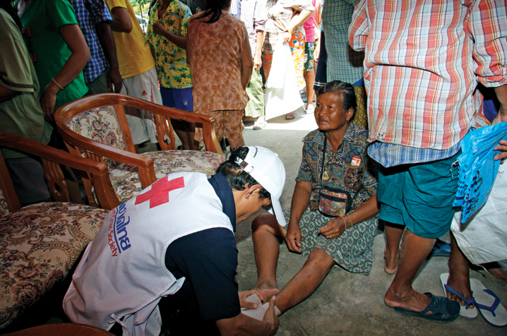 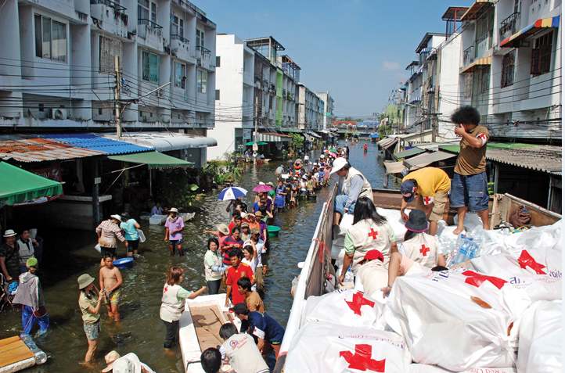

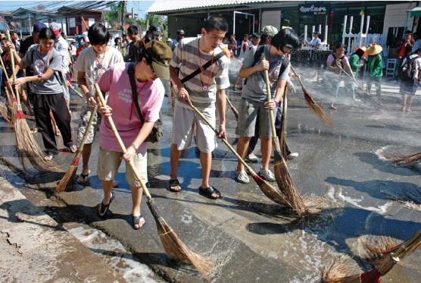 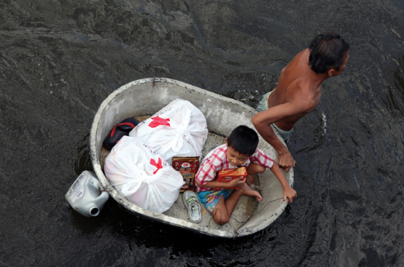

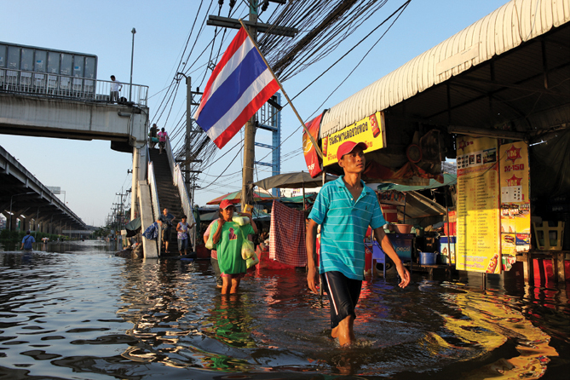

All photos ©Thai Red Cross

**THE PROBLEM:** Thailand's 2011 floods affected 65 of the country's 77 provinces. Between mid-July and December 2011 it was estimated that as many as 13.6 million people - almost 20% of Thailand's population - were affected in some way and at some time. Many communities were flooded and more than 800 lives were lost.

The impact on the country economy was significant. The World Bank estimates that the floods cost about 1.425 billion Thai Baht - approx 47 million US dollars - in damages and losses.

The floods were probably the worst in Thailand's history and were, in many ways, a deeply personal experience for all people in Thailand. It was a story of suffering and frustration of course, but it was also a story of sacrifice, courage, and incredible generosity. Of resilience and solidarity.

*IMAGES OF THE STORY: Please share as attachment separately high resolution (above 1 MB) images to support the success story.*

**THE OUTCOMES**

- As of 13 December 2011, 344,012 relief kits and 324,944 packs of bottled water worth THB 340,203,430 were distributed to flood victims

- 13,393 affected people in 7 provinces; Lopburi, Nakornsawan, Pranakorn Sri Ayutthaya, Nonthaburi, Patumthani, Nakhon Pathom and Bangkok; were reached and assisted by medical units

- 258,000 affected people in Nakornsawan, Lopburi, Chai Nat, Nonthaburi, Patumthani and Bangkok were provided clean water by 8 water purification units

-78,680 people stranded in 13 provinces; Sukhothai, Ubonratchathani, Nakornsawan, Uthaithani, Chainat, Tak, Pranakorn Sri Ayutthaya, Lopburi, Singburi, Pathumthani, Nonthaburi, Nakhon Pathom and Bangkok; were evacuated by 22 TRC flatted bottom boat

|  |
| --- |
|  |

IMPLEMENTING AND PARTNER AGENCIES LOGOS:

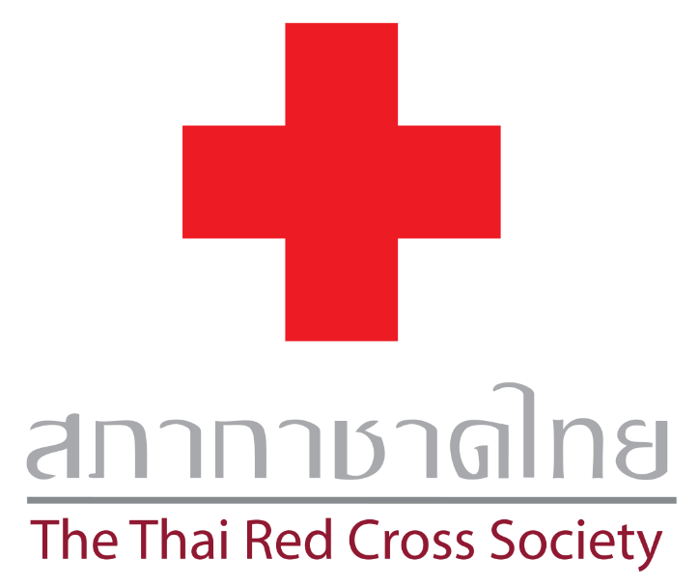

**WAY FORWARD**

What worked well:

- Thai Red Cross (TRC) enhanced its reputation as a trusted organization

- TRC has strong networks and partners and could mobilize significant support, in addition to the support brought by a huge number of dedicated volunteers and staffs.

- TRC has the ability to manage and send relief items to beneficiaries according to their needs in a timely manner.

TRC also recognized that they need some improvements:

- Not enough TRC staffs to manage the work, no contingency plan in case that a few staff needs to take absent

- Not enough working area (area for volunteers to work, car park for donators, warehouse space

- Cannot control number of volunteer, volunteer database

- Lack of communication tools and channels (ie. Phone)

- Lack of main person as relief operation team leader to manage the daily operations (ie. make decision, solve problems)

- TRC staffs need to be supported in some skills, such as language skills.

- Lack of some work tools and equipments for the operation

- Work & responsibility distribution to the team and work structure

- Coordination improvement ie. among department, foreign donators

Recommendations and followed up actions:

- Develop relief operation evaluation and following up system

- Volunteer database management

- Expand and improve work area including warehouse, parking etc.

- Set up TRC information centre/call centre

- Clear work process and responsibility among staffs

- Assign relief operation team leader to manage daily operation

- Identify staffs/volunteers with competencies needed ie. language skills. Also develop existing staffs on competency gap as well as recruit new staff with those competencies/skills

- Manpower planning for sufficient number/qualification of staffs and volunteers including contingency planning.

- Use IT system to help with operation management process

- Increase communication tools/signage

- Spread DRR knowlege to community through CBDRR project

**THE ACTIVITIES**

Thai Red Cross:

- Provided Rapid Assessment Teams (RAT), Relief Teams and Provincial Red Cross Chapter survey and assess damages 513 times

- Set up war room and provided relief supplies and assistance worth USD 11,343,750; distributed relief kits, flat-bottomed boats, floating toilets, shelter box sets, ready to eat meals and drinking water

- Migrants and foreign labors affected by flood in 5 provinces; Nonthaburi, Pathum Thani, Nakhon Pathom, Bangkok and Samut Sakhon; received 4,511 relief kits, ready to eat meals and drinking water from TRC

- Provided mobile medical team, mobile kitchen unit, water purification unit

- Donation management, logistics and volunteer management