***TITLE OF SUCCESS STORY:* Recovery and Risk Reduction through Livelihood Support in Timor-Leste – A Success Story from the Red Cross (CVTL)**

***Agencies names, address and focal contact person:*** Kathryn Clarkson, Head of IFRC Regional Delegation, Dili kathryn.clarkson@ifrc.org

*IMAGES OF THE STORY: Please share as attachment separately high resolution  
(above 1 MB) images to support the success story.*

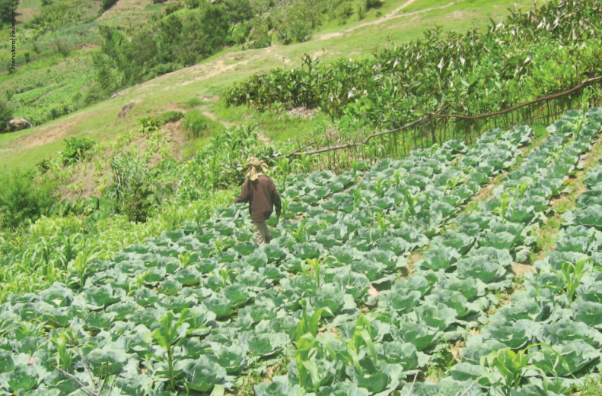 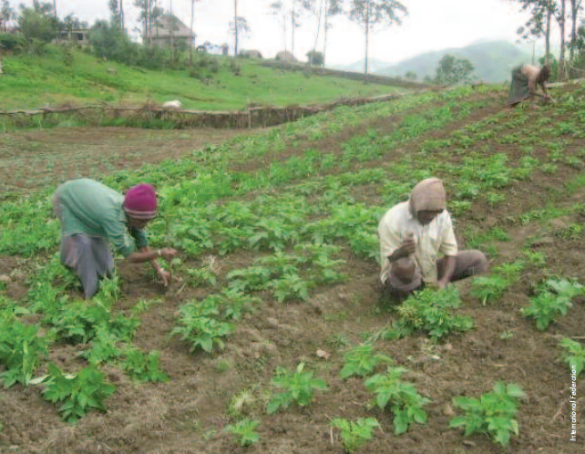

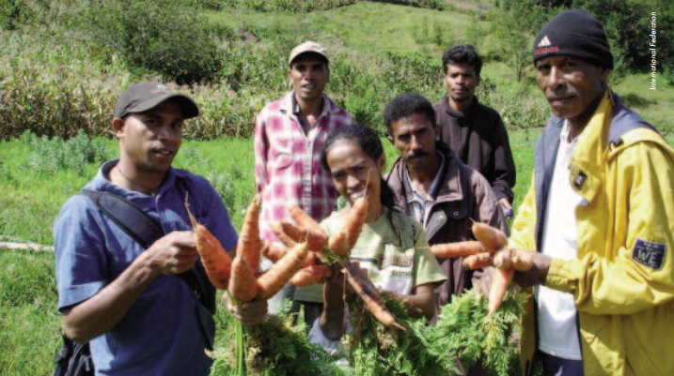

All photos © IFRC

*QUOTE FROM LOCAL COMMUNITY MEMBER INVOLVED IN THE PROJECT*

**THE PROBLEM:**

Timor Leste's location and topography have made it vulnerable to a range of natural hazards that threaten lives and livelihoods. It is prone to natural disasters, incluing earthquakes, tsunamis, floods, landslides, and drought - in addition. Many villages are exposed to strong winds that each year destroy homes and crops.

In 2004, in the remote village of Manumera, in Hatu Builico sub-district in the south-west of the country, about 4,000 people suffered food shortages as a result of a prolonged drought. CVTL responded by distributing food to 754 beneficiaries identified as being particularly in need.

The following year, the situation deteriorated with the failure of the potato crop, the community's only cash crop, as a result of drought-related disease. The affected communities faced malnourishment and hunger, with children and lactating mothers the hardest hit.

**THE OUTCOMES**

The number of community groups engaged in market gardeing grew sponaneously from 4 to 21 in less than two years. Each group owns a market garden, growing a variety of vegetables, such as cabbages, carrots and potatoes

The vegetable gardens yielded a good harvest. This enabled the groups to generate a small income from selling vegetables (ranging from US$45 to US$260 per group) and increased their access to fresh vegeatbels for personal consumption.

The groups acquired new knowledge of and skills in market gardening and in disease-resistant crop varieties and were able to grow vegetables out of season as a result of the new irrigation system. The agricultural inputs and skills acquited also strnegthened the community's overall capacity.

Group members created and maintained mutual support structures and acted as "contacts" for other groups wishing to learn from their experiences

**THE ACTIVITIES**

Prompted by the worsening crisis, the CVTL launched a livelihood project in 2005 to support the community in addressing the chronic food insecurity. The aim of the project was to increase food security at household level through increased agricultural productivity and income generation.

A coordination meeting was held for all stakeholders, attended by village chiefs, local government officials, CVTL staff members, volunteers and board members, and representatives of other non-governmental organisations. Recommendations were made for possible interventions in the affceted communities.

The CVTL and community members jointly organised a participatory risk analysis in two hamlets in Mulo village: Maula-Hulo and Manumera. In all, 72 community members participated in the exercise, which resulted in a decision to develop market gardens. Through this process, the community's key priorities were identifed and, on that basis, a one-year Community Action Plan was drafted, specifying the respective roles and responsibilities of the community and CVTL. Accordingly, the community agreed to contribute the necessary labour and locally sourced materials. The CVTL committed to providing training in relevant gardening skills, supply agricultural implements and seeds, and help upgrade irrigation systems.

The community established four farmers' groups, each comprisin 20 members, of whom 20 per cent were women. Each group then developed its own structure, work schedule and moniroting plan and defined the roles and responsbilities of the group coordinator and individual members.

The CVTL worked in coordination with the Ministry of Agriculture to facilitate the training of the group members in agriculutal skills to improve productivity, focusing on the preparation of the seed beds and the planting of the vegetables. The CVTL livelihood officer, who was based in the community, provided the groups with ongoing support and coaching in other gardening techniques, such as composting. In line with the Community Action Plan, the CVTL and the community jointly carried out the work to protect a spring, to pipe water for irrigation and drinking in Maula-Hulo, and to repair an existing water scheme.

On the recommendation of the Ministry of Agriculture, the CVTL distributed two varities of potato seeds, to replace the local variety of potato that had ben affected by disease in the previous three years. Ministry officials also supported the community in planting new varieties of vegetables. By the end of the first year of the project, the groups had reaped a good harvest. They were able to sell part of the produce in the local market, thereby generating a small income to cover their everyday needs. Out of their income, the groups decided to buy other vegetables seeds for the next season. They also resolved that some of the funds generated would be put aside for emergency food support in the event of a future disaster.

Thus, the project provided a sustainable way for people to recover from disaster and reduce future risk.

|  |
| --- |
|  |

IMPLEMENTING AND PARTNER AGENCIES LOGOS:

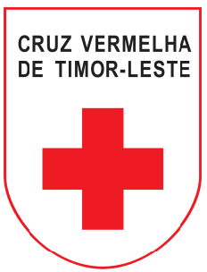

**WAY FORWARD**

The way forward:

- Building on its success and the lessons learned, the project could be expanded to new areas. The participatory planning and implementation process should be mainatined.

- The groups in the project were keen to share their knowledge and skills with other interested groups in neighbouring areas. This support to the other community members will be enhanced.

- The lessons learned from this project may be integrated into community-based disaster preparedness and risk reduction programming for better results.

- The most pressing need of the farmers' groups now is for an integrated approach to pest control. The CVTL has formed a partnership with a local university to develop this aspect.